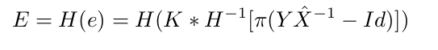
新图像到来

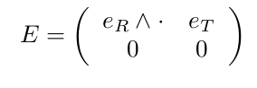

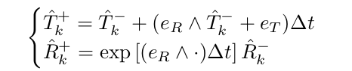

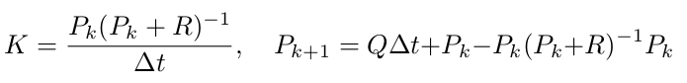

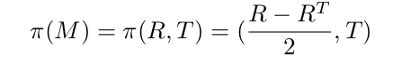

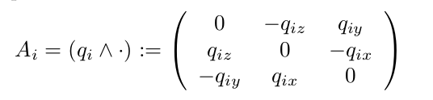

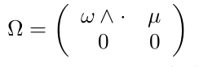

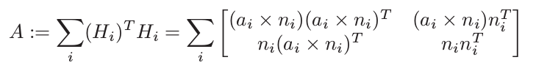

第一个文件 ITMEKF.h

#pragma once
//#include "../Utils/ITMLibDefines.h"
#include "../../ORUtils/CUDADefines.h"
//#include <cstdio>
#include <cstdlib>
//#include <cuda_runtime.h>
#include <cublas_v2.h>
#include "../Objects/ITMTrackingState.h"
#include "../Objects/ITMView.h"
//#include "../Engine/ITMLowLevelEngine.h"
//#include "../Engine/DeviceAgnostic/ITMPixelUtils.h"
//#include "../Engine/DeviceSpecific/CUDA/ITMCUDAUtils.h"
#include "../../ORUtils/PlatformIndependence.h"
using namespace ITMLib::Objects;
namespace ITMLib
{
namespace Engine
{
class ITMEKF
{
private:
void tranS(const Matrix3f & R, Vector3f &p1);//invS
void splitRT(const Matrix4f & M, Matrix3f & R, Vector3f & T);//4to3+1
void proM(Matrix3f & R,const Vector3f & T, Matrix4f &p2);
void tranSinv(const Vector3f & q,Matrix3f & M);//com S
void proH(const Vector3f & R,const Vector3f & T, Matrix4f & H);// com H
void proHinv(const Matrix4f &H, Vector6f & Xh);// com invH
Matrix6f constM;
void expmat(float* R, float* T, float* dst);
public:
ITMEKF();
virtual ~ITMEKF(void);
void invert(float* src, float* dst, int n);
void multicublas(float* src1, float*src2,float* dst, int n1,int n2,int n3);
void compRT(float dt, Matrix6f &Pk, const Matrix4f &Xk,const Matrix4f &Yk,Matrix3f &curR, Vector3f &curT, bool &mattruth);
virtual void covmat(ITMTrackingState *trackingState, const ITMView *view, bool &validpoint, float *covN)=0;
void updateP(ITMTrackingState *trackingState,const ITMView *view,float dt);
};
}
}
第二个文件ITMEKF.cpp

void ITMEKF::expmat(float* R, float* T, float* dst)
{
TooN::Vector<3,float> rotation;
for(int i=0;i<3;i++)
{
rotation[i] = *(R + i);
//std::cout << rotation[i] <<'\n';
}
TooN::Vector<3,float> trans;
for(int i=0;i<3;i++)
{
trans[i] = *(T + i);
//std::cout << trans[i] <<'\n';
}
TooN::Vector<6,float> mu;
mu.slice(0,3) = trans;
mu.slice(3,3) = rotation;
TooN::SE3<> se = TooN::SE3<>::exp(mu);
TooN::SO3<> t = se.get_rotation();
TooN::Matrix<3,3,float> Rf= t.get_matrix();
for(int i=0;i<3;i++)
for(int j=0;j<3;j++)
{
//std::cout << Rf(i,j) << '\n';
*dst++ = Rf(j,i);
}
}

TooN::Matrix<6,6,float> mat;
int c=0;
for(int i=0;i<6;i++)
for(int j=0;j<6;j++)
{
mat(j,i) = a[c];
//std::cout << mat(i,j) <<'\n';
++c;
}
float dst1;
dst1 = TooN::determinant_gaussian_elimination(mat);
if(dst1!=0.0f)
{
invert(a,a,6);}
else{
mattruth = false;
return;
}

第三个文件ITMEKF_CUDA.h
#pragma once
#include "../../ITMEKF.h"
namespace ITMLib
{
namespace Engine
{
class ITMEKF_CUDA : public ITMEKF
{
public:
struct accuCell;
ITMEKF_CUDA();
~ITMEKF_CUDA(void);
void covmat(ITMTrackingState *trackingState, const ITMView *view, bool &validpoint, float *covN);
private:
accuCell *accu_host1;
accuCell *accu_device1;
};
}
}

第四个文件ITMEKF_CUDA.cu
void ITMEKF_CUDA::covmat(ITMTrackingState *trackingState, const ITMView *view, bool &validpoint, float *covN)
{
Matrix4f approxInvPose = trackingState->pose_d->GetInvM();
float *depth = view->depth->GetData(MEMORYDEVICE_CUDA);
Vector4f *pointsMap = trackingState->pointCloud->locations->GetData(MEMORYDEVICE_CUDA);
Vector4f *normalsMap = trackingState->pointCloud->colours->GetData(MEMORYDEVICE_CUDA);
Vector4f sceneIntrinsics = view->calib->intrinsics_d.projectionParamsSimple.all;
Vector2i sceneImageSize = trackingState->pointCloud->locations->noDims;
Vector4f viewIntrinsics = view->calib->intrinsics_d.projectionParamsSimple.all;
Vector2i viewImageSize = view->depth->noDims;
Matrix4f scenePose = trackingState->pose_pointCloud->GetM();
float distThresh = 0.1f * 0.1f;
dim3 blockSize(16, 16);
dim3 gridSize((int)ceil((float)viewImageSize.x / (float)blockSize.x), (int)ceil((float)viewImageSize.y / (float)blockSize.y));
ITMSafeCall(cudaMemset(accu_device1, 0, sizeof(accuCell)));
g_rt_device << <gridSize, blockSize >> >(accu_device1, depth, approxInvPose, pointsMap, normalsMap,
sceneIntrinsics, sceneImageSize, scenePose, viewIntrinsics,
viewImageSize, distThresh);
ITMSafeCall(cudaMemcpy(accu_host1, accu_device1, sizeof(accuCell), cudaMemcpyDeviceToHost));
/*printf("%f,%f,%f,%f,%f,%f,%f,%f,%f\n",accu_host1->g[0],accu_host1->g[1],accu_host1->g[2],accu_host1->g[3],
accu_host1->g[4],accu_host1->g[5],accu_host1->g[6],accu_host1->g[7],accu_host1->g[8]);*/
memcpy(covN, accu_host1->g, 36 * sizeof(float));
validpoint = accu_host1->numPoints/(viewImageSize.x * viewImageSize.y)>0.8;
}

Vector3f r,r1;
r.x = curr3Dpoint.y * corr3Dnormal.z - curr3Dpoint.z * corr3Dnormal.y;
r.y = curr3Dpoint.z * corr3Dnormal.x - curr3Dpoint.x * corr3Dnormal.z;
r.z = curr3Dpoint.x * corr3Dnormal.y - curr3Dpoint.y * corr3Dnormal.x;
A[0] = r.x * r.x;
A[1] = r.y * r.x;
A[2] = r.z * r.x;
A[6] = r.x * r.y;
A[7] = r.y * r.y;
A[8] = r.z * r.y;
A[12] = r.x * r.z;
A[13] = r.y * r.z;
A[14] = r.z * r.z;
A[3] = corr3Dnormal.x * r.x;
A[4] = corr3Dnormal.y * r.y;
A[5] = corr3Dnormal.z * r.x;
A[9] = corr3Dnormal.x * r.y;
A[10] = corr3Dnormal.y * r.y;
A[11] = corr3Dnormal.z * r.y;
A[15] = corr3Dnormal.x * r.z;
A[16] = corr3Dnormal.y * r.z;
A[17] = corr3Dnormal.z * r.z;
A[18] = r.x * corr3Dnormal.x;
A[19] = r.y * corr3Dnormal.x;
A[20] = r.z * corr3Dnormal.x;
A[24] = r.x * corr3Dnormal.y;
A[25] = r.y * corr3Dnormal.y;
A[26] = r.z * corr3Dnormal.y;
A[30] = r.x * corr3Dnormal.z;
A[31] = r.y * corr3Dnormal.z;
A[32] = r.z * corr3Dnormal.z;
A[21] = corr3Dnormal.x * corr3Dnormal.x;
A[22] = corr3Dnormal.y * corr3Dnormal.x;
A[23] = corr3Dnormal.z * corr3Dnormal.x;
A[27] = corr3Dnormal.x * corr3Dnormal.y;
A[28] = corr3Dnormal.y * corr3Dnormal.y;
A[29] = corr3Dnormal.z * corr3Dnormal.y;
A[33] = corr3Dnormal.x * corr3Dnormal.z;
A[34] = corr3Dnormal.y * corr3Dnormal.z;
A[35] = corr3Dnormal.z * corr3Dnormal.z;
return true;

关于elasticfusion和Infinitam 程序的融合
顶层cmakelists.txt修改：
find_package(efusion REQUIRED)
find_package(Pangolin 0.1 REQUIRED)

并加入相关的findXXX.cmake
加入
include_directories(/home/hwj/ElasticFusion/Core/src)
include_directories(${Pangolin_INCLUDE_DIRS})

set(CMAKE_CXX_FLAGS "-O3 -msse2 -msse3 -Wall -std=c++11")

target_link_libraries(InfiniTAM ${EFUSION_LIBRARY})
target_link_libraries(InfiniTAM
${Pangolin_LIBRARIES})

ITMLIB下的cmakelists.txt修改：
加入
include_directories(/home/hwj/ElasticFusion/Core/src)
include_directories(${Pangolin_INCLUDE_DIRS})

修改

if(WITH_CUDA)
if(NOT DEFINED CUDA_COMPUTE_CAPABILITY)
include(${PROJECT_SOURCE_DIR}/cmake/CUDACheckCompute.cmake)
endif()
set(CUDA_ARCH ${CUDA_COMPUTE_CAPABILITY} CACHE STRING "CUDA architectures to compile for")
string(REPLACE " " ";" CUDA_ARCH_LIST ${CUDA_ARCH})
foreach(a ${CUDA_ARCH_LIST})
set(CUDA_ARCH_OPTIONS "${CUDA_ARCH_OPTIONS} -gencode arch=compute_${a},code=compute_${a}")
endforeach()
#SET(CUDA_PROPAGATE_HOST_FLAGS OFF)
set(CMAKE_CXX_FLAGS "${CMAKE_CXX_FLAGS} -std=c++11 -std=gnu++11")//改动
#list(APPEND CUDA_NVCC_FLAGS "-std=c++11;-O3;-DVERBOSE")
SET(CUDA_PROPAGATE_HOST_FLAGS OFF)//改动
#set(CMAKE_CXX_FLAGS "-O3 -msse2 -msse3 -Wall -Xcompiler -std=c++11")
cuda_add_library(ITMLib
${ITMLIB_CPU_OBJECTS}
${ITMLIB_CUDA_OBJECTS}
${ITMLIB_COMMON_OBJECTS}
OPTIONS "${CUDA_ARCH_OPTIONS} --use_fast_math")
else()
add_definitions(-DCOMPILE_WITHOUT_CUDA)
add_library(ITMLib ${ITMLIB_CPU_OBJECTS} ${ITMLIB_COMMON_OBJECTS})
endif()
target_link_libraries(ITMLib Utils)
target_link_libraries(ITMLib ${CUDA_LIBRARY})
target_link_libraries(ITMLib ${EFUSION_LIBRARY})//改动
target_link_libraries(ITMLib
${Pangolin_LIBRARIES})//改动

