去掉manifest.xml中的 <depend package="opencv2"/>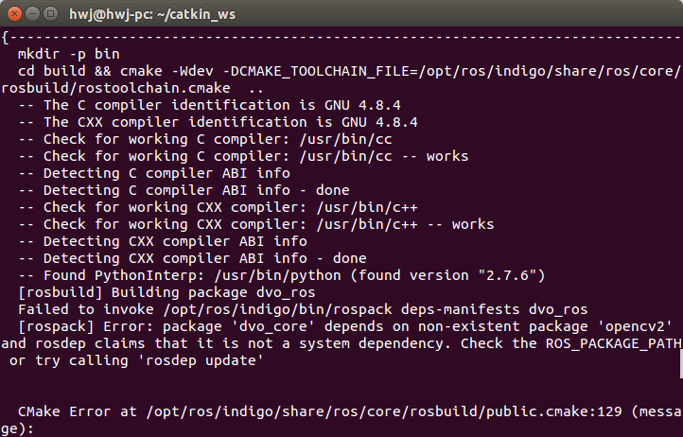

 CMakeLists.txt 中加入

find_package(OpenCV)

include_directories(${OpenCV_INCLUDE_DIRS})

target_link_libraries(my_awesome_library ${OpenCV_LIBRARIES})

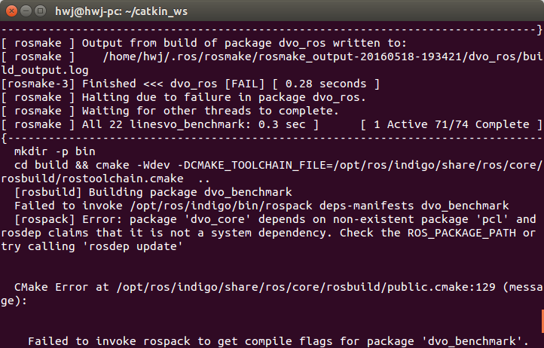

manifest.xml中改为<depend package="pcl_ros"/>

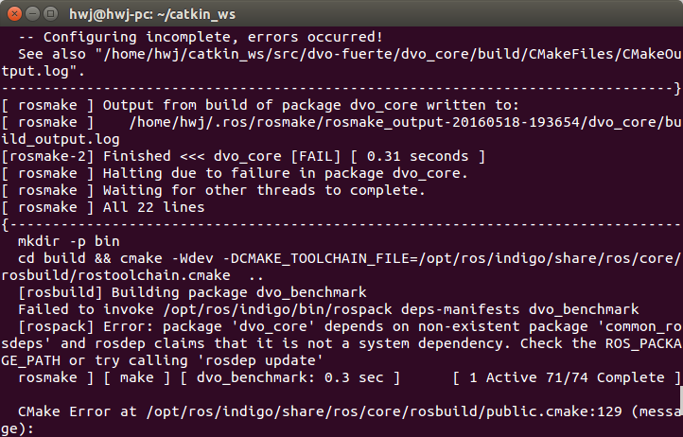

去掉manifest.xml中<depend package="common_rosdeps" />

卸载cuda7.5重新装载7.0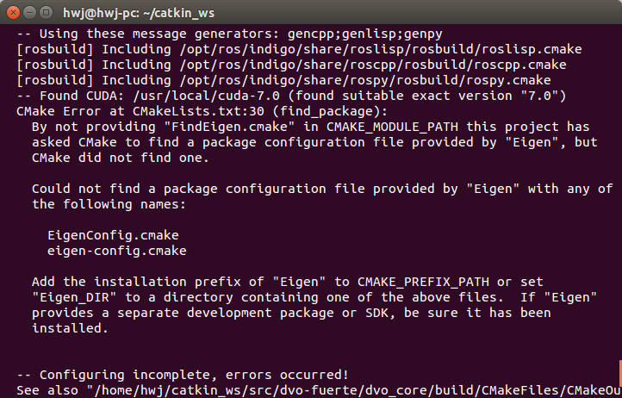

CMakeFiles/rotate_cam.dir/src/rotate_cam.cpp.o: In function `RotateImage::RotateImage()':

rotate_cam.cpp:(.text+0x6dc): undefined reference to `cv::imread(cv::String const&, int)'

CMakeFiles/rotate_cam.dir/src/rotate_cam.cpp.o: In function `cv::String::~String()':

rotate_cam.cpp:(.text._ZN2cv6StringD2Ev[_ZN2cv6StringD5Ev]+0x14): undefined reference to `cv::String::deallocate()'

CMakeFiles/rotate_cam.dir/src/rotate_cam.cpp.o: In function `cv::String::String(std::string const&)':

rotate_cam.cpp:(.text._ZN2cv6StringC2ERKSs[_ZN2cv6StringC5ERKSs]+0x69): undefined reference to `cv::String::allocate(unsigned long)'

如图修改cmakelists.txt加入unset语句

# don't use opencv as found by any prior running of find_package

unset(OpenCV_CONFIG_PATH CACHE)

unset(OpenCV_DIR CACHE)

set(TMP_PREFIX_PATH ${CMAKE_PREFIX_PATH})

set(CMAKE_PREFIX_PATH "$ENV{HOME}/special/install")

find_package(OpenCV 3.0 REQUIRED)

# restore CMAKE_PREFIX_PATH and other cached variables

# so nothing other package finds this opencv

set(CMAKE_PREFIX_PATH ${TMP_PREFIX_PATH})

unset(OpenCV_CONFIG_PATH CACHE)

unset(OpenCV_DIR CACHE)

...

include_directories(

include

${catkin_INCLUDE_DIRS}

${OpenCV_INCLUDE_DIRS}

)

target_link_libraries(foo_node

${catkin_LIBRARIES}

${OpenCV_LIBS}

)

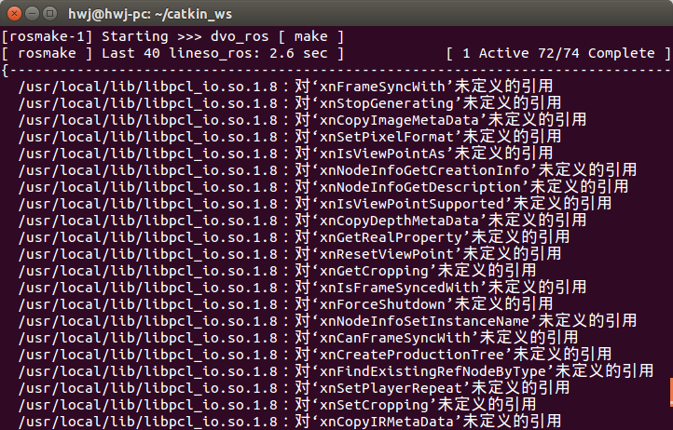

卸载OpenNI2,重装OpenNI1

undefined reference to symbol '_ZN2cv6imreadERKNS_6StringEi' //usr/local/lib/libopencv_imgcodecs.so.3.0: error adding symbols: DSO missing from command line collect2: error: ld returned 1 exit status make: *\** [DI] Errore 1

遇到上述错误卸载Opencv3，重装Opencv2.4.8

error: "invalid static_cast from type ‘vtkObjectBase* const’ to type ‘vtkRenderWindow*’"

遇到上述错误加入头文件#include "vtkRenderWindow.h"

建议加入绝对路径