Nick Iudiciani

*Systems Analysis and Design: Homework Chapter 3*

Problems 19, 24, 26, 28

Professor Chen

2/10/2019

**3-19**

1. Here is the network diagram. Red arrows and boxes show the critical path and their proper activities.

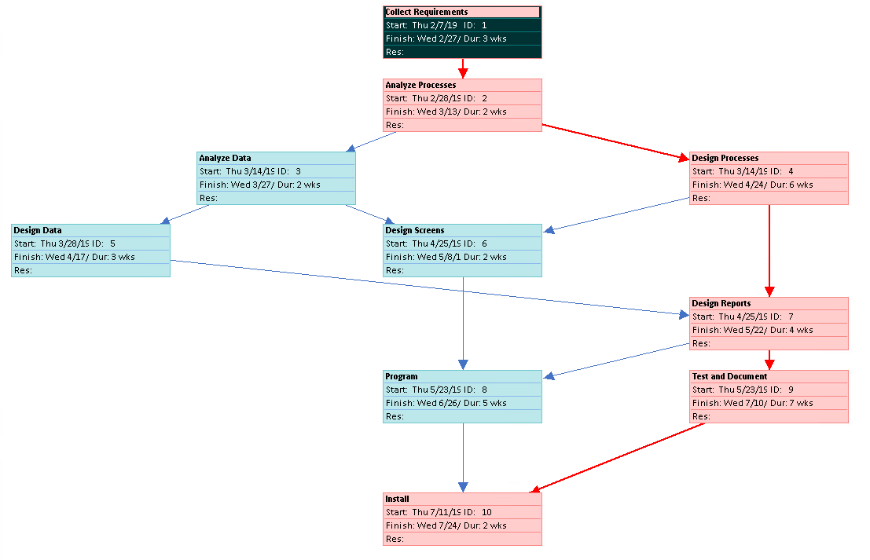

1. 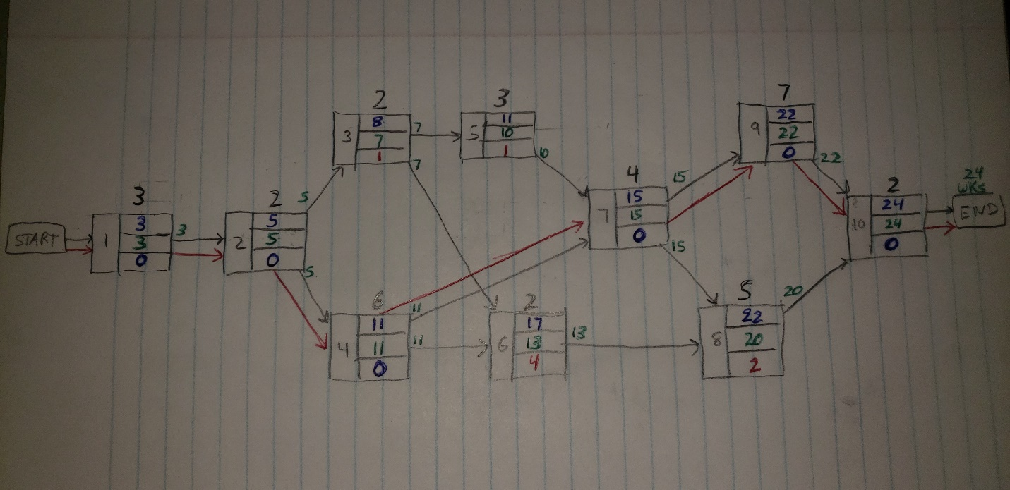The earliest expected completion time of this project is 24 weeks, denoted by the green number “24 wks” above the project’s “end” phase.
2. The critical path is 1-2-4-7-9-10, as denoted in part a) and b) as the red arrows pointing to the proper activities.
3. If the Design screening process were revised to 6 weeks instead of two, the earliest completion time would still be 24 weeks, but we would actually have a total of 3 different critical paths as opposed to one path if activity 6 were still 2 weeks. All of the paths would be:

* 1-2-4-7-9-10 (original CP)
* 1-2-4-6-8-10
* 1-2-4-7-8-10

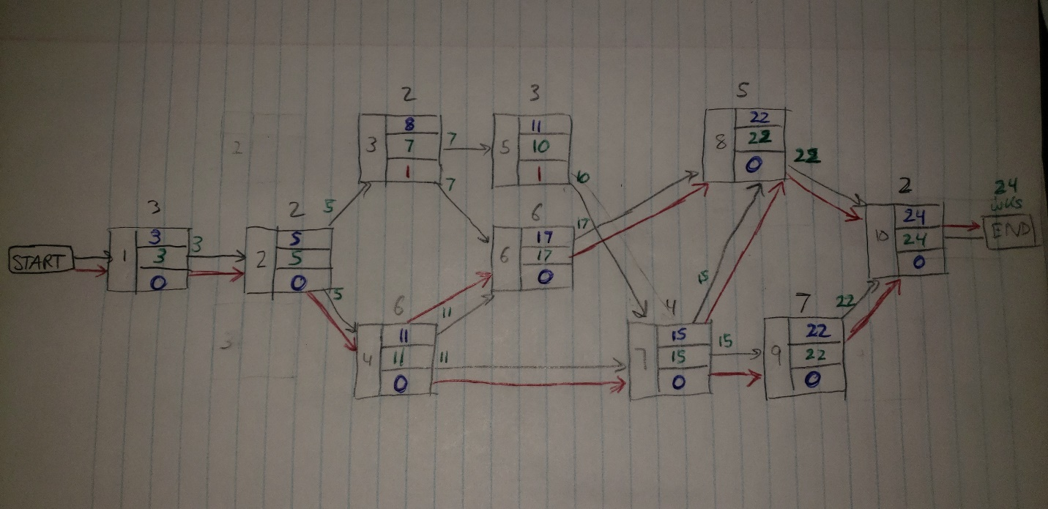

**3-24**

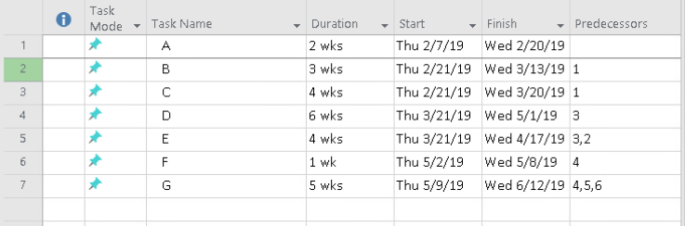The first image at right shows the activities and each of their durations (weeks is the default measurement though no unit of time is specified in the problem). The second image shows the Gantt chart, and the third image shows the estimated time of completion network diagram. In the network diagram, the LF (late finish) is written in blue in the first row of each activity, the EF (early finish) is written in green in the second row, and the slack is written in red in the third row if there is a non-zero value, and in blue to denote zero slack. There are tow critical paths here denoted by the red arrows showing each of their directions. They are:

* A-C-D-G
* A-C-D-F-G

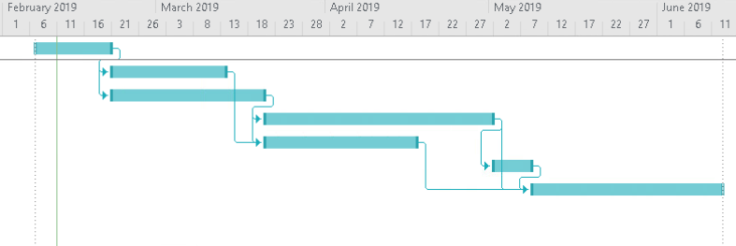

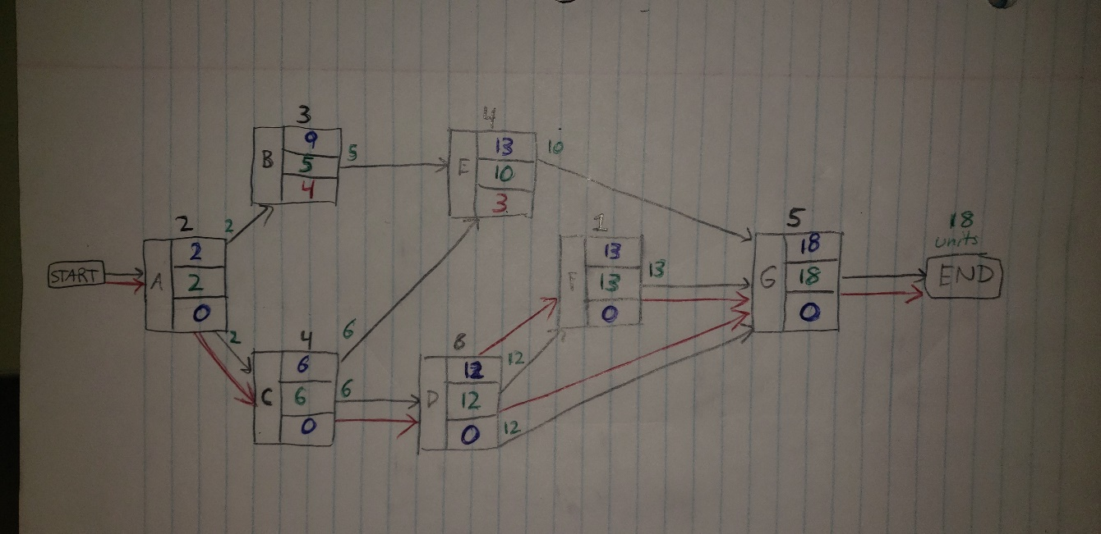

**3-26**

Similar to the previous network diagram problems, the critical path is denoted by the red arrows and also the activities with zero slack, written in blue in the third row of each activity block. The latest completion time is written in blue in the first row, and the earliest completion time written in green in the second row. Although activity B does not have a following path, it is understood that activity B can be completed and the team would have 22 weeks (or whichever units since they are not specified in the problem) to either focus on helping other teams complete their activities or enjoy a nice long vacation, and 22 weeks would be nice. The critical paths and their tasks are as follows:

* A-E-F-I-J
* A-D-E-F-I-J

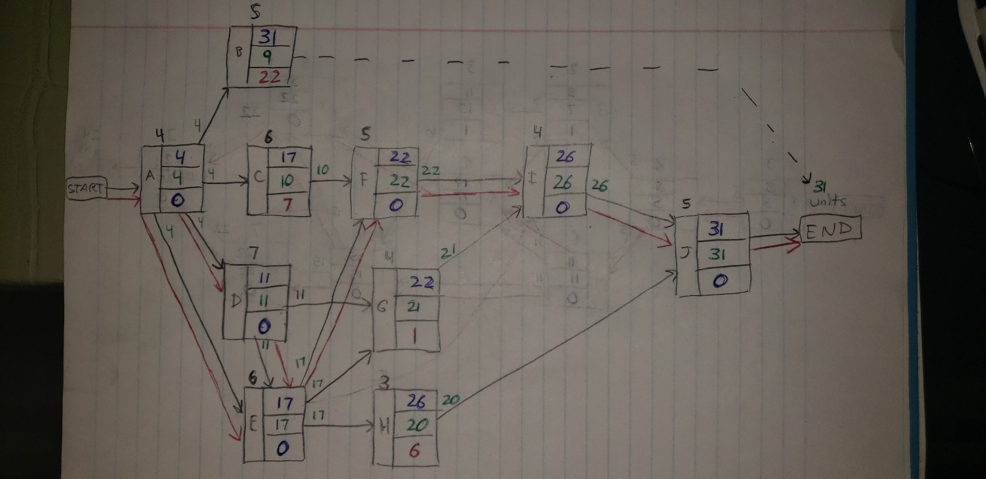

**3-28**

Below are the Gantt chart and network diagram for this project. For network diagram, the critical path and its activities are denoted by red arrows and their slack values of zero, which is written in blue in the third row of each activity block. The LF is written in blue in the first row of the blocks, and the EF is written in green in the second row of each block. The critical path(s) and their activities are:

* A-C-D-F-H-I-J
* 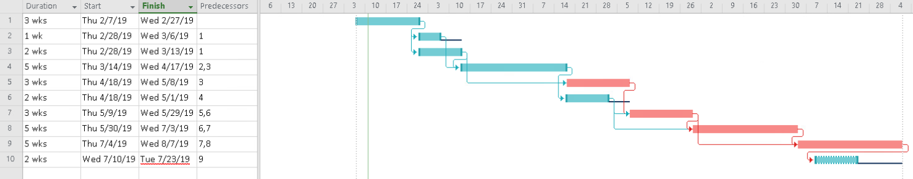A-C-D-F-G-I-J
* A-C-D-F-G-H-I-J

