Milestone 1:

Altamas Kadawala, Nicholas Iudiciani,

Ryan Heinold

A.P. Event Pro, Inc.

Table of Contents

1.0 System Planning and Selection 2

1.1 System Service Form 2

1.2 Scenario 3

1.2.1 Describing the project scope 3

1.2.2 Describing the project alternatives 4

1.2.3 Describing the project feasibility 4

1.2.3.1 Economic Feasibility 4

1.2.3.2 Operational feasibility 4

1.2.3.3 Technical feasibility 5

1.2.3.4 Schedule feasibility 5

1.2.3.5 Legal and contractual feasibility 6

1.2.3.6 Political feasibility 6

1.3 Dividing the project into manageable tasks 7

1.4 Estimating tangible costs and benefits and creating a preliminary budget 10

1.5 Return on Investment and Break-Even Analysis 133

1.6 Developing a communication plan 144

1.7 Determining project standards and procedures 155

1.8 Identifying and assessing risk 156

1.9 Setting up a Baseline Project Plan 166

2.0 User Requirements 20

3.0 System Requirements 20

**1.0 System Planning and Selection**

## 1.1 System Service Form

A.P. Event Pro, Inc.

System Service Request

_____________________________________________________________________________________________

REQUESTED BY : Nick Iudiciani DATE: February 5, 2019

DEPARTMENT: Information Technology, Human Resources

LOCATION: Melrose, MA

CONTACT: 617-894-4997

TYPE OF REQUEST: URGENCY:

[ X ] New System [ ] Immediate – Operations are impaired, or Opportunity lost

[ ] System Enhancement [ X ] Problems exist, but can be worked around

[ ] System Error Correction [ X ] Business losses can be tolerated until the new system installed.

PROBLEM STATEMENT

Our current system of keeping employee records and scheduling are outdated and need revision and/or system overhaul. As our company of independent contracting grows, we take on more contracts and therefore have more clients that require more staffing. Schedules and other employee records are not stored in a digital repository. Rather, they are stored in filing cabinets containing rows of documents that are vastly underutilized, a very inefficient method of storage. When new applicants join the security staff, the most valuable asset is their phone number, since all forms of communication are done via text. The staffing director would send out a mass text to all employees a picture of the handwritten schedule riddled with markups and corrections from previous errors. Because of this, team peer supervisors are unaware of any changes that are made to the schedule, which creates a tense and difficult working environment for both management and employees.

SERVICE REQUEST

We request an evaluation of the current aforementioned areas of the business. We emphasize importance on the means of scheduling for current employees by implementing software and/or database system that allows for the storage of current employee and new candidate information, along with schedules for weekly operations that are easily accessible by management and supervision staff for updates and other changes.

IS LIAISON: Ryan Heinold (Ryan_Heinold@Student.uml.edu)

SPONSER: Altamas Kadawala (Altamas_Kadawala@student.uml.edu) Sales and IT Manager

------------------------------------------TO BE COMPLETED BY SYSTEMS PRIORITY BOARD-----------------------------------------------

[ X ] Request approved Assigned to: Nick, Ryan & Altamas

Start Date: 2/7/2019

[ ] Recommend revision

[ ] Suggest user development

[ ] Reject for reason: _______________________________________________________________

_______________________________________________________________

_______________________________________________________________

_______________________________________________________________

## 1.2 Scenario

### 1.2.1 Describing the project scope

For a company whose management and staff pride themselves on their personal interactivity, AP Event Pro has not embraced technology as much as it should. Because of a failed effort to develop and maintain the company’s website, AP Event Pro’s only point of contact is liaisons through personal communication. There is no email address or phone number associated with the small business. Rather, the company uses its familiar and trusted faces as points of contact through the sharing of their personal information in order to stay in contact. Though the project will not pursue a web page overhaul, this is another potential opportunity that will complement the system effectively.

This project seeks to develop a system to gather, store, and update information and data regarding management, staff, clientele, and even work schedules from within a shared repository. This system would greatly reduce the amount of paper waste due to error corrections, and would greatly improve communication and chemistry between schedule director and managers, and between managers and their respective staff. By eliminating the one-time costs of filing cabinets and drawers, the recurring costs of paper and pens, and adding in the one-time cost of perhaps a tablet or computer to easily track the system, AP Event Pro will see significant upswings inefficiency and employee satisfaction.

The system layout is rather simple: develop a Java Program based on user input, one for clients who would like to contact our security services, one for candidates applying to our company, and perhaps even one that organizes events and assigns employees to them for scheduling. There also needs to be a database built using SQL that would store these user and admin inputs for later access.

For this system to truly shine and radically change the company’s operations, the owners and staff will need basic training on reading schedules and working their mobile devices to effortlessly navigate the system. This can be done easily with a one-on-one sitting with a systems developer.

### 1.2.2 Describing the project alternatives

Because the project is based around the execution of programs and their linked structures, a redesign of the entire website would be one of AP Event Pro’s alternative pursuits. The website appears so dated and obsolete that it is no longer used and serves no basic needs. The site has only three redirected pages, two of which use the same query form for contact and work applications, and one very short “About Us” page. The site’s design, structure, and depth are overall well-below representable levels. In order to focus our attention more on the website rather than the programs, perhaps hiring systems developers to work on the proposed programs while the website is redesigned by the project team.

### 1.2.3 Describing the project feasibility

#### 1.2.3.1 Economic Feasibility

Described later in sections 1.4 and 1.5 of the workbook, the project seems highly feasible economically. Reducing paper waste and increasing efficiency, among other factors, are pivotal to this project. The budget is also rather small due to the system’s small size and low level of technological complexity.

#### 1.2.3.2 Operational feasibility

The current business operations of AP Event Pro never see a day without confusion or miscommunication. Employees on a regular basis report that their schedules are constantly shifted, sometimes at inopportune moments, and management are constantly on the phone talking to the scheduling director about missed changes to staffing. The proposed system will definitely shorten the length of time for communicating changes up the corporate ladder and down to the frontline employees. However, due to the great change this system brings, there may be some resistance and doubt within the organization which will greatly reduce the potential this system brings. AP Event Pro has been around for 15 years, and the owners have resorted to old school methods since day 1. The company is capitalizing on the biggest and most prominent force in everyday personal and business life: technology. The confidence placed in this system is very high, high enough that once employees understand the full scope of the project, their doubt will turn into assurance, and the risk of the company collapsing from within will dissolve to nothing.

#### 1.2.3.3 Technical feasibility

AP Event Pro does not have much technological embrace. Communications are only done via phone calls or text messages, and the company does not have computers or tablets as assets. Rather, schedules are written out by hand, and employee records are stored in filing cabinets. The company is currently in the process of renting office space in the surrounding Melrose area, but as of now, operations are done out of the owner’s home. Luckily, staff members with systems development experience are the ones who proposed the project to the company’s owner, which he happily accepted. The blueprint for the project was small in size, low in developmental and operational complexity, and promised great results.

#### 1.2.3.4 Schedule feasibility

Due to the small size of the project, completion dates can be easily met without interfering with business practices. Because the company can still get by with its current practices, the project can be undertaken in the background and independently of the rest of the business. Also, the needs for security contractors at frequent client venues are located outdoors, so demand for our services are currently low during the winter months. Since the project can be completed in less than a month and a half, the system should be ready for full implementation and deployment during the spring season, when demand for company services increases significantly.

#### 1.2.3.5 Legal and contractual feasibility

The proposed system includes a simple and easy-to-use Java program with a SQL-created database in which to store information. The company has never sought external or third-party assistance for this system, so there is no legal or contractual risk for undertaking the project from within the company. Sure, the design of the programs may mirror those of other developers, but the company’s system developers are not overstepping and legal or contractual boundaries. However, the project team cannot account for what the owner wishes to do with the information that is stored in the repository. Because AP Event Pro is a security-based company, criminal CORI background checks are conducted on our employees, and some information that is collected from the system may be crucial to those background checks, and the owner may have to oblige in supplying that information.

#### 

#### 1.2.3.6 Political feasibility

The company’s current stakeholders are its employees and the client companies it makes contracts with. Because there is a vast miscommunication from within the company throughout the corporate ladder, everyone within the company will be satisfied with the end result once sufficient knowledge and skills are developed. Clients, too, will be impressed with the transformation, though the company’s services on a personal level are what define our image to our external stakeholders.

## 1.3 Dividing the project into manageable tasks

Tasks:

|  |  |  |  |
| --- | --- | --- | --- |
| # | Task name | Duration | Predecessors |
| 1 | Requirement Collection | 5 Days |  |
| 2 | Create a plan and define the logical structure | 3 Days | 1 |
| 3 | Screen design | 5 Days | 2 |
| 4 | Database design | 5 Days | 2,3 |
| 5 | User Documentation | 5 Days | 4 |
| 6 | Programming | 5 Days | 4 |
| 7 | Testing | 3 Days | 6 |
| 8 | Final rollout | 3 Days | 5,6,7 |

Gantt Chart:

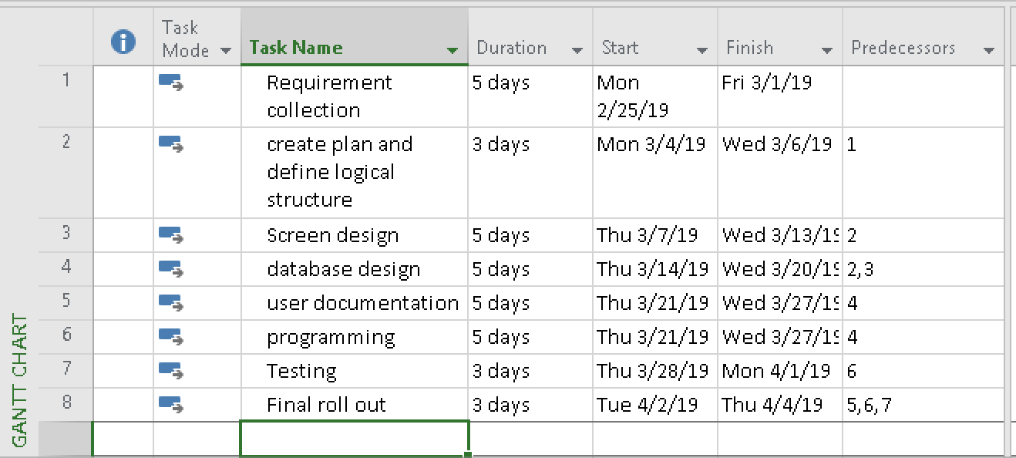

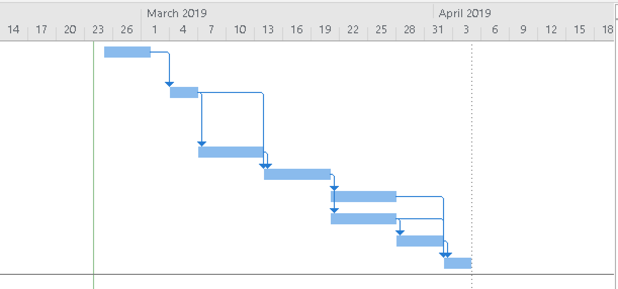

Network Diagram: 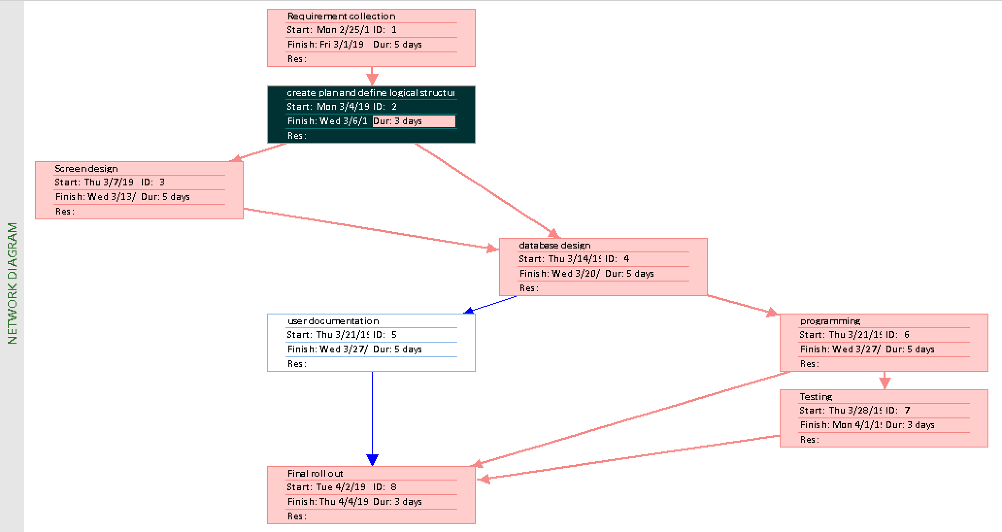

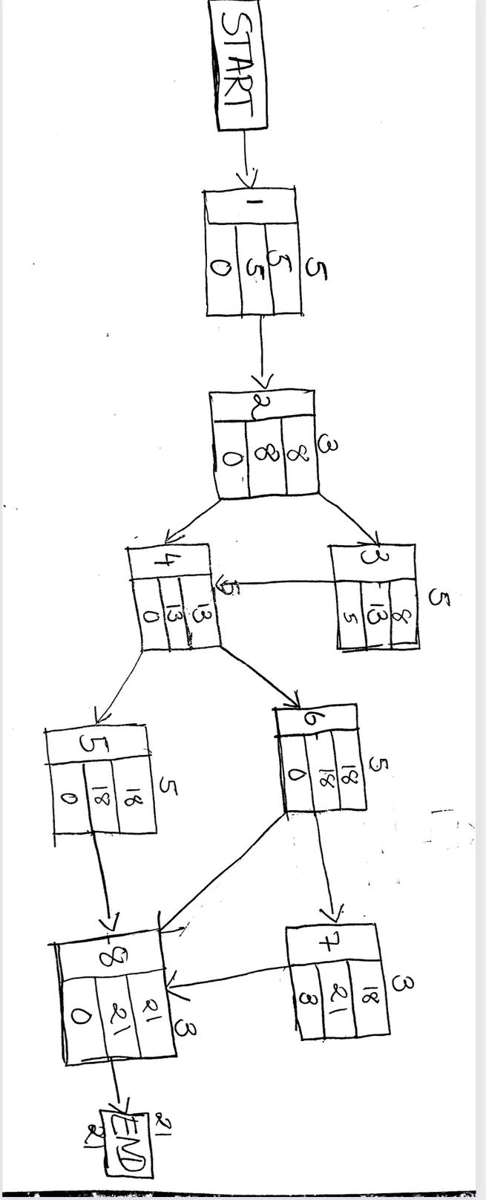

## 1.4 Estimating tangible costs and benefits and creating a preliminary budget

|  |  |
| --- | --- |
| **Tangible Benefits Worksheet**  *Workforce Management and Company Records Project*  Year 1 through 5 | |
| 1. Cost Reduction 2. Error Reduction in scheduling 3. Increased speed of use 4. Improvement in management planning/control 5. Other _________________________________   ----------------------------------------------------------------------------------  **TOTAL Tangible Benefits** | $4,000  $9,000  $4,500  $10,000  $0  ---------------------------------------  **$27,500** |

The tangible benefits worksheet reflects our expected beneficial results from developing and implementing this system. Through the next 5 years, we would save $4000 in paper waste and physical storage units, and $9000 in the time it takes for management to make, correct, and communicate those corrections, to the rest of the management and supervision staff. We would also save $4500 for increased speed and ease of use compared to the other system, as well as a $10000 benefit for improved control, calculated on 10% of our boss’s $100,000 salary.

|  |  |
| --- | --- |
| **Tangible Costs Worksheet**  One-Time and Recurring Costs  *Workforce Management and Company Records Project* | |
| One-Time Costs (Year 0)   1. New Computer/Tablet 2. System Development Costs 3. User Training 4. Other______________________________________   **----------------------------------------------------------------------------------**  **TOTAL One-Time Costs** | $3,000  $15,000  $1,000  $0  **---------------------------------------**  **$18,000** |
| Recurring Costs (Year 1 Through 5)   1. System Software maintenance 2. Data storage needed ($50/GB for 5GB estimated data storage) 3. New Hires “Hands-On Training” 4. Other______________________________________   **----------------------------------------------------------------------------------**  **TOTAL Recurring Costs** | $7,500  $250  $0  $0  **---------------------------------------**  **$7,750** |

For one-time and recurring costs, the project will not see much difficulty in funding and financing this project. Because it does not involve complex work systems and high-tech hardware, costs will remain relatively low for the first 5 years. The project works to redesign the entirety of the current system, but the cost of developing it would only call for a $15,000 payment to the systems developers. After the $1,000 training session, employees and managers are expected to be well-versed in the system and communicate that knowledge to any new employees that join the staff. Though the training session will be very in-depth, the overall message of how the system works and its ease of use will be enough to steer new employees in the right direction for the new system, hence a zero-cost for on-job training.

**Intangible Benefits Assessment**

This new workforce management and planning system would reduce our paper waste, generating more of a technological embracement rather than a “go green” image. The old system was very frustrating and demotivating for employees and management. On many occasions, employees would show up to their assigned location, only to receive a call from the scheduling director that their assignment was changed. This new system will greatly improve employee confidence and morale while reducing scheduling errors and risks of miscommunication. Also, going to a more structured and organized digital system will allow for a changing of the company’s culture and overall norms, emphasizing a need for technology and knowledge of it as well. Employees and management will need to learn how to navigate their phones effortlessly to breeze through the interface and maximize efficiency.

**Intangible Costs Assessment**

Due to the demographics of the current company staff - the systems developers are 23 years old, whereas fellow employees and management and owners are at least in their 40s - the proposed system may be met with some change resistance and operational inefficiency in the early stages of implementation. The project team expects the interface to be so easy that that kind of speculation is shed more positively, and the change will be embraced accordingly. We also believe that having a better system allows for better communications with our clients, boosting their confidence to work with us for future events.

For this economic feasibility analysis, the NPV of benefits comes out to $99,131 which is more than double the costs NPV of $45,937, further reinforcing our need and capabilities for this project. What this means is after 5 years since the new system’s creation and implementation, the company sees overall cash inflows of $53,194, a positive step in the positive, or right direction for the favorable outcome.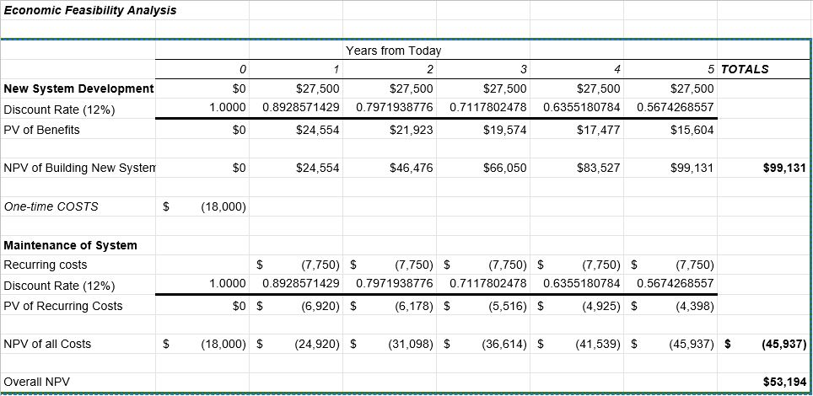

## 1.5 Return on Investment and Break-Even Analysis

After analyzing the ROI and Break-Even analysis, it seems imperative that this project is undertaken, completed and implemented. Because the overall benefits almost double that of the costs, the company would receive a 115.80% return on investment. An ROI that high would mean that returns and benefits greatly exceed costs and the project would return a big net gain, relative to the figures in the table.

The break-even analysis also shows promising results. Break-even is the point at which tangible benefits equals tangible costs, any point before that implies that costs are greater, and any point after means that the project is more beneficial than costly. In this case, AP Event Pro, will see benefits just after 1 year of the system’s implementation. Because overall Net Present Cash flows turn positive after year 1, the project will break-even in year 2. The break-even ratio of 0.023 means that 2.3% into year 2 is the exact date when the project will break-even calculated as between 8.3 and 8.6 days into January. This can be interpreted as January 8th, during the early morning hours or around noon, of the second year of the system’s operation.

## 1.6 Developing a communication plan

Communication is a huge part of a successful project. It is crucial that team members communicate with each other, and that the team as a whole communicates with management and IT. We have determined the communication details in the table below.

|  |  |  |  |  |
| --- | --- | --- | --- | --- |
| **Stakeholder** | **Document** | **Format** | **Team Contact** | **Date Due** |
| Team Members | Status Report | Project Workbook  (hard copy) | Altamas  Nick  Ryan | First Wednesday of every Month |
| Management | Status Report | Project Workbook  (hard copy) | Nick  Altamas | First Wednesday of every Month |
| User | Status Report | Project Workbook  (hard copy) | Altamas Ryan | First Wednesday of every Month |
| Internal IT | Status Report | Project Workbook  (E-mail) | Ryan  Nick | First Wednesday of every Month |
| IT Manager | Status Report | Project Workbook  (hard copy) | Ryan  Altamas  Nick | First Wednesday of every Month |
| Contract Programmers | Specific Software Details | Programming document (E-mail) | Nick  Altamas  Ryan | March 20th, 2019 |
| Training Subcontractor | Training Plan | Training document (hard copy) | Nick  Altamas  Ryan | April 2nd, 2019 |

## 1.7 Determining project standards and procedures

Determining how we are going to prepare this project is an important step. We will mostly follow the System development life cycle. The first step will be to plan the system. We begin this stage by identifying our problem, which is that the current solution to storing information and creating weekly schedules is outdated. Our proposed solution is to create a database to store employee information and create schedules. We then begin to analyze the proposed system. We start by analyzing all the current problems with the outdated system. These problems will let us know exactly what we are attempting to improve with the new database. We will then design the system. This step is crucial, as we need to design not just the physical database, but also the logic behind the project. The logical design will show exactly how the new system will be implemented throughout the company. It focuses on the business aspect, and how the system will influence day-to-day activities. Finally, we will implement the system. We will code, test, and re-test before releasing the system to the entire company.

Other important standards not within the SDLC are also important to consider. We will do most of our work in the project workbook. This will be the main document we use to track our progress and the main document will we show to our Manager and the IT team when meeting. This document will mainly be in Arial font, size 11 with normal spacing and margins. There will be charts and tables throughout this workbook in order to show further details. Keeping this workbook updated and organized will ensure that our project stays on track.

## 1.8 Identifying and assessing risk

There is some potential risk that needs to be identified. Identifying risk and planning for the worst possible outcome will help prepare us for the future. The most obvious risk is that the employees of A.P Event Pro Inc. might be hesitant to change. They have been using the handwritten system to get their schedule for years and while it might not be the most efficient system, it is familiar. This is especially a concern for the older members of the staff. They might not be comfortable with the new technology and could struggle with finding the correct information. If an employee is unable to access the system or understand the system for whatever reason, there could be chaos with the schedule. Hopefully, with proper training, all employees will be able to confidently use the new system.

Another potential risk is that there are bugs within the software upon release. There is going to be a lot of information put into this database, and there is a possibility of something going wrong. There is certainly a chance that not everything is running smoothly when we first release this software. This will cause concern from management down throughout the whole company. We will need to carefully prepare the system and go through many stages of testing before releasing the software.

## 1.9 Setting up a Baseline Project Plan

1.0 Introduction

1. Project Overview- A.P. Event Pro, Inc. on-demand security service provider, seeks a new system to manage their employee scheduling and keep all of the clientele information in one system. The system will be developed and presented to its employees and management. This project is very fast paced and will be finished estimated just over a month. Due to handwritten scheduling and missing important clientele information, the ROI will be as quick as 6 months. A.P. Event Pro, Inc. will be as efficient as other security providers in the market.
2. Recommendation- The project timeline should be followed in a timely fashion. The system should not be compromised, and extra time will be given if needed.

2.0 System Description

1. An alternative- There are many alternatives systems available in the market, but with this custom made system will provide greater flexibility.
2. System Description- System will be developed with two sections access one for management and one for employees. It will also have a general information section on how the client can reach out for business and career section for potential new hire. A database will also be developed to store all of the data.

3.0 Feasibility assessment

1. Economic feasibility- Sections 1.2.3.1, 1.4, and 1.5 all highlight the intricacies and specifics of why this project is economically feasible. The tangible and intangible benefits outweigh the tangible and intangible costs while providing a substantial return on investment and short period for break-even.
2. Technical Analysis- As described in 1.2.3.3 of the workbook, AP Event Pro is in need of some form of technological acceptance in order to function at much higher efficiency levels. The company is currently filled with miscommunication problems that can easily be rectified with this system.
3. Operational Analysis- Upon management and employee adoption, this project will be in used on a day to day operation. With the new system, it will be easier for potential new business to submit a service request.
4. Legal and Contractual Analysis- System will be made solely use for A.P. Event Pro, Inc and will not be shareable. It will be licensed whenever needed.
5. Political Analysis- We do not see any political threats due to the fact the company is small and local.
6. Schedules, Timeline, and Resource Analysis- Scheduling is very tight as we can see in the task chart. The project will be done in just over a month. Resources will become available as needed.

4.0 Management Issues

1. Team Configuration and Management- Teams will be broken into It manager, programmer, and training staff. Teams will be encouraged to work collaboratively.
2. Communication Plan- Communication will be mostly done through emails. Teams will be meeting every week to work on a project using project workbook.
3. Project Standards and Procedures- This project is very fast paced and it will be done in little over a month. Work should be efficient in order to ensure it’s done in a timely manner. A plan must be in place if missing any day of work.
4. Other Project-Specific Topics- There are no other relevant issues.

1.10 Preparing a project scope statement

|  |  |
| --- | --- |
| Project: | New Systems for A.P Event Pro Inc. |
| Created by: | Altamas Kadawala, Nicholas Iudiciani, Ryan Heinold |
| Date: | 02/26/2019 |
| Reason for the project: | We are creating this project in order to improve cost and efficiency for the company A.P Event Pro. This project will reduce costs, reduce the potential for errors in scheduling, and improve management's time and resources. |
| Description: | For this project, we will develop a Java program that can bring the company into the 21st century. This program will help clients reach the company, help interested candidates apply to the company, and even create weekly schedules for the employees. We will also make a SQL based database in order to store employee information. Currently, all employee information is stored in filing cabinets throughout the company. Our project will make A.P Event Pro a more efficient and organized company. |
| Deliverables: | * Project workbook * Gantt chart/network diagram * Java program * SQL database * Staff training |
| Project objectives: | * Successfully create a Java program * Successfully create a database using SQL * Successfully train employees * Get employees comfortable with the new system |
| Cost objectives: | * Stay at or below tangible costs estimated in section 1.4 * Have this project save the company money in the long run |
| Schedule objectives: | * Stay on track with the schedule outlined in section 1.3 * Roll out the final product by our intended date (April 4th, 2019) |
| Acceptance criteria: | We will determine this project successful if we are able to train the employees to use our new system. There will certainly be things to work out upon release of the system, but if within a month of release all employees are using the system to check their schedule with no problems then this will be a successful project. |
| Constraints: | * Time * Cost * Resources * Quality * Risk |
| Assumptions: | * We assume that we will have appropriate IT staff available to help create our systems * We assume that we will have the support of management * We assume that the employees will be able to grasp the new system |

**2.0 User Requirements**

* Users must be able to read and use a computer, tablet, and/or mobile device to access and use the system.
* A user must be able to fill out a query similar to a work application, but from within the system rather than on a written document.
* A user must be able to collect and organize data and information from queries and schedules (Administrative use only).
* A user must be able to communicate effectively to allow admins to quickly change or update schedule or status changes

**3.0 System Requirements**

* In order to run this system, the device must meet the following specs
  + Operating System: Windows XP, Windows 7, Windows 8, Windows 10
  + Processor: 32-bit (x86) or 64-bit (x64) Processor
  + Permissions: Read (Employee), Read & Write (Administrative)
  + Software (Admin Use): Java Standard Edition Development Kit with Java Runtime Environment