Milestone 3:

Altamas Kadawala, Nicholas Iudiciani,

and Ryan Heinold

A.P. Event Pro, Inc.

Table of Contents

1.0 Data Flow Diagrams 2

[1.1 Context Diagram](https://docs.google.com/document/d/1gihh6Tc_cdspc2OjJ4YRSfHYUuG_z5xVMRdB7v8GMO4/edit#heading=h.hdqfk23ozp05)  2

[1.2 Level-0 Diagram](https://docs.google.com/document/d/1gihh6Tc_cdspc2OjJ4YRSfHYUuG_z5xVMRdB7v8GMO4/edit#heading=h.xubjhgrxk4ia)  3

1.3.1 Level-1 Diagram of Process 1.0 4

1.3.2 Level-2 Diagram of Process 4.0 5

2.0 Entity-Relationship Diagrams 6

3.0 Data Dictionary 7

**1.0 Data Flow Diagrams**

1.1 Context Data Flow Diagram

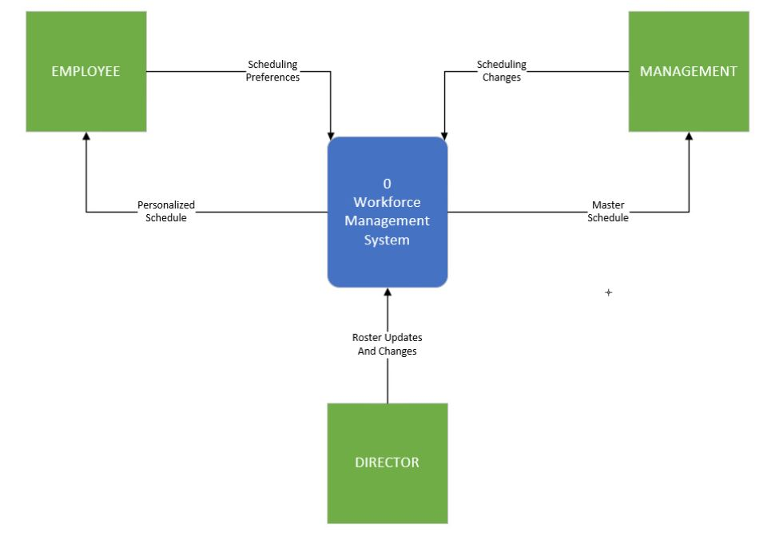

For our workforce management system, there will be 3 inputs and 2 outputs. The employee and manager will provide details into their scheduling needs - from a personal preference on the employee’s part (weekly hours needed, or a day-to-day basis), and a priority need on the manager’s part (judgmental view on who performs better). The system will give them their respective schedules, one for the employee based on their individual agendas, and the master schedule for the manager to coordinate with supervisors and other staff. The Scheduling director will also put their two cents into the mix, offering changes to the roster based on employee’s past needs and new recruits.

1.2 Level-0 Data Flow Diagram

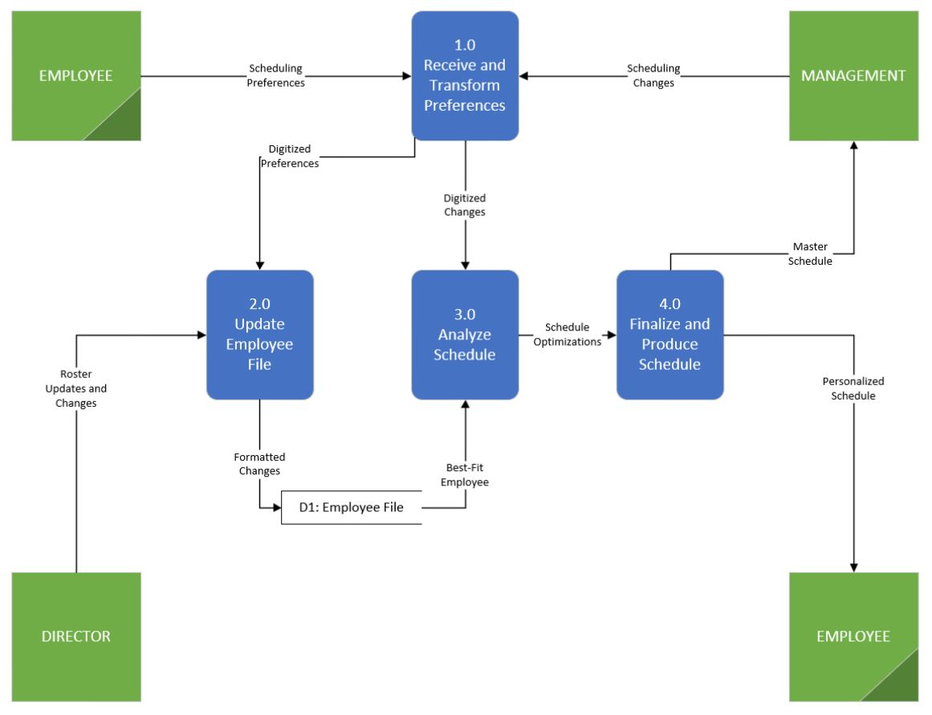

At level-0, a broad overview of the system is given above. The system includes 4 processes to absorb the manager and employee preferences, update the employee file with those changes along with director admin changes, and finally optimize the schedule and produce it for the manager and employee.

1.3.1 Level-1 Decomposition of Process 1.0

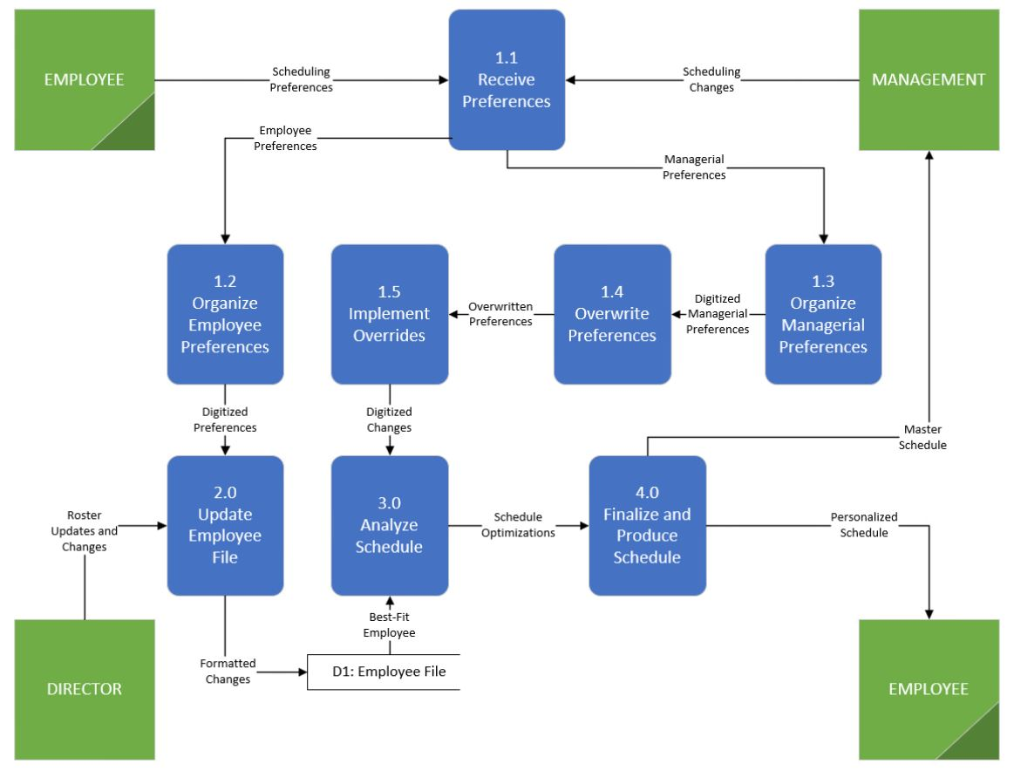

Further decomposing Process 1.0, we see that the system easily processes the employee’s needs, but the manager’s need to judgmentally override certain preferences is a little more complex. The manager knows what is best at this point, so although the director has a hand in helping organize the schedule, the manager has the final say and is allowed to make that executive override, ignoring Process 2.0 and the updating of the data store 1 that is mentioned.

1.3.2 Level-1 Decomposition of Process 4.0

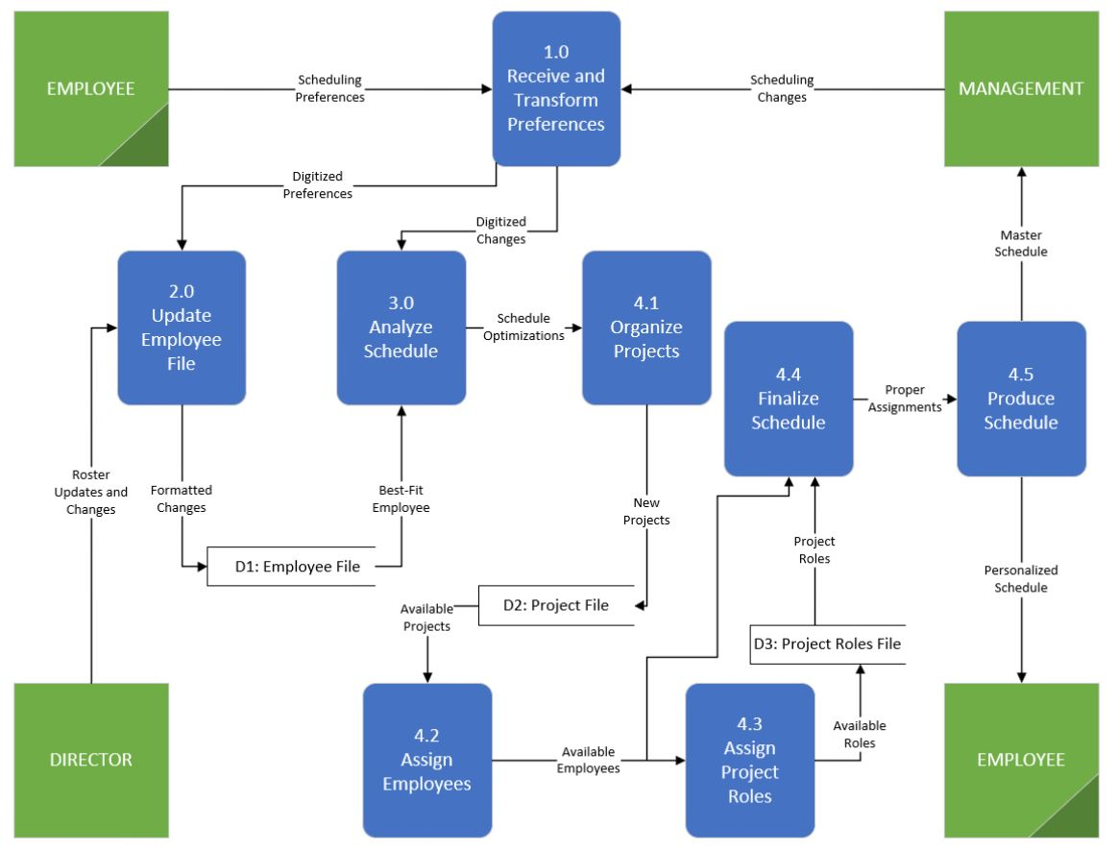

After decomposing Process 4.0 of the finalizations for the schedule, we see that 2 more data stores are used. Each of the company’s clients provides us with different projects to complete under contract, which we keep a file dedicated for them. We know the weekly assignments for them so there are rarely any surprises or sudden changes needed. The third data store is for assigning roles to each of the employees. Depending on the daily demand of our clients, we may have to delegate supervisor roles to non-supervisors in order to both allow them to work at that level and also alleviate pressure from our bosses, who will sometimes come and fill those supervisor roles on their own.

2.0 Entity-Relationship Diagrams

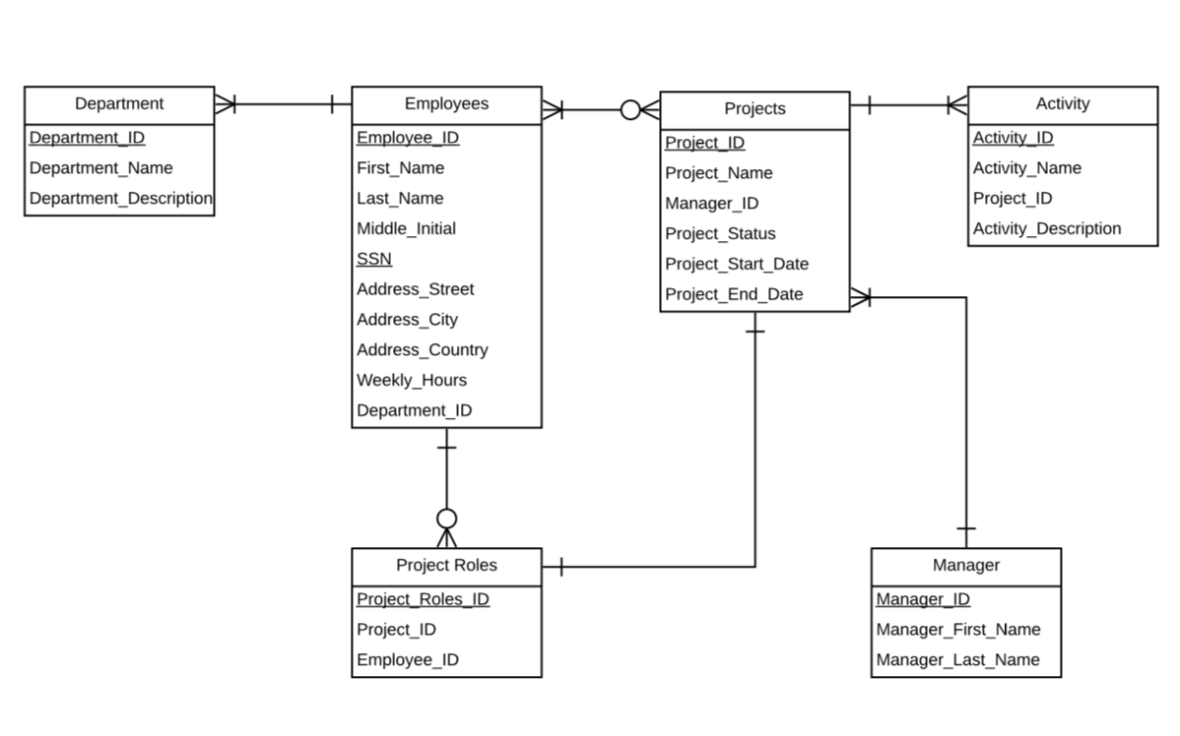

Above is our Entity relationship diagram. Entities includes Employees, Projects, Activity, Department, Manager and Project roles. Employees includes attributes such as employee ID and SSN which is also our primary key. It includes First_Name, Last_Name, Middle_Initial, Address_Street, Address_City, Address_Country, Weekly_hours and Department_ID.

Projects includes Project_ID as primary key. Project_Name, Manager_ID, Project_Status, Project_Start_Date, Project_End_Date.

Activity includes Activity_ID as primary key. Activity_Name, Project_ID and Activity description as attributes. Manager includes Manager_ID as primary key. Also has Manager_First_Name, Manager_Last_Name as attributes.

ProjectRoles has Project_Role_ID as primary key. Also has Project_ID and Employee_ID as attributes.

Department has Department_ID as primary key. Also has Deparment_Name and Department_Describtion as Attributes.

Employees can have no projects or can have many projects, Projects will have one or many employees work on them. Employees will have no roles or many roles but project roles will have at least one employee assigned to it. A project will have one or many activities and activities will have at least one project. Manager will be assigned to at least one project but project could have one or many managers. Employees could assigned to one or many departments but department will have at least one employee.

3.0 Data Dictionary

|  |  |  |  |  |
| --- | --- | --- | --- | --- |
| **Entity** | **Attribute** | **Data Type** | **Size** | **Domain/Mask** |
| Project | **Project_ID** | Numerical | 6 | 0-9 |
|  | Project_Name | Alphabetical | 20 | A-Z |
|  | Manager_ID | Numerical | 8 | 0-9 |
|  | Project_Status | Alphabetical | 20 | A-Z |
|  | Project_Start_Date | Numerical | 8 | MM/DD/YYYY |
|  | Project_End_Date | Numerical | 8 | MM/DD/YYYY |
| Activity | **Activity_ID** | Numerical | 6 | 0-9 |
|  | Activity_Name | Alphabetical | 20 | A-Z |
|  | Project_ID | Numerical | 6 | 0-9 |
|  | Activity_Description | Alphabetical | 20 | A-Z |
| Employee | **Employee_ID** | Numerical | 8 | 0-9 |
|  | First_Name | Alphabetical | 20 | A-Z |
|  | Last_Name | Alphabetical | 20 | A-Z |
|  | Middle_Initial | Alphabetical | 1 | A-Z |
|  | SSN | Numerical | 9 | 0-9 |
|  | Address_Street | Alphanumerical | 20 | 0-9, A-Z |
|  | Address_City | Alphabetical | 20 | A-Z |
|  | Address_State | Alphabetical | 20 | A-Z |
|  | Address_Country | Alphabetical | 20 | A-Z |
|  | Weekly_Hours* | Numerical | 3 | 0-9 |
|  | Department_ID | Alphanumerical | 7 | 0-9, A-Z |

|  |  |  |  |  |
| --- | --- | --- | --- | --- |
| Project Roles | **Project_Roles_ID** | Numerical | 6 | 0-9 |
|  | Project_ID | Numerical | 6 | 0-9 |
|  | Employee_ID | Numerical | 8 | 0-9 |
| Department | **Department_ID** | Numerical | 6 | 0-9 |
|  | Department_Name | Alphabetical | 20 | A-Z |
|  | Department_Descrpition | Alphabetical | 20 | A-Z |
| Manager | **Manager_ID** | Numerical | 8 | 0-9 |
|  | Manager_First_Name | Alphabetical | 20 | A-Z |
|  | Manager_Last_Name | Alphabetical | 20 | A-Z |
|  |  |  |  |  |