Nick Iudiciani

4/11/18

MIST3030 Section 201 – Prof. Li

HW #3

1a)

FLIGHT

**Flight ID**

**(Flight Number, Date)**

Number of Passengers

…

Flight

|  |  |  |
| --- | --- | --- |
| FlightNumber | Date | NumberOfPassengers |

1b)

Employee

|  |  |
| --- | --- |
| EmployeeID | EmployeeName |

Certificate

|  |  |  |  |
| --- | --- | --- | --- |
| CertificateNumber | EmployeeID | CourseID | DateCompleted |

Course

|  |  |
| --- | --- |
| CourseID | CourseTitle |

1c)

|  |  |  |  |  |
| --- | --- | --- | --- | --- |
| VehicleID | Price | EngineDisplacement | Make | Model |

Vehicle

Car Truck

|  |  |  |
| --- | --- | --- |
| TVehicleID | Capacity | CabType |

|  |  |
| --- | --- |
| CVehicleID | NumberOfPassengers |

1d)

Patient Responsible Physician

|  |
| --- |
| PhysicianID |

|  |  |  |  |
| --- | --- | --- | --- |
| PatientID | PatientName | AdmitDate | *PhysicianID* |

Outpatient Resident Patient

|  |  |
| --- | --- |
| OPatientID | CheckbackDate |

|  |  |  |
| --- | --- | --- |
| RPatientID | DateDischarged | *BedID* |

Bed

|  |
| --- |
| BedID |

2)

Course

|  |  |  |
| --- | --- | --- |
| CourseID | CourseTitle | PrerequisiteCourseID |

Section

|  |  |  |
| --- | --- | --- |
| SectionID | CourseID | ScheduledDayTime |

|  |  |
| --- | --- |
| PrerequisiteCourseID | PrerequisiteCourseTitle |

Prerequisite

3a)

|  |  |  |  |  |
| --- | --- | --- | --- | --- |
| Part No | Description | Vendor Name | Address | Unit Cost |
| 1234 | Logic Chip | Fast Chips | Cupertino | 10 |
| 1234 | Logic Chip | Smart Chips | Phoenix | 8 |
| 5678 | Memory Chip | Fast Chips | Cupertino | 3 |
| 5678 | Memory Chip | Quality Chips | Austin | 2 |
| 5678 | Memory Chip | Smart Chips | Pheonix | 5 |

3b and d)

Part No 🡪 Description

Vendor Name 🡪 Address

Part No, Vendor Name 🡪 Unit Cost

**PartNo and VendorName can be the candidate keys for the PART SUPPLIER relation.**

PART SUPPLIER

|  |  |  |  |  |
| --- | --- | --- | --- | --- |
| PartNumber | Description | VendorName | Address | UnitCost |

3c)

Modification Anomaly: If the address of a particular Vendor is changed, it should be updated in all related records of that specific vendor.

3e)

This relation is in 1NF because it does not contain repeated attributes.

3f and g)

PART

|  |  |
| --- | --- |
| PartNo | Description |

PART SUPPLIER

|  |  |  |
| --- | --- | --- |
| PartNo | VendorName | UnitCost |

VENDOR

|  |  |
| --- | --- |
| VendorName | Address |

|  |  |
| --- | --- |
| PART | |
| PK | PartNo |
|  | Description |

|  |  |
| --- | --- |
| PART SUPPLIER | |
| PK, FK1  PK, FK2 | PartNo  VendorName |
|  | UnitCost |

|  |  |
| --- | --- |
| VENDOR | |
| PK | VendorName |
|  | Address |

4)

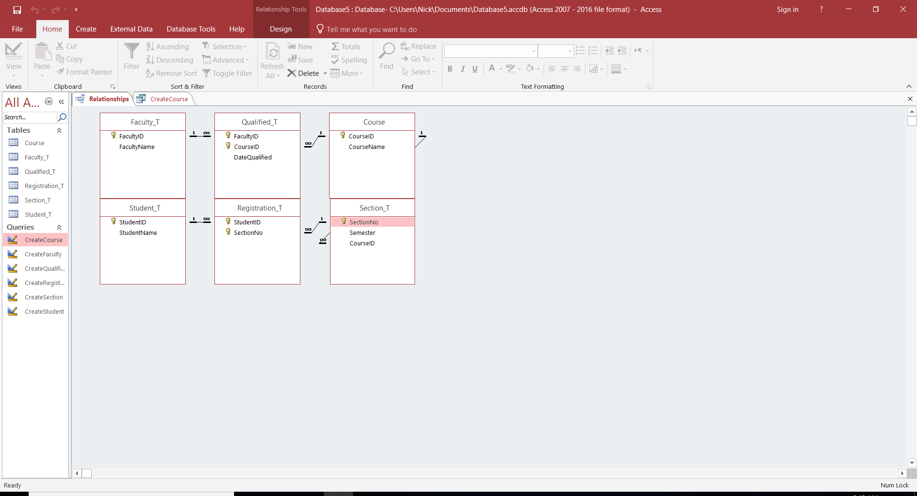

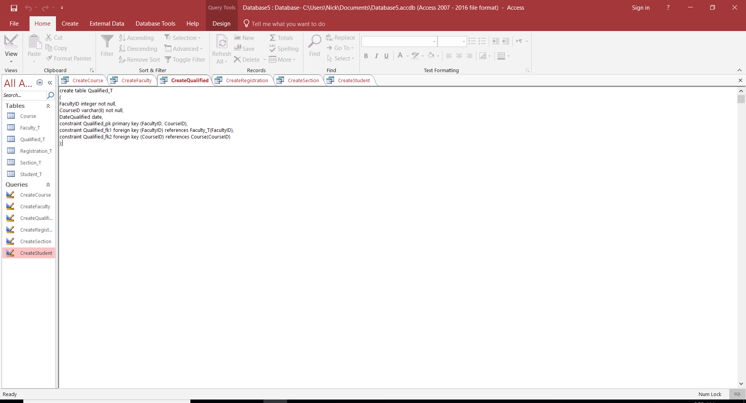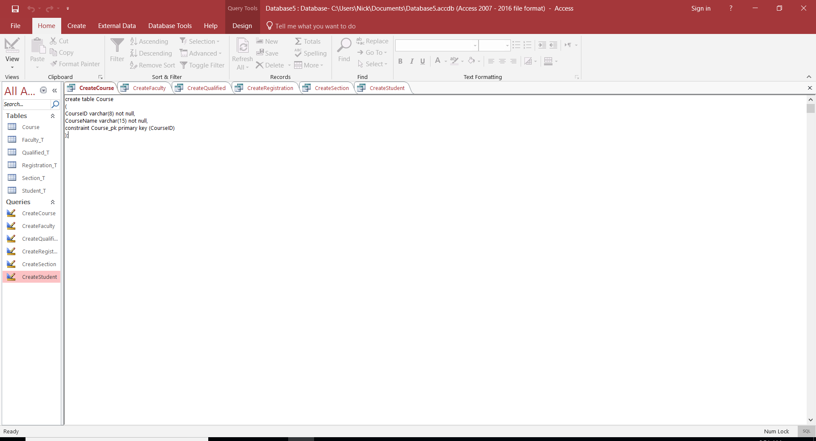

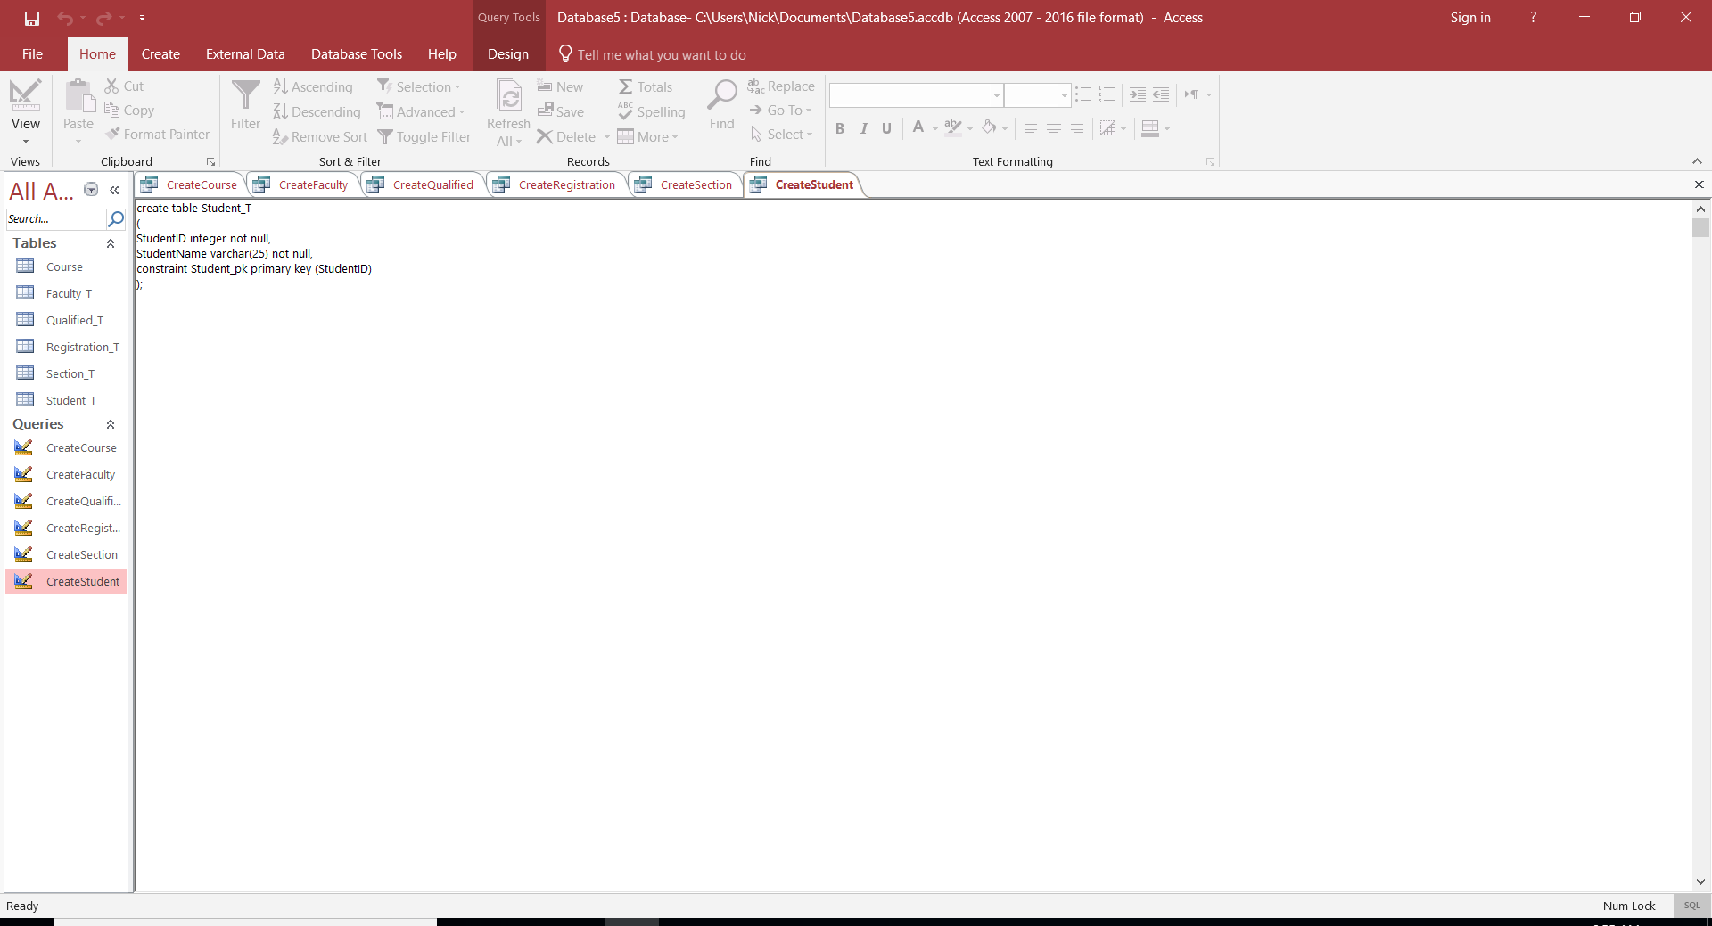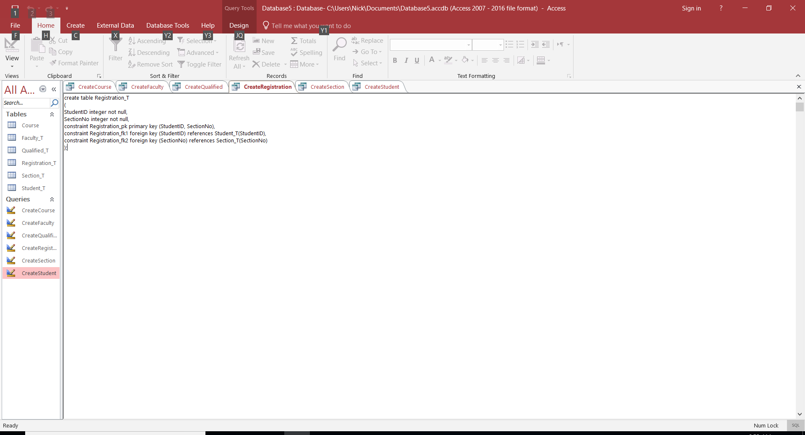

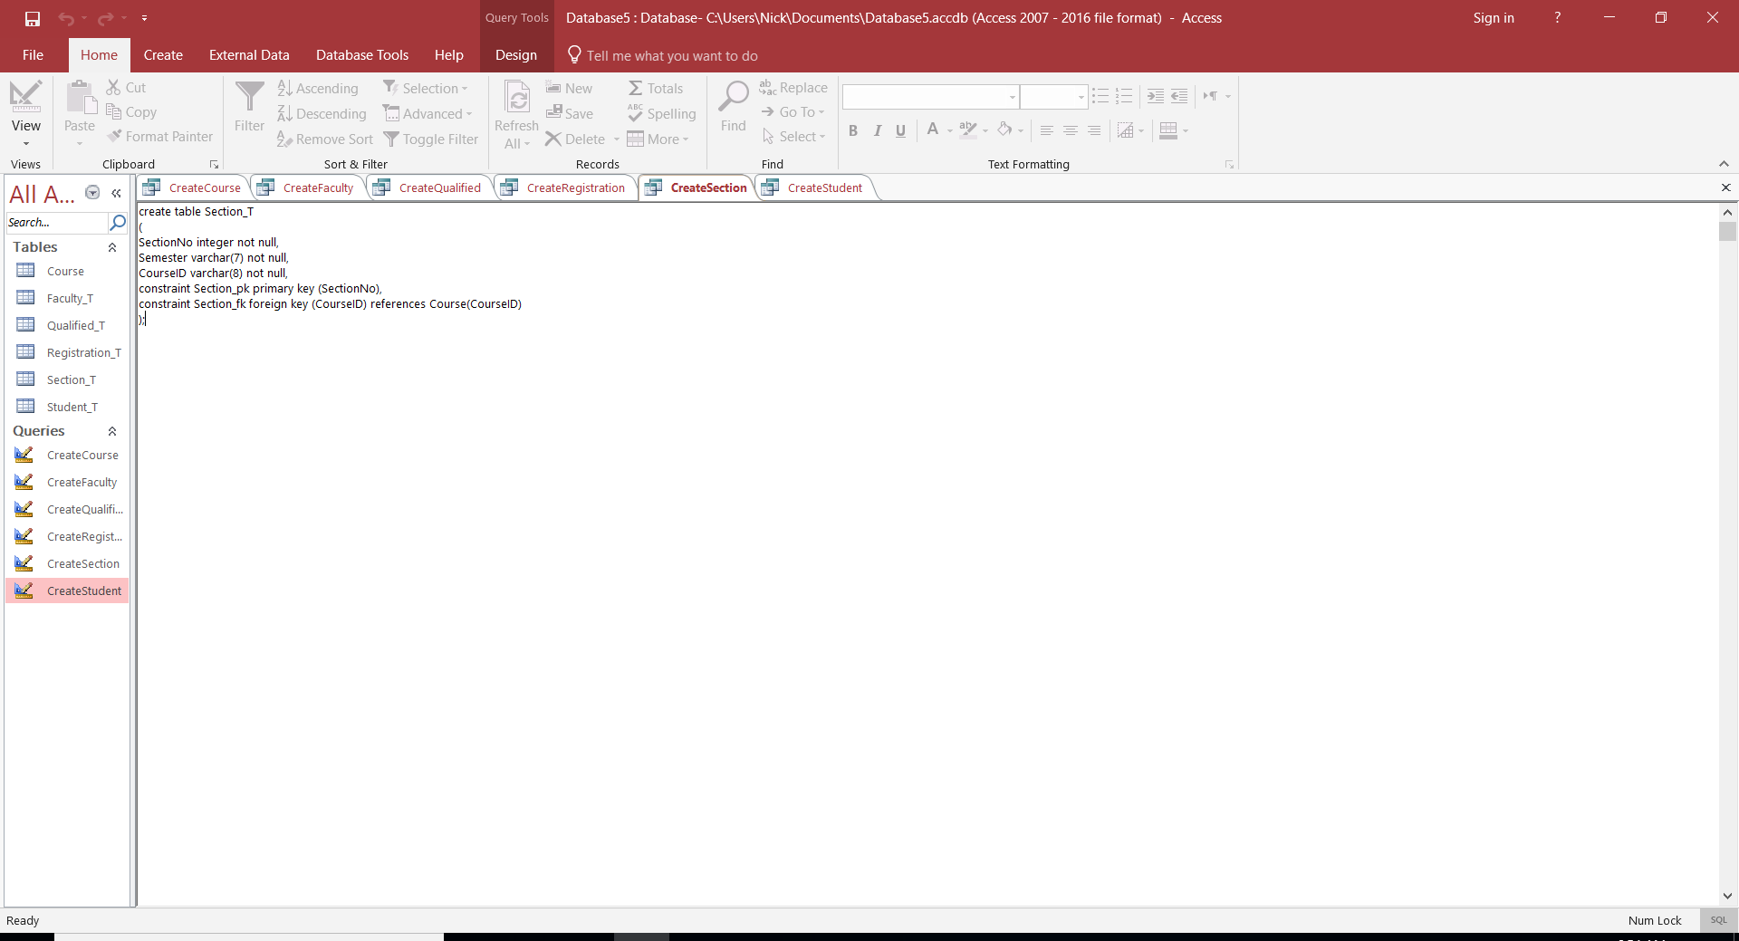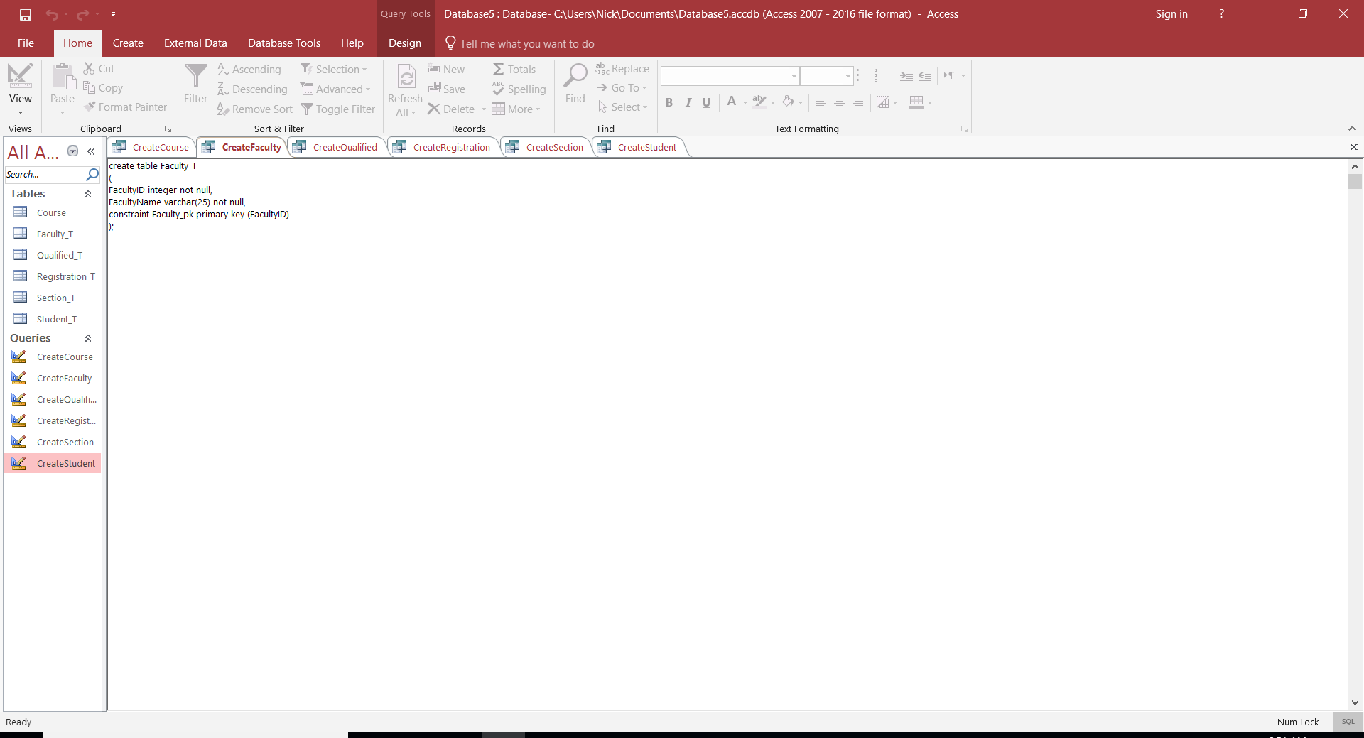

5)

