Program Structures & Algorithms  
Spring 2022  
Assignment No. 3

Name: Niul Panvalkar  
(NUID): 002950308

•Task  
•Output screenshot  
•Relationship Conclusion  
•Evidence / Graph   
•Unit tests result

**TASK:**

Step 1:  
(a) Implement height-weighted Quick Union with Path Compression. For this, you will flesh out the class UF_HWQUPC. All you have to do is to fill in the sections marked with // TO BE IMPLEMENTED ... // ...END IMPLEMENTATION.

(b) Check that the unit tests for this class all work. You must show "green" test results in your submission (screenshot is OK).

Step 2:  
Using your implementation of UF_HWQUPC, develop a UF ("union-find") client that takes an integer value n from the command line to determine the number of "sites." Then generates random pairs of integers between 0 and n-1, calling connected() to determine if they are connected and union() if not. Loop until all sites are connected then print the number of connections generated. Package your program as a static method count() that takes n as the argument and returns the number of connections; and a main() that takes n from the command line, calls count() and prints the returned value. If you prefer, you can create a main program that doesn't require any input and runs the experiment for a fixed set of n values. Show evidence of your run(s).

Step 3:  
Determine the relationship between the number of objects (n) and the number of pairs (m) generated to accomplish this (i.e. to reduce the number of components from n to 1). Justify your conclusion in terms of your observations and what you think might be going on.

OUTPUT SCREENSHOT: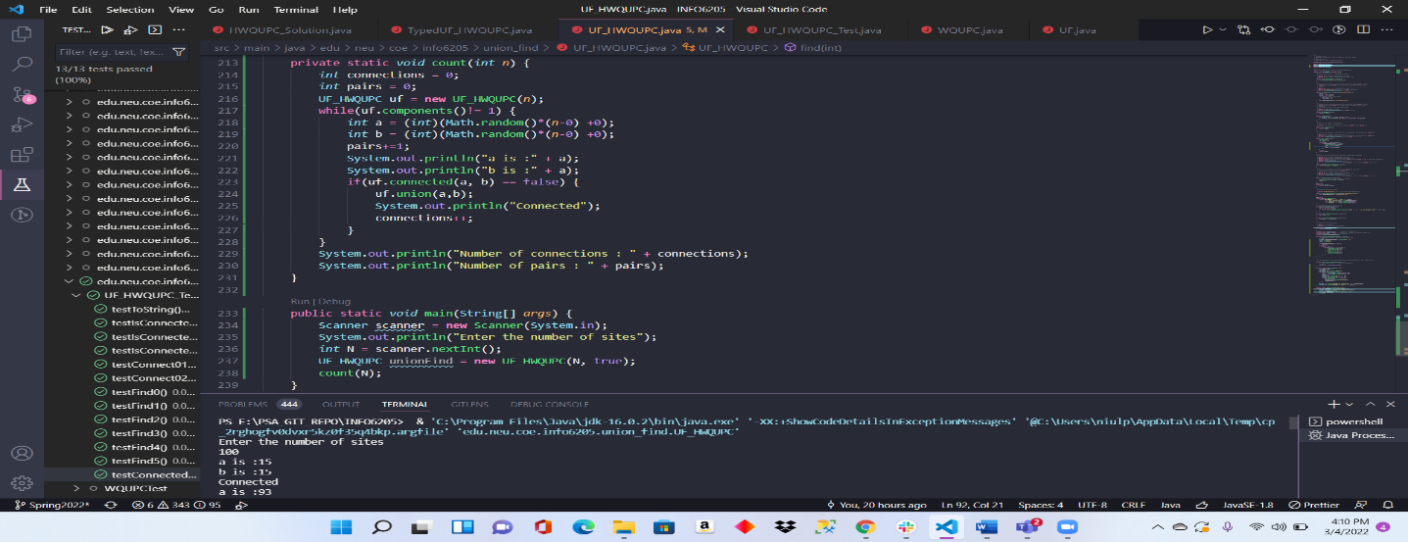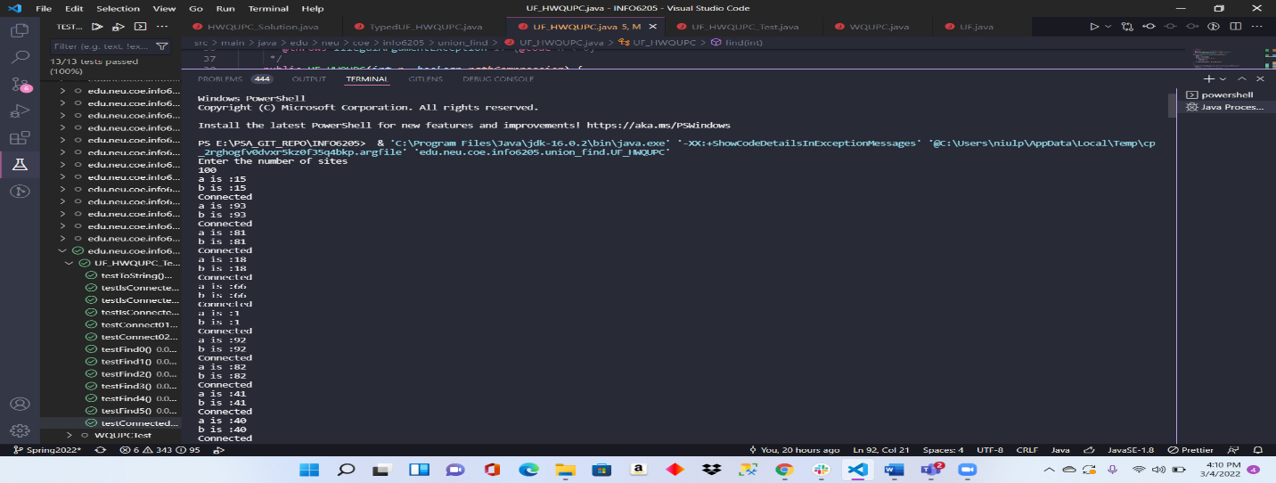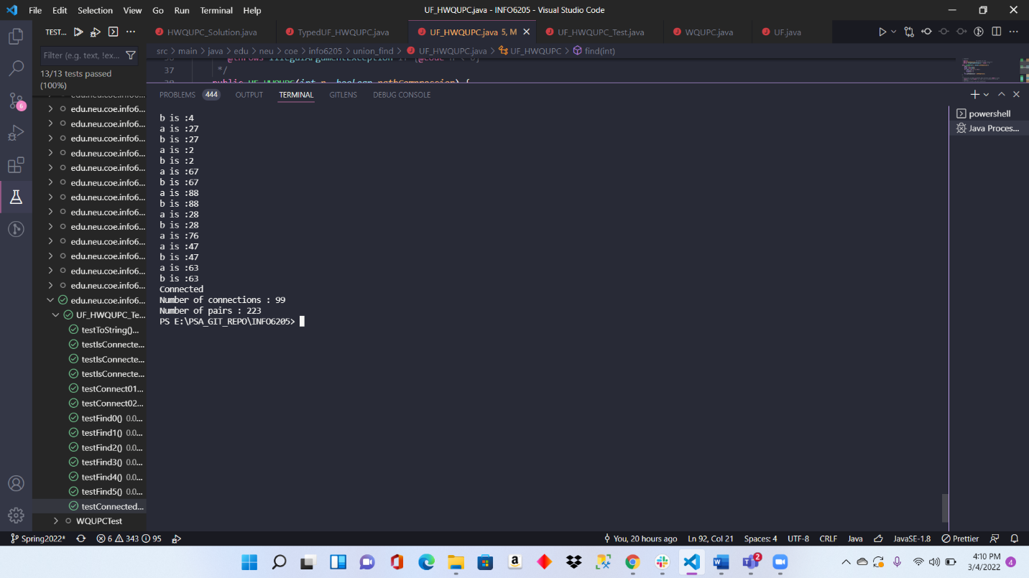

EVIDENCE AND RELATIONSHIP CONCLUSION:

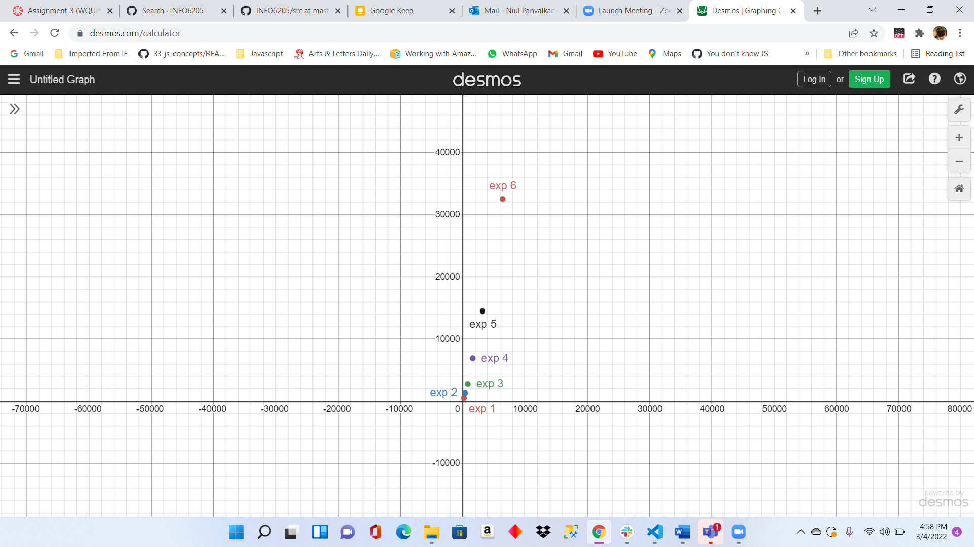

From the graph , we can see that it is exponential. **X-axis** represents the **number of sites** and **Y-axis** represents the **number of pairs** generated.

So, we can say that the relationship is close to ***p = en*** where p is the number of pairs and n is the number of sites.

UNIT TEST RESULT:

