**Risk factors analysis of intraoperative cardiac arrest in a Chinese tertiary hospital with machine learning approaches**

**Introduction**

Numerous complications may occur during anaesthesia and surgery. Intraoperative cardiac arrest (IOCA) is a rare but extremely serious risk event with high mortality. Intraoperative cardiac arrest is defined commonly as the loss of circulation prompting resuscitation with chest compressions and/or defibrillation in the operating[1]. The intraoperative period was defined as the time spent in the operating room[2]. IOCA occurs in the presence of trained professionals and monitoring equipment, unlike out-of-hospital or other units in-hospital cardiac arrests[3]. In recent years, the incidence of in-hospital cardiac arrest increased slightly[3], but many reports confirm that the incidence of IOCA has declined over recent decades[5]. In general, the incidence of IOCA is 21 per 100,000 surgeries (ethetic specific?) while it is associated with high mortality rates of approximately 35% immediately[7] and 30-days mortality rate of 63%[8].

Although IOCA causes many problems for anaesthesiologists, systematic understanding and controlling therisk factors related to clinical outcomes and mortality after IOCA are still in their infancy, especially in a systematic manner[8].

Please briefly review more literature about specific advances and approaches in the field of risk factors analysis and controlling/monitoring of IOCA:

Current disease severity scores do a poor job of predicting survival outcome for patient groups [].

Machine learning algorithms build a model based on sample data in order to make predictions or decisions.Integrating machine learning into clinical medicine has the potential to dramatically improve health care delivery[9]. Machine learning models are more accurate at estimating the risk of death, and are able to explain the reasoning behind the risk estimate given for a particular patient. Machine learning approaches may enhance predictive discrimination for mortality following intraoperative cardiac arrest compared to existing illness severity scores and logistic regression[10]. Several machine learning methods more accurately predict clinical deterioration than logistic regression[11].

Innovations/significance of this work:

1. Machine learning approaches: actually not really new ?
2. Data scarcity in IOCA when using machine learning?
3. Chinese data?

Motivations/objectives of this work:

The objective of this retrospective study is to recognize and analyse risk factors and outcomes of IOCA and predict high-risk patients and survival outcome with machine learning approaches. The study will identify the risk factors to mitigate and rescue IOCA, bringing model-based prediction and data-driven strategies to clinical practice ofIOCA to reduce the incidence and improve the prognosis.

**Materials and Methods**

This retrospective study was approved by (number: ). The requirement for obtaining written informed consent from patients was waived because this study was retrospective. The electronic medical records of 829,370 patients, who underwent a surgical procedure under general anaesthesia, intraspinal anesthesia, regional anaesthesia or monitored anaesthetic care from January 2013 to December 2020, were reviewed. Among the 829,370 anaesthetic records, 80 patients who suffered IOCA were enrolled in this study (Figure 1). Brain-dead organ donors and babies undergoing cardiac compressions due to arrest immediately after caesarean section were excluded from the analysis. Patients who suffered an IOCA on cardiopulmonary bypass (CPB), or extracorporeal membrane oxygenation (ECMO), were also excluded because cardiac compressions are not needed in such situations and the use of such devices can significantly affect clinical outcomes.

Data were collected and categorized by three anaesthesiologists retrospectively.

Landscape

Data were classified into cardiac arrest and non-cardiac arrest. Data variables of non-cardiac arrest included gender, age, Body Mass Index(BMI), co-morbidity, emergency, trauma, five-category physical status by the American Society of Anaesthesiologist’s Physical Status classification, surgical type, anaesthetic type, operative position, the amount of blood lost and blood transfused, atropine use, anti-arrhythmic drug use, continuous infusion of inotrope or vasopressor, and total epinephrine dose. In addition, variables of cardiac arrest are the timing of cardiac arrest and the explicit link (causes of) with operation, defibrillation situation, duration of cardiopulmonary resuscitation(CPR). The primary outcome measure was 3-month mortality after IOCA.

**Prediction models**

**Statistical analysis**

**Result**

A total of 1353 patients were enrolled in this study, and 80 patients experienced intraoperative cardiac arrest(IOCA) and 1273 patients didn’t.

**Explanability**

**Accuracy may often not be sufficient to evaluate the model, and thus we want to explain the model**

**References:**

[1]. Andersen, L.W., et al., In-Hospital Cardiac Arrest: A Review. JAMA, 2019. 321(12): p. 1200-1210.

2.

[2]. Constant, A.L., et al., Predictors of functional outcome after intraoperative cardiac arrest. Anesthesiology, 2014. 121(3): p. 482-91.

[3]. Chen, L.M., et al., Association between a hospital's rate of cardiac arrest incidence and cardiac arrest survival. JAMA Intern Med, 2013. 173(13): p. 1186-95.

[4]. Holmberg, M.J., et al., Annual Incidence of Adult and Pediatric In-Hospital Cardiac Arrest in the United States. Circulation: Cardiovascular Quality and Outcomes, 2019. 12(7).

[5]. Hur, M., et al., The incidence and characteristics of 3-month mortality after intraoperative cardiac arrest in adults. Acta Anaesthesiol Scand, 2017. 61(9): p. 1095-1104.

[6]. Hur, M., et al., The incidence and characteristics of 3-month mortality after intraoperative cardiac arrest in adults. Acta Anaesthesiol Scand, 2017. 61(9): p. 1095-1104.

[7]. Peberdy, M.A., et al., Cardiopulmonary resuscitation of adults in the hospital: a report of 14720 cardiac arrests from the National Registry of Cardiopulmonary Resuscitation. Resuscitation, 2003. 58(3): p. 297-308.

[8]. Goswami, S., et al., Intraoperative cardiac arrests in adults undergoing noncardiac surgery: incidence, risk factors, and survival outcome. Anesthesiology, 2012. 117(5): p. 1018-26.

[9]. Char, D.S., N.H. Shah and D. Magnus, Implementing Machine Learning in Health Care — Addressing Ethical Challenges. The New England journal of medicine, 2018. 378(11): p. 981-983.

10.

[10]. Nanayakkara, S., et al., Characterising risk of in-hospital mortality following cardiac arrest using machine learning: A retrospective international registry study. PLOS Medicine, 2018. 15(11): p. e1002709.

[11]. Churpek, M.M., et al., Multicenter Comparison of Machine Learning Methods and Conventional Regression for Predicting Clinical Deterioration on the Wards. Critical Care Medicine, 2016. 44(2): p. 368-374.

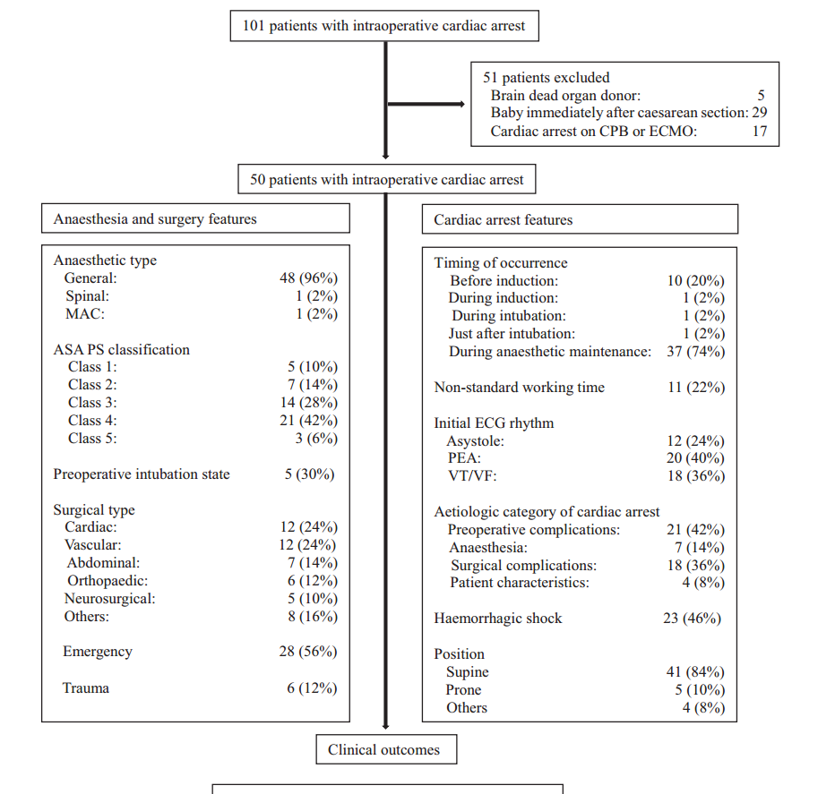

Figure 1

