折线图line graph

开头：改写题目

主体1：总开头+解释说明(列数字)+总

主体2：

结尾：

1. 改写题目(开头)

# The line graph illustrates the changes/trends in [变量] over a [number]-year period from [起始年] to [结束年].

**The line graph illustrates the changes in** electricity consumption **over a 10-year period from** 2010 **to** 2020.

（这张折线图展示了2010年至2020年间电力消耗的变化。）

# The graph compares the trends in [指标] between [对象1] and [对象2] over the period from [起始年] to [结束年].

**The graph compares the trends in** internet usage **between** China **and** the United States.

（这张图比较了中国与美国互联网使用趋势的变化。）

# The line graph provides data on changes in … measured in [单位] across [地点] from … to …

**The line graph provides data on changes in** average temperature, **measured in** degrees Celsius, **across** three cities **from** 2000 **to** 2020.

（折线图展示了2000年至2020年间三个城市的平均气温变化，单位为摄氏度。）

主体段

上升：

# The number of [something] increased significantly from [A] to [B].

**The number of** car owners **increased significantly from** 1 million **to** 5 million.

（车主数量显著上升，从100万增加到500万。）

# A dramatic surge was observed in [something] over the period from [A] to [B].

**A dramatic surge was observed in** the number of smartphone users **over the period from** 2010 **to** 2020.

（2010年至2020年间，智能手机用户数量出现了显著上升。）

# 这里的上升都可以改为下降。

平稳：

# There was no significant change recorded in … between … and …

**There was no significant change recorded in** the unemployment rate **between** 2010 **and** 2020.

（2010年至2020年间失业率没有显著变化。）

峰值/低谷：

#In [year/time], the number/percentage bottomed out at [数值].

The unemployment rate **bottomed out at 3% in 2015.**

#[Subject] reached the peak (or top) at [数值] in [时间]

The number of visitors **reached a peak at 2 million in 2019.**

交点：

# At around [年份/时间], the number of A and B met/were equal, both standing at approximately [数值].

**At around** 2015, **the number of** male **and** female university students **met**, **both standing at approximately** 60 thousand.

（大约在2015年，男女大学生人数相等，均约为6万人。）

多个交点：

# The first intersection between A and B occurred in [年/时间] at [数值1], followed by a second intersection between A and C in [年/时间], both standing at approximately [数值2].

**The first intersection between** imports **and** exports **occurred in** 2010 **at** 40 million dollars, **followed by a second intersection between** exports **and** production **in** 2015, **both standing at approximately** 60 million.

（进口与出口的第一次交叉发生在2010年，数值为4000万；随后在2015年，出口与产量之间出现第二次交叉，两者均约为6000万。）

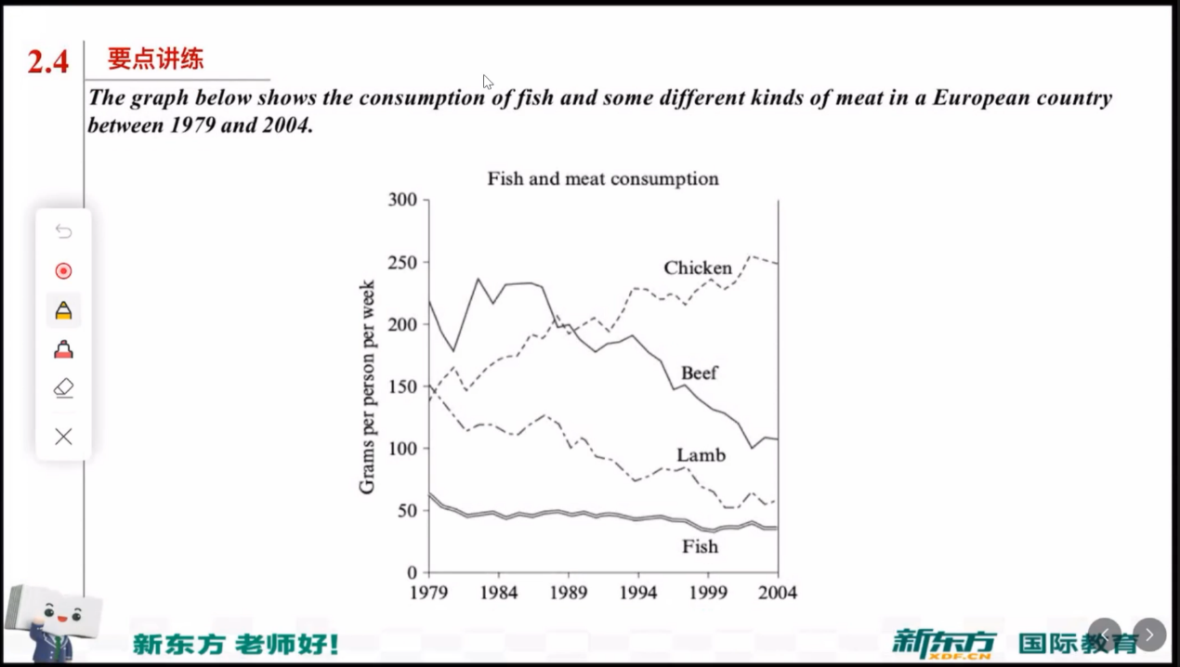

AI 按照我上面的改的

The line graph provides data on changes in the consumption of four types of meat (chicken, beef, lamb, and fish) measured in grams per person per week in a European country between 1979 and 2004.

后加的综述段：

Overall, the consumption of beef and lamb showed a clear downward trend, whereas the figure for chicken increased steadily. The amount of fish consumed remained relatively stable throughout the period.

To begin with, beef consumption declined significantly over the 25-year period. It started at about 220 grams per person per week in 1979 and then dropped sharply to around 100 grams by 2004. Similarly, lamb consumption fell from approximately 150 grams to about 60 grams during the same time frame. In contrast, fish consumption experienced almost no noticeable change, remaining at roughly 50 grams per person per week throughout the period. Therefore, it can be observed that people gradually lost interest in eating beef, lamb, and fish over these years.

On the other hand, the consumption of chicken showed an opposite trend. It rose dramatically from around 150 grams in 1979 to nearly 300 grams in 2004, becoming the most preferred type of meat. Around 1989, the amount of chicken consumed overtook that of beef, with both standing at approximately 180 grams at that time. Consequently, chicken became increasingly popular over the years.

In conclusion, while the consumption of beef and lamb declined markedly and fish intake remained almost unchanged, the demand for chicken increased sharply, making it the most popular meat by 2004.

柱状图 the bar chart

极值：

指标 was the highest in 类别, at over 数1 + 单位

Whereas the lowest was recorded in 类别2, at about 数2

整体趋势：

It is clear that 主体 was more prevalent in 类别 compared to 其他类别, in 年份。

倍数(组内)：

The exports of southland in 类别 was 数值, slightly more than the double/triple the figure of …

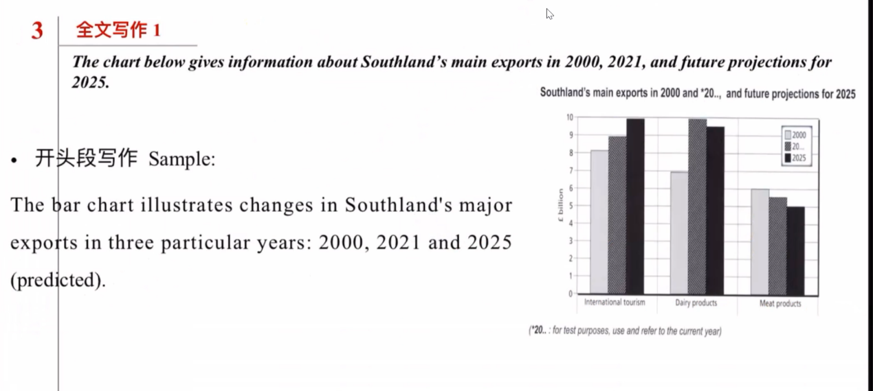

The bar chart illustrates changes in Southland’s major exports in three particular years: 2000, 2021 and 2025(predicted).

It was 8 billion for international tourism in 2000, which was the lowest point in this sort. It gradually climbs from 9 billion in 2021 to about 10 billion in the future (2025).

On the other hand, the exports of dairy product were 7 billion in 2000. By contrast, it was surged at 10 billion in 2021. In the forecast, in 2025, the exports will fall at 9.6 billion.

Conversely, the trend of meat product is downward. The highest number of meat product was in 2000, the figure at 6. It declined step by step to 5.8 and in the future (2025) it will fall to 5 billion, which is the lowest export number among these 3 categories.

The bar chart illustrates changes in Southland’s major exports in three particular years: 2000, 2021 and 2025 (predicted).

In 2000, international tourism was 8 billion, which was the lowest among the three categories. It then gradually increased to 9 billion in 2021 and is expected to reach about 10 billion in 2025.

On the other hand, the export value of dairy products was 7 billion in 2000. By contrast, it surged to 10 billion in 2021, becoming the highest of all three exports. However, it is predicted to fall slightly to around 9.6 billion by 2025.

Conversely, the trend for meat products shows a continuous decline. The figure stood at 6 billion in 2000, then dropped slightly to 5.8 billion in 2021, and is expected to fall further to 5 billion in 2025, which will make it the lowest export figure among the three sectors.

In conclusion, while international tourism and dairy products are expected to remain Southland’s leading exports, meat products will continue to decline steadily during the given period.

表格(table)

table = graph = data table = statistical breakdown

开头：

# The graph gives a breakdown of 名词 in 地点 in 时间

# The statical table provides details of 名词(主题) in 地点 in 时间

# As the chart is shown, there are significant different in 数据对象(国家) across 维度(消费类型)

结尾：

# Overall, … share similar patterns of …, but have some difference in specific values.

# Overall, … share similarities in …, but … are different in …

引出类别：

As for + 类别

When it comes to + 类别

In terms of + 类别

对比：

By contrast However while

相似：

similarly =likewise=in the same way

占比：

Accounting for = make up=constituting

Account for the largest proportion of …

The maximum/the minimum

强调：

notably, most significantly, in particular

补充说明：

In addition, moreover, furthermore

单类别数据：

In terms of 类别， … spent an average of 数值, accounting for 百分比 of ….

When it comes to 类别, … has the lowest/highest figure at 具体数值, which was more/less than that 百分比 of 其他.

多数据作比较：

While 类别 in … made up 百分比 of its total 名词 the corresponding proportion in 其他 was only 百分比

极值Notably, the … had the highest 指标 among all the 名词 listed, at 数.

**WRITING TASK 1**

You should spend about 20 minutes on this task.

***The table below gives information on consumer spending on different items in five different countries in 2002.***

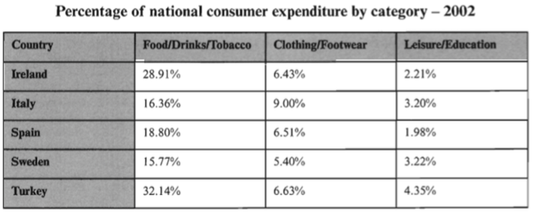

AI 改后的版本

The graph gives a breakdown of consumer expenditure on three types of items in five different countries in 2002.

Regarding spending on food, drinks and tobacco, the percentage in Turkey was the largest of all figures, at 32.14%. It was closely followed by Ireland, at 28.91%. Italy and Sweden were similar in percentage (16.36% and 15.77%, respectively), and Spain was slightly higher than these two, at 18.80%.

As for clothing and footwear, the proportion of spending in Italy was larger than the others, at 9%. In contrast, that of Sweden was the smallest, at only 5.4%. The figures for the other three countries were almost the same, all around 6.5%.

When it comes to the last category, leisure and education, the proportion in Turkey was again the largest (4.35%), while that of Spain was the smallest (1.98%). Italy was similar to Sweden again, both slightly above 3%. The spending on this category accounted for 2.21% in Ireland.

Overall, all five countries share similar patterns of spending, with the highest proportion of expenditure on food, drinks and tobacco, followed by clothing and footwear, and the lowest on leisure and education. However, there were some differences in specific values, with Turkey and Ireland showing higher spending levels across all categories.

饼图(pie chart)

同意替换：

# first= initial

# second = subsequent

占比：

Dominate 占主导地位

Comprise 组成，占比

Constitute 构成

Account for 基础占比不占主导地位

极大，极小：

The smallest fraction 小部分

A tiny minority 小部分

The vast majority 绝大部分

相似：

Be similar to

Share a similar proportion

Be comparable to

差异：

Be marginally lower than … 略低于

Be significantly higher than … 显著高于

Different slightly from 与… 略有差异

句式：

Accounting for 百分比 of the total, … is the most significant component in the graph.

对比并列：

While … make up the proportion(百分比)， … and … which account for 百分比 and 百分比 respectively, are the second and third most common categories.

强调差距：

There is a notable difference between … and … ; the former occupies 百分比 of total, whereas the latter represent only 百分比.

相近占比：

类别1 and 类别2 share relatively similar proportions, with the former representing 百分比 and the latter 百分比 ——a different of merely 差值 percentage points.

总结：

Overall, it is clear that … is the most significant category in ….



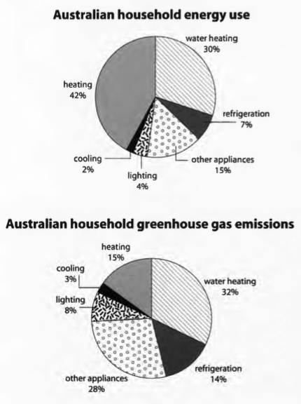

混合图

动态折线图+静态表格

1. 开头

最好再有个综述段

1. 图一
2. 图二
3. 结尾

开头：

# The line graph illustrates … in/during/between…

# The data as show differences in …. and … in water consumption.

图一 开头：

Looking at the initial graph, it is clear that …

图二开头：

Moving onto the table, it is apparent that …

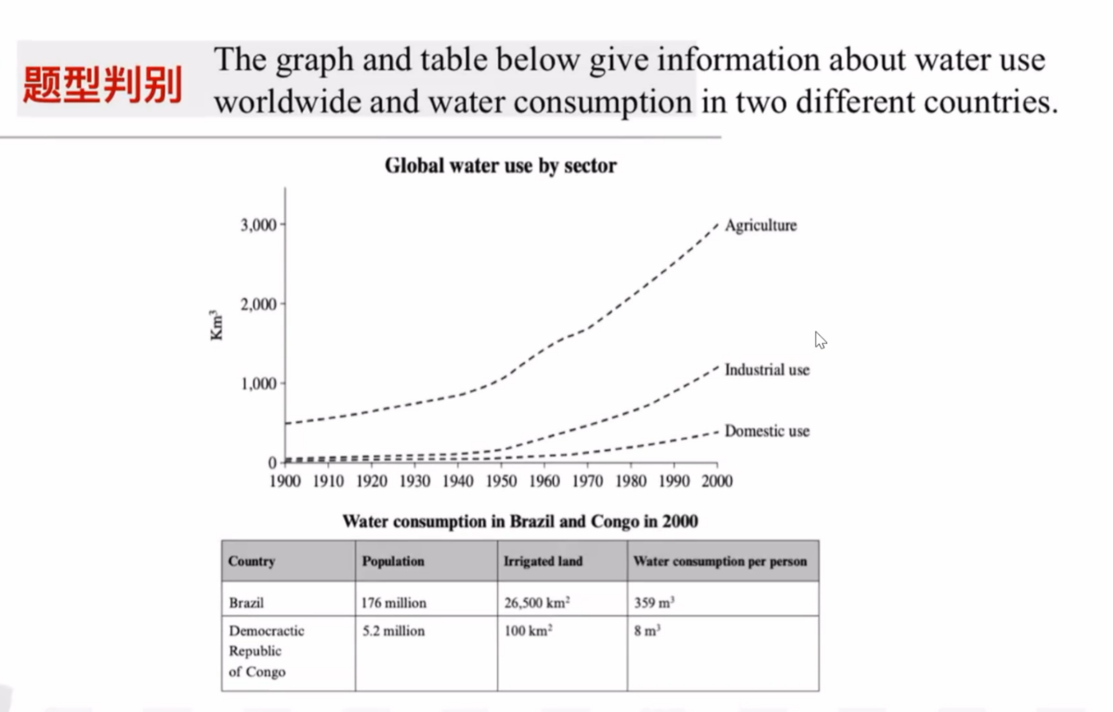

The line graph illustrates the global water use between 1900 and 2000, while the table provides data on water consumption in Brazil and the Democratic Republic of Congo in 2000.

Looking at the initial graph, it is clear that the usage of water in agriculture, industry, and domestic sectors all showed an upward trend. However, the demand for water in agriculture increased dramatically from about 500 km³ to 3,000 km³ over the 101 years. By contrast, the use of water for industrial and domestic purposes both started at approximately 0 km³ and rose to around 1,000 km³ and 300 km³, respectively.

Moving on to the table, it is apparent that there was a significant difference in water consumption between the two countries. Notably, both the population and irrigated land in Brazil were the highest, at 176 million and 26,500 km². By contrast, these two figures in Congo were merely 5.2 million and 100 km². Furthermore, as a result, the water consumption per person in Brazil reached 359 m³, while in Congo it was only 8 m³.

Overall, it is evident that global water consumption increased steadily over the 100 years, and in 2000, there was a great difference between Brazil and Congo in terms of population, irrigated land, and water use per person.

流程图

第一步： 改写题目

The diagram (flow chart) below shown the way … olive oil produced.

总结句：

# There are … main/major stages in doing something, beginning with doing something and ending with doing something.

# The process of doing something is complex/simple, which entails/involves … main/major stages in total.

核心词汇：

1. 开始/初始阶段

begin start initial

start point initial stage beginning begin with start with

1. 步骤

Process proceed undergo go through

Step stage phase process

1. 结束

End finish complete conclude result in

Finial stage end product outcome result

1. 顺序连接

After …, it is followed by At the following stage, 接下来的步骤

Then/afterward/latter/subsequently/following this

Meanwhile/ at the same time

**The diagram below shows how olive oil is produced.**

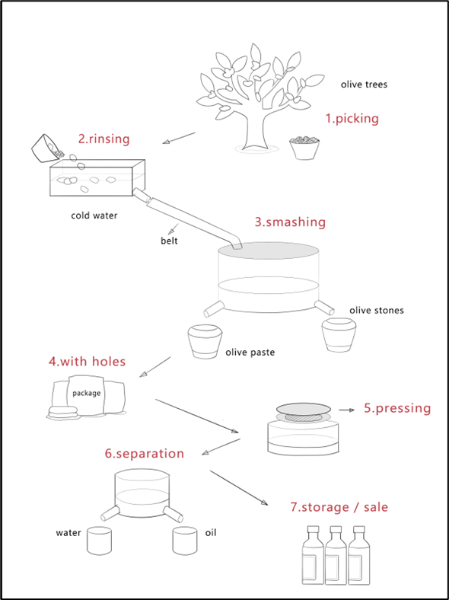

The flow chart illustrates the process of how olive oil is produced.

Overall, it is clear that the production of olive oil is not very complex, which involves seven major stages in total. The whole process begins with picking the olives and ends with separating oil from water before storing or selling the final product to customers.

First of all, olives, the raw material, are picked from olive trees. Then, the olives are poured into a container filled with cold water. The olives are rinsed so that the dust can be removed. The next stage is to deliver the clean olives to a smashing machine through a belt. After they are smashed, the olive stones and olive paste are placed into different containers. The olive paste is then packaged into bags that have holes. After that, the bags are put into a machine so that the olive paste is pressed to extract oil. The following stage is to separate the oil from water. Finally, olive oil is stored or sold to customers.

In summary, the process of making olive oil is quite simple, which involves seven major stages in total—from harvesting and cleaning the olives to pressing, separating, and eventually storing or selling the final product.

**The diagram below shows how glass bottles are recycled.**

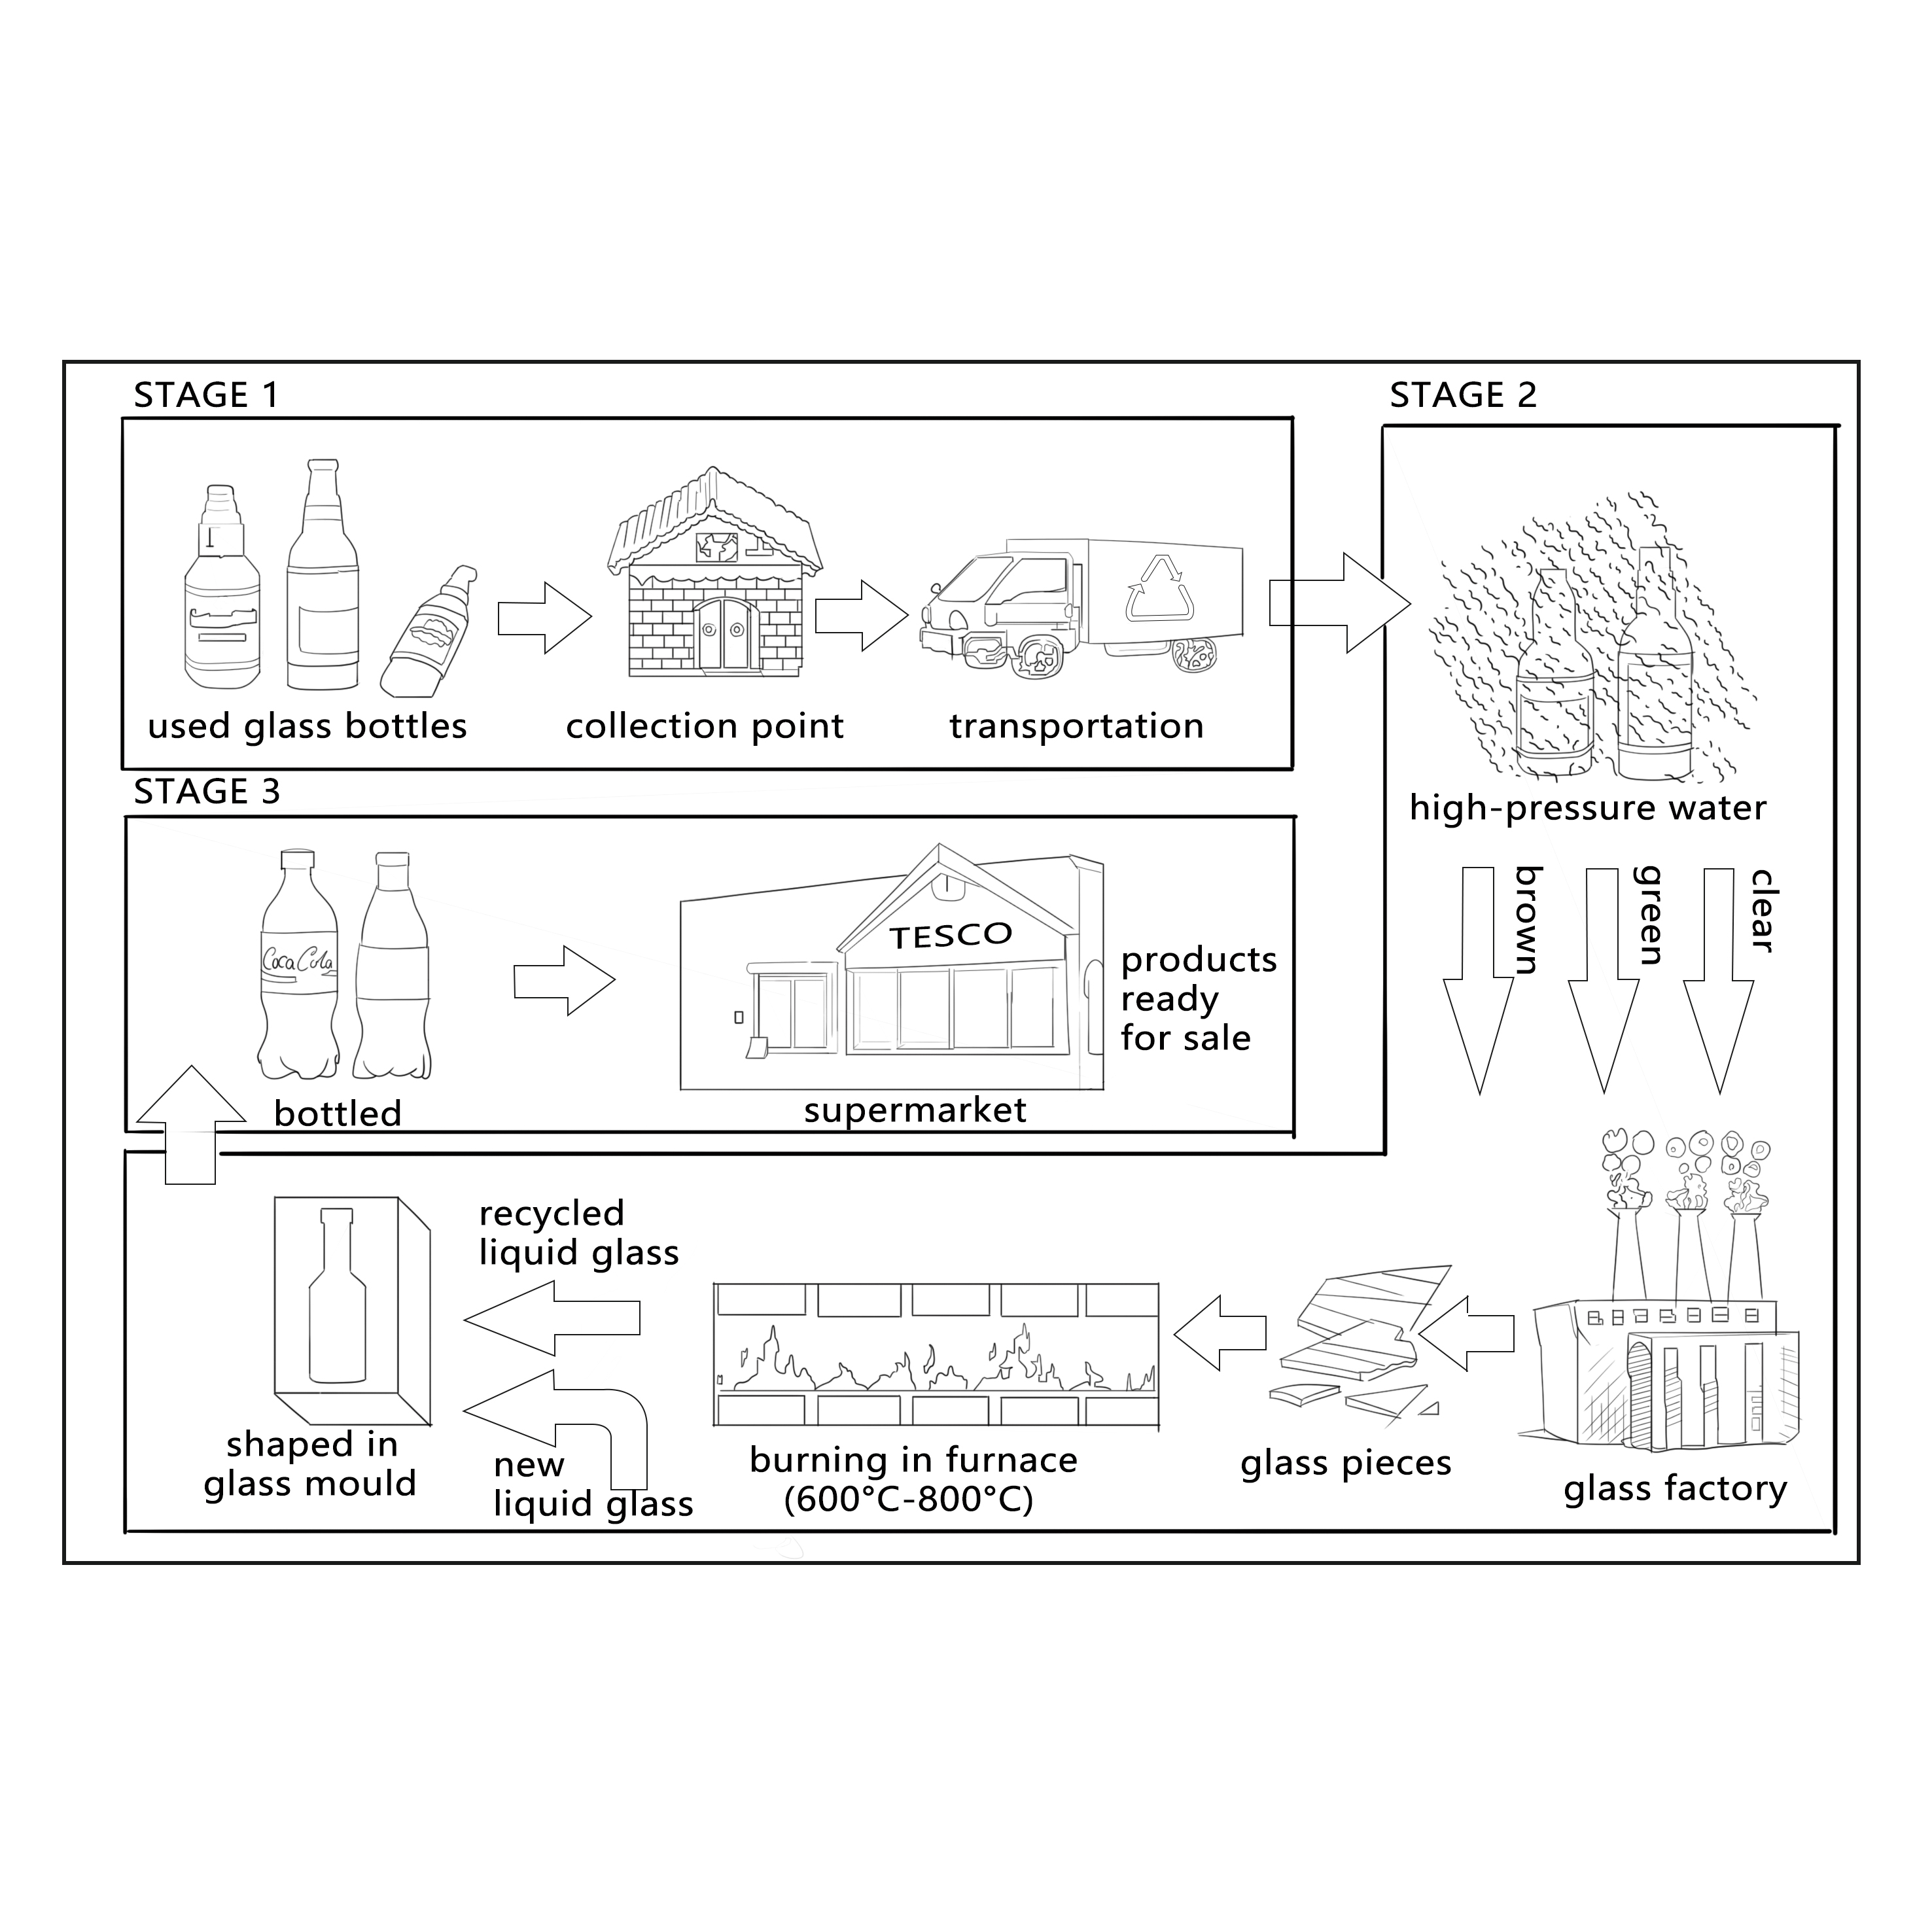

The flow chart illustrates the process of how glass bottles are recycled.

**Overall, it can be seen that the recycling of glass bottles consists of a series of organized steps, starting from collection and cleaning to remelting and forming new bottles for reuse.**

At first, the process begins with sending the used glass bottles to a collection point. After the collection, they are transported to another location. Then, they are cleaned by high-pressure water. Following that, the bottles are divided into different types according to their colors (clear, green, and brown). Subsequently, the bottles are broken into glass pieces in a glass factory. At the same time, the glass pieces are burned in a furnace, which reaches a temperature between 600°C and 800°C. Afterwards, the new liquid glass is mixed with recycled glass, and the mixture is poured into a glass mould and shaped into new bottles. Finally, the new bottles are sent to the supermarket, and the products are ready for sale.

To sum up, the process of recycling glass bottles is quite complex, which involves three main stages in total.

地图(plan, graph, maps, diagrams)

Changes=adjustments=modification

Present=in present day

Development=improvement

From … to … = during the period between … and …

总结句：

# In conclusion, the maps vividly demonstrate that 地点 has undergone a comprehensive transformation, with changes in its infrastructure land use, special arrangement, reflecting the force of development.

# Overall, the alterations in 地点 from 时间1 to 时间2, signify it progress toward a more functional and sustainable future, despite some challenges that may have arisen during the process.

表示方位的词：

Adjacent to 紧邻

Beside/near/next 紧挨着

Proximate to 在附近（不一定紧挨着）

Close to = contiguous with 贴着

In the vicinity of 范围附近

Opposite 对面

Along 沿着

Amid 在 … 中间

At the fringe of 在… 的边沿

表示变化的词：

新增：initiated, inaugurated(落成) be added, be newly built, erected

拆除：razed, dismantled, torn down, demolished

扩建：augmented, amplified, elongated加长,broadened加宽

缩小：contracted(收缩了的), diminished, compressed(缩紧)

迁移：relocated，transferred，shifted，displaced

句式：

# … is strategically positioned /situated on/in the 方位 of 地点, which not only enjoys convenient access to 旁边 but also serves as a pivotal point with the area.

# Nestled in 方位 of 地点， xxx stands out as a prominent landmark, surrounded by …

变化描述：

# A remarkable shift has occurred in 地点, with 原来 being completely replaced by 现在, thereby fundamentally altering the character of the area.

替换：

A is transformed into B = A is converted into B

不变：

No changes will be made

缩小：

The size if A is reduced/ shrink to

描述：

Looking first at the top map from 年， it is clear that the area was 主要特征, the 方位 part was primally occupied by 建筑名, adjacent to 地点2.

The 方位 of it/this, there was 地点3, which was located to 地点4. Meanwhile, the 另一方位 section featured 地点5, running along the 地点6.

***The plans below compare the changes of one library in 1995 and the same area at present.***

***Summarise the information by selecting and reporting the main features, and make comparison where relevant.***

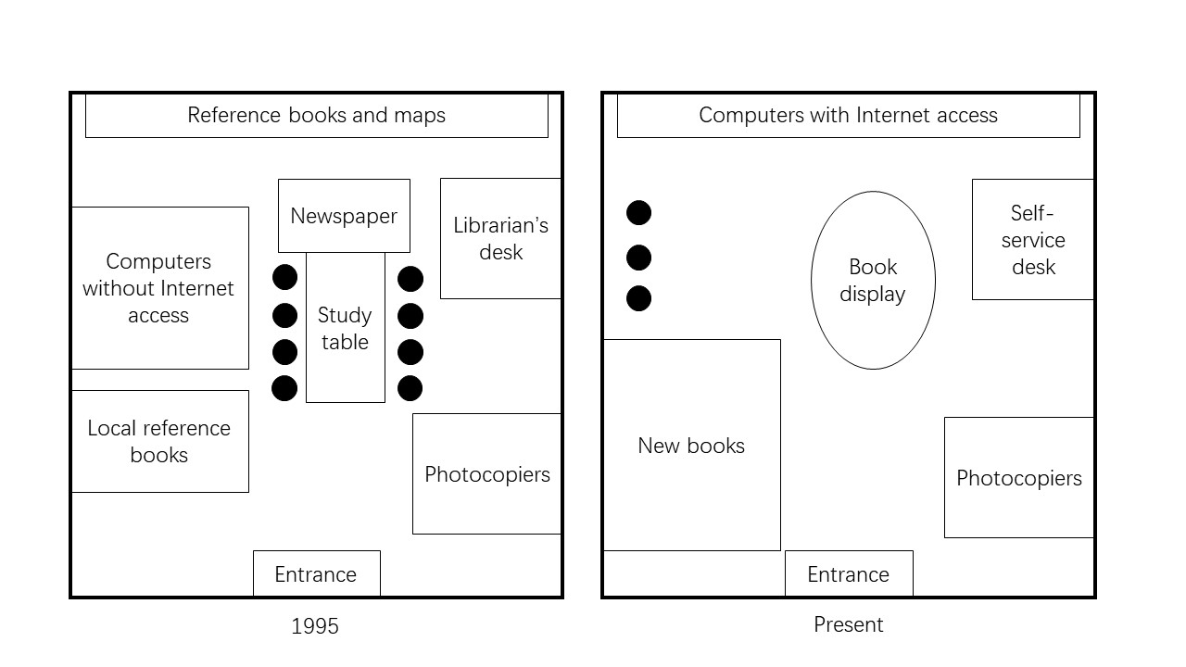

The maps show the layout of a particular library in 1995 and the same library in the present day.

Back in 1995, entering from the south, one could find a place for photocopiers on the right-hand side, and another for local reference books on the left. In the central part of the library, there was a study table, with seats on both sides. The shelf for newspaper was on the north of the table, while a room for computers without internet access was to the west, and the librarian’s desk to the east. The northernmost part was for reference books and maps.

At present, while the entrance and the photocopiers remain still, there have been changes to the other facilities. The old place for local reference books has turned into an area for new books, Also, the study table, along with the newspaper shelf, has disappeared, and the place is now used as book display. Computers have been moved to the northern end in order to make way for a small number of chairs. Librarians seem to be unnecessary, as the librarian’s desk has been replaced by the self-service desk.

Overall, there had been and will be a number of changes to the campus’ layout, including the replacement of some old facilities as well as the adding of new ones.

大作文

1. 讨论一个观点，同意与否；
2. 讨论两个观点，discuss both 并且给出自己的观点
3. 分析一种现象，积极的消极的positive，advantage，why和what

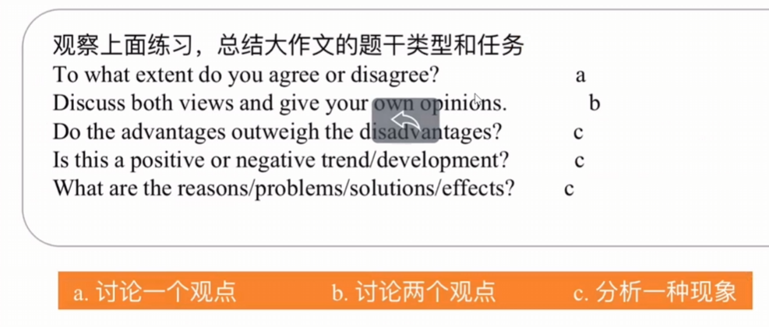

教育写作：

• **Tap one’s potential** —— 发掘某人的潜能

• **Fulfill one’s potential** —— 充分发挥潜能

• **Expand social circle** —— 扩大社交圈

• **Sharpen skills** —— 提升/磨练技能

• **Decent job** —— 体面的工作

• **Develop self-discipline** —— 培养自律能力

• **Boost confidence** —— 提升自信心

• **Strengthen adaptability** —— 增强适应能力

• **Life skills** —— 生活技能

• **Integrate theory with practice** —— 理论与实践相结合

• **Acquire knowledge** —— 获取知识

• **Release knowledge** —— 传播知识

• **Gain knowledge** —— 增长知识

• **Set a solid foundation for…** —— 为……打下坚实的基础

• **Cultivate skills** —— 培养技能

• **Foster skills** —— 培养技能

• **Prepare for future career** —— 为未来职业做好准备

• **Develop good learning habits** —— 养成良好的学习习惯

• **Gain practical experience** —— 获得实践经验

• **Lose practical experience** —— 失去实践经验

• **Logical skills** —— 逻辑思维能力

• **Enhance comprehensive quality** —— 提高综合素质

• **Broaden one’s knowledge** —— 拓宽知识面

• **Expand one’s view** —— 开阔视野

消极：

• **Lose individuality** —— 失去个性

• **Lower efficiency** —— 降低效率

• **Intensify academic pressure** —— 加剧学业压力

• **Undermine creativity** —— 削弱创造力

• **Damage children’s physical and psychological well-being** —— 损害儿童的身心健康

作文的格式：

**第一段：**

句式：引出话题

1. … is rapidly gaining its popularity all over the word.
2. Along with the development of society, more and more problems are brought to our attention, one od which is that …
3. In recent years, there has been a growing trend towards + 话题
4. In contemporary society, an increasing number people are paying attention to the debate surrounding + 话题.

改写题目

我的立场

1. from my point of view, I firmly support that …
2. From my perspective, I firmly agree/disagree with that
3. I completely agree/disagree with this view point for the following reasons.

**第二段：**

**让步段，阐述和你观点相反的观点。**

先用一个小的开头再次说明反向观点，举例论证，需要用两个东西来论证这个观点，并且要有举例说明。

开头： Admittedly, this phenomenon/argument can cause/bring advantage/disadvantage. That is because + 主题（你不同意的那个）。

**中间用来论述**

**让步段结尾：**

1. Therefore, this is why it is important for …
2. However, + 反驳

**论证段：阐述你的抓哟观点**

开始还是阐述主题（你同意的那一个）

On the other hand/However/Furthermore, I strongly contend that + 主体 provides a far more balance and effective result to the issue.

中间：最少给出三个理由+举例子，而且一个理由要向后推字少两下

…, this means that …

…, to illustrates …

论证段结尾：

In a word, … are the advantage for 主体

总结段：可以再次强调下主题，然后再写下未来怎么样。

In conclusion, I fully believe that the advantages of … outweigh the drawback/disadvantages, as the merit are remarkable and negative impact can be solved through ….

大作文信息链：

大学教育价值/理论实践哪一个重要、

Online education replaces <——>traditional school.

个人发展：不仅学习知识→培养解决问题能力→适应未来工作环境→长期目标,成功

1. Acquire knowledge→foster critical thinking→soft skills →enable adaptation to repeatedly change job market
2. Acquire knowledge→foster problem-solving skills→long term goal/ career success

人际关系：与同龄人校友教授交流平台→建立宝贵的人脉关系→对未来职业打开大门

Platform to interact with… →Build valuable social network→Open doors to future career opportunities/ Provide opportunities to future career life

社会效益：高等教育公民更有公民意识和社会责任感→促进社会进步

Highly educated citizens often lead to responsible society and civically engaged→promote social progress

经济负担：学费贵→背债→毕业后生活选择困难→经济压力大

High tuition fees→lead to crippling student debt→Delay in buying a home→negatively impacts→post-graduation life choices

与市场脱节：理论性强，更新慢→无法提供市场所需技能→毕业生难找工作→教育资源浪费

Theoretical and slow to update→fail to teach practical skills in high demand→struggling to find relevant jobs→waste educational resources

**科技**：科技能不能让生活更美好？ 远程办公利弊，人工智能

效率提升：科技发展→自动化工作→提高生产力和效率→减低企业运营成本→产品/服务价格下降→消费者受益

Development of technology→automate tasks→boost productivity and efficiency→reduce operational costs for business→potentially lower prices for goods and services→benefit consumers

错误减少：辅助工作→数据/影像更精准→减少错误

aid works→Analyze images and data with greater precision→Reduce human errors

创新驱动：处理→推动科学研究与技术创新→解决复杂的社会问题

Process vast dataset→accelerate scientific research and technological innovation→solve complex social problems

失业问题：job displacement

自动化/科技/AI 取代许多中低端技能置位→导致结构性失业→加剧社会贫富差距→引发社会不稳定

Automation/Artificial intelligence replaced mid-to-low skills jobs→lead to structural unemployment→widen the wealth gap→cause social unrest

隐私侵蚀：erosion of privacy

依赖大量数据运行→鼓励企业和政府大规模监控和数据收集→侵犯个人隐私权→权利失衡个人操纵

Depend/rely on massive data collection→surveillance→infringe on individual privacy right→power imbalance and manipulation(操控)

简单模版：

首段：1背景引入。2表明话题。3明确立场

句式：

In contemporary era, … became more and more popular, the invention of mobile phones made individuals life more convenience. 改写题目, while acknowledge the potential drawbacks, I am firmly of the opinion that the benefits are more substantial.

中间段 ：开头+举例子+信息链推理+小结尾

结尾段：总结+重申个人立场+展望/升华

I reiterate my position that 优/缺 of this growing trend carry grater weigh.

社会类：

1. 老龄化 aging population

提升消费市场：老龄群体形成新的消费市场→刺激投资和创新→创造新的就业机会和经济活力

Expand consumer market→Elderly population creates a new consumer market→Simulate investment and innovation in healthcare and elderly care→new jobs and economic vitality

经验价值：丰富的知识技能和经验→继续工作传授技能给年轻人→减少社会经验流失，促进知识/文化传承

A wealth of knowledge, skills and experience→Continue to work→convey knowledge to→reduce the waste of social experience/ promote knowledge and cultural transfer

社会认同感：老人工作认为自己有价值有能力→减少代沟→社会认同

Reduce the gap between … and …→the ascription of society

劳动力短缺：适龄的劳动人口下降→劳动力市场供给不足→拖累国家潜在经济增长力和竞争力

Shrinking workforce: a declining proportion of working-age adults→lead to a shortage in the labor supply→hamper national economic growth and competitiveness

挤占医疗资源：老人容易生病→对医疗保健的需求量增大→医疗系统资源紧张，巨大压力→整体医疗质量下降

Healthcare strain, elder people require for more healthcare serves than young→a paucity of medical resource and face to huge pressure→decrease in the quality of healthcare to everyone

养老金压力：pension crisis

退休人数上升，在职人数少→养老金收支失衡→政府财政压力大；增税降福利

Increasing number of pensioners support by a smaller working population→ imbalance in pension system→immense pressure on government finance, potentially leading to high taxes or reduced benefits

环境：

**支持政府/企业承担主责的**

规模效应：政府定法律→约束所有人（企业）→产生大规模系统性影响

Scale of impact : enact laws and regulation→carbon emission caps/plastic bans→mandates compliance from all corporations and individuals→large-scales, systemic effect

资源与开发：大的企业和政府的钱和资源更多→研发绿色资源和技术(太阳能)→根本性的技术改革，改变环境问题

Resource and research development: capital→invest in developing green energy and technology(solar)→driving fundamental technological breakthrough necessary for solving environmental problems

引导消费：guiding consumption

企业通过生产营销决定市场→企业生产环保产品；消费者才有选择→源头在企业

Corporations determine market through production and marketing→ produce eco-friendly products, consumers gain sustainable options→responsibility originates with corporations

**支持个人：**

需求决定供给：选择发出信号→更多人选择环保产品，企业会增加供应→推动整个行业变得环保

Demand drives supply; purchasing decision send signals to the market→more choices of eco-friendly products will be produced due to maximize profits→drives/leads entire industries to become greener

道德义务：moral duty

享受资源是每个人的权利→保护环境也是每个人的道德义务→不能推给政府

Enjoy resources/enjoy the right of using resources→protecting environment is a moral obligation for all not solely the responsibility of government and corporations/business

句式：

首段：

There exists a divergence of opinion regarding 主题

介绍观点：It is often contended by some that …, whereas other advocate for the perspective that …

主体段：

Proponents of first view put forward several arguments. The central tenet of their belief is that+ 论点. That is because +观点。

For instance, …. The line of reasoning is compelling as it highlights the importance of ….

On the other hand/However, advocates of the alternative stance would rebut this by asserting that ….

总结：

In summary, this essay has explored the contrasting views on 主题。

Although A has some validity in its emphasis on 优点。B is more reasonable and convincing.

一题两问：

气候变化（环境）

原因:

交通排放→汽车飞机轮船增加

**transport emissions** →**the growing number of cars, airplanes, and ships.**

工业化能源生产→化石燃料

**Industrialization** and **energy production→combustion of fossil fuels**

城市化→砍伐森林→减少吸收CO2

**Urbanization→deforestation→reduces the earth’s capacity to absorb carbon dioxide**

影响：

**环境：**

温室气体浓度升高→全球变暖→海平面上升→淹没沿海城市

Rising greenhouse gas concentration → global warming → sea-level rise → coastal flooding

**经济：**

极端天气（干旱，海啸，地震）→农作物破坏→经济损失

Extreme weather (droughts, tsunamis, and earthquakes)→ crop destruction → economic loss

措施：

**交通**：

发展电车产业→绿色出行

Developing the electric vehicle industry→ green and sustainable transportation.

能源和工业投资可再生能源→增收碳税

Investing in renewable energy→increasing carbon taxes

**森林：**

立法保护森林→再造林

Implementing forest protection laws→reforestation

社会：收入不平等

原因：

城市大小：偏远地区教育资源匮乏→知识，技能

Urban size and education disparity：Remote areas often suffer from a lack of educational resources→leading to **insufficient knowledge and skills** among local residents

全球化/科技增加：科技代替中低端岗位→只有高等人才，工资高

Globalization and technological advancement→ Technology replaces low- and medium-skilled jobs→ only highly educated talents can remain competitive→ resulting in higher wages for the educated and wider income gaps

影响：

贫富差距扩大→社会分层→削弱社会凝聚力、流动性

Widening wealth gap→ leads to social stratification→ which weakens social cohesion and reduces social mobility

健康：低收入人群没钱→更少的医疗条件→寿命短

Health inequality→ Low-income groups cannot afford adequate medical services→ resulting in poorer health conditions and shorter life expectancy

犯罪：人群收入少→心里扭曲→犯罪率提高

Poverty and crime→ Financial hardship and psychological frustration→ may lead to higher crime rates in disadvantaged communities

措施：

增加公共教育投入，提供贫困地区的教育支持

Increase public investment in education→ Provide better educational support in impoverished or remote areas

提供职业培训，适应经济需求

Offer vocational training programs→ help people acquire practical skills and adapt to changing economic demands

第一种：

**Some people consider that school education should be concentrated on academic subjects which would be helpful for their future careers, and subjects like music and sport are not useful.**

**To what extent do you agree or disagree?**

There is a debate around the areas of focus for students at school. It is said that academic subjects give greater value to students, and other areas, such as music and sport, are of little use to them. However, I take the opposing view that these non-academic subjects should not be ignored.

Some people argue that more academic subjects provide not only more knowledge but also more career opportunities. This is because, nowadays, most high-paid jobs, such as doctors and lawyers, require extensive academic study, and even entry-level positions in a company often ask for knowledge in specific fields. In order to provide for themselves and their future families, students need to consider their career prospects when choosing subjects to study. It is, therefore, important for students to focus on academic disciplines.

However, this does not discount other areas of life. Less academic subjects, such as music and sport, can provide great enjoyment and even career opportunities if students have a real passion for them. Furthermore, non-academic subjects offer significant health benefits. Taking part in sports is beneficial for physical health, while music and other art subjects can contribute to mental well-being. There is a growing body of research suggesting that both making and listening to music have significant therapeutic value. Therefore, students can thrive by choosing to focus on these areas, and these less academic fields should not be neglected in the school curriculum.

To sum up, I feel that schools should provide a balance of subjects for students to study. While academic subjects serve an important purpose, they are not the be-all and end-all, and some students may prefer and excel in non-academic subjects. In addition, the health benefits of these subjects should not be overlooked.

第二种：

**Some people think getting old is bad for them in the modern world, while others think older people today live better than in the past. Discuss both sides and give your views.**

It is undeniable that the world has changed considerably in recent decades due to a number of factors. While some people say that ageing in the past was more comfortable than it is now, I disagree for several reasons.

There are those who point to the fact that growing old in the past was usually experienced within a larger and more stable family unit. Traditionally, younger generations would help care for and provide company to their elder relatives. This could be seen as more beneficial than in today’s smaller families, where both parents are often busy working. However, thanks to scientific advances, medical care has greatly improved. When family members are not always available to help, hospitals or care homes can step in with a high level of expertise. This also relieves some of the pressure on younger family members.

Moreover, technological developments mean that older people can live a more comfortable life nowadays. With Internet access being widely and cheaply available, the elderly can still socialise online if they are not fit enough to go out frequently, whereas in the past, an older person might have become lonely if unable to see friends. In addition, in the modern world, the elderly have plenty of entertainment options online, such as films, a wide variety of television programmes, and even online shopping from the comfort of their own homes. They can also walk or exercise in city parks to maintain better health. None of these opportunities were available two decades ago.

To sum up, I firmly believe that ageing today is actually more comfortable and convenient than in the past. At present, there are far more activities available for elderly people than before, many of which can be enjoyed without even leaving home.

第三种：

**Today, anybody can use a mobile phone to answer phone calls from work and in their personal life 24 hours a day and 7 days a week.**

**Does this development have more positive or negative effects on both the individuals and the society?**

Nowadays, people are more connected than in the past. One of the major changes responsible for this is the rise in mobile phone usage and the ability to contact each other anytime and anywhere. In my opinion, this development has brought more advantages than disadvantages for both individuals and society as a whole.

One positive impact of mobile phones has been in the workplace. It is now easier to contact both colleagues and customers than in the past, for example. This means that work and business can be done more quickly rather than having to wait for people to return to their desks or get home to talk to them. This leads to economic benefits for both individuals and, in turn, society. Another positive effect has been on families. Parents can have peace of mind when their children go out, as mobile phones allow instant communication in the event of any problems. This can also make children feel safer, knowing that their parents are always just a phone call away.

In contrast, many people have become over-reliant on mobile phones. In the past, people had more freedom. Children, for example, were not constantly monitored by their parents and therefore were able to develop a sense of independence earlier. Moreover, it is more difficult for people to relax nowadays, as their downtime can be interrupted by a phone call. The well-defined working hours of the past have disappeared since colleagues can easily contact each other in the evening or at the weekend. Insufficient relaxation time can sometimes lead to increased stress and even mental health problems.

In summary, our dependence on this instant and always-available form of contact has indeed brought some drawbacks for people to deal with, but there are far more advantages to having mobile phones for both individuals and society, in the workplace and at home.