PUBLIC BEFORE / AFTER DEMONSTRATION
Same synthetic numbers.
Defensible scientific claims.
How CNS Skills turns fluent overclaiming into an evidence-bounded manuscript without inventing data.
FULLY SYNTHETIC · NO REAL RESEARCH · NO REAL CITATIONS · ALL 10.0000/cns.synthetic IDENTIFIERS ARE DELIBERATELY NON-RESOLVING
18  TOY ROWS | 12 / 6  TRAIN / HOLDOUT | 1  FICTIONAL BATCH | 0  REAL CITATIONS

What this artifact demonstrates
The before manuscript uses polished language to outrun a fixed toy dataset. The after manuscript preserves every reported value while correcting autonomy, replication, safety, efficacy, mechanism, and translation claims. The objective is not cosmetic rewriting; it is visible control of the inference boundary.
Decision | Before | After
Workflow | Autonomous closed loop | Retrospective ranking only
Evidence unit | Three wells prove reproducibility | Technical wells from one fictional batch
Biological claim | Universally safe and effective | No safety, efficacy, or mechanism inference
Translation | Immediate clinical readiness | Prospective independent validation still required
Independent project. CNS means Cell · Nature · Science as an aspirational editorial benchmark; it is not publisher affiliation, endorsement, or an acceptance guarantee.

BEFORE · INTENTIONALLY FLAWED

Autonomous AI discovers a universally safe antimicrobial wound hydrogel
SYNTHETIC DEMONSTRATION — the language below is intentionally unsupported and must not be reused as scientific evidence.

Abstract
Artificial intelligence has revolutionized biomaterials discovery. We created 18 peptide hydrogels and used an autonomous closed-loop model to discover H-07, a universally effective dressing that eradicated bacteria while remaining completely safe. H-07 reduced bacterial signal by 78.4% and retained 90.3% fibroblast viability, proving that the model can replace conventional screening. These findings establish immediate clinical readiness and will transform wound care [1].

Methods
Eighteen formulations were evaluated. Twelve were used for training and six for validation. Each assay was repeated three times. A ridge model optimized bacterial reduction and cell viability, then selected the best material. Because the model examined a validation set after training, the workflow was fully autonomous and closed loop. [TODO: insert independent batch and statistical test before submission]

Results
The model achieved state-of-the-art accuracy and generalized across the entire hydrogel design space [3]. Figure 2 shows that H-07 destroyed almost all bacteria without toxicity. Compared with the peptide-free formulation H-18, H-07 increased bacterial reduction from 18.4% to 78.4% and therefore caused superior wound healing. The three replicate wells establish reproducibility and safety.

Discussion
Our closed-loop system discovered a material that is effective for all wound types. The 78.4% reduction proves bactericidal activity, whereas 90.3% viability proves biocompatibility. These results demonstrate that computational optimization can eliminate animal testing and support direct clinical deployment. Future studies will confirm the universal mechanism.
Reader-visible leakage in the source also includes a TODO, an editorial assessment, an author query, and a ‘Revised version’ output label.

EVIDENCE BOUNDARY · DECISION RECORD

The revision changes the inference—not the numbers
Five gates convert the same fixture into a more defensible report. Automated checks expose structure; human scientific judgment decides whether a citation entails a claim and whether the stated validation layer is accurate.
Gate | Before risk | Evidence-bounded correction | State
Evidence boundary | Universal safety / efficacy | One-batch descriptive fixture | Narrowed
Autonomy | Closed-loop discovery | No next experiment was selected | Reclassified
Citations | Missing 3; unused 2; duplicate DOI | 3/3 placed; all synthetic placeholders | Resolved
Displays | Figure 2 missing; captions orphaned | Figure 1 and Table 1 introduced in prose | Resolved
Clean copy | TODO, editor note, author query, output label | Reader-visible manuscript only | Resolved

Source lock
Frozen toy inputs: 18 fictional formulations; 12 training rows; six holdout rows; one fictional preparation batch; three emulated technical wells per endpoint; no random generator; no laboratory, animal, patient, or external publication data.

Permitted central claim
A transparent ridge model retrospectively ranked six held-out synthetic rows under a toy viability constraint; this fixture demonstrates reporting discipline, not material discovery or biological performance.

What remains unresolved in a real study
Independent synthesis batches, blinded outcome measurement, biological-replicate uncertainty, an appropriate antimicrobial comparator, prospective model-guided selection, mechanism testing, organism-level tolerability, and clinical relevance.

AFTER · EVIDENCE-BOUNDED MANUSCRIPT

Retrospective ranking of a synthetic antimicrobial hydrogel panel under single-batch in vitro constraints
FULLY SYNTHETIC — all values and placeholder references are invented for software demonstration.

Abstract
A frozen toy dataset was used to test whether a transparent ranking model could prioritize hydrogel formulations while preserving the limits of the supplied evidence. Ridge regressions trained on 12 synthetic formulations ranked six held-out formulations by predicted bacterial-signal reduction, subject to predicted fibroblast viability of at least 85%. H-07 ranked first, with predicted values of 67.6% reduction and 91.1% viability; its frozen holdout values were 78.4% and 90.3%, respectively. These values emulate technical-well means from one synthetic batch. They illustrate retrospective ranking within this fixture, not material discovery, biological replication, safety, efficacy, mechanism, or clinical performance.

Methods

Synthetic source and split
The dataset contains 18 fictional formulations generated by the deterministic rules in reproduce_demo.py and frozen in synthetic_data.csv [1]. No observation came from a laboratory, animal, patient, or external publication. The split was fixed before model fitting: 12 rows were assigned to training and six to holdout evaluation. Each endpoint emulates the mean of three technical wells from one fictional preparation batch; technical wells are not independent biological replicates.

Retrospective model and selection rule
Separate ridge regressions predicted bacterial-signal reduction and fibroblast viability from crosslinker percentage, peptide concentration, and porogen fraction. The intercept was unpenalized, all other coefficients used an L2 penalty of 1.0, and no feature scaling or hyperparameter search was performed [2]. Holdout formulations were ranked by predicted reduction after excluding any with predicted viability below 85%. This threshold is a toy selection constraint, not a biological or regulatory safety criterion. The model did not choose a subsequent experiment, and no result was returned to the model; the workflow is therefore retrospective rather than closed loop.

Reporting limits
Results are descriptive. Because the fixture contains one synthetic batch and no well-level dispersion, it does not support variance estimates, hypothesis tests, confidence intervals, batch-to-batch reproducibility, or causal inference. The report separates predicted values from frozen outcomes and retains these limits next to each inference [3].

AFTER · RESULTS AND VISUAL EVIDENCE

Results
All six holdout formulations satisfied the toy predicted-viability constraint. H-07 ranked first, with predicted bacterial-signal reduction of 67.6% and predicted viability of 91.1%; its frozen outcomes were 78.4% reduction and 90.3% viability [1,2]. The peptide-free holdout formulation H-18 had frozen values of 18.4% and 98.0%, respectively [1]. Figure 1 displays predicted and frozen bacterial-signal reduction for the six holdout formulations. These descriptive differences apply only to the fixed synthetic rows and do not establish superiority in an independent experiment.
Table 1 summarizes the selected formulation and the peptide-free holdout comparator without converting the toy viability threshold into a safety claim.
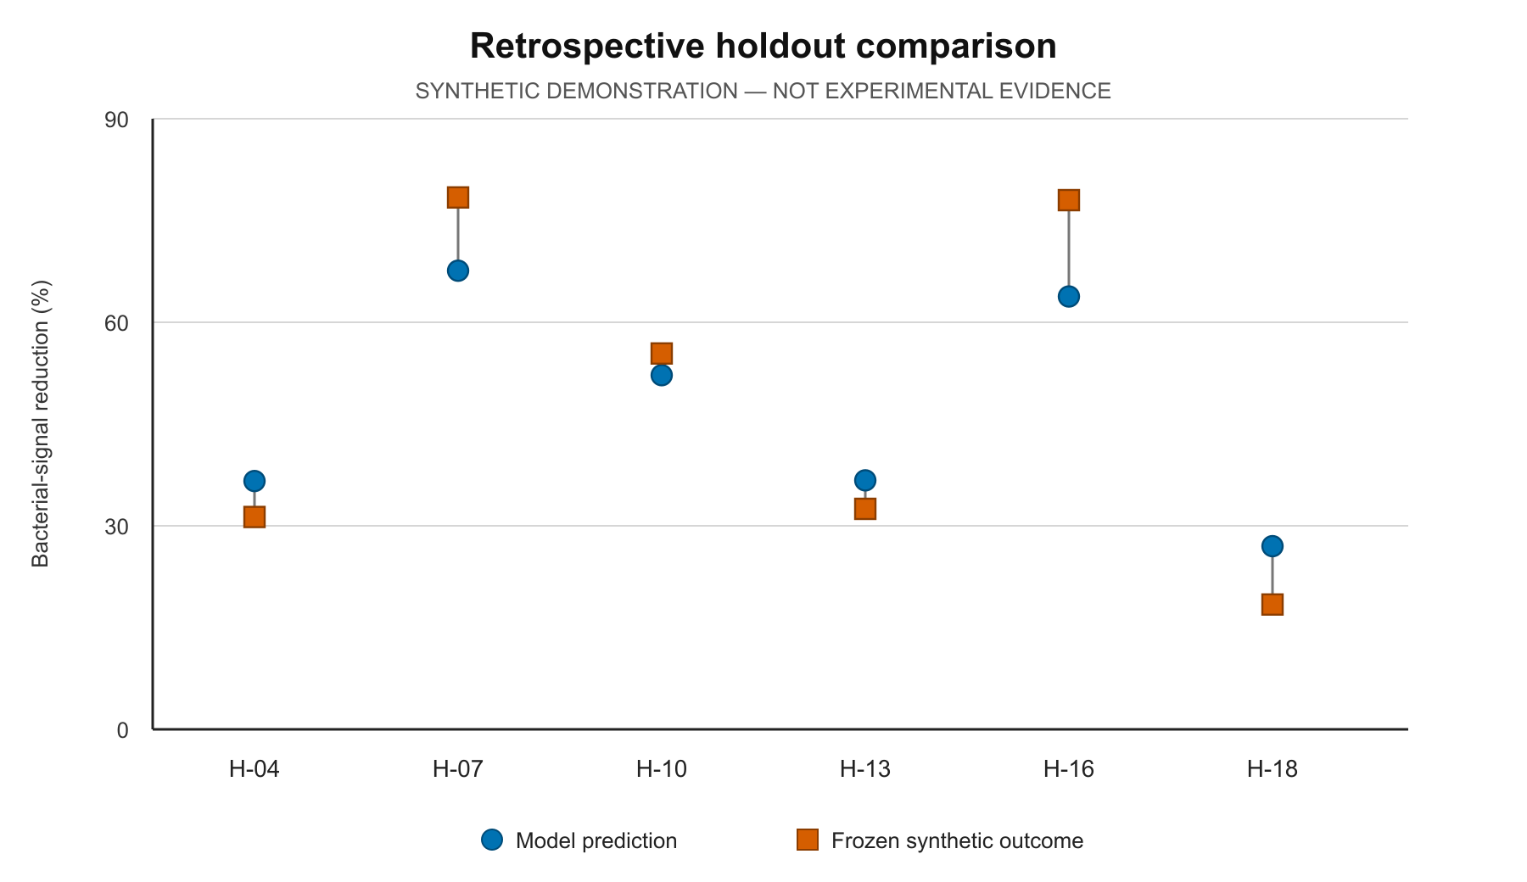
Figure 1 | Predicted and frozen bacterial-signal reduction in six held-out synthetic formulations. Shape supplements color; no uncertainty is shown because independent replicate data do not exist.
Table 1 | Retrospective ranking outputs and frozen synthetic outcomes for H-07 and H-18.
Formulation | Pred. reduction | Pred. viability | Frozen reduction | Frozen viability | Permitted interpretation
H-07 | 67.6% | 91.1% | 78.4% | 90.3% | First-ranked holdout row under the toy rule
H-18 | 27.0% | 96.3% | 18.4% | 98.0% | Peptide-free holdout comparator

AFTER · DISCUSSION, CITATIONS, AND AUDIT STATE

Discussion
The ranking placed H-07 above the other held-out rows, and its frozen reduction value exceeded the corresponding prediction. This agreement is internal to a dataset generated from fixed equations; it cannot test transfer to another batch, hydrogel chemistry, assay, microbial strain, or laboratory. The viability values represent a fictional cell-assay endpoint and cannot establish organism-level tolerability or patient benefit.
The analysis also does not demonstrate autonomous experimentation. A closed loop would require one experiment's result to change the model's next experimental choice. Here, all rows existed before fitting, and no new choice was executed. A scientifically informative next step for a real study would be a preregistered prospective test using independently synthesized batches, blinded outcome measurement, an appropriate antimicrobial comparator, and uncertainty defined over biological replicates. This demonstration supplies none of that evidence and makes no claim about the likely result.

Synthetic placeholder references
1. CNS Skills demonstration fixture. Frozen synthetic hydrogel dataset. Synthetic record, 2026. Placeholder DOI: 10.0000/cns.synthetic.dataset.001 (deliberately non-resolving).
2. CNS Skills demonstration fixture. Standard-library ridge-ranking specification. Synthetic record, 2026. Placeholder DOI: 10.0000/cns.synthetic.method.002 (deliberately non-resolving).
3. CNS Skills demonstration fixture. Evidence-boundary reporting card. Synthetic record, 2026. Placeholder DOI: 10.0000/cns.synthetic.reporting.003 (deliberately non-resolving).

Validation snapshot
Deterministic fixture: PASS · strict clean-copy on revised source: PASS · display cross-references: clean · numeric citations: 3/3 placed · real or resolvable citations: 0
These checks do not prove citation entailment, biological truth, or DOCX quality by themselves. This document was separately rendered page by page for visual QA before public use.

