http://kns.cnki.net/KCMS/detail/detail.aspx?dbcode=CMFD&dbname=CMFD201802&filename=1018194630.nh&uid=WEEvREcwSlJHSldTTEYzU3EydDRPaFp6R21NU1FyS1hPR0FWNWg0WTduZz0=$9A4hF_YAuvQ5obgVAqNKPCYcEjKensW4IQMovwHtwkF4VYPoHbKxJw!!&v=Mjc5NDNVUkxPZlp1ZHNGeUhnVXJ6QlZGMjZGckt4R3RmUHI1RWJQSVI4ZVgxTHV4WVM3RGgxVDNxVHJXTTFGckM=

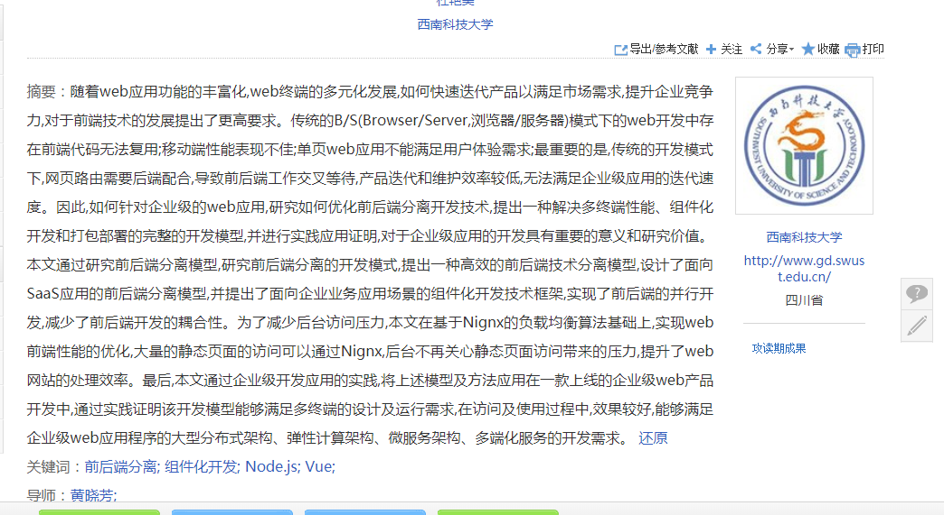

<http://www.cnblogs.com/dujunfeng/p/7979014.html>



<http://xueshu.baidu.com/usercenter/paper/show?paperid=02c9660d603058f56000e4d81dc63a7c&site=xueshu_se>

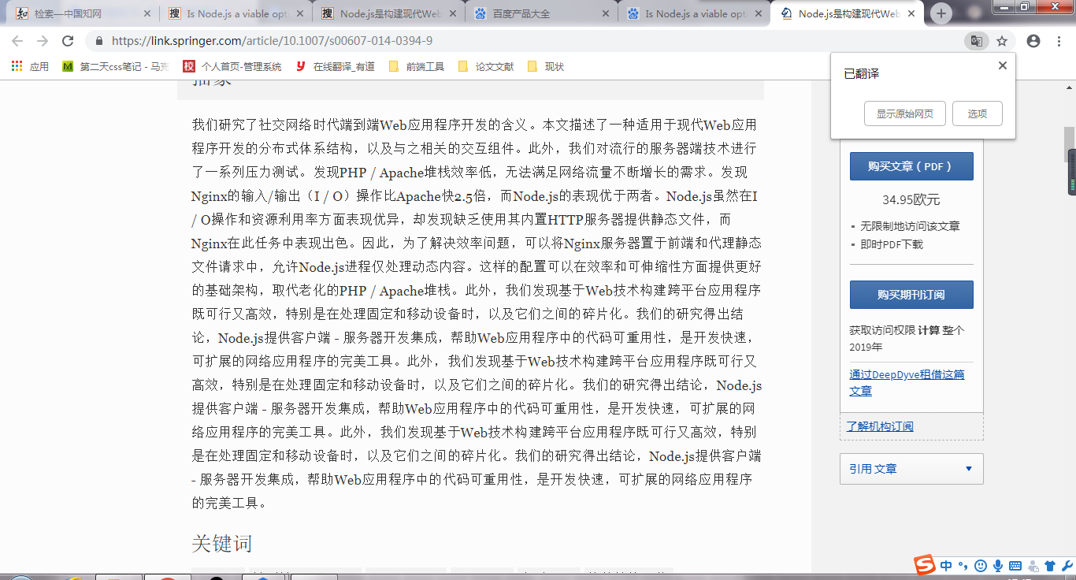

<https://link.springer.com/article/10.1007/s00607-014-0394-9>

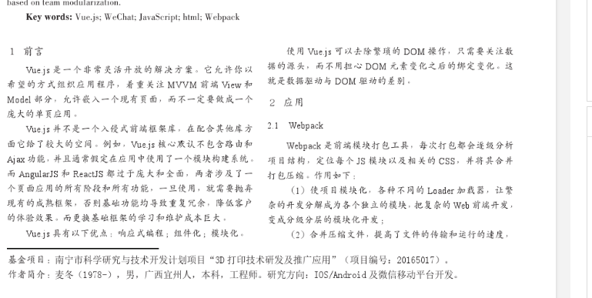

<https://www.ixueshu.com/document/9ce30363d5ec88afbafae32faf5e676f.html#pdfpreview>

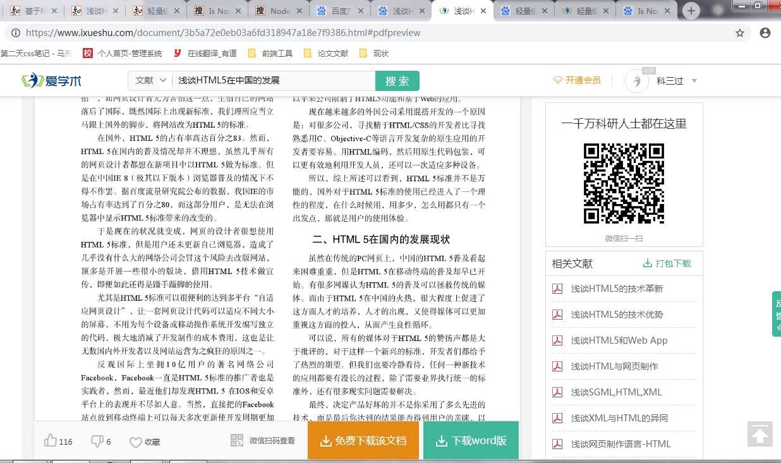

<https://www.ixueshu.com/document/3b5a72e0eb03a6fd318947a18e7f9386.html#pdfpreview>

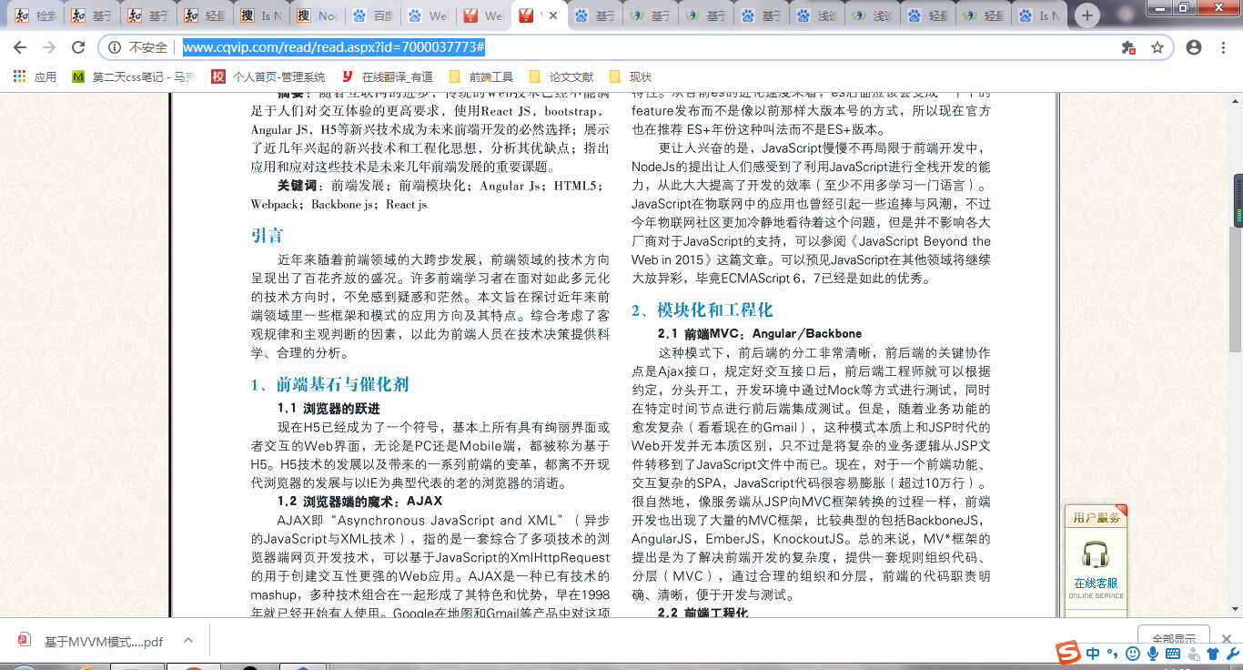

<http://www.cqvip.com/read/read.aspx?id=7000037773#>

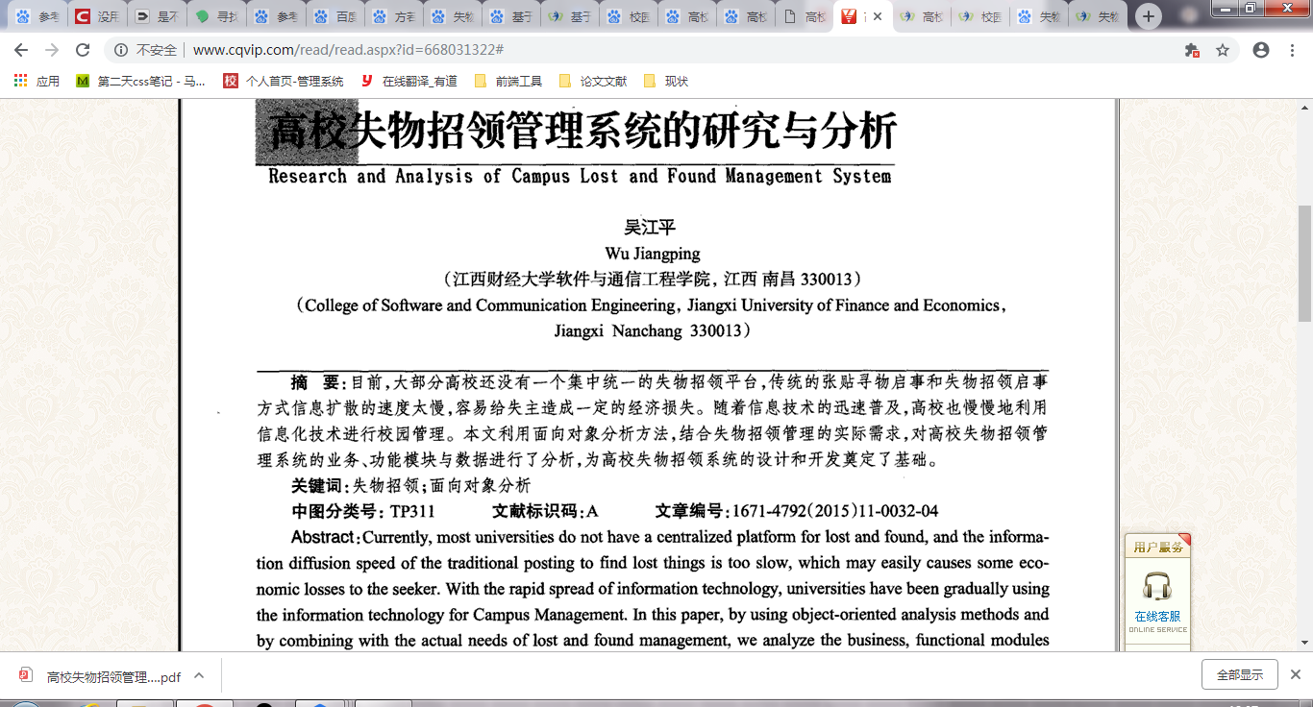

http://www.cqvip.com/read/read.aspx?id=668031322#

1. 王杰．基于Android系统的失物招领平台的设计与实现[D]．2015
2. 黄小青．校园失物招领平台的研究——以广东培正学院为例[J]．智库时代 Think Tank Era: 2018年34期
3. 百家号（百度），https://baijiahao.baidu.com/s ，2017-06-23
4. 凤凰资讯．失物招领怎样走出尴尬，http://news.ifeng.com/a/20160525/48842395_0.shtml
5. 杜艳美. 基于web前端的性能优化框架模型研究[D].西南科技大学,2018.
6. Vue.js官网． <https://cn.vuejs.org/>
7. Node.js官网． <http://nodejs.cn/api/>
8. 方若男, 赵竞天, 蒋伟. 基于Web的高校寻物启事及失物招领平台开发[J]. 教育教学论坛, 2013(26):245-246.
9. National Association of Unclaimed Property Administrators．Missing Money Home Page[EB/OL]