# Data Explanation

Bookshelfia have been storing their data in a series of csv files. As part of your deliverables for your 12-week internship programme mentioned in the assignment brief, you will have to take the data from these csv files and import them into your newly designed database solution. The company’s data is split across 5 different files, which are described below.

## Product_info.csv

This file contains information about 2048 different products (books, ebooks, audiobooks and magazines) that the company has. As described in the assignment brief, information about each product is stored here, including the product type, title, author, publisher, genre, format, ISBN, unit price, publication date, number of pages, narrator, length and customer rating (on a 0 – 5 scale).

## Inventory.csv

This file contains information about the stock level at each one of the company’s warehouses; in Corby, Newcastle and Chester.

## Customer ID.csv

This file contains information about all of the customers that have ever bought anything from Bookshelfia. It contains information such as their name, address, email and telephone number, as well as a unique customer ID number.

## Orders.csv

This file contains summary information about each order received and processed by Bookshelfia. This includes a unique order ID, the date and time of the order, the ID of the customer that made the purchase, the total value of the order (in £), information about the payment method (credit card, paypal, etc), the card number or the authorisation code (depending on whether a card was used, or whether Google Pay or Paypal was used). Note, information about the actual products bought is not contained within this file, this is kept in order_detail.csv

## Order_detail.csv

This file contains three columns; the order ID (which is repeated if multiple items are purchased), the ISBN of the product, and the amount of that item.

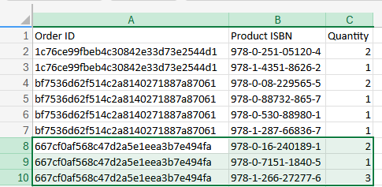

For instance, for order 667cf0af568c47d2a5e1eea3b7e494fa, two copies of the product with ISNB “978-0-16-240189-1” were purchased, along with a single copy of “978-0-7151-1840-5” and three copies of “978-1-266-27277-6”.