SYSTEM REQUIREMENTS

Minimum requirements
Processor: Pentium 4 2 GHz
RAM: 1 GB
Video card: GeForce6600 GT (Radeon X1300) 128 MB VRAM or equivalent (25 fps).
DirectX: 9.0c
Sound card: DirectX-compatible card
Available hard disk space: 4 GB

Recommended specifications
Processor: Core2Duo 3 GHz
RAM: 2 GB
Video card: GeForce 8800 (Radeon HD 3850) 512 МB VRAM or equivalent (40 fps).
DirectX: 9.0c
Sound card: DirectX-compatible card
Available hard disk space: 4 GB

THE PRIME WORLD INTERFACE

CASTLE

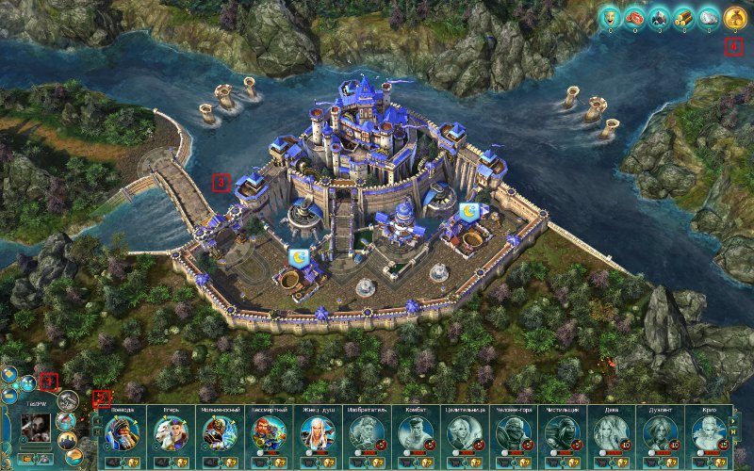

- Character Panel. All of the castle's basic control elements are found here. There are buttons for "Heroes", "Friends", "Chat", "Construction", "Inventory", "Menu", camera zoom, and switching between fullscreen and windowed mode. The "Inventory" button will become available later. The character’s fame level and your character's avatar are also displayed here.
- The Hero Selection Menu is a set of panels with portraits of the heroes that the player has already purchased and those that will become available with development. The heroes available for purchase are displayed in color along with their cost. The number next to each unpurchased hero's portrait is the fame level the player must achieve to be able to purchase the hero. The number next to purchased heroes shows their current level of development. As this level increases, so does the hero’s number of Mastery Points, which can be used to improve the hero’s characteristics. Heroes that are not currently available are shown in gray. The helmet button opens a window where you can change the hero's settings and talents and read his or her biography.
- The Castle. The Lord’s Castle is not only a simple military base for hiring heroes, but also a sort of a home front that supplies everything needed for victory. There are many buildings available to the player that are responsible for collecting raw materials, processing them, and producing talents. A population is required for industrial and agricultural development; therefore players must build residential housing as well as resource storage, not just production buildings. Thanks to these resources, a castle owner can reduce the time it takes to recover heroes’ stamina and maintain a library, which lets him or her keep a large talent collection for continuous improvement of his or her characters. Furthermore, you can create talents yourself and therefore prevent yourself from becoming dependent on random battle rewards! Your castle is also a tool to collaborate with your friends by recruiting them to your team, communicating, and planning tactics for the upcoming battle!
- Player Resources. This section displays the amount of resources and your population. Resources can be collected in the castle or earned in battle.

BATTLE

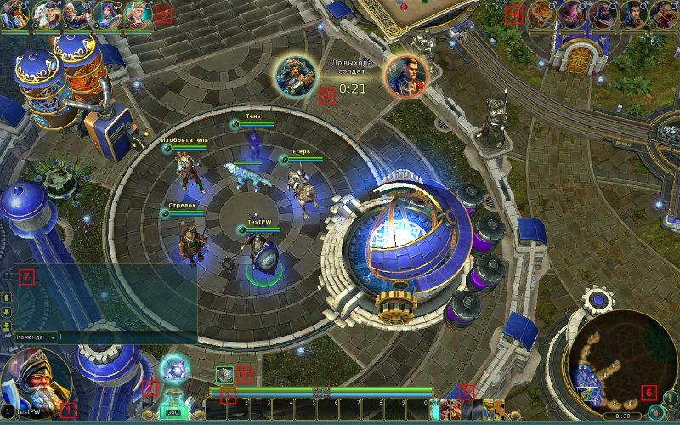

- Hero Portrait. The current level and portrait of your hero in battle are shown here.
- Prime Level. This is where the amount of Prime you have earned on the field of battle is shown. If you see a talent's icon burning over the container of Prime, you can click on it to have the game automatically allocate it. To manually allocate talents, click on the container of Prime.
- Skill Panel. Here you will find your active skills displayed along with your current health level and mana points.
- The Status Panel shows both the positive and negative effects that currently apply to your character.
- Action Menu. Here you can bring up a panel with the hero's talents and characteristics, the inventory, game statistics, or the game menu.
- The Mini-map displays a simplified view of the field of battle. It shows allied and enemy heroes, towers, buildings, and forest monsters. This is also where you will find the buttons to link the camera to a character and send a signal on the mini-map.
- Player Chat. This is where you can send messages to your teammates or to all of the players in the current session.
- The Information Zone reports on current events and achievements earned.
- The Allied Character Panel displays the current health of allied characters. Here you can find out the characteristics and talents of the selected hero.
- The Enemy Character Panel displays the current health of enemy characters. Here you can find out the characteristics and talents of the selected hero.

List of hotkeys

When using an English keyboard layout:

T — talent window;

C — hero characteristics;

B — hero inventory;

Q — select place for hero to move to;

A — order a hero to attack;

S — order a hero to stop;

Z — toggle display of the health bar;

Tab — game statistics for this session;

Esc — close open windows; if there are no open windows, display the window with the main menu and settings;

W — center the camera on your hero;

0-9 — activate skills or potions;

F10 — take a screenshot;

F11 — toggle FPS display;

Enter — chat;

-/+ — zoom out/in with the camera;

Arrow keys: Left, Right, Up, Down — control the camera.

Insert – rotates the camera to the right;

Delete – rotates the camera to the left;

Alt+click on the minimap – displays an exclamation symbol on the minimap.

Frequently Asked Questions

Question: How do I start playing Prime World?
Answer: Go to the website playpw.com. Click on the "Play!" button. Download and launch the installer. The launcher will ensure that the most recent version of the client is installed. Then, you can provide authorization via your preferred social network and start the game.

Question: What is Force?
Answer: We introduced the concept of Force to visually represent the game's current mechanisms for development.

Force depends on the number of rare talents a hero has, as well as the number of allocated mastery points.

Force, like Rating, is a consideration when players are selected for battle. This allows players to be matched more closely, not only according to their mastery but also according to the degree to which their heroes have been developed.

When a hero's Force exceeds 1,000, the growth of all of the character's characteristics for a Prime Level increases. The growth is balanced so that, for any combination of talents, the hero will not suffer a critical reduction of any of his or her main characteristics (Health, for example).

A value of 1,000 roughly corresponds to the Force of a level-1 hero with the basic set of talents.

In addition, heroes with high values of Force require more Energy to use talents with each Prime Level. This is necessary to compensate for the hero's excessive amount of Energy.

The bonus to maximum Energy given for activating shared passive talents does not affect the cost of using active talents. Thus, you will still be able to use more active talents while activating passive talents with additional Energy.

A hero's Force is shown in the castle when the character is selected in the Hero Academy.

Question: How do I change the game settings?
Answer: Go to the game menu and select the "Settings" or click the button in the game launcher.

Question: Why do I have to wait so long to begin a game?
Answer: This has to do with the game-making system selecting teams of allies and opponents based on a number of parameters to optimally balance the teams. Don't be in too much of a rush. If you leave a game, you will restart the search for a session. This will only increase your wait time.

Question: What is the maximum hero level in a session?
Answer: The maximum level for heroes is 36.

Question: How many talents can I learn per session?
Answer: The maximum number of talents that can be learned in a single game session is 36.
Question: How do I find the mini-game?
Answer: You can get to the mini-game through special playing grounds that are located near where heroes are spawned in the Imperium's or the Keepers' base.
Question: Why are so few male heroes geared toward support and healing?
Answer: The current lineup is just the beginning. We will be improving it and releasing new heroes. It is possible that, in the future, there will be male heroes with these specializations.

Question: What characteristics do heroes have? And what are they needed for?
Answer:
General hero characteristics:
Rating.
Each of a player's heroes has his or her own rating, which changes depending on the number of wins and losses as well as the makeup of the team engaged in battle. Hero ratings are considered when a game is arranged.

Power.
Power depends on the number of rare talents that hero possesses, as well as the number of assigned mastery points. Power, just like rating, is calculated during the selection of players for battle.

Endurance.
Indicates a hero's level of fatigue. A hero with low endurance will receive a reduced number of rewards after the battle.

Hero’s battle characteristics:
Health.
The hero's life. When this characteristic reaches zero, the hero dies.
Energy.
The hero's energy. It is expended using talents.
Speed.
Determines the speed with which a hero moves about the game's map. Measured in standard units. The standard speed is 50 units.
Strength.
This characteristic increases the physical damage dealt by a hero. This is most important for heroes with a physical attack.

Intellect.
This characteristic increases the magic damage dealt by a hero. This is most important for heroes with a magic attack.
Cunning.
This characteristic increases the hero’s chances of dealing critical damage and penetrating an opponent's defenses. The chance of a critical attack (i.e. dealing double damage) increases as this characteristic grows.

Increasing the "Chance of Critical Attack" is useful for heroes whose strong point is a basic attack. In addition, greater Cunning increases the hero’s Power.
Agility.
This characteristic determines how often a hero can use his or her basic attack. Measured in units. Agility is most important for heroes whose strong point is their basic attack.
Life Drain.
This characteristic displays how many units of health are added to your hero's Health as a result of damage dealt to an opponent. The life drained can be increased by some talents, but cannot exceed the value of the damage inflicted.

Fortitude.
This characteristic reduces the amount of physical damage taken by a hero by a certain percentage (physical protection). Physical protection decreases with the attacker's Power characteristic.
Will.
This characteristic reduces the amount of magic damage taken by a hero by a certain percentage (spirit protection). Spirit protection also decreases with the attacker's Power characteristic.

Base attack – hero’s physical or magical attack, which is used automatically, without the activation of additional talents.

Physical damage increases as the Strength of the attacker is increased and decreases as the Fortitude of the attacked target increases. In other words, the more Strength your hero has, the more damage he can inflict, but the more Fortitude your opponent has, the less total damage can be inflicted by your attack.

Magic damage depends on the attacker’s Intellect and the target’s Will. The higher the attacker’s Intellect, the more magic damage is inflicted, but the stronger the Will of the attacked target, the better he can withstand the attack.

Basically, all talents that inflict damage, with a few exceptions, depend on the Intellect or Strength of the hero. However, the talents of some heroes inflict physical or magic damage that does not depend on Intellect or Strength, but on other parameters, such as Agility. In these cases, this is specifically mentioned in the talent description.

Question: What is the mini-game for?
Answer: The mini-game is another way to obtain Prime. Fighting in battle doesn't compare to the mini-game in terms of how quickly Prime can be earned. Moreover, for players who have experience in similar games, the mini-game is an even more advantageous way to develop a hero. The absence of a player from the line of battle and the opponent's resulting advantage is compensated for by scrolls created in the mini-game.

Question: Does the game have a standard recharge time for talents?
Answer: Yes. The recharge time is 0.2 seconds.

Question: Is it possible to vote to surrender?
Answer: Yes. If the team believes the match is undeniably lost, you can use a button in the menu to initiate a vote to surrender.

Question: Can I see the statistics for the game session?
Answer: Yes. You can bring up the match statistics using the system's Tab key.
Question: Is it possible for me and my friends to create a match together in the game?
Answer: Yes. You can play together with your friends using the "Friends" section in the castle.

Question: Which levels unlock the next set of talents?
Answer: This occurs every 4 levels. But keep in mind that certain talents add more than one level.
Question: What differentiates the various talents?
Answer: The rarity of the talent is indicated by color: Yellow -> Green -> Blue -> Purple. The most common talents are Yellow, and the rarest are Purple. Class talents are possessed by every hero. They are unique to his or her class and can be improved by other talents.
Question: How do the talents work? I want to know about the formulas and specific values used.
Answer: We don't reveal the formulas and specific values of the talents.
Question: Why are the heroes arranged in a particular order?
Answer: They are arranged from simple to complex. The heroes are also grouped by gender.
Question: Which players are given preference when playing in a match?
Answer: The game first attempts to arrange a battle between two teams. However, if this can't be done for a long time, a group of individual players may be selected for a team.
Question: Will it be possible to sell or exchange talents?
Answer: Yes, we plan to introduce this ability in subsequent game updates.
Question: Can you play in PVP mode against Bots?
Answer: Absolutely. You can create a training battle against Bots and run through some drills with them.

Technical Support
If you encounter problems or find a bug in the game, please contact customer support at http://support.zzima.com.
In order to submit a form, you need to:

- Be a registered ZZima.com user;
- Login to the support system using your username and password for ZZima.com,
- open a new submission form,
- select the Prime World project,
- and describe the details of the problem on the submission form.

If possible, attach screenshots and include information about your computer's configuration, your operating system, your DirectX version, and any other information that might be helpful in troubleshooting the problem.

