- Running Hadoop can be using tutorial in this page: https://hub.docker.com/r/apache/hadoop
The file needed included in the git folder, docker-compose.yml and config. To build docker compose of Hadoop using command:
docker-compose up

Can also using docker extension in vscode to start Hadoop.
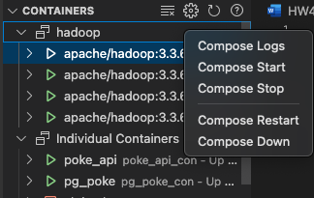

- This is the scrip to get pokemon ability, also included in ipynb for more comment:
- import requests
- import csv

- def fetch_and_save_pokemon_abilities(start_id, end_id, filename):
- abilities = []
- for ability_id in range(start_id, end_id + 1):
- url = f"https://pokeapi.co/api/v2/ability/{ability_id}"
- response = requests.get(url)
- if response.status_code == 200:
- abilities.append(response.json())
- else:
- print(f"Failed to fetch ability with ID {ability_id}")
- return False # Stop fetching on failure

- with open(filename, 'w', newline='') as file:
- writer = csv.writer(file)
- writer.writerow(["id", "name", "effect", "short_effect"])

- for ability in abilities:
- for effect_entry in ability.get('effect_entries', []):
- if effect_entry.get('language', {}).get('name') == 'en':
- writer.writerow([
- ability.get('id'),
- ability.get('name'),
- effect_entry.get('effect'),
- effect_entry.get('short_effect')
- ])
- return True

- def main():
- batch_size = 100
- total_abilities = 999
- for start_id in range(1, total_abilities + 1, batch_size):
- end_id = min(start_id + batch_size - 1, total_abilities)
- filename = f"pokemon_abilities_{start_id}_to_{end_id}.csv"
- if not fetch_and_save_pokemon_abilities(start_id, end_id, filename):
- print(f"Stopping at abilities {start_id} to {end_id} due to failure.")
- break
- print(f"Saved abilities {start_id} to {end_id} in {filename}")

- if __name__ == "__main__":
- main()

3. sample of the output like this:
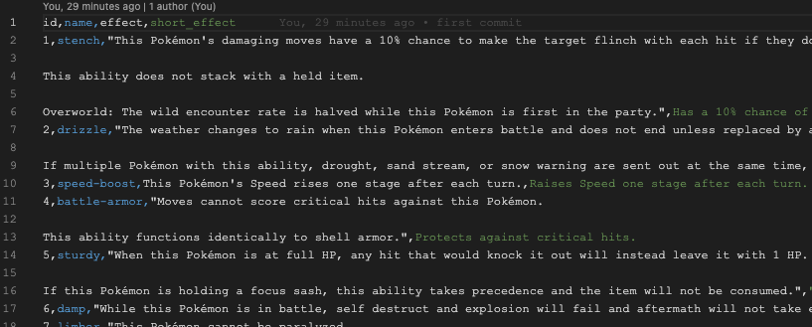
I’m only using Pokémon ability id, name, effect and short effect, and lock the language to English only. The ability only up to 300 and not 999 because that’s the data.

4. the next step is importing to Hadoop. Using:

docker cp <source_file> <container_name>:<destination_path>

