- Find all books authored by "Author 5" that have been borrowed by any user but not yet returned.
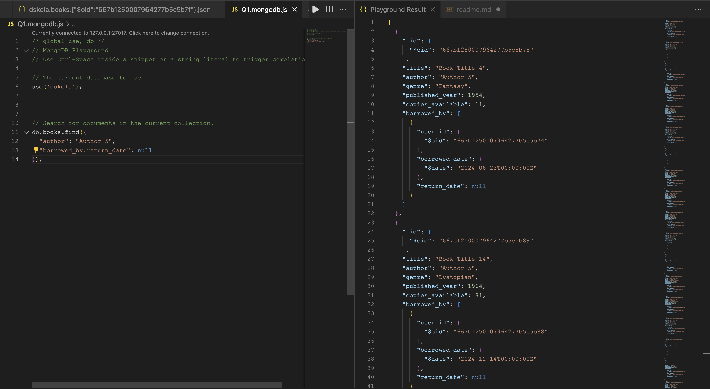

- List all books published before the year 1980 and have more than 5 copies available.

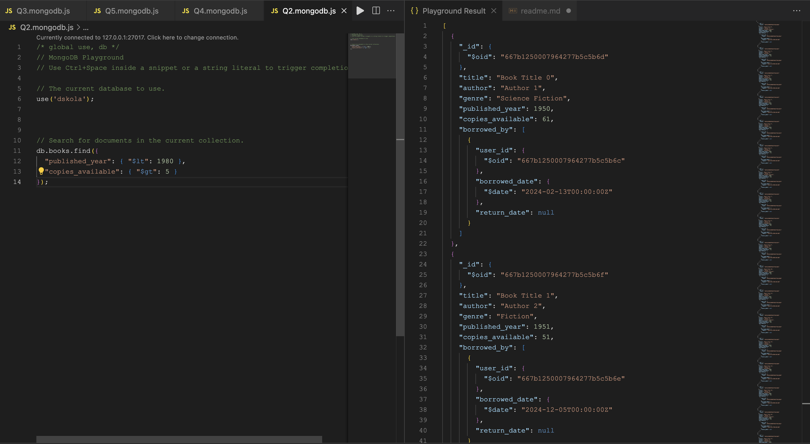

- Find the top 5 most recently published books in the "Fantasy" genre.
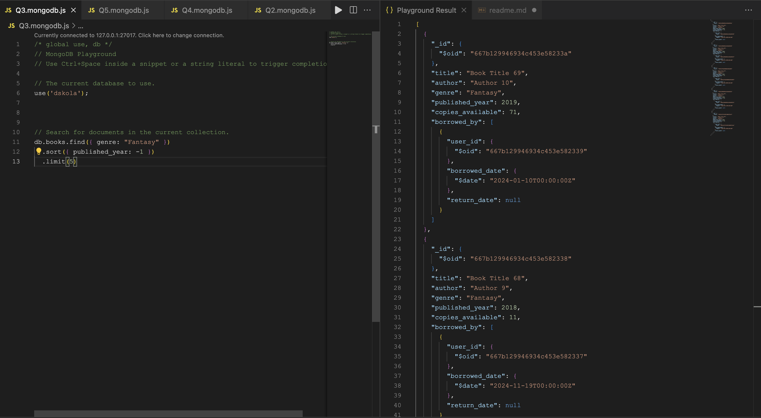

- Count the number of books available for each genre.

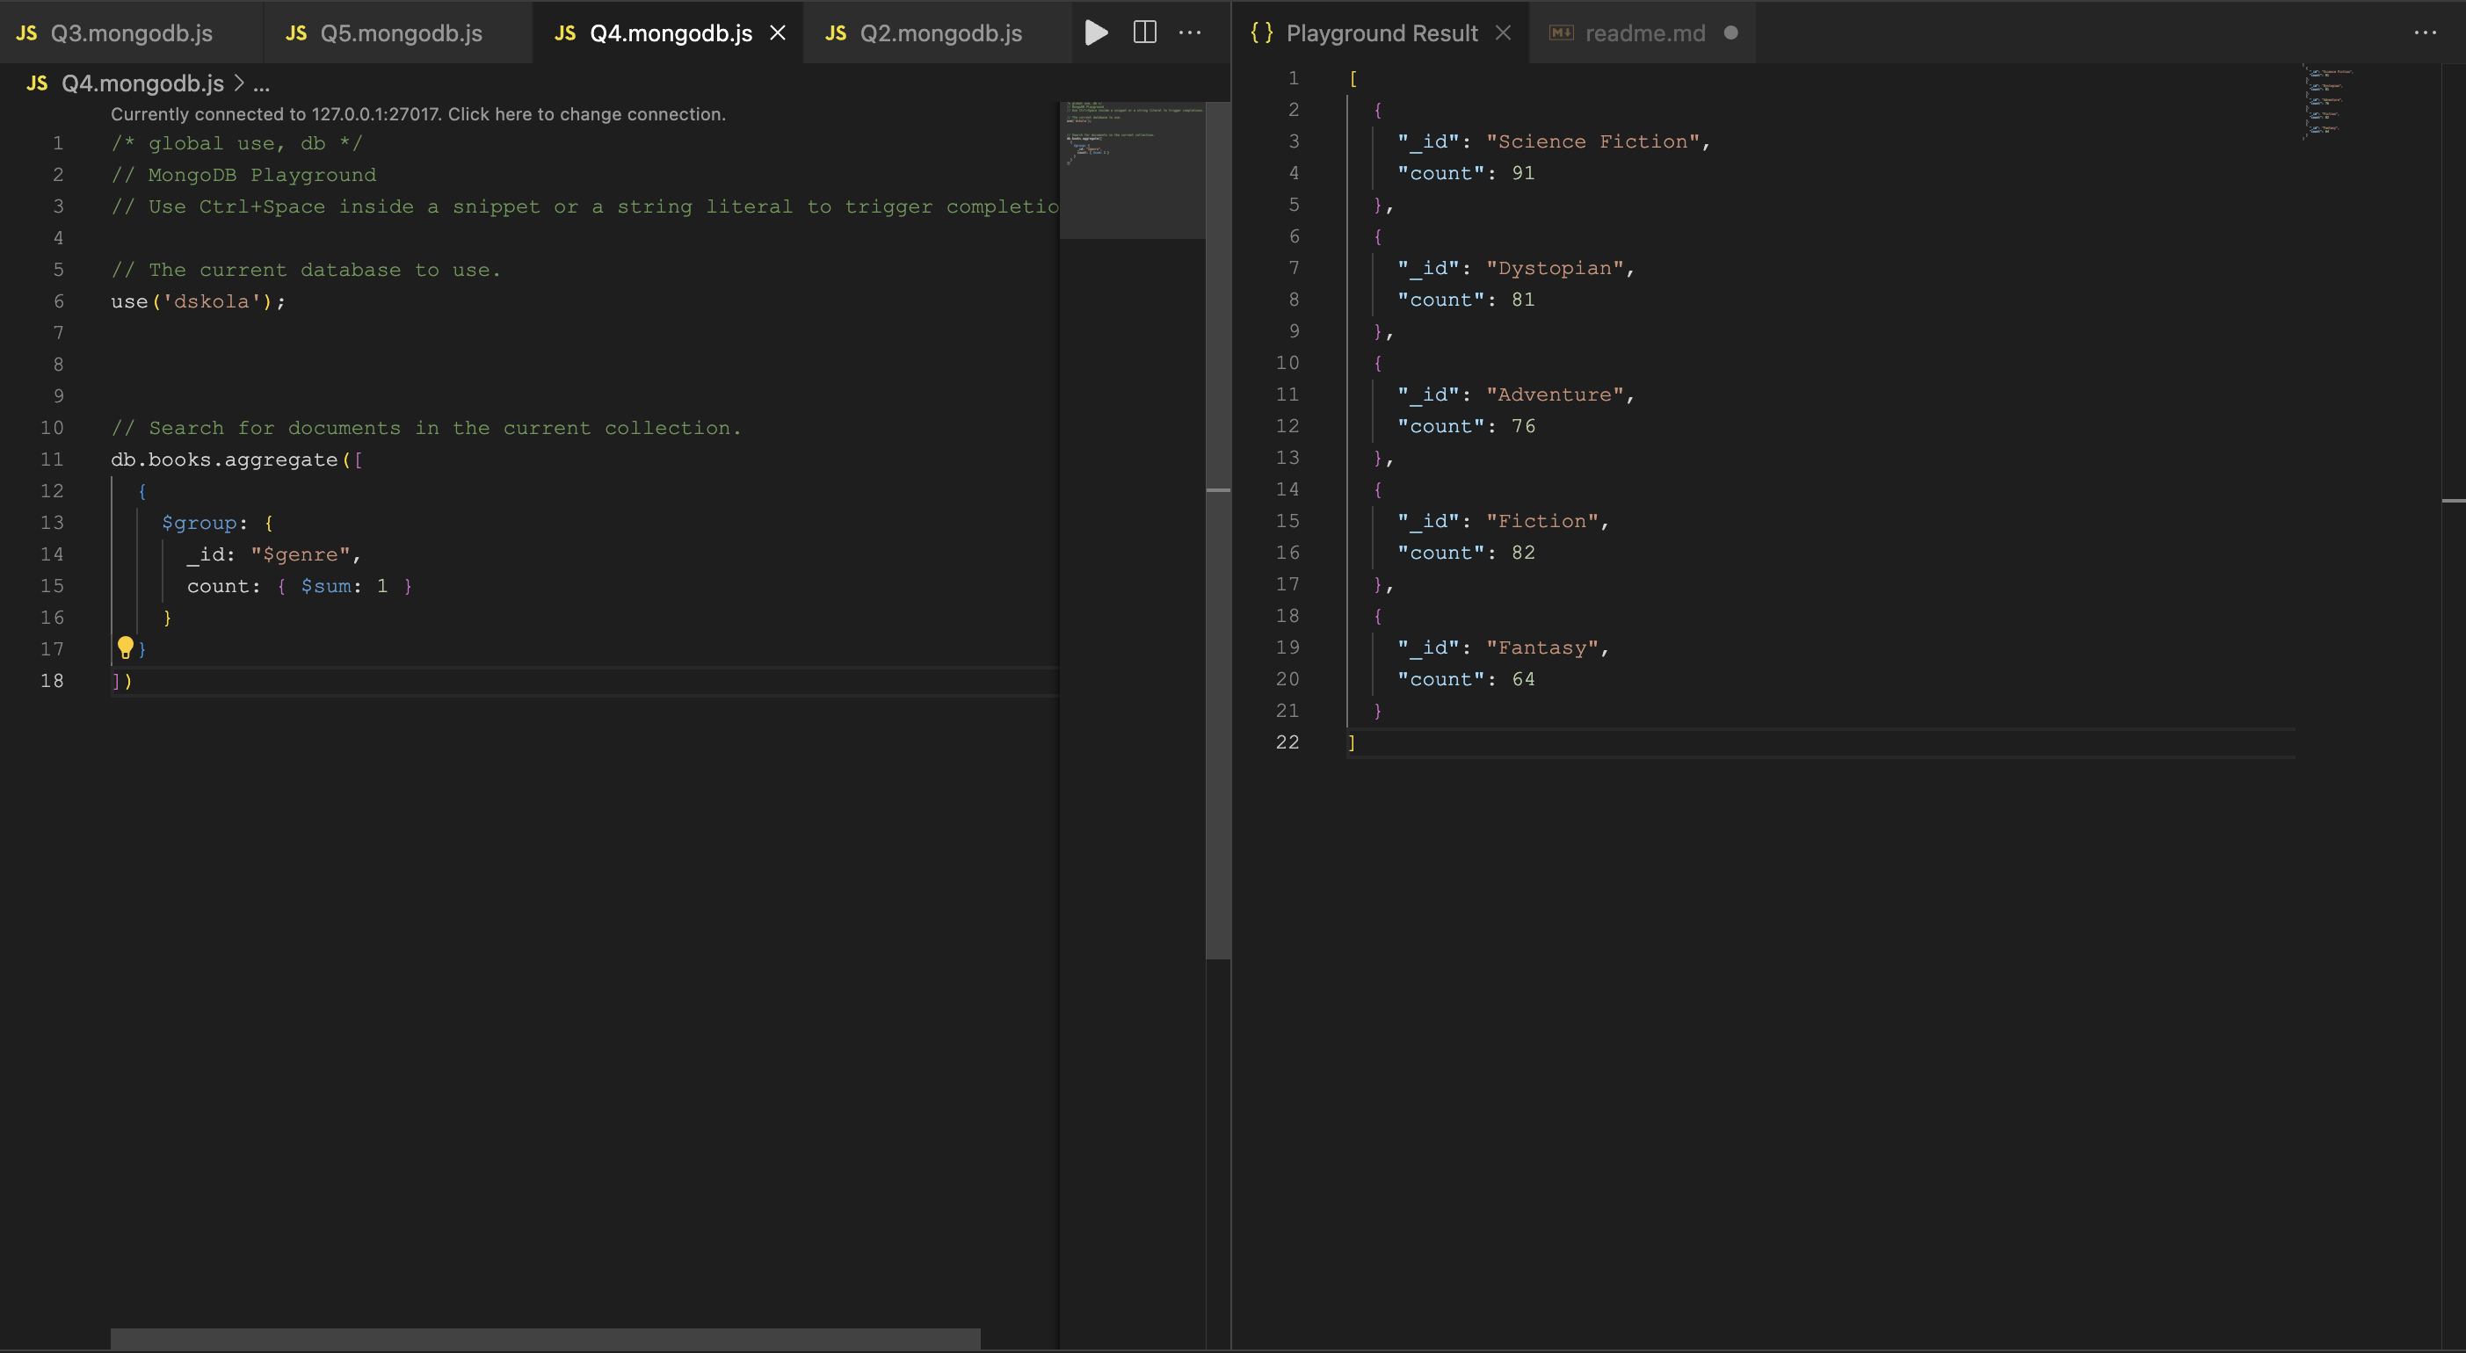

- Find all books that have never been borrowed by any user.
