DAY8 SESSION ASSIGNMENTS(Theory)
ACADGILD1

1.When to use (Rapid Application Development) RAD model
When not to use (Rapid Application Development) RAD model

RAD model can be used when:

- The system is to be modularised in 2-3 months and is to be produced in short span of time.
- There is high availability of designers for modelling.
- The budget is high enough to afford the cost of designers and other automated tools
- resources with high business knowledge is available.
- The requirements are well known.
- The technical risks identified in the project is less.
- The customer to be involved through out the project development.

RAD model is not to be used when:

- there is lack of availability of high skilled engineers.
- The system cannot be modularised.
- The project is of low budget as cost of modeling and automated code generation is very high.
- System is not scalable.
- The project is a long term one.

2.Define an ER diagram of a software Organization
with all the relationship model that was discussed in the classroom

An entity relationship model, also called an entity-relationship (ER) diagram, is a graphical representation of entities and their relationships to
each other, typically used in computing in regard to the organization of data within databases or information systems.

Name
id
id
Name

EMPLOYEE
DEPARTMENT
Works for
salary

Address
No:of
employees

Manages
controls
supervises

Works on

PROJECT

id
Name

The above entity diagram consists of three entities:
- Employee
- Department
- Project
The attributes are:
- Employee – id, name, salary, address
- Department – id, name, no:of employees
- Project – id , name
The employees join under various departments.A department has several employees.There will be an employee to supervise other employees.The department controls the projects.The employees works on various projects.Each project is developed by one or more employees.

3.Describe the Entity Relationships for the following diagram
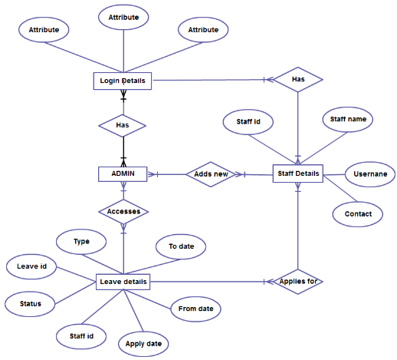

In the above ER diagram ,the entities are :
- Login details
- Staff details
- Admin
- Leave details

The attributes are those enclosed in ellipses like staff id , staff name , username , contact etc...

The entity relationship diagram depicts that:

- Each staff has their login details.One staff has a single login detail.Similarly multiple admins has the login details and can log in.Also each login has one or more admins to monitor.Login details can have multiple staffs.

- The staffs has the attributes staff id , staff name , username and contact.The staff applies for the leave.The staffs are added by the admins.

- The leave details has the attributes Type , To date , From date , Apply date , Staff id ,Status and Leave id .The leave details may contain multiple staff details.

- The admin can login and access all the leave details of the staffs.The admin can also add new staffs.

This entity relationship diagram symbolises a system in which the staffs can login and enter their leave details .Multiple staffs can login to the system with their login credentials.The admins also have their login details.There can be one or more admins for the system.The admin can login and access the leave details of the staffs.Also the admin can add new staffs to the system.

