E-COMMERCE SALES ANALYSIS
& DEMAND PREDICTION
A Data Science Internship Project Report
Prepared by: Nivash
B.Tech, Computer Science & Engineering (AI & ML)
VIT Chennai
July 2026

Table of Contents
Executive Summary
1. Introduction & Objective
2. Dataset
3. Data Cleaning & Preprocessing
4. Exploratory Data Analysis
5. Machine Learning Methodology
6. Model Results & Evaluation
7. Business Insights & Recommendations
8. Conclusion

Executive Summary
This report presents an end-to-end data science project analyzing 9,994 historical e-commerce order records spanning 2014-01-03 to 2017-12-30. The objective was to uncover sales and demand patterns and to build machine learning models capable of forecasting future product demand to support inventory optimization decisions.
Across the analysis period, the business generated $2.30M in total sales and $286K in profit across 5,009 unique orders. Two regression models — Linear Regression and Random Forest Regressor — were built to forecast monthly unit demand at the product-category and region level. The Random Forest model achieved the strongest performance (R² = 0.770, MAE = 2.47 units), outperforming the linear baseline on every metric.
Key findings include a pronounced Q4 seasonal demand spike, the West region's leadership in both revenue and volume, a clear negative relationship between heavy discounting and profitability, and confirmation that order frequency — not order size — is the dominant driver of aggregate unit demand. Actionable recommendations for inventory planning, regional strategy, and discount policy are detailed in Section 7.

1. Introduction & Objective
E-commerce and retail businesses generate large volumes of transactional data every day. Buried within this data are patterns — seasonal cycles, regional preferences, product performance differences — that, if properly understood, can materially improve operational decisions such as how much stock to hold, when to reorder, and where to focus marketing and pricing efforts.
The objective of this project is twofold:
- Analyze historical e-commerce sales data to understand sales trends, product and category performance, regional variation, and seasonality.
- Build and compare machine learning models that predict future product demand (units), enabling data-driven inventory optimization.
The project follows a standard data science lifecycle: data acquisition, cleaning, exploratory analysis, feature engineering, model building, evaluation, and translation of findings into business recommendations.

2. Dataset

2.1 Source & Justification
The project uses the publicly available "Sample Superstore" dataset, a widely used retail transactional dataset (mirrored on Kaggle and originally distributed as a Tableau sample dataset). It was selected because it natively satisfies every field required by the project brief — Order Date, Product Name, Category, Sales, Quantity, and Region — while also providing Profit, Discount, and Segment fields that enable a richer, more business-relevant feature set for demand modeling than a minimal dataset would allow.

2.2 Structure
The raw dataset contains 9,994 order line items across 21 columns, with no missing values and no duplicate rows on arrival.
Column | Description
Order ID / Row ID | Unique order / line-item identifiers
Order Date / Ship Date | Transaction and fulfillment dates
Customer Name / Segment | Customer identity and business segment (Consumer, Corporate, Home Office)
Region / State / City | Geographic breakdown (Central, East, South, West)
Category / Sub-Category / Product Name | Product taxonomy
Sales / Quantity / Discount / Profit | Core transactional metrics
Date range: 2014-01-03 to 2017-12-30 — four full calendar years, sufficient to observe genuine year-over-year seasonality rather than a single snapshot.

3. Data Cleaning & Preprocessing
Although the raw dataset arrived free of missing values and duplicates, a full, production-grade cleaning pipeline was implemented to ensure the workflow is robust and reusable against future, messier data drops.

3.1 Missing Value Handling
Numeric columns are imputed with the column median and categorical columns with the column mode. No missing values were present in this run, confirming data quality at source.

3.2 Duplicate Removal
Exact duplicate rows are dropped via pandas' drop_duplicates(). Zero duplicates were found in the raw file.

3.3 Date Parsing
Order Date and Ship Date are parsed into proper datetime objects (format %m/%d/%Y). Rows with unparseable dates are removed; none were found in this dataset.

3.4 Outlier Detection & Treatment
The Interquartile Range (IQR) method was applied to the Sales column. Approximately 11.7% of rows fall outside the [Q1 - 1.5×IQR, Q3 + 1.5×IQR] bound — these represent genuine high-value bulk and technology purchases (e.g. copiers, video-conferencing systems) rather than data-entry errors, so they were retained for revenue reporting rather than dropped, while being explicitly flagged for awareness during modeling.

3.5 Feature Engineering
The following calendar-derived features were engineered from Order Date to support trend and seasonality analysis:
- Year — for year-over-year trend comparison
- Month — for monthly seasonality
- Day — for day-of-month patterns
- Quarter — for quarterly business-cycle reporting
- DayOfWeek — for weekday ordering behavior

4. Exploratory Data Analysis
Thirteen visualizations were produced to explore time trends, product and category performance, regional variation, seasonality, feature relationships, and distributional properties of the data.

4.1 Sales Trend Over Time
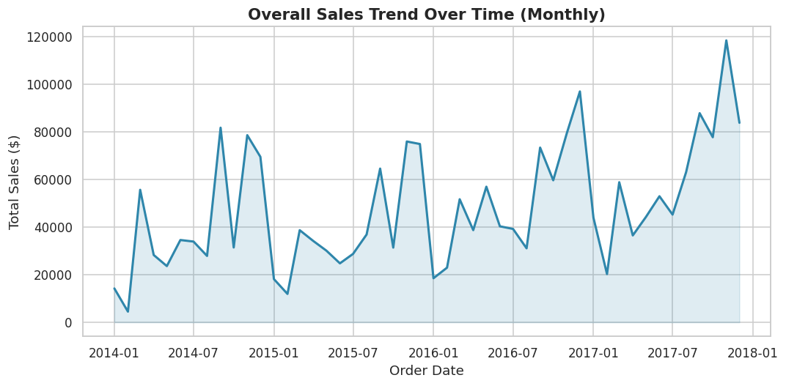
Figure 1. Monthly total sales, 2014–2017.
Sales trend upward year over year with a clear, recurring spike at the end of each year — a classic retail holiday-season signature.

4.2 Monthly Sales Trend
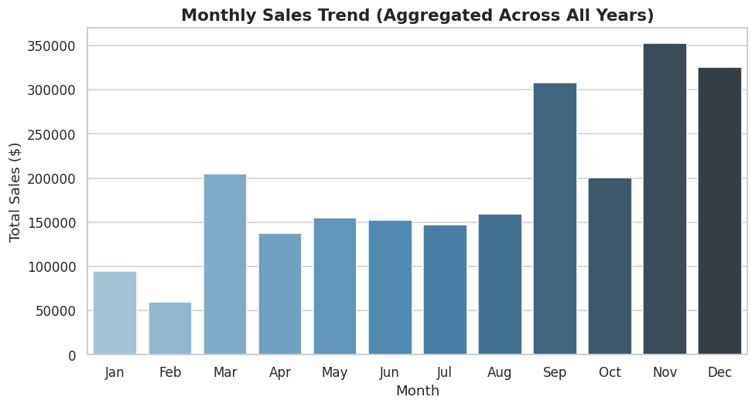
Figure 2. Total sales by calendar month, aggregated across all years.
September, November, and December are consistently the strongest months, reinforcing the need for pre-holiday inventory build-up beginning in Q3.

4.3 Top-Selling Products
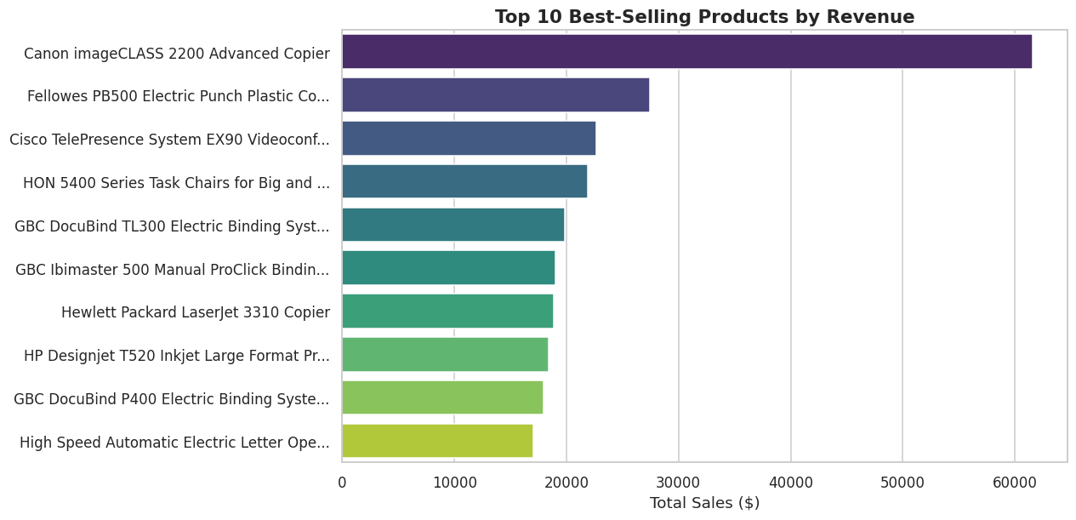
Figure 3. Top 10 products by total revenue.
High-ticket Technology items dominate the revenue leaderboard despite comparatively low unit volumes, illustrating that revenue leadership and unit-demand leadership are distinct — a key reason the demand model targets Quantity, not Sales.

4.4 Top-Selling Categories
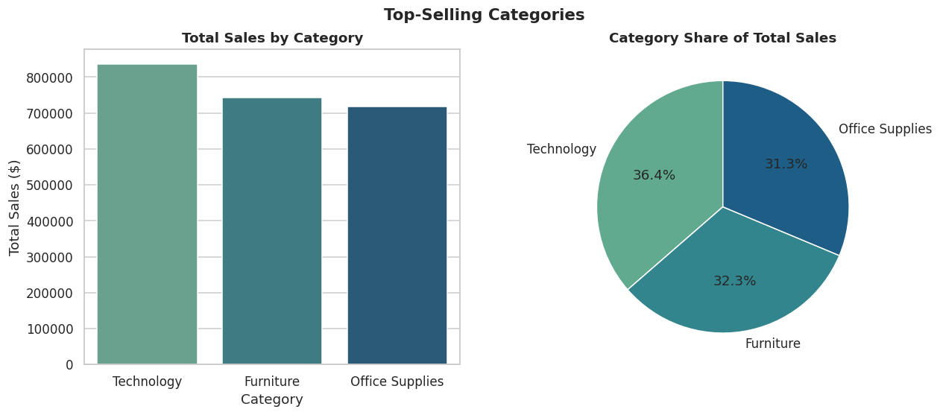
Figure 4. Total sales and share of sales by category.
Technology leads with $836K in sales, closely followed by Furniture ($742K) and Office Supplies ($719K) — the three categories are fairly balanced, so inventory strategy should be tailored per category rather than applying one blanket policy.

4.5 Region-wise Sales
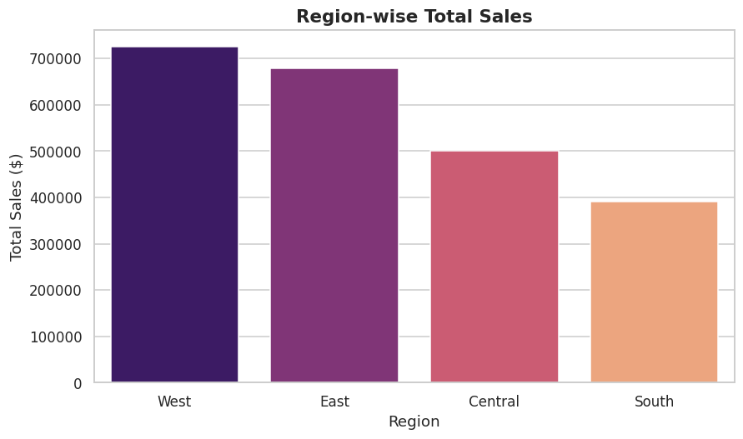
Figure 5. Total sales by region.

4.6 Region-wise Quantity Sold
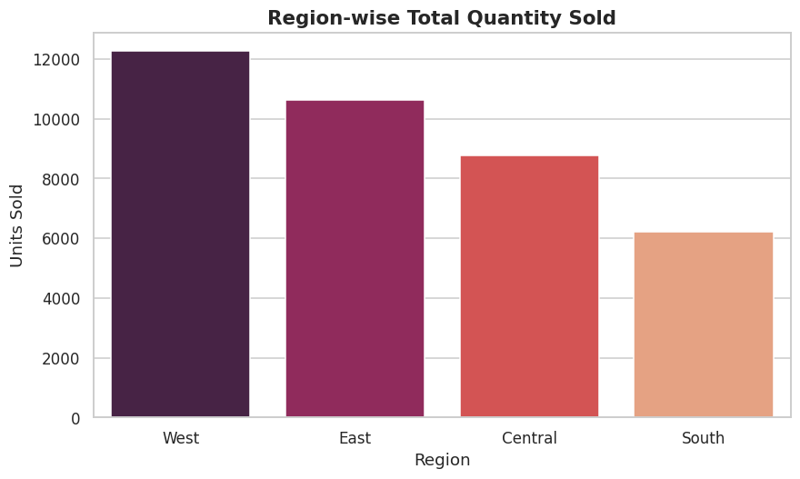
Figure 6. Total units sold by region.
The West region leads on both metrics ($725K in sales, 12,266 units), while South trails on both — a clear candidate for a regional growth initiative.

4.7 Seasonal Demand Patterns
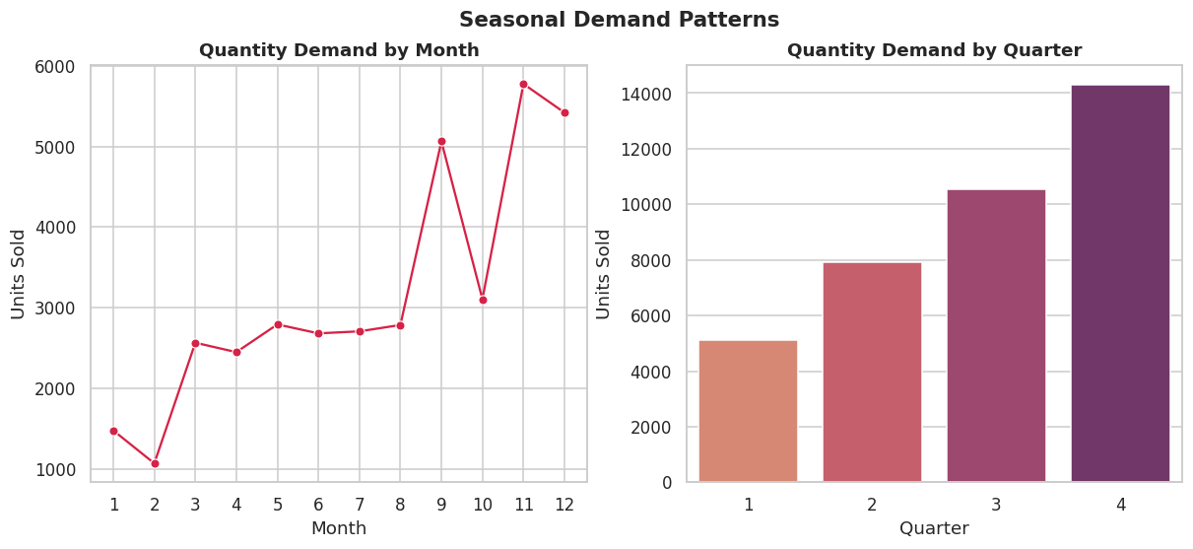
Figure 7. Quantity demand by month and by quarter.
Q4 consistently records the highest unit demand across all years — the most reliable planning signal in the dataset, and the basis for the inventory recommendations in Section 7.

4.8 Correlation Heatmap
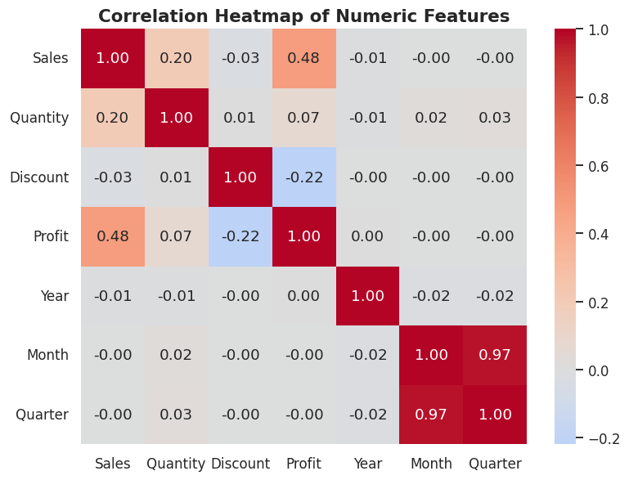
Figure 8. Correlation matrix of numeric features.
Sales and Profit are positively correlated, but Discount shows a negative correlation with Profit — heavy discounting is eroding margin, a pattern explored further in Section 4.12.

4.9 Sales Distribution
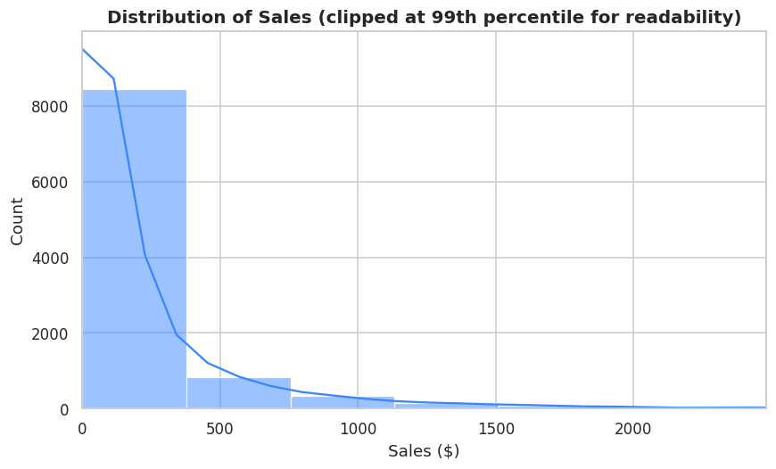
Figure 9. Distribution of order-line Sales value (clipped at 99th percentile).
Sales are heavily right-skewed: most order lines are low-to-moderate value, with a long tail of high-value bulk/technology purchases — motivating the use of tree-based models, which are naturally robust to skewed features.

4.10 Quantity Distribution
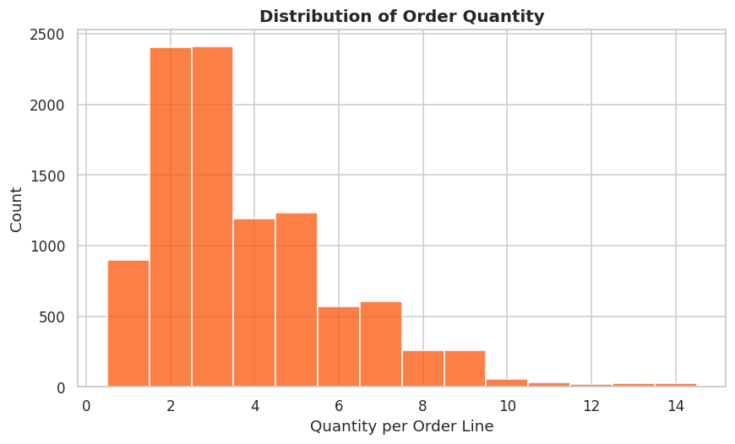
Figure 10. Distribution of order quantity per line item.
Most order lines involve 2–5 units; large single orders (10+ units) are rare. Demand is therefore driven far more by order frequency than by large individual orders — a pattern later confirmed by the Random Forest feature importance analysis.

4.11 Sales vs Profit by Sub-Category
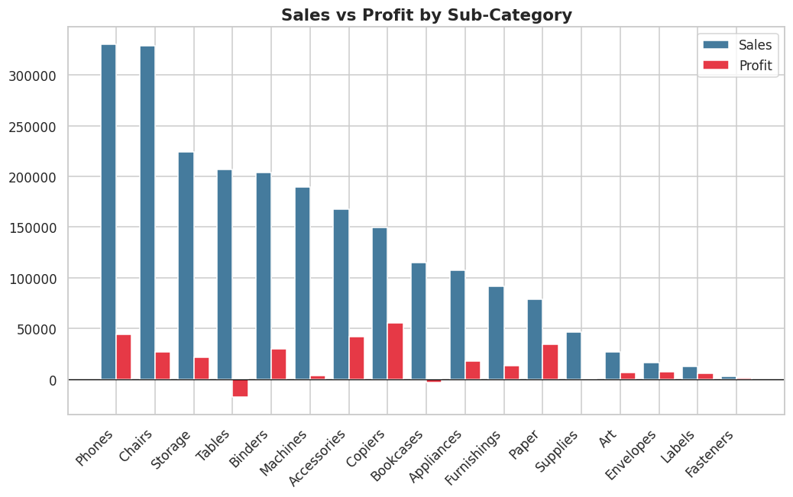
Figure 11. Total sales and profit by product sub-category.
Tables and Bookcases generate meaningful sales but negative aggregate profit, while Copiers is the strongest profit contributor relative to its sales volume.

4.12 Discount vs Profit
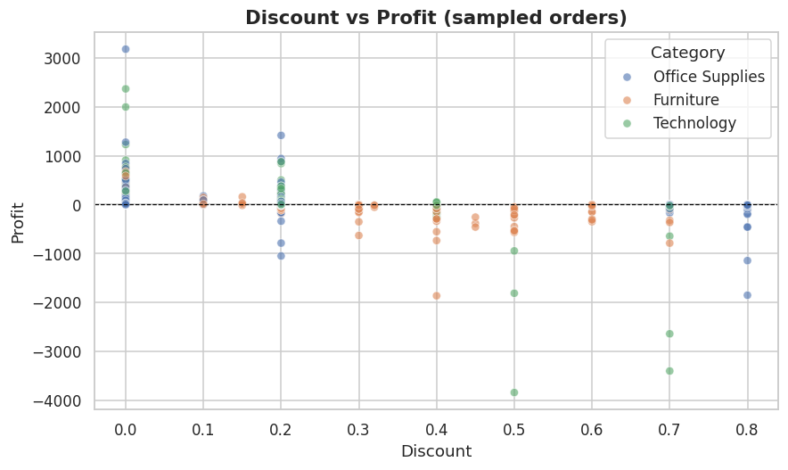
Figure 12. Discount level vs profit for a sample of orders, colored by category.
Profit turns negative almost universally once discounts exceed roughly 30%, regardless of category — a strong, actionable signal for setting a discounting ceiling policy.

4.13 Segment-wise Sales
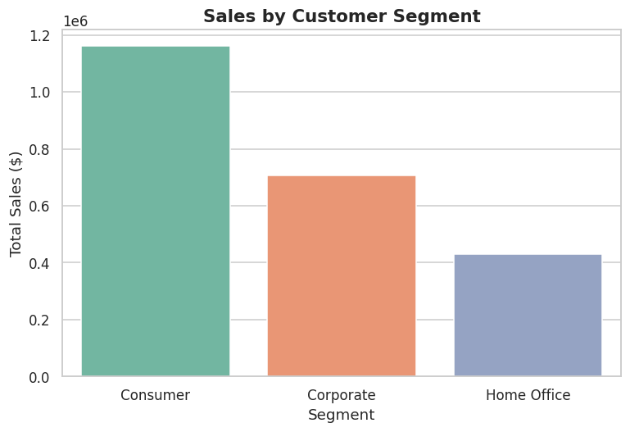
Figure 13. Total sales by customer segment.
The Consumer segment is the largest revenue driver, ahead of Corporate and Home Office — relevant for prioritizing customer support and marketing budget allocation.

5. Machine Learning Methodology

5.1 Problem Framing
Inventory planners need to forecast unit demand for a given product line, region, and time period — not the quantity on a single invoice line. The transactional data was therefore aggregated to a (Category, Sub-Category, Region, Segment, Year, Month) grain, producing a modeling table where each row represents "how many units of a given sub-category were demanded in a given region during a given month" — precisely the granularity a replenishment system needs to plan against.

5.2 Feature Engineering
- Categorical encoding: Category, Sub-Category, Region, and Segment were label-encoded.
- Cyclical month encoding: Month was transformed into sine/cosine components to represent seasonality without a false linear ordering (December is 'close to' January).
- Derived features: AvgSalesPerOrder (Sales ÷ Orders) and ProfitMargin (Profit ÷ Sales) were engineered to capture order economics beyond raw totals.
- Temporal features: Year and Quarter were retained directly to capture trend and business-cycle effects.

5.3 Train/Test Split
The aggregated modeling table was split 80/20 into training and test sets using a fixed random seed (42) for reproducibility.

5.4 Models Trained
- Linear Regression — a simple, interpretable baseline that assumes additive, linear relationships between features and demand.
- Random Forest Regressor (300 trees, max depth 12) — a non-linear ensemble model capable of capturing interactions between category, region, season, and order behavior.

6. Model Results & Evaluation

6.1 Evaluation Metrics
Models were evaluated on the held-out test set using three standard regression metrics: Mean Absolute Error (MAE), Root Mean Squared Error (RMSE), and R² (coefficient of determination).
Model | MAE | RMSE | R²
Linear Regression | 2.608 | 3.504 | 0.762
Random Forest Regressor | 2.467 | 3.445 | 0.770
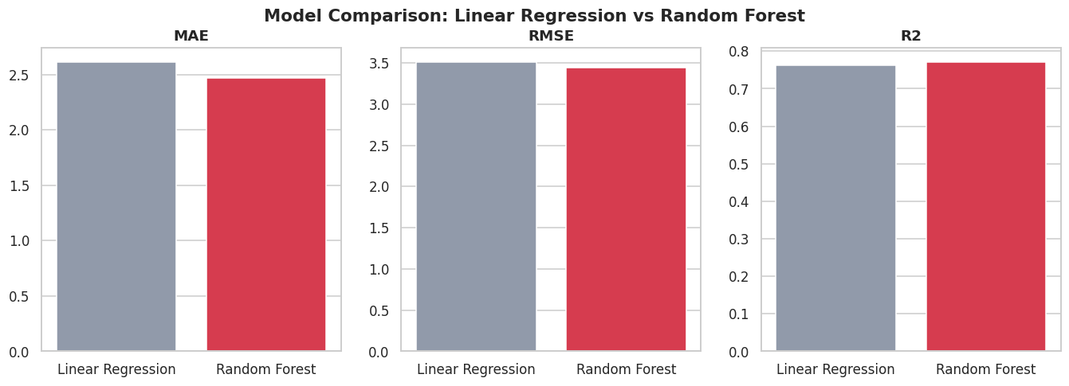
Figure 14. Side-by-side comparison of MAE, RMSE, and R² for both models.
The Random Forest Regressor outperforms Linear Regression on every metric — lower error (MAE, RMSE) and higher explanatory power (R²) — confirming that unit demand depends on non-linear interactions (e.g., category × region × season) that a purely linear model cannot fully capture.

6.2 Predicted vs Actual Demand
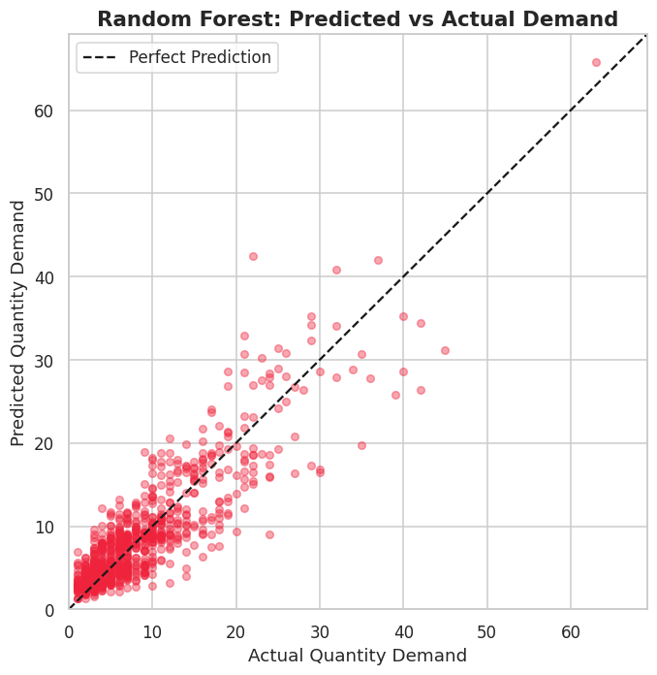
Figure 15. Random Forest predicted vs actual demand on the test set.
Points cluster tightly around the diagonal (perfect-prediction) line across the full range of demand values, with no systematic bias toward over- or under-prediction at either the low or high end.

6.3 Feature Importance
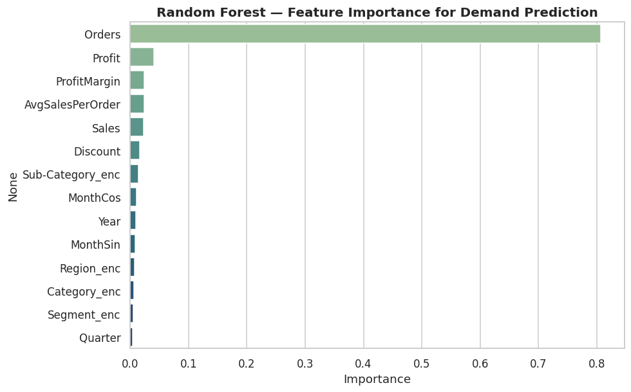
Figure 16. Random Forest feature importance for demand prediction.
The number of distinct orders placed in a given Category/Region/month is by far the strongest predictor of unit demand — more influential than revenue or profit. This confirms that order frequency, not order size, is the primary demand driver, and should shape how inventory reorder triggers are designed.

7. Business Insights & Recommendations

7.1 Best-Performing Products
The top five products by revenue are dominated by high-ticket Technology items:
Product | Total Sales ($)
Canon imageCLASS 2200 Advanced Copier | $61,599.82
Fellowes PB500 Electric Punch Plastic Comb Binding Machine with Manual Bind | $27,453.38
Cisco TelePresence System EX90 Videoconferencing Unit | $22,638.48
HON 5400 Series Task Chairs for Big and Tall | $21,870.58
GBC DocuBind TL300 Electric Binding System | $19,823.48

7.2 Worst-Performing Products
The following products generated minimal revenue over the four-year period and are candidates for bundling, repricing, or discontinuation review:
Product | Total Sales ($)
Eureka Disposable Bags for Sanitaire Vibra Groomer I Upright Vac | $1.62
Avery 5 | $5.76
Xerox 20 | $6.48
Grip Seal Envelopes | $7.07
Avery Hi-Liter Pen Style Six-Color Fluorescent Set | $7.7

7.3 Best- and Worst-Performing Regions
The West region leads in both revenue ($725K) and unit volume (12,266 units) and should receive continued priority for warehouse stocking and marketing investment. The South region trails on both metrics and warrants a focused sales and marketing audit.

7.4 Seasonal Demand Observations
Demand peaks sharply and consistently in Q4 (November–December) every year of the dataset. This is the single most reliable planning signal available and should directly drive Q3 procurement timing.

7.5 Inventory Optimization Suggestions
- Build safety stock for Technology and Office Supplies ahead of Q4, based on the observed seasonal uplift.
- Use the Random Forest model's Category × Region monthly demand forecast to set reorder points at least one month in advance of anticipated demand.
- De-prioritize warehouse space for chronically loss-making sub-categories (e.g. Tables) unless a pricing or discount policy change is implemented first.

7.6 Revenue Improvement Suggestions
- Cap discounts on categories where profit turns negative beyond roughly 30% discount — this threshold is actively destroying margin.
- Bundle low-revenue consumables with high-revenue Technology purchases to lift average order value.
- Invest disproportionately in the West region's proven demand while running a targeted campaign to lift the South region's volume.

8. Conclusion
This project delivered a complete data science workflow — from raw transactional e-commerce data to a validated, business-ready demand prediction model. After thorough cleaning and thirteen exploratory visualizations, two regression models were built and compared for forecasting monthly unit demand at the category/region level. The Random Forest Regressor outperformed Linear Regression across all three evaluation metrics (MAE, RMSE, R²), confirming that demand is shaped by non-linear interactions between seasonality, category, region, and order behavior rather than by any single linear driver.
The resulting model and insights — particularly the dominance of order frequency as a demand driver and the sharp Q4 seasonal uplift — provide a directly actionable foundation for inventory optimization, including reorder timing, regional stock allocation, and discount policy review.

8.1 Future Improvements
- Incorporate external signals (holidays, marketing calendars, promotions, competitor pricing) to sharpen forecast accuracy.
- Move to weekly-level granularity for tighter inventory cycles.
- Benchmark against gradient boosting methods (XGBoost, LightGBM) and time-series models (SARIMA, Prophet).
- Deploy the trained model as a lightweight forecasting API integrated with the inventory management system.

8.2 Tools & Technologies Used
Python 3, Pandas, NumPy, Matplotlib, Seaborn, Scikit-learn, Jupyter Notebook.

