SALESTORM 2026
SYSCRAFTERS — COMPLETE SYSTEM DESIGN DOCUMENTATION
PHASE I → PHASE V + ALL FINAL DELIVERABLES
High-Scale E-Commerce Flash Sale | Design-First, AI-Assisted
Challenge | Target
Concurrent purchase requests | 10,000
Available units | 100
Primary guarantee | Never oversell
Required reliability | Idempotent payment/order + failure recovery
Design principle | Design first; code is optional validation

1. Problem Statement & Business Objectives
SALESTORM is a high-volume e-commerce flash-sale platform. Thousands of customers may attempt to buy a limited-stock product simultaneously. The architecture must scale traffic, protect inventory, process payments safely and maintain a correct order lifecycle when services or external dependencies fail.
- Support 10,000 simultaneous purchase attempts for 100 available units.
- Prevent overselling, duplicate reservations, duplicate payments and duplicate orders.
- Support temporary inventory reservations with expiry/release.
- Recover safely from payment timeout/failure and Order Service outages.
- Scale horizontally and provide measurable observability.

2. Requirements, Assumptions & NFRs
Area | Requirement
Functional | Product discovery → cart → inventory check/reservation → checkout → payment → order → fulfilment/shipment/notification.
Inventory | available + reserved + sold = total stock; no negative stock.
Reservation | RESERVED with expiry; release on timeout/payment failure.
Payment | Success, failure, timeout and duplicate requests must have deterministic handling.
Order | CREATED → PAYMENT_PENDING → CONFIRMED → PROCESSING → SHIPPED → OUT_FOR_DELIVERY → DELIVERED.
Scale | Approximately 10,000 req/s normal traffic; architecture should reason about up to 500,000 req/s flash-sale traffic.
Security | HTTPS, authentication/authorization, rate limiting, validation, secure payment handling, audit logs and secrets management.
Observability | Metrics, structured logs, distributed traces and alerts.

3. Phase I — System Context & HLD
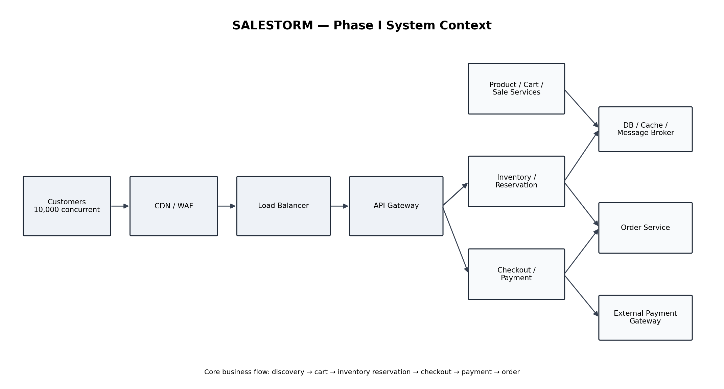
Figure 1 — System context.
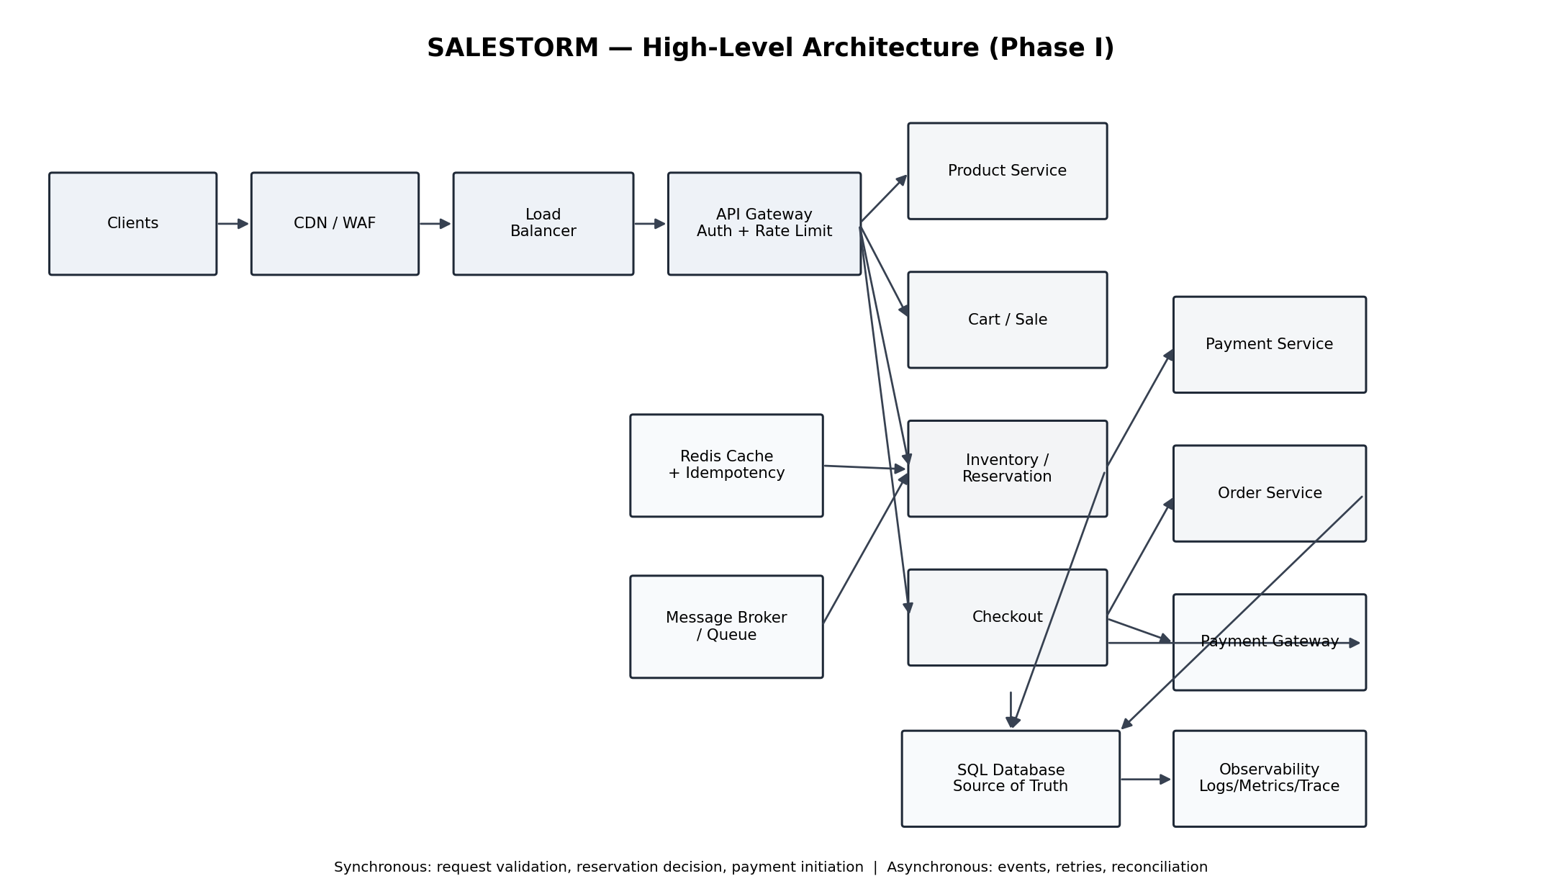
Figure 2 — High-level architecture.
Component | Responsibility
CDN/WAF | Edge caching and abuse/DDoS protection.
Load Balancer | Horizontal distribution of stateless instances.
API Gateway | Routing, authentication, authorization and rate limiting.
Product/Cart/Sale | Read-heavy catalogue, cart and promotion operations.
Inventory/Reservation | Only authority for stock mutations.
Checkout | Coordinates reservation and payment initiation.
Payment | Gateway integration, idempotency and reconciliation.
Order | Owns order lifecycle.
Message Broker | Events, retries and asynchronous recovery.
SQL Database | Transactional source of truth.
Redis | Cache and fast idempotency/result lookup; not authoritative inventory.

4. Container & Communication Design
Interaction | Mode | Reason
Product read | Sync | Customer needs immediate result; cacheable.
Reservation decision | Sync command | Customer needs reservation outcome.
Payment initiation | Sync | Checkout needs provider initiation/result.
PaymentSucceeded → Order | Async | Decouples services and enables recovery.
Reservation expiry | Async | Background lifecycle work.
Notifications/fulfilment | Async | Not required to block checkout.

5. Phase II — High Concurrency & Inventory Reservation
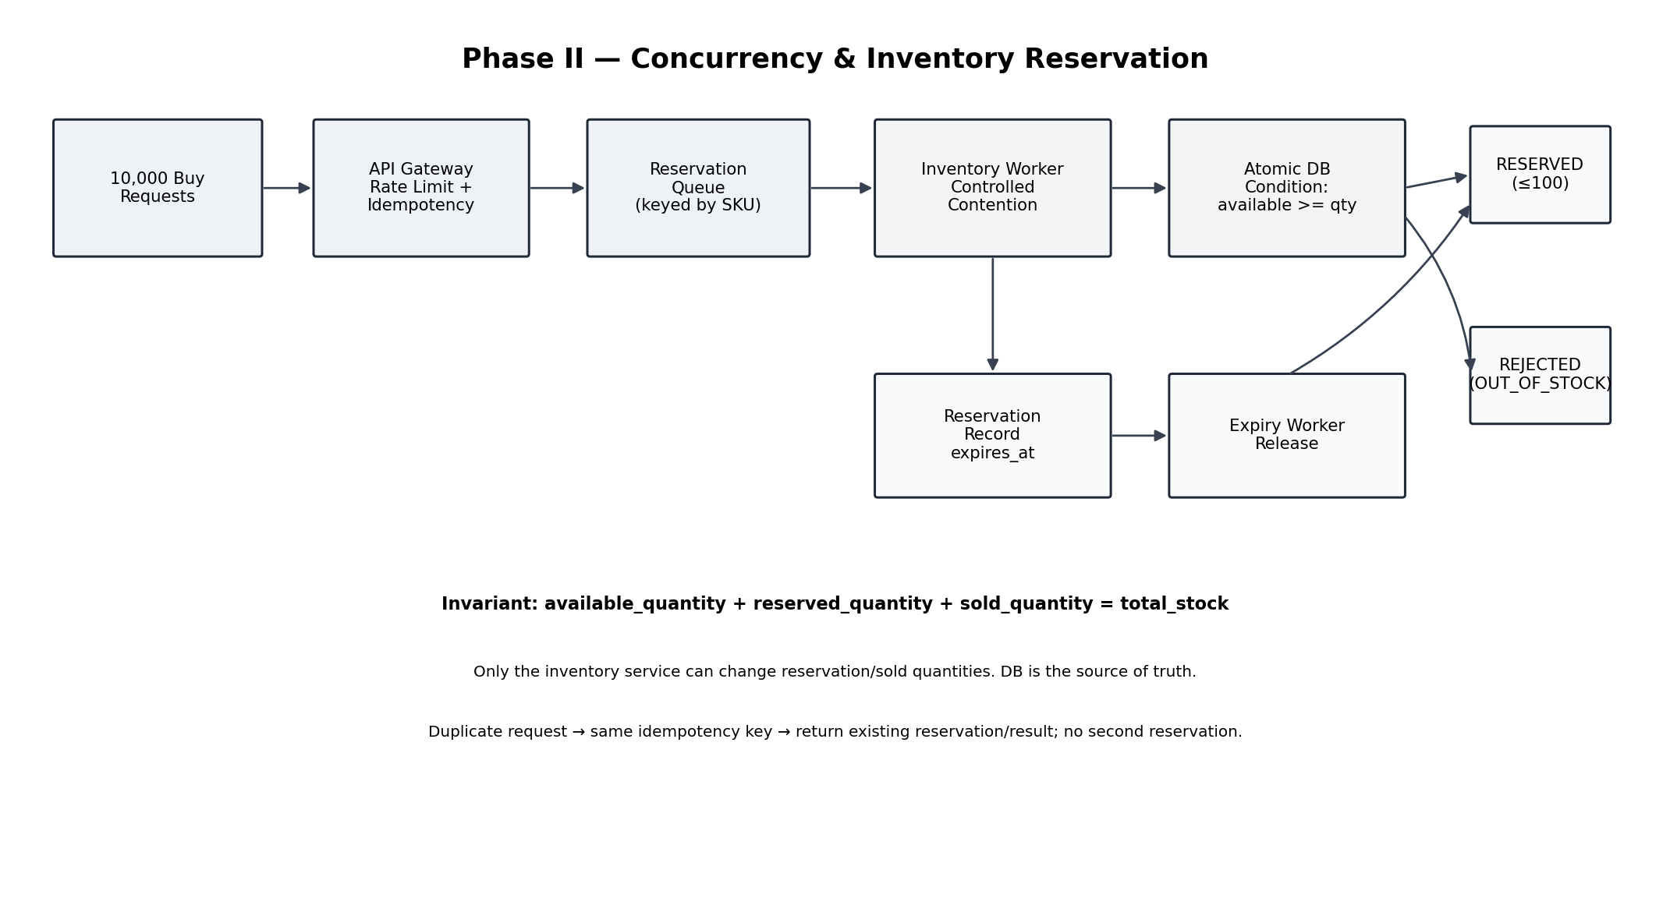
Figure 3 — Controlled contention and inventory reservation.
- Every mutating reservation request carries an idempotency key.
- Reservation commands are queued/partitioned by product/SKU to control hot-row contention.
- Inventory worker executes a short SQL transaction.
- Atomic conditional update succeeds only when available_quantity >= requested quantity.
- Reservation is created in the same transaction.
- Zero affected rows means OUT_OF_STOCK / RESERVATION_FAILED.
- Expired or failed reservations release inventory transactionally.
Concurrency approach | Strength | Weakness | Decision
Optimistic locking | Simple version check | Hot SKU causes retries | Alternative
Pessimistic locking | Simple serialization | Hot-row lock contention | Alternative
Atomic update + controlled queue | Short transaction + controlled contention | Queue/idempotency complexity | RECOMMENDED

6. Database / ER Design
Entity | Important fields / constraints
CUSTOMER | customer_id
PRODUCT | product_id, category_id
INVENTORY | inventory_id, product_id, available_quantity, reserved_quantity, sold_quantity, version, updated_at
INVENTORY_RESERVATION | reservation_id, product_id, quantity, status, expires_at, idempotency_key; unique idempotency key
CART / CART_ITEM | cart_id, customer_id, product_id, quantity
ORDER / ORDER_ITEM | order_id, customer_id, reservation_id, payment_id, status, line items
PAYMENT | payment_id, order_id, provider_transaction_id, idempotency_key, status; unique provider transaction
SHIPMENT | shipment_id, order_id, tracking/status
NOTIFICATION | notification_id, order_id/customer_id, type, status
SALE / DEAL / COUPON | promotion rules
OUTBOX_EVENT | event_id, aggregate_id, event_type, payload, processing status

Database requirements include primary/foreign keys, indexes, constraints, transaction boundaries, concurrency control, consistency and audit information.

7. Purchase / Reservation Sequence
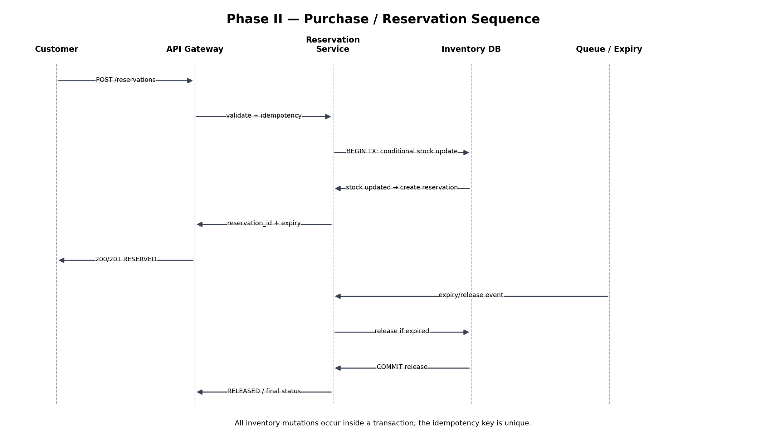
Figure 4 — Reservation sequence. The database transaction is the final correctness boundary.

8. Phase III — Payment Reliability
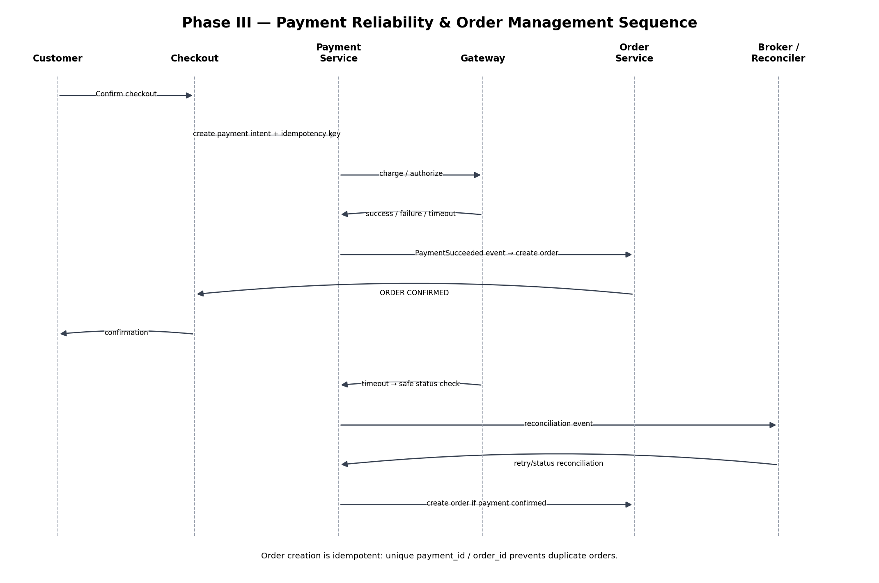
Scenario | Required response
Payment succeeds | Persist success and trigger order creation.
Payment fails | Mark failure and release reservation.
Payment timeout | Reconcile provider status before retry; never blindly charge again.
Duplicate payment | Idempotency key + unique transaction reference.
Payment succeeds; Order Service fails | Durable PaymentSucceeded event + retry/reconciliation + idempotent order creation.
Gateway unstable | Circuit breaker and safe pending/reconciliation path.

9. Order Lifecycle & State Design
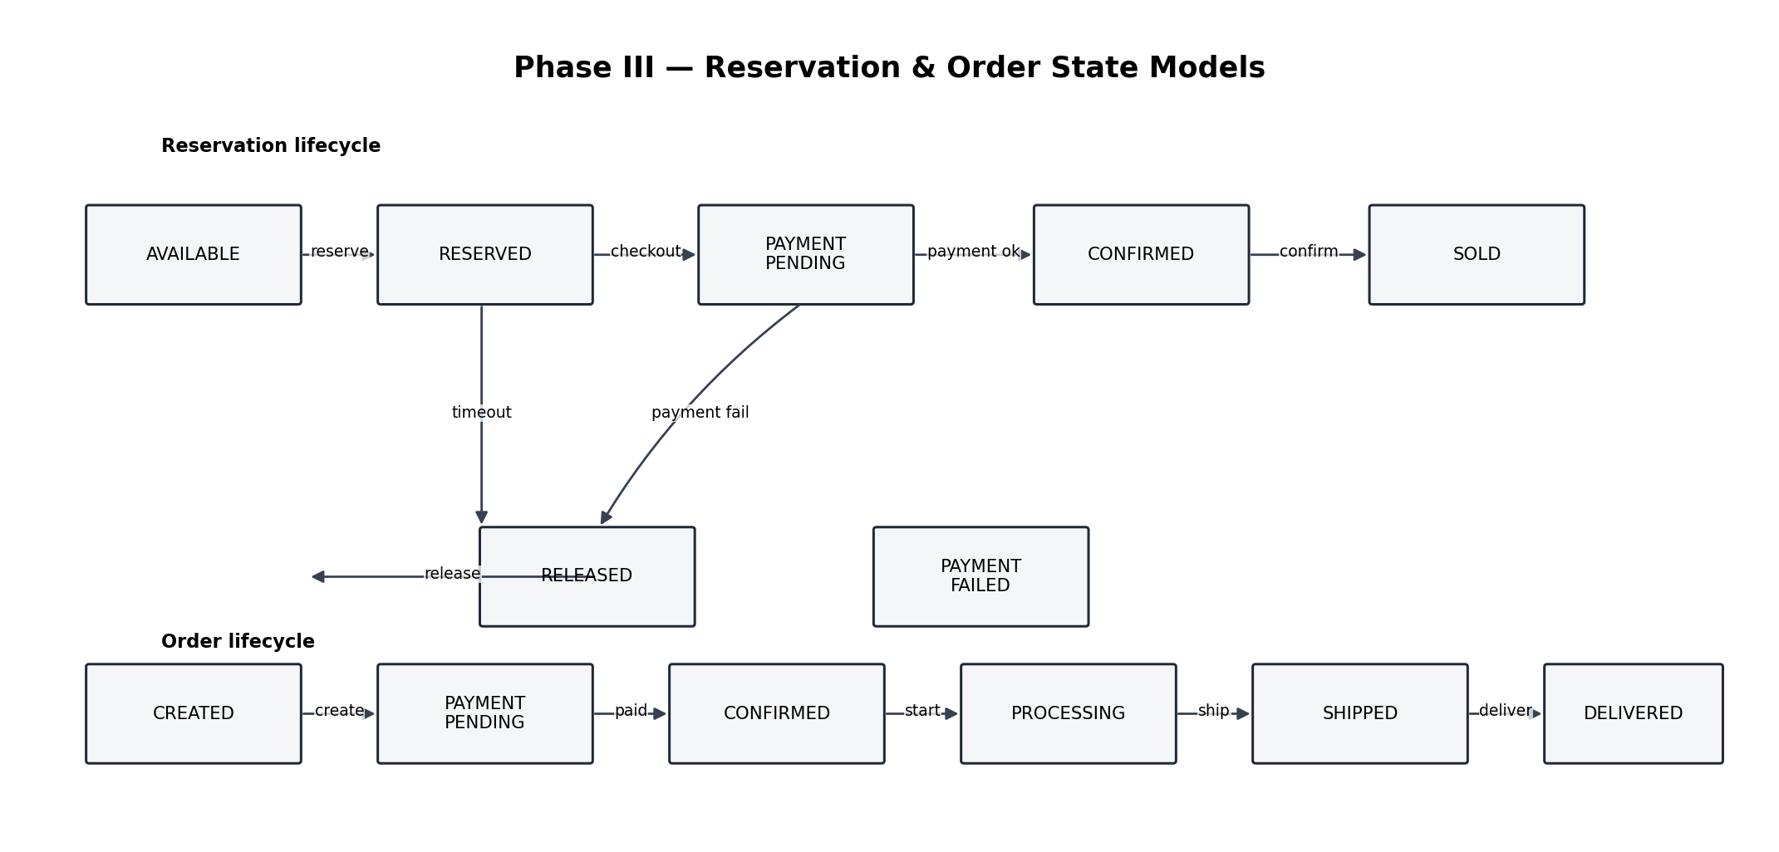
Reservation: AVAILABLE → RESERVED → PAYMENT_PENDING → CONFIRMED → SOLD. Failure: RESERVED → PAYMENT_FAILED/TIMEOUT → RELEASED.
Order: CREATED → PAYMENT_PENDING → CONFIRMED → PROCESSING → SHIPPED → OUT_FOR_DELIVERY → DELIVERED.

10. API Specification
Method | Endpoint | Purpose | Idempotency
GET | /products/{id} | Product discovery | No
POST | /reservations | Reserve stock | Required
GET | /reservations/{id} | Reservation status | No
POST | /checkout | Start checkout | Required
POST | /payments/{id}/confirm | Provider confirmation | Yes
GET | /payments/{id} | Payment status | No
POST | /orders | Create order | Required
GET | /orders/{id} | Order status | No

11. Phase IV — Low-Level Design
The brief requires at least three critical modules, preferably Inventory, Payment and Order.
Class / Interface | Responsibility
ReservationService | Reserve, release, confirm.
InventoryRepository | Atomic stock mutation and persistence.
PaymentService | Payment orchestration/reconciliation.
PaymentStrategy | Payment provider abstraction.
PaymentGatewayAdapter | Adapts external provider API.
OrderService | Create and transition orders.
OrderRepository | Order persistence.
IdempotencyService | Detect and persist duplicate-request results.
EventPublisher | Publish/retry domain events.

Class-level UML can be represented with the modules above; the Phase IV implementation should preserve these boundaries.

12. SOLID Mapping
Principle | Application
SRP | Separate payment, inventory, order and notification responsibilities.
OCP | Add payment/pricing strategies without changing core orchestration.
LSP | Payment providers remain substitutable behind an abstraction.
ISP | Focused interfaces instead of one large service interface.
DIP | Services depend on repository/gateway/event abstractions.

13. Design Patterns
Pattern | SALESTORM use
Strategy | Payment/pricing/delivery selection.
Factory | Create payment provider objects.
State | Reservation/order lifecycle.
Observer | Domain events and notifications.
Adapter | External payment/delivery providers.
Repository | Persistence abstraction.
Facade | Checkout orchestration.
Circuit Breaker | Protect from failing external services.

14. Phase V — Stress Scenarios & Jury Challenge
Scenario | Expected outcome
100 stock / 10,000 users | ≤100 successful one-unit reservations.
95% payment success / 5% failure | Failures release reservations; successes eventually create orders.
2% duplicate requests | No duplicate reservation/payment/order.
Order Service unavailable 30 seconds | Payment remains durable; event backlog retries after recovery.
Inventory reaches zero | Subsequent requests deterministically fail.
50× traffic increase | Scale edge/API/worker tiers; queue hot SKU; protect DB.
DB failure | Fail safely and recover/reconcile.
Payment gateway failure | Circuit breaker + safe reconciliation.

15. Scalability & Bottleneck Design
- Scale stateless API services horizontally.
- Use CDN/Redis for read-heavy product/catalog traffic.
- Use load balancing and autoscaling.
- Queue hot-SKU reservations to prevent a database stampede.
- Monitor queue depth and consumer lag.
- Use database replicas/read scaling for suitable read workloads; keep inventory writes authoritative.
- Keep transactions short and avoid distributed locks across services.
- At 50× traffic, increase edge/API capacity first while preserving the same inventory correctness boundary.

16. Reliability & Failure Handling
Failure | Recovery
Service timeout | Bounded retry for idempotent operations.
Payment timeout | Status reconciliation before retry.
Circuit breaker open | Fail fast/safe pending path until dependency recovers.
Dead-letter message | Quarantine and manual/automated replay after correction.
Duplicate message | Idempotent consumer using event/request ID.
Distributed workflow failure | Compensation or reconciliation.
Database outage | Safe failure, retry only when idempotent, reconcile after recovery.

17. Security & Observability
- Authentication and authorization.
- HTTPS and secure API communication.
- Rate limiting and abuse protection.
- Input validation.
- Secure payment handling/tokenization.
- Secrets management and audit logging.
- Metrics: request rate, p95/p99 latency, error rate, reservation failures, payment failures, order conversion.
- Structured logs for critical business events.
- Distributed tracing across checkout → inventory → payment → order.
- Alerts for inventory inconsistency, payment failure spikes, queue backlog and DB saturation.

18. Architecture Decision Records
ADR | Decision | Trade-off
ADR-001 | SQL is inventory source of truth | Consistency over maximum write availability.
ADR-002 | Product-keyed reservation queue | Better burst control but adds queue complexity.
ADR-003 | Atomic conditional update | Strong correctness at DB boundary.
ADR-004 | Durable idempotency | Storage/cleanup complexity for duplicate safety.
ADR-005 | Async PaymentSucceeded | Eventual consistency in exchange for recovery.
ADR-006 | Circuit breaker | Requires tuning and monitoring.
ADR-007 | Cache reads, not authoritative stock | Scale without weakening correctness.

19. AI-Assisted Prototype / Validation
The brief permits AI-assisted boilerplate, API stubs, tests, concurrency data, load-test scripts, simulations, documentation and UML. AI must not replace requirements analysis, architecture selection, concurrency reasoning, consistency decisions, trade-off analysis, security/reliability decisions or the final technical explanation.
Validation | Evidence to produce
Concurrency | 10,000 reservation attempts, stock=100, successful reservations ≤100.
Idempotency | Repeated same key returns same result.
Expiry | Expired reservation restores available stock.
Payment timeout | No duplicate charge after reconciliation.
Order outage | 30-sec outage followed by eventual exactly-once logical order creation.
50× traffic | Report throughput, latency, errors and queue behaviour.

AI-use note: record tool name, purpose, prompts used, generated artefacts, validation performed and corrections made. Every team member must understand the generated artefact.

20. Final 5-Minute Pitch
Time | Content
30 sec | Problem — industry need and flash-sale challenge.
30 sec | Requirements — functional, NFRs and constraints.
60 sec | HLD — architecture and major decisions.
60 sec | Critical design — 10,000 customers competing for 100 units.
45 sec | Payment + Order — success, failure and recovery.
45 sec | LLD + SOLID + Patterns — one critical module.
30 sec | Scalability, reliability and AI validation.

Core jury answer: requests enter through WAF/load balancing/API Gateway, receive idempotency protection, and enter a product-keyed reservation path. An atomic SQL condition permits at most 100 units to be reserved. Successful reservations proceed to idempotent payment. Payment success emits a durable event; Order Service creates the order idempotently. Payment failure/timeout releases or reconciles safely. If Order Service is down, the event is retried after recovery without charging again.

21. Team Roles
Student | Primary ownership
Student 1 — System Architect | HLD, architecture, scalability, deployment.
Student 2 — LLD & Design Engineer | LLD, UML, SOLID, design patterns.
Student 3 — Data/API & Reliability Engineer | Database, APIs, events, concurrency, security, recovery.

All team members should understand the complete architecture because the brief states that any member may be questioned on any module.

22. Complete Mandatory Deliverables Checklist
# | Deliverable | Covered
1 | Requirements & Assumptions | YES
2 | System Context Diagram | YES
3 | HLD Architecture | YES
4 | Container Diagram | YES
5 | Component Diagram | YES
6 | Deployment Diagram | YES
7 | Database / ER Diagram | YES
8 | Class Diagram | YES
9 | Purchase / Reservation Sequence | YES
10 | Payment Sequence | YES
11 | Order Sequence | YES
12 | Order / Reservation State | YES
13 | SOLID Mapping | YES
14 | Design Pattern Mapping | YES
15 | API Specification | YES
16 | Scalability & Reliability | YES
17 | Security & Observability | YES
18 | ADR | YES
19 | AI Prototype / Simulation Evidence | TEST PLAN INCLUDED
20 | AI Usage Note | TEMPLATE INCLUDED
21 | Final Presentation | PITCH INCLUDED

23. Submission Folder Structure
SALESTORM_TEAM_NAME/
01_Requirements/
02_HLD/
03_LLD/
04_Database/
05_API/
06_SOLID/
07_Design_Patterns/
08_Scalability_Reliability/
09_Security_Observability/
10_ADR/
11_AI_Assisted_Validation/
12_Presentation/
README.md

24. Source Alignment
This documentation follows the supplied SALESTORM brief: the business scenario and required pipeline; 10,000 concurrent requests for 100 units; inventory reservation and payment challenges; mandatory diagrams and deliverables; LLD/SOLID/design-pattern requirements; security, scalability and observability; ADRs; AI-use policy; stress scenarios; team roles; evaluation and final-pitch structure.
The brief explicitly says the primary evaluation is system design quality and that production implementation is not required. The complete deliverable list is specified in the brief's Deliverables section, while the practical evaluation focuses on high-concurrency HLD, inventory consistency, payment/order workflow and stress/architecture defense.

