AWS CLOUD COMPUTING – ROUND 2 & ROUND 3

1. Create the Amazon S3 Storage Bucket
S3 Console
- Open the AWS Management Console and search for S3.
- Click Create bucket.
- Enter a globally unique bucket name, for example: nivash-cloud-storage-2026.
- Select the required AWS Region.
- Keep Block all public access enabled.
- Enable Bucket Versioning.
- Keep Default Encryption enabled and select SSE-S3.
- Click Create bucket.
- Open the bucket, click Upload, and upload a sample file.

2. Create the EC2 Security Group
EC2 Console → Security Groups
- Open EC2 and select Security Groups.
- Click Create security group.
- Enter the name WebServer-SG.
- Select the VPC created earlier.
- Add an inbound SSH rule on port 22 with Source = My IP.
- Add an inbound HTTP rule on port 80 with Source = 0.0.0.0/0.
- Keep outbound traffic allowed.
- Click Create security group.

3. Launch the EC2 Web Server
EC2 Console → Instances
- Click Launch instance.
- Enter the instance name Cloud-Web-Server.
- Select an Amazon Linux AMI.
- Choose the required instance type, such as t2.micro/t3.micro if available.
- Select or create a key pair.
- Under Network settings, select the previously created VPC.
- Select the Public Subnet.
- Enable Auto-assign Public IP.
- Select WebServer-SG.
- Click Launch instance.

4. Install and Configure the Web Server
EC2 → Connect → EC2 Instance Connect
- Select the running EC2 instance.
- Click Connect and choose EC2 Instance Connect.
- Connect to the instance.
- Run: sudo dnf update -y
- Run: sudo dnf install -y httpd
- Start Apache: sudo systemctl start httpd
- Enable Apache at boot: sudo systemctl enable httpd
- Create a test page: echo "<h1>AWS Cloud Web Server Working</h1>" | sudo tee /var/www/html/index.html
- Open the EC2 Public IPv4 address in a browser.

5. Create the RDS MySQL Database
RDS Console
- Open RDS and click Create database.
- Select Standard create.
- Choose MySQL.
- Select the appropriate template, such as Free Tier if available.
- Enter DB identifier: cloud-mysql-db.
- Create the master username, for example admin.
- Set a strong password.
- Under Connectivity, select the existing VPC.
- Select the DB subnet group containing the private DB subnets.
- Set Public access to No.
- Set database port to 3306.
- Select or create the RDS Security Group.
- Click Create database.

6. Configure the RDS Security Group
EC2 Console → Security Groups
- Open Security Groups.
- Select the security group attached to RDS.
- Click Edit inbound rules.
- Add MySQL/Aurora TCP port 3306.
- Set Source to WebServer-SG instead of a public CIDR.
- Save the inbound rules.

7. Verify VPC Routing
VPC Console → Route Tables
- Open VPC → Route Tables.
- Identify the route table associated with the EC2 subnet.
- Verify the required local VPC route provides connectivity toward the RDS private subnet.
- Confirm the RDS subnet is associated with the correct private route table.
- Check the Network ACLs associated with both subnets.

8. Test DNS Connectivity from EC2
EC2 → Connect → EC2 Instance Connect
- Open the EC2 terminal.
- Run: nslookup <RDS-ENDPOINT>
- Replace <RDS-ENDPOINT> with the actual RDS endpoint.

9. Test Port 3306 Connectivity
EC2 Terminal
- Run: nc -zv <RDS-ENDPOINT> 3306.
- Use the actual RDS endpoint in place of <RDS-ENDPOINT>.
- Use VPC Reachability Analyzer if the connection fails.

10. Install the MySQL Client on EC2
EC2 Terminal
- Run: sudo dnf install -y mariadb105.
- If that package is unavailable for the selected Amazon Linux version, install the available MariaDB/MySQL-compatible client package from the configured repository.
- Run: mysql --version to verify the client.

11. Connect EC2 to RDS MySQL
EC2 Terminal
- Run: mysql -h <RDS-ENDPOINT> -P 3306 -u admin -p.
- Enter the RDS master password when prompted.
- Run: SHOW DATABASES;.

12. Create a Database and Table
MySQL Prompt
- Run: CREATE DATABASE cloudapp;
- Run: USE cloudapp;
- Create a table: CREATE TABLE students (id INT PRIMARY KEY AUTO_INCREMENT, name VARCHAR(100), department VARCHAR(50));
- Insert a record: INSERT INTO students (name, department) VALUES ('Nivash', 'AIML');
- Run: SELECT * FROM students;

13. Store Database Credentials in AWS Secrets Manager
AWS Secrets Manager
- Open Secrets Manager.
- Click Store a new secret.
- Select Credentials for RDS database.
- Enter the database username and password.
- Select the RDS database.
- Enter a secret name such as cloudapp/rds/mysql.
- Click Store.

14. Configure the Application to Use RDS
EC2 Web Application
- Configure the application to obtain database credentials from AWS Secrets Manager.
- Use the RDS endpoint and port 3306 for the database connection.
- Use the database name cloudapp.
- Ensure credentials are not stored directly in source code.
- Restart the application if required after changing its configuration.

15. Integrate S3 with the Application
EC2 Web Application + S3
- Configure the application to access the S3 bucket.
- Upload a file through the application or AWS interface.
- Verify that the file reaches the S3 bucket.
- Use RDS for structured application data.
- Confirm that S3 and RDS operations work independently and together.

16. Test the Complete End-to-End Application
Browser + EC2 Terminal
- Open http://<EC2-Public-IP> in a browser.
- Verify that the web application loads.
- Run nc -zv <RDS-ENDPOINT> 3306 from EC2.
- Connect using mysql -h <RDS-ENDPOINT> -u admin -p.
- Run USE cloudapp; and SELECT * FROM students;.
- Upload and retrieve a sample file through S3.
- Verify that the complete user-to-application-to-database/storage flow works.

17. Enable CloudWatch Monitoring
CloudWatch Console
- Open CloudWatch.
- Check EC2 monitoring metrics.
- Check RDS metrics such as CPU utilization, database connections, free storage, and read/write activity.
- Check application/system logs where configured.
- Create CloudWatch alarms if required by the experiment.

18. Perform Final Troubleshooting
AWS Console + EC2 Terminal
- For a 30-second timeout, first verify the RDS endpoint and DNS.
- Check TCP port 3306 connectivity.
- Check the EC2 Security Group and RDS Security Group.
- Check Route Tables and Network ACLs.
- Confirm that RDS is available and not publicly exposed unnecessarily.
- For Access denied, verify username, password, Secrets Manager, and MySQL privileges.
- For Unknown database, run SHOW DATABASES; and verify the application database name.
- Use VPC Reachability Analyzer to identify network path problems.

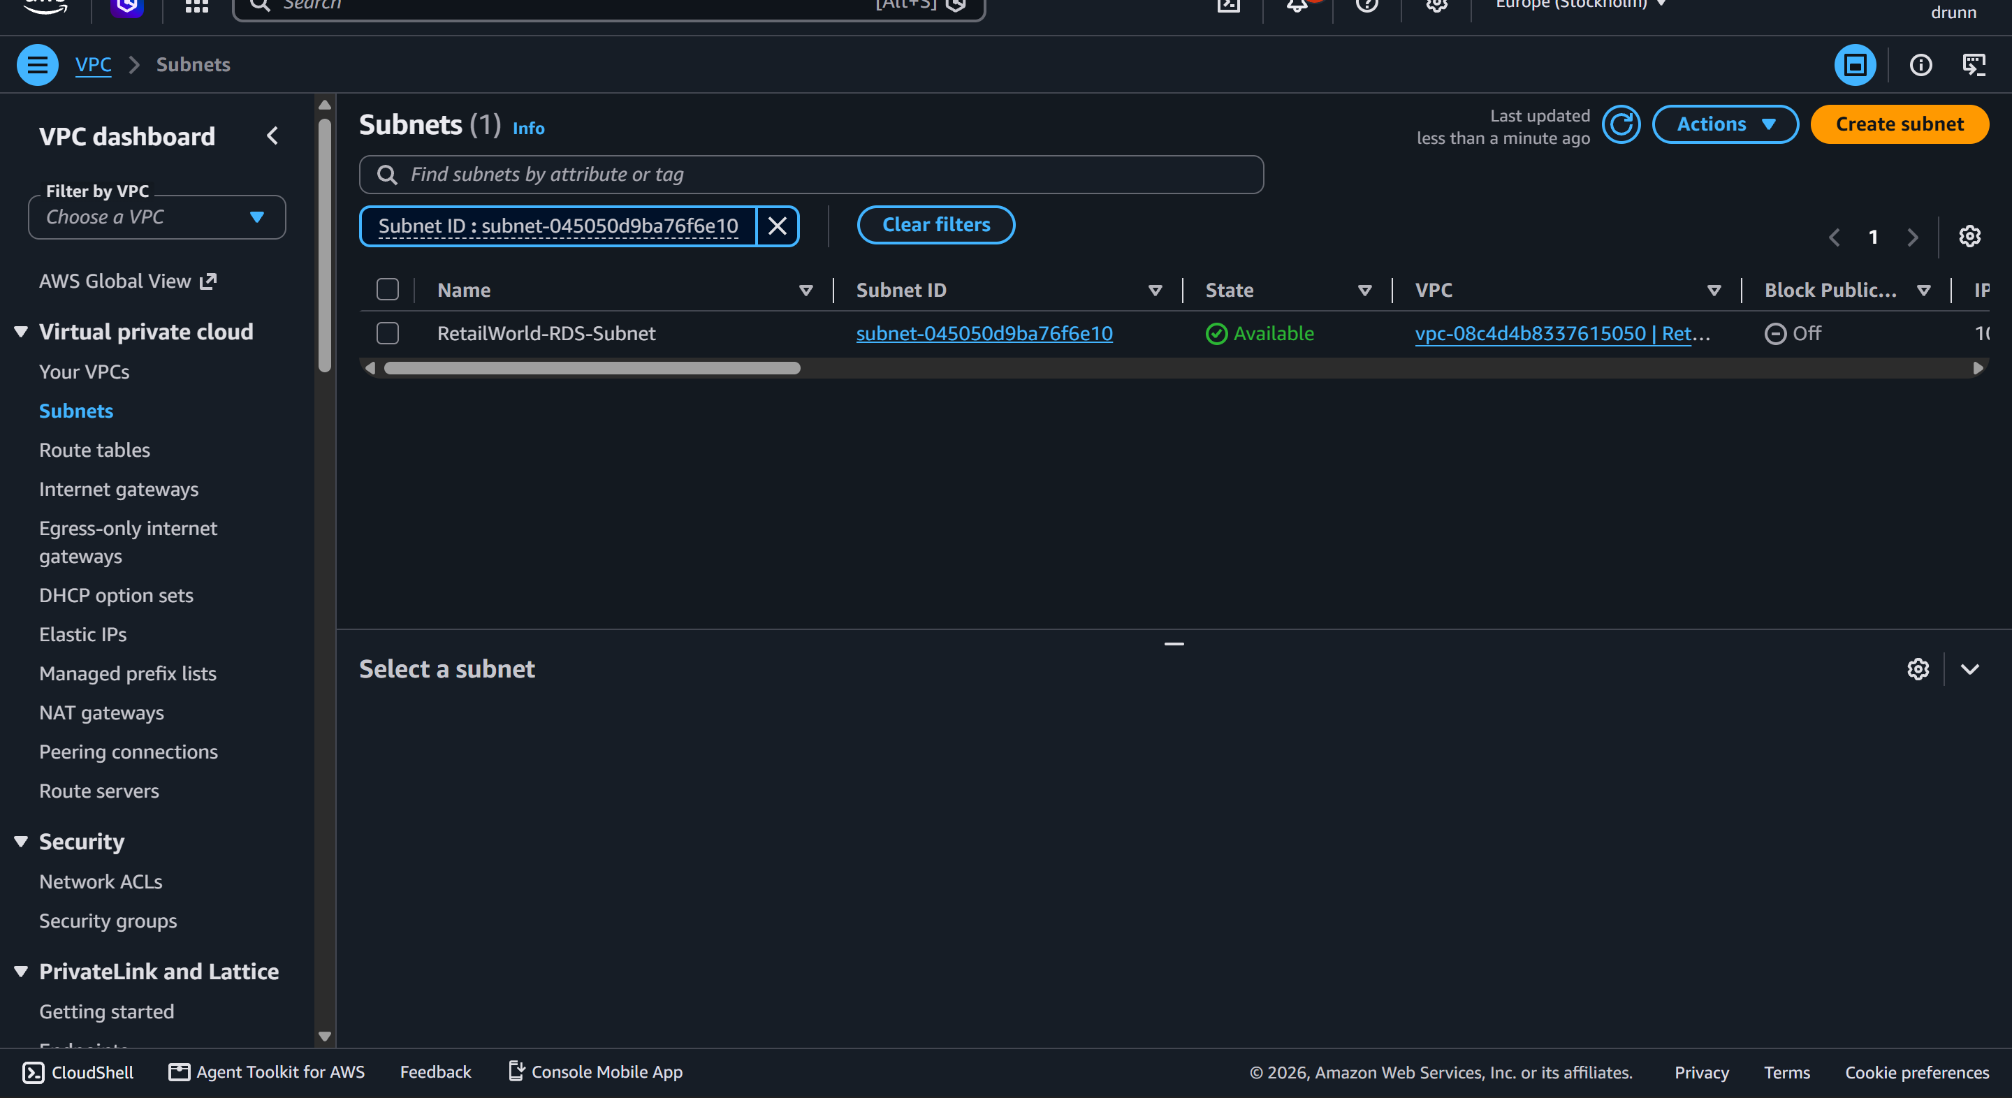
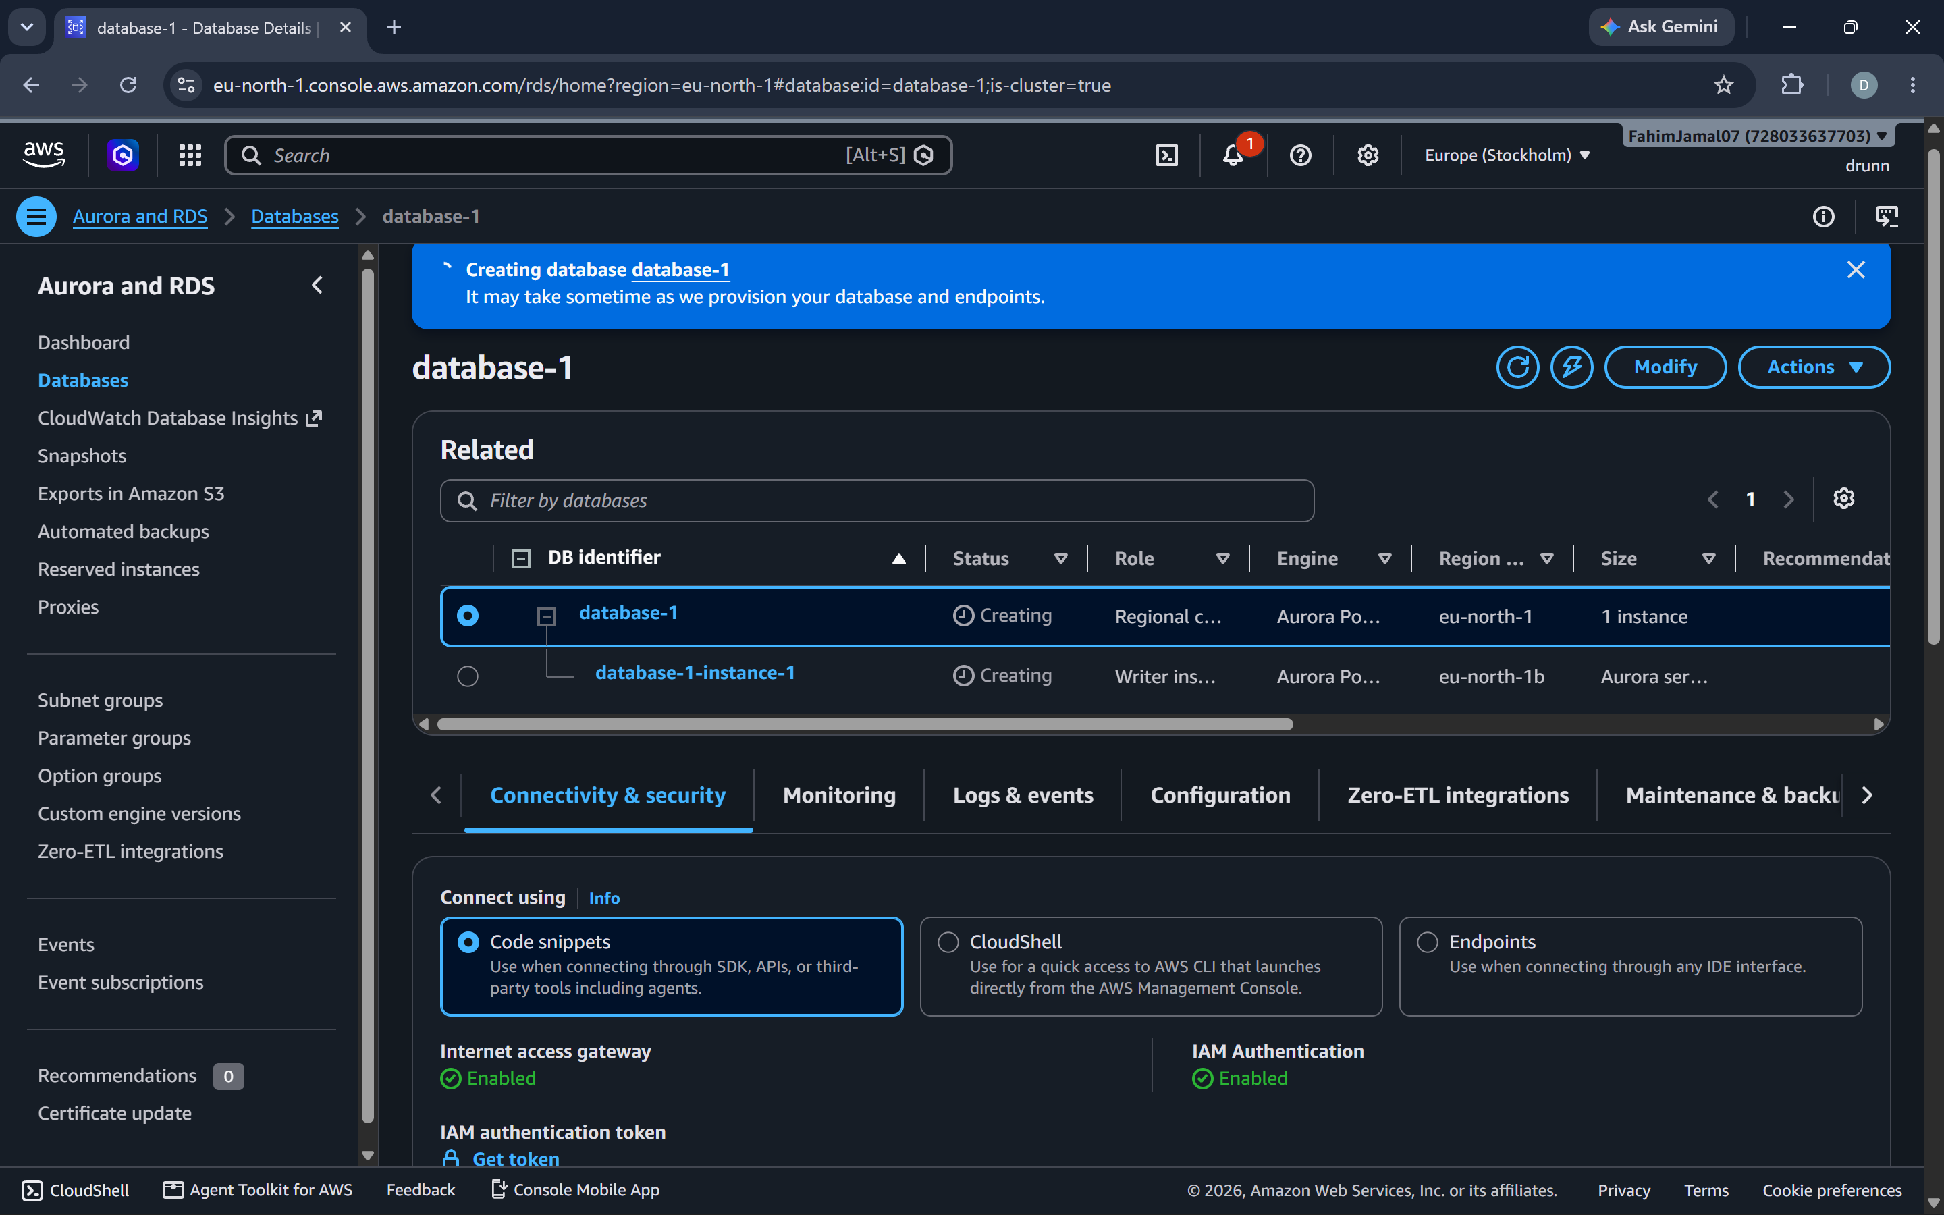

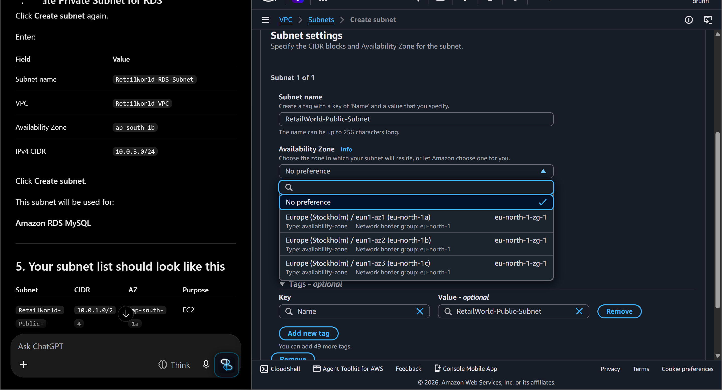

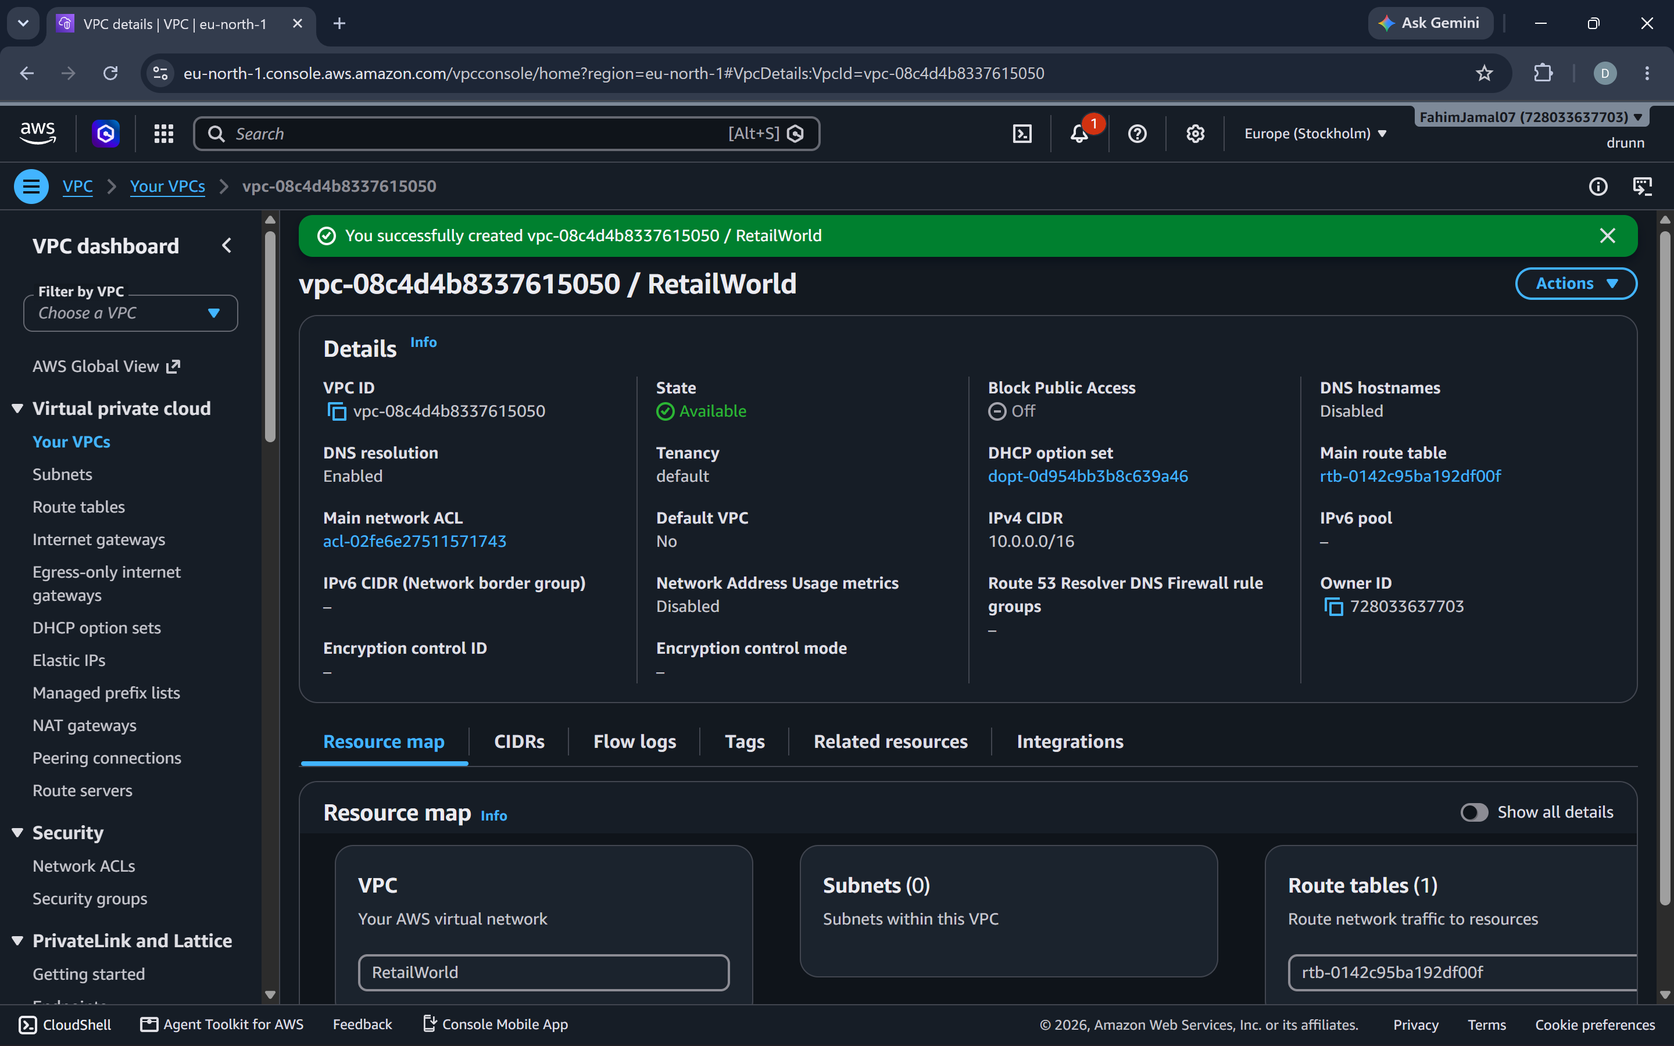

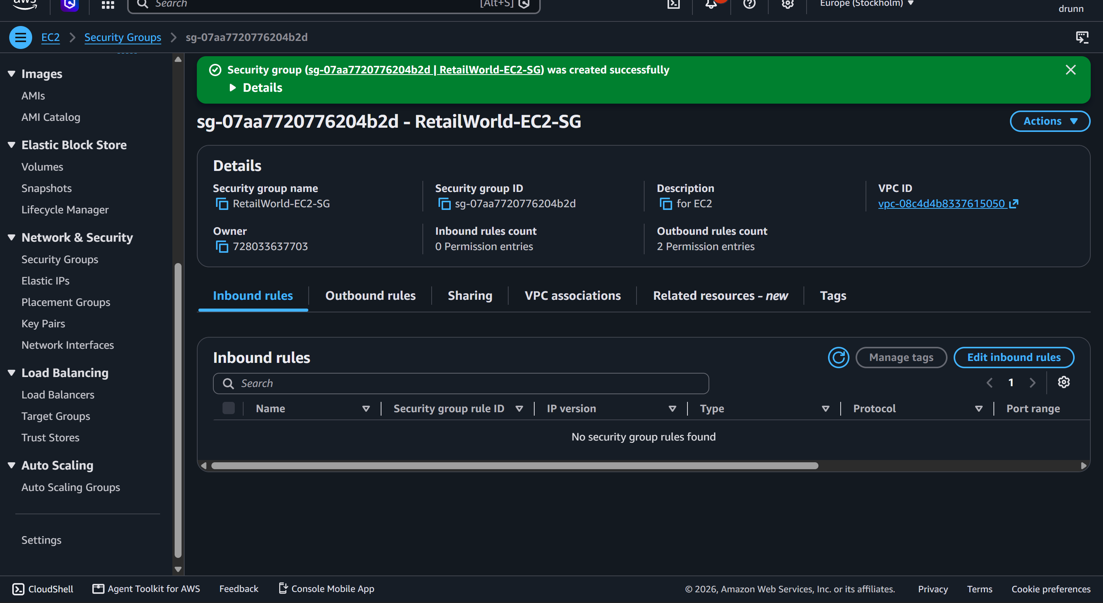
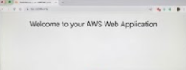

19. Create the Input and Output S3 Buckets
S3 Console
- Create the input bucket, for example nivash-image-input-2026, in the same Region as the Lambda function and SQS queue.
- Create a separate output bucket, for example nivash-image-output-2026. Writing results to a different bucket prevents the Lambda function from re-triggering itself in an endless loop.
- Keep Block all public access enabled on both buckets and keep default encryption (SSE-S3).
- In the input bucket, create a folder (prefix) named uploads/. All test images will be uploaded here.

20. Create the SQS Queue and Dead-Letter Queue
SQS Console
- Click Create queue, choose Standard, and name it image-processing-dlq. Set Message retention period to 14 days and click Create queue. This is the dead-letter queue (DLQ).
- Create a second Standard queue named image-processing-queue. This is the main buffer queue.
- Set Visibility timeout to at least 6 times the Lambda timeout. For a 60-second function timeout use 360 seconds or more.
- Set Receive message wait time to 20 seconds (long polling) to reduce empty receives.
- Under Dead-letter queue, choose Enabled, select image-processing-dlq, and set Maximum receives to 5. A value of at least 5 is recommended so that temporary throttling does not push healthy messages into the DLQ.
- Open the Access policy of image-processing-queue, choose Edit, and allow S3 to send messages to the queue. Replace the account ID and ARNs with your own values:
{
"Version": "2012-10-17",
"Statement": [{
"Effect": "Allow",
"Principal": {"Service": "s3.amazonaws.com"},
"Action": "sqs:SendMessage",
"Resource": "arn:aws:sqs:<REGION>:<ACCOUNT-ID>:image-processing-queue",
"Condition": {
"ArnLike": {"aws:SourceArn": "arn:aws:s3:::nivash-image-input-2026"},
"StringEquals": {"aws:SourceAccount": "<ACCOUNT-ID>"}
}
}]
}

21. Create the Lambda Function
Lambda Console
- Click Create function, choose Author from scratch, and enter the name image-processor.
- Select a current Python runtime and create a new execution role with basic Lambda permissions.
- Attach the AWS managed policy AWSLambdaSQSQueueExecutionRole to the role so Lambda can read from and delete messages in the queue.
- Add an inline policy that allows s3:GetObject on the input bucket and s3:PutObject on the output bucket.
- Under Configuration, set Memory to 512 MB and Timeout to 60 seconds.
- Add the environment variable OUT_BUCKET = nivash-image-output-2026.
- Paste the following code into the code editor and click Deploy. The S3 client is created outside the handler so warm invocations reuse it, and the function reports only the failed messages so the rest of a batch is not retried:
import json, os, urllib.parse
import boto3

s3 = boto3.client("s3") # created once per execution environment
OUT_BUCKET = os.environ["OUT_BUCKET"]

def process_image(bucket, key):
obj = s3.get_object(Bucket=bucket, Key=key)
data = obj["Body"].read()
# TODO: resize / analyse the image here (for example with a Pillow layer)
s3.put_object(Bucket=OUT_BUCKET, Key="processed/" + key.split("/")[-1], Body=data)

def lambda_handler(event, context):
failures = []
for record in event["Records"]: # one SQS message per S3 upload
try:
body = json.loads(record["body"])
for r in body.get("Records", []): # S3 event wrapped inside the message
bucket = r["s3"]["bucket"]["name"]
key = urllib.parse.unquote_plus(r["s3"]["object"]["key"])
process_image(bucket, key)
except Exception as e:
print("ERROR", record["messageId"], str(e))
failures.append({"itemIdentifier": record["messageId"]})
return {"batchItemFailures": failures}

22. Connect S3 to SQS and SQS to Lambda
S3 Console + Lambda Console
- Open the input bucket, go to Properties, and click Create event notification under Event notifications.
- Enter the name image-upload-to-sqs, set Prefix to uploads/, and select All object create events.
- Set Destination to SQS queue and select image-processing-queue. Save the changes.
- Open the Lambda function image-processor and click Add trigger.
- Select SQS as the source and choose image-processing-queue.
- Set Batch size to 10 and Batch window to 5 seconds.
- Enable Report batch item failures.
- Under Maximum concurrency, enter a value such as 50. This caps how many parallel invocations the queue can trigger, so the account concurrency limit is not exhausted.
- Click Add and wait until the trigger status shows Enabled.

23. Predict and Explain the Behaviour for 1,000 Images in One Minute
Concurrency, throttling, retries, cold starts, buffering
- Arrival rate: 1,000 uploads in 60 seconds is about 17 images per second. Required concurrency is approximately arrival rate multiplied by average duration. With 3 seconds per image about 50 environments run in parallel; with 10 seconds per image about 170.
- Account concurrency limit: all functions in a Region share one account limit, 1,000 by default. Check Service Quotas because newer accounts can have a lower value. Reserved concurrency guarantees capacity to one function but also caps it, and at least 100 units must stay unreserved.
- Concurrency scaling: a function can add up to 1,000 new execution environments every 10 seconds, so this burst is within the scaling rate. Throttling happens only when demand reaches the account limit, a reserved concurrency cap, or the SQS Maximum concurrency setting.
- Throttling: a throttled invocation is rejected before the code runs, so it appears in the Throttles metric and not in the function logs.
- Asynchronous invocation (S3 directly to Lambda): Lambda places events in an internal queue. Throttled events are retried with backoff for up to the Maximum event age (6 hours by default). If the function itself returns an error, Lambda retries twice (about 1 minute and then 2 minutes later). When retries or event age are exhausted, the event goes to the configured on-failure destination or DLQ; otherwise it is discarded.
- Cold starts: every new execution environment must download the code, start the runtime, and run the initialisation code before handling its first event. At the start of the burst almost every concurrent invocation is a cold start, so the first batch takes longer (init time is added to Duration). Later invocations reuse warm environments. Reduce the effect with provisioned concurrency, SnapStart where supported, smaller packages, clients created outside the handler, and more memory (more CPU).
- SQS buffering: S3 sends one message per uploaded image and the queue stores it durably, so the spike is absorbed by the queue and not by Lambda. Lambda polls the queue and scales up gradually, while throttled or failed messages simply return to the queue and are retried. Nothing is lost during throttling.
- Batch size: each invocation receives up to 10 messages, so about 100 invocations handle 1,000 images. A larger batch means fewer invocations but a longer run, and the function timeout must exceed batch size multiplied by the time per image. Partial batch responses prevent one bad image from forcing the whole batch to be retried.
- Visibility timeout: while Lambda works on a message it is hidden from other consumers. If the visibility timeout is shorter than the processing time, the message becomes visible again and is processed twice. Use at least 6 times the function timeout plus the batch window.

24. Configure the DLQ / On-Failure Destination and Reprocess Failed Events
SQS Console + Lambda Console
- For the SQS trigger, failed messages are handled by the redrive policy configured in section 20: after 5 failed receives a message moves to image-processing-dlq. The Lambda DLQ setting does not apply to SQS event source mappings.
- If the function is also invoked directly (asynchronously), open Lambda → Configuration → Asynchronous invocation → Edit. Set Retry attempts to 2, set Maximum event age (for example 1 hour), and add an On-failure destination of type SQS pointing to image-processing-dlq. Destinations are preferred over the older DLQ setting because they include the error details.
- Open CloudWatch → Alarms → Create alarm on the SQS metric ApproximateNumberOfMessagesVisible for image-processing-dlq with the condition greater than 0.
- Test the failure path by uploading a corrupt or non-image file that makes the function raise an error. After 5 attempts confirm that the message appears in the DLQ.
- To inspect failures, open the DLQ and click Send and receive messages → Poll for messages. Read the message body and the CloudWatch logs for the cause.
- Fix the cause, then open the DLQ and click Start DLQ redrive, choose Redrive to source queue, and start the redrive. The messages are reprocessed by Lambda.
- Make the function idempotent: SQS delivers at least once, so the same image can arrive twice. Writing to a fixed output key (as in the sample code) means reprocessing overwrites the same result.

25. Run the Load Test with 1,000 Images
AWS CloudShell or Local Terminal
- Create 1,000 test images from one sample image: mkdir images && for i in $(seq 1 1000); do cp sample.jpg images/img_$i.jpg; done
- Upload them in one burst: aws s3 cp images/ s3://nivash-image-input-2026/uploads/ --recursive
- Open SQS and watch ApproximateNumberOfMessagesVisible rise and then fall to 0 as Lambda drains the queue.
- Count the results: aws s3 ls s3://nivash-image-output-2026/processed/ --recursive | wc -l. The expected value is 1000.
- Confirm the DLQ contains 0 messages. Note the start and end time of the run for the CloudWatch analysis.

26. Analyse the Run with CloudWatch Metrics and Logs Insights
CloudWatch Console
- Open CloudWatch → Metrics → AWS/Lambda → By Function Name → image-processor, set the time range around the test, and graph these metrics:
- Invocations (Sum, 1 minute): number of function invocations. With batch size 10 expect about 100, not 1,000.
- Errors (Sum): invocations that failed with an error or timeout.
- Throttles (Sum): invocations rejected because of concurrency limits. Any value above 0 shows the limit or the Maximum concurrency cap was reached.
- Duration (Average, p95 and Maximum): run time per invocation. Compare Maximum with the configured timeout.
- ConcurrentExecutions (Maximum): peak number of parallel executions. Compare it with the account limit and with the configured Maximum concurrency.
- Also graph the SQS metrics ApproximateNumberOfMessagesVisible and ApproximateAgeOfOldestMessage for the main queue and ApproximateNumberOfMessagesVisible for the DLQ.
- Open CloudWatch → Logs → Logs Insights, select the log group /aws/lambda/image-processor, set the same time range, and run the queries below.
- Invocations per minute:
filter @type = "REPORT"
| stats count(*) as invocations by bin(1m)

- Cold starts and initialisation time (only cold-started invocations have @initDuration):
filter @type = "REPORT"
| stats count(*) as invocations, count(@initDuration) as coldStarts,
avg(@initDuration) as avgInitMs, max(@initDuration) as maxInitMs

- Duration statistics per minute:
filter @type = "REPORT"
| stats avg(@duration) as avgMs, pct(@duration, 95) as p95Ms, max(@duration) as maxMs by bin(1m)

- Memory used compared with memory configured:
filter @type = "REPORT"
| stats max(@maxMemoryUsed/1024/1024) as usedMB, max(@memorySize/1024/1024) as configuredMB

- Errors and timeouts with the request ID:
fields @timestamp, @requestId, @message
| filter @message like /ERROR|Task timed out|Exception/
| sort @timestamp desc
| limit 50

- Interpret the results: a high Throttles count means increasing the account quota, reserved concurrency, or Maximum concurrency; a high maxInitMs means cold starts dominated the first batch; a rising ApproximateAgeOfOldestMessage means the queue is draining slower than it fills; any message in the DLQ means redrive after the fix.

