Lab | Type | Practical
 | HTML
1 | A  A  B  B  C  C | Case Study on basic Internet Protocol.  - Understanding Internet and Web.  - Explore different web browsers and search engines.  - Identify and explain common internet protocols (HTTP, HTTPS, FTP).  - Understanding HTTP requests and responses.  - Demonstrate client-server communication using HTTP requests (GET, POST).  - Demonstrate HTTP Response Status Codes.
2 | A  B  C | Demonstrate HTML Organizing tags  - Create an HTML page that demonstrates the use of text formatting tags such as <b>, <i>, <u>, <strong>, and <em>.  - Design a webpage that displays mathematical and chemical expressions using <sup> and <sub> tags (e.g., H<sub>2</sub>O, x<sup>2</sup>).  - Create an HTML document that uses <pre> and <code> tags to display preformatted text or code snippets exactly as typed.
3 | A  A  A  B  C | Demonstrate HTML tags and HTML controls  - Design a webpage that organizes content using different heading tags (<h1> to <h6>) and <p> for paragraphs. (A)  - Address, B, U, I, Blockquote, Marquee, Link, Meta. (A)  - Anchor tag, Image control. (B)  - Iframe tag. (B)  - List controls. (C)
4 | A  B  B  C | Implementation of table tag with rowspan and colspan.  - Make the table of the following design using HTML.(A)  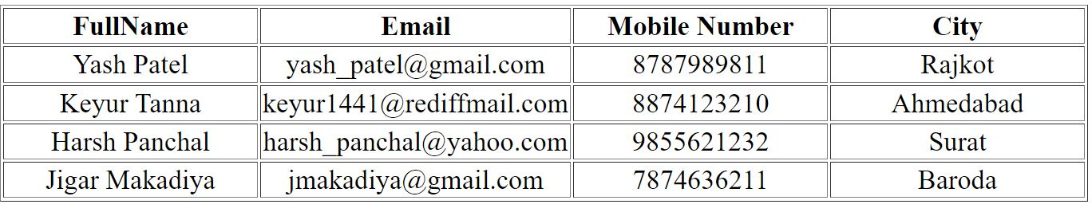  - Make the table of the following design using HTML.(B)  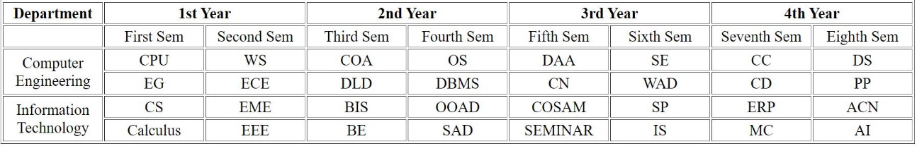  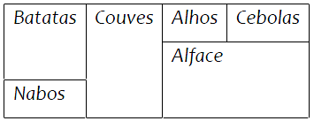  - Make the table of the following design using HTML.(B)  - Make the table of the following design using HTML.(C)  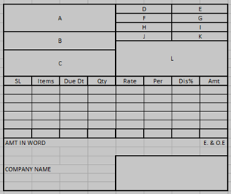
5 | A  B  C | Imlement HTML form for the given layouts.  1. Design Form of Student Registration, COVID-19 vaccine registration and Employee registration with following fields and also use HTML5 validation.(A)  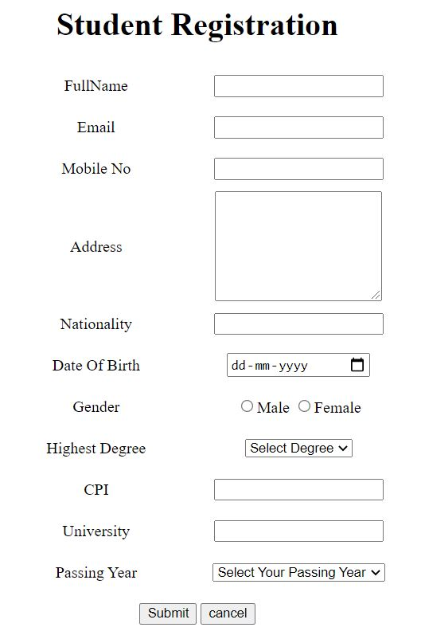  2.  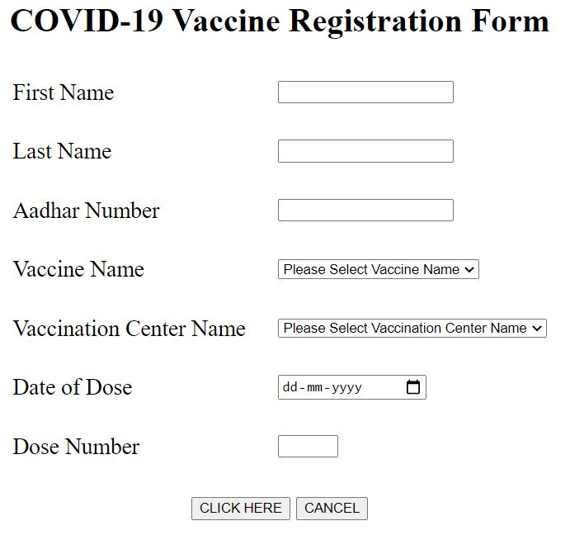  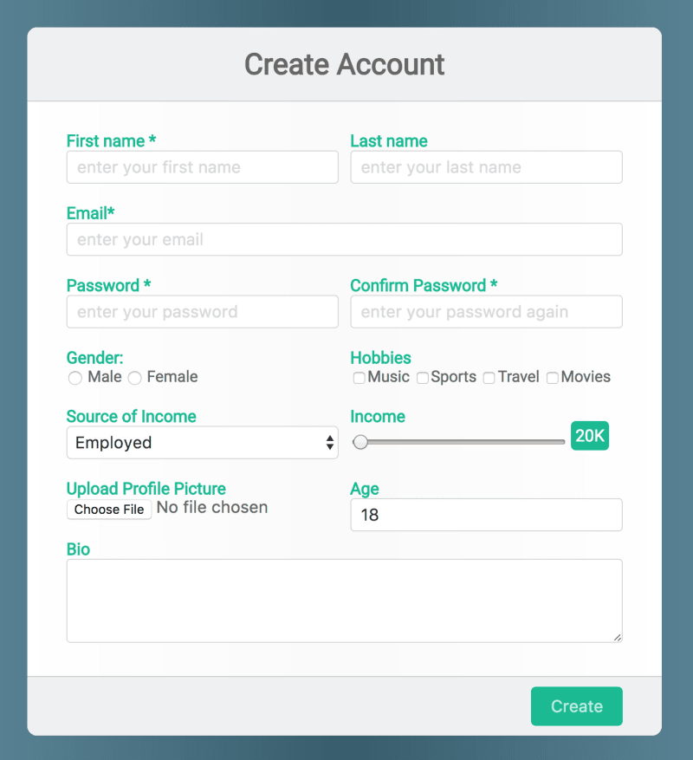  3.
6 | A  A  A  B  C | Demonstrate HTML5 Semantic Tags and Form Validations  - Create an HTML5 page using semantic tags like <header>, <nav>, <main>, <article>, <section>, and <footer> to structure the layout of a simple website.  - Develop a contact form using HTML5 form elements such as <input type="email">, <input type="tel">, <input type="date">, and <textarea>.  - Create an HTML form with fields like Name, Email, and Phone Number using the required attribute to ensure the user cannot submit without filling them.  - Design a registration form that uses type="email", type="number" and pattern attributes to validate email format, number ranges, and custom patterns (e.g., password rules).  - Create a feedback form where minlength, maxlength, min, and max attributes are used to control input length and numerical value range.
II | CSS
7 | A  B  C | Demonstrate the selectors.  - Create an HTML page that applies different styles using basic CSS selectors: element selector (p), class selector (.className), and ID selector (#idName).  - Design a webpage that applies common styles to multiple elements using the group selector (h1, p), universal selector (*), and descendant selector (div p).  - Create a webpage that shows the use of:  - Child Selector (ul > li)  - Adjacent Sibling Selector (h2 + p)  - Attribute Selector (input[type="text"]) to target specific elements and apply CSS rules.
8 | A  B  C | Apply CSS for the following pages.  - Design the following page using CSS.(A)  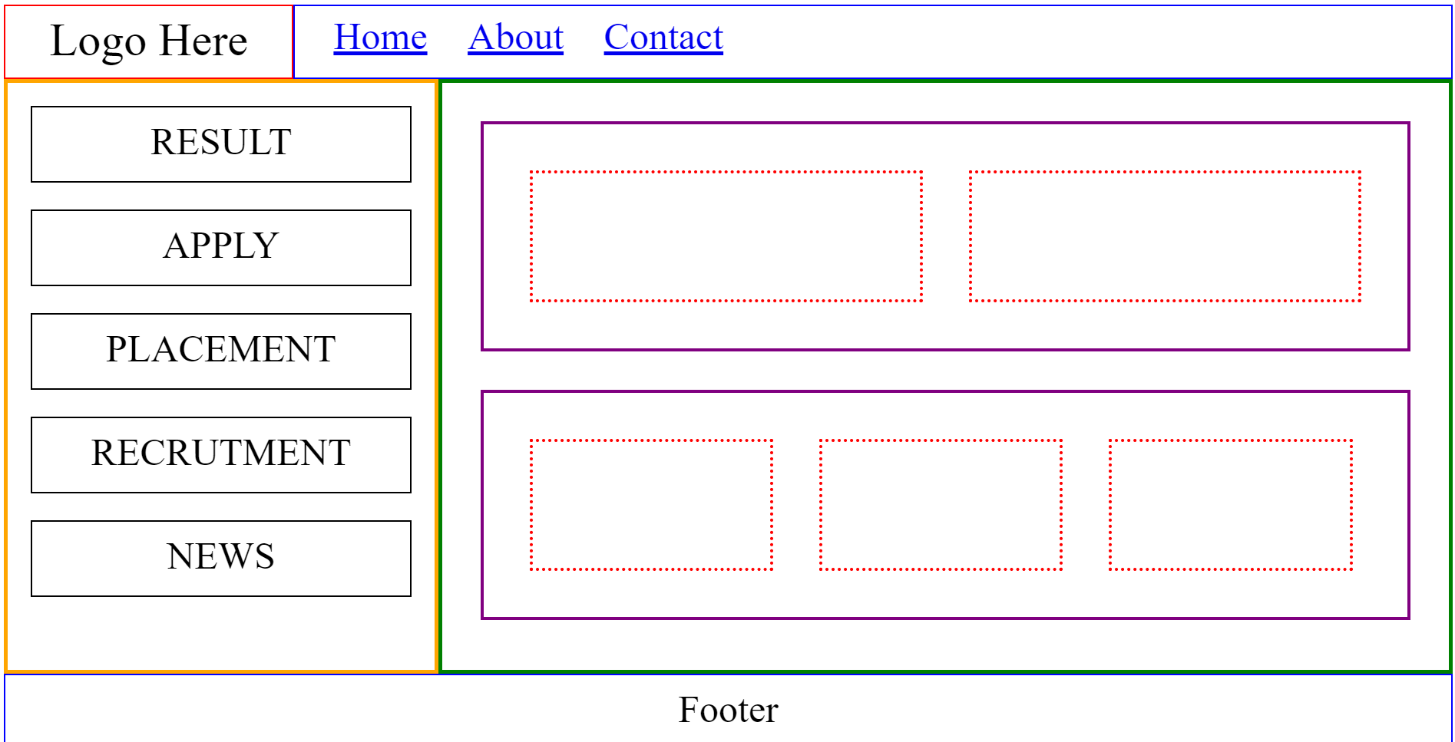  - Design the following page using CSS.(B)  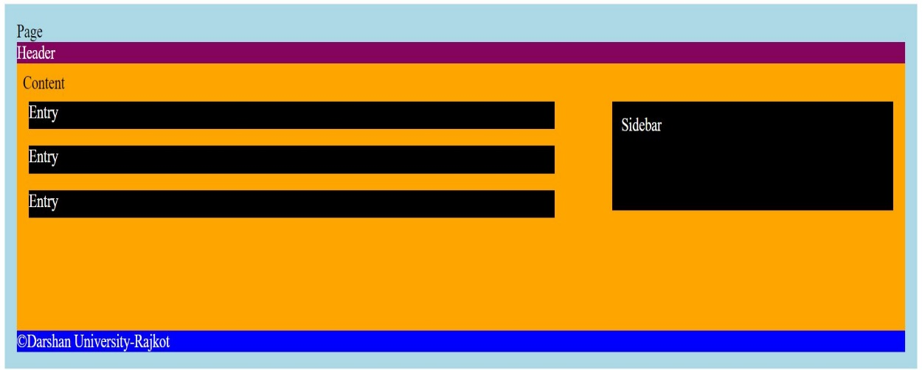  - Design the following page using CSS.(C)  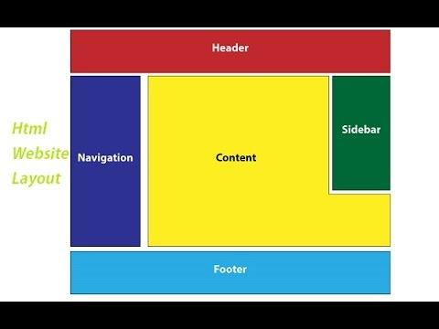  (Link for the other layout for the practice will be shared)
9 | A  B  C  C | Demonstrate CSS3 Animation for the following layouts.  - Write HTML, CSS3 code for following animation effects.(A)  - Changing the background color of div from red to yellow.  - moving div from Left to right, right to bottom, bottom to left and left to top.  - put delay of 2s in the animation.  - Change the animation-iteration count property of program 2 to run infinite times  - Change animation direction property to run it in reverse order.  - Change value of the animation-timing-function property to change the speed of the animation  - Write an HTML snippet with CSS for following effects: (B)  - Link after visited red color before visited orange color  - Add special style(change color,font size etc) to first line of paragraph  - Add special style (change color,font size etc) to first letter of paragraph  - Change background color to yellow when user select particular text  - Add special style to an element when user mouse over it.  - Create custom animation of your choice.(C)  4 . Create animation similar to screen saver.(C)
10 | A  A  B  C | Apply media query for the following scenario.  - Demonstrate CSS3 Animation for the following layouts.  - Create a webpage that changes its background color or layout when viewed on different devices using media queries (e.g., mobile: max-width 600px, tablet: 601px–1024px, desktop: 1025px and above).  - Design a webpage where font size and image dimensions adjust based on screen width using media queries to improve readability on all devices.  - Build a responsive HTML page where specific elements (like a sidebar or extra content) are hidden or shown based on screen size using media queries.
11 | A  B  C | Apply Pseudo-classes and Pseudo-elements.  - Create a webpage that applies different styles to elements using pseudo-classes such as :hover for buttons, :focus for form inputs, and :nth-child for styling specific list.  - Design a webpage that highlights the first line of a paragraph, enlarges the first letter, and changes background color when text is selected using pseudo-elements.  - Build a webpage that combines pseudo-classes and pseudo-elements — for example, changing the color of the ::first-letter only on :hover of a paragraph.
III | JS
12 | A  A  A  B  B  C | Implement basic programs using JavaScript.  - WAP in JavaScript to make simple calculator using popup box.(A)  - WAP in JavaScript to check whether the given no. is prime or not.(A)  - WAP in JavaScript to find the factorial of given number.(A)  - WAP in JavaScript to print the Fibonacci series of a number.(B)  - WAP in JavaScript to check whether the given number is palindrome or not.(B)  - WAP in JavaScript to check whether the given number is Armstrong or not.(C)
13 | A  A  A  A  A  B  C  C | Solve the logical programs using JavaScript.  - WAP in JavaScript to print the factors of given number.(A)  - WAP in JavaScript to prime number between the given range of number. (A)  - WAP to display given patterns using JavaScript. (A)  - WAP in JavaScript to print the GCD of two number. (A)  - Write a JavaScript to take 2-digit number and then separate these 2 digits, then multiply first digit by itself for second digit times. (For example, 23 should be separated as 2 and 3. 2 should multiply with itself 3 times). (B)  - Write an HTML page with JavaScript that takes a number from popup box in the range 0-999 and display it in words. If the number is out of range, it should show “out of range” and if it is not a number ,it should show “not a number” message in the result box. (C)  - Write an HTML file with JavaScript that finds position of first occurrence of vowel “a”, last occurrence of vowel “a” in a given word and returns the string between them. For example, ajanta- then script would return first occurrence of “a”-that is position 1 and last occurrence-6 and string between them is “jant”. (C)
14 | A  A  B  C  C | Explore the JavaScript array.  1. Demonstrate the use of array to find maximum number. (A)  2. WAP to read an array from the user and sort them in ascending order. (A)  3. WAP to read an array from the user and sort them using bubble sort. (B)  4. WAP to read an array form the user and sort them using quick sort. (C)  5. Write a JavaScript that uses a loop that searches a word in sentence held in an array,  returning the index of the word. (C)
15 | A  A  B  C | Demonstrate various array methods in JavaScript.  1. WAP to display Faculties stored in array. (A)  2. WAP to display students stored in array. (A)  3. WAP to display products stored in array. (B)  4. Demonstrate different array functions like push, pop, shift, unshift, splice, sort etc.. (C)
16 | A  A  B  C | Design HTML pages with JavaScript.  1. WAP to create a basic graphical Calculator using HTML and JavaScript.(A)  2. WAP to create a static login page using HTML and JavaScript.(A)  3. WAP to create a scientific graphical calculator using HTML and JavaScript.(B)  4. Write a JavaScript program to validate user data given from the HTML form(C)  1) username must be of minimum 8 characters  2) password must contain at least 1 digit and 1 special character and should be between 8-12 characters  3) password and repeat password must be same  4) age must be greater than 18 (calculate from date of birth)  5) enrollment must be of 11 digits  6) email validation
17 | A  A  A  A  A  B  B  C | Explore event handling using HTML and JavaScript.  1. WAP to change background color on click of button. (A)  2. WAP to recognize which mouse event is fired. (A)  3. WAP to recognize which keyboard event is fired. (A)  4. WAP to recognize which form event is fired. (A)  5. WAP to demonstrate change in properties of HTML element using JavaScript. (A)  6. WAP to prepare student registration form and validate it using JavaScript. (B)  7. WAP to perform CRUD operation on Array using HTML and JavaScript.  8. Write a JavaScript that handles following mouse events. Add necessary elements.If the  mouse is over the heading should turn yellow and if the mouse goes out of the  heading it should turn black. If findtime button is clicked show time and date  information. If button named “red” is clicked, background should change to red and If  button named “green” is clicked, background should change to green. (B)  9. Write a JavaScript that handles following mouse events. Add necessary elements.  JavaScript gives the key code for the key pressed. (B)  10.If the key pressed is “a”,”e”,”i”,”o”,”u”, the script should announce that vowel is  pressed.When the key is released background should change to blue. (C)
18 | A  A  A  A  A  A  A  A  B  B  C | Apply control statements in JavaScript for the following definitions.  - WAP to demonstrate callbacks in JavaScript. (A)  - Demonstrate the difference between let and var. (A)  - Demonstrate the default parameter while using a function. (A)  - Demonstrate the spread operator. (A)  - Demonstrate the ‘for of’ loop. (A)  - Demonstrate the Array and Object Destructuring. (A)  - Demonstrate the Arrow functions. (A)  - Demonstrate how to create a class in Java Script. (A)  - Create a Snake game using Java script. (B)  - Write JavaScript that handles following mouse event. (B)  - If mouse left button pressed on browser, it displayed message “Left Clicked”.  - If mouse right button pressed on browser, it displayed message “Right Clicked”.  - Write a JavaScript having a list of checkbox and by clicking on checkbox, it should show list of selected value in comma separated format. (e.g. list of roll number as checkbox value, and display selected roll number in comma separated format) (C)
19 | A  A  B  B  C | Demonstrate JQuery for the definitions given below.  - Using jQuery, write a script that listens for a click event on the button. (A)  - When the button is clicked, change the text of the paragraph to "Button clicked!". (A)  - Write a jQuery script that adds a click event handler to each list item. (B)  - When a list item is clicked, change its background color to yellow and slide it up, then fade it out. (B)  - Define a jQuery plugin called "wordCount" that counts the number of words in a textarea element. (C)
20 | A  A  B  B  C | Use JQuery and HTML to make web pages interactive.  - Write a jQuery script that animates the button to move 200 pixels to the right when clicked. (A)  - Create an HTML file with a button element and an empty paragraph element. Use jQuery to write a script that listens for a click event on the button. (A)  - Write jQuery code to toggle the visibility of the additional content when an item is clicked, providing an accordion effect. (B)  - Write jQuery code to animate the movement of images when the user clicks navigation buttons (e.g., previous and next) or automatically scrolls. (B)  - Write jQuery code to validate the form on each input field upon submission, providing feedback to the user for invalid inputs (e.g., displaying error messages). (C)
IV | ES6
21 | A  A  B  B  C | Hands-On with Core ES6 Syntax  - Create a function to calculate the square of a number using the traditional function keyword. Then rewrite the same function using arrow syntax. Show the difference in how this behaves inside each.  - Write a function that accepts a student's name and course. If no course is given, it should default to "Web Development". Show output with and without passing the course argument.  - Write a function that accepts a student's name and course. If no course is given, it should default to "Web Development". Show output with and without passing the course argument.  - Take user input like name, age, and city, and generate a paragraph using template literals to print a formatted bio string. Print it on the console or inject it into the DOM.  - Create a student object with nested properties and an array of marks. Use object destructuring to extract name and subject; use array destructuring to get first two marks. Display them in the console.
22 | A  A  B  B  C  C | Working with Collections and Functional Programming  - Use map() to double an array of numbers and filter() to find even numbers.  - Use reduce() to calculate the total of a shopping cart with item prices.  - Create and use Set to remove duplicate values from an array.  - Create a Map to store and retrieve student names and marks.  - Use for...of to iterate over an array and for...in over an object.  - Demonstrate object/array cloning using the spread operator and Object.assign().
23 | A  A  B  B  C  C | ES6 Modules and Asynchronous JavaScript  - Create ES6 modules using export and import with simple math functions.  - Simulate an asynchronous operation using Promises with resolve/reject.  - Chain multiple Promises to represent steps in a task (e.g., load → process → save).  - Use async and await to simplify Promise-based code.  - Fetch and display user data from a dummy API using fetch() and async/await.  - Add try...catch to handle errors in async operations gracefully.
III | Bootstrap
24 | A  B  C | Write HTML, and Bootstrap code for the following definitions.  - Write HTML, Bootstrap code for following effects.(A)      - Use Bootstrap typography to put abbreviation in paragraph. (B)  - Use Bootstrap typography to align text (left, center, right). (B)  - Create Unstyled list using Bootstrap typography. (B)  - Use Bootstrap to display responsive image in webpage. Also use alignment to align it in left, center and right side of webpage. (B)  - Use Bootstrap to create thumbnail of image. (B)  - Design page of your choice which use above concept. (C)
25 | A  B  C | Create a design similar to Practical No-5 using the grid system of bootstrap.  Layout-1 of practical No.-5.(A)  Layout-2 of practical No.-5.(B)  Layout-3 of practical No.-5.(C)
26 | A  B  C | Write HTML, and Bootstrap code for the following images.  - Write HTML, Bootstrap code to design following image.(A)  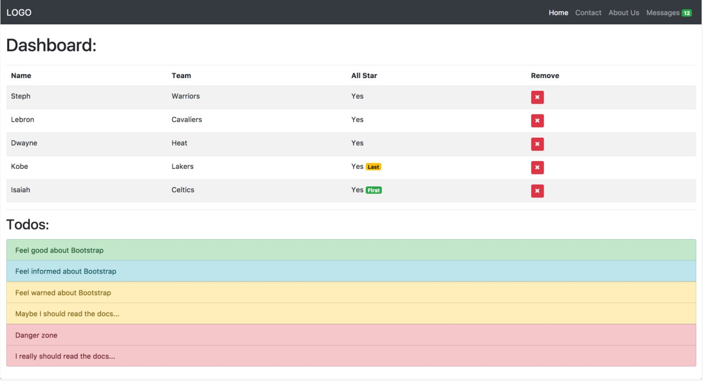  - Design SIGN-IN form using Bootstrap.(A)  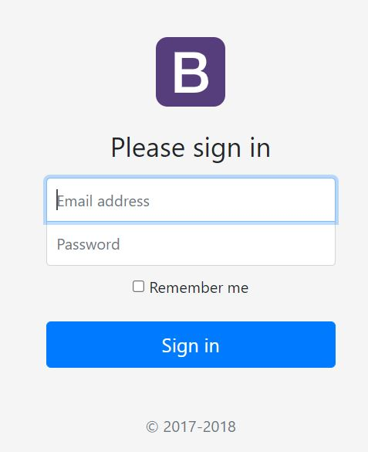  - Redesign forms created in Practical No-4 using Bootstrap.(C)
27 | A  B  C | Write HTML, CSS, and Bootstrap code to design the following layouts.  - Write HTML, Bootstrap code to design following image. (A)  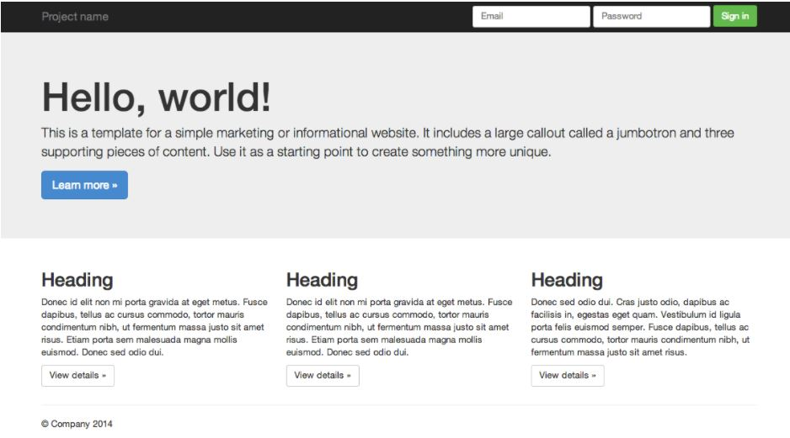  - Write HTML, Bootstrap code to design following image. (B)  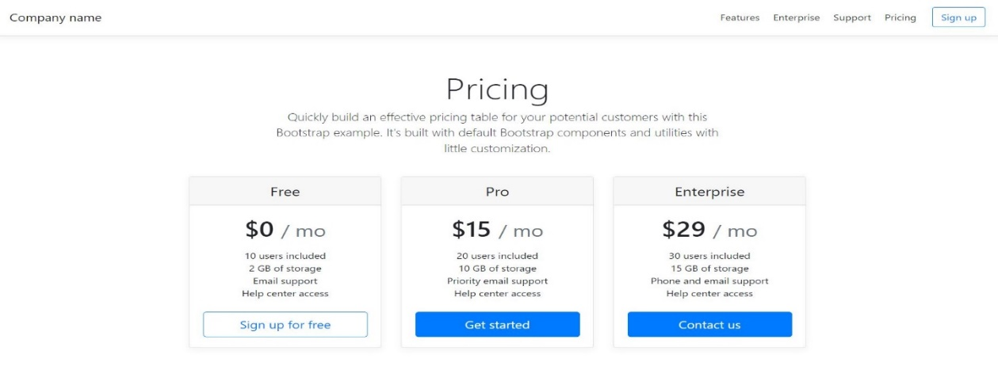  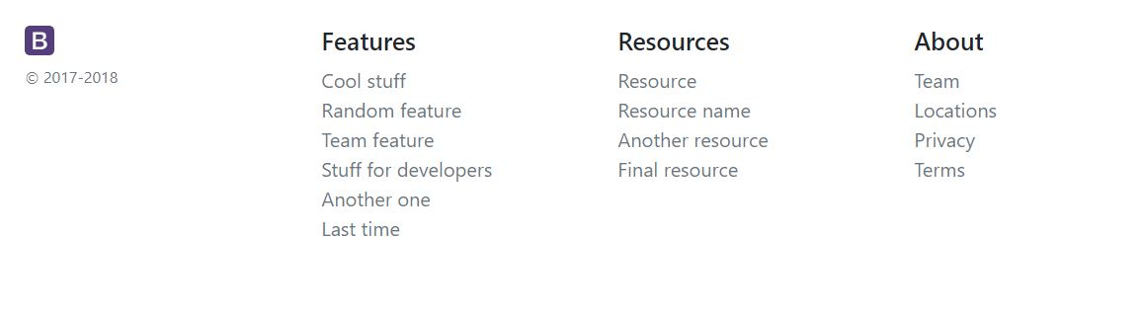  - Write HTML, Bootstrap code to design following image.(C)  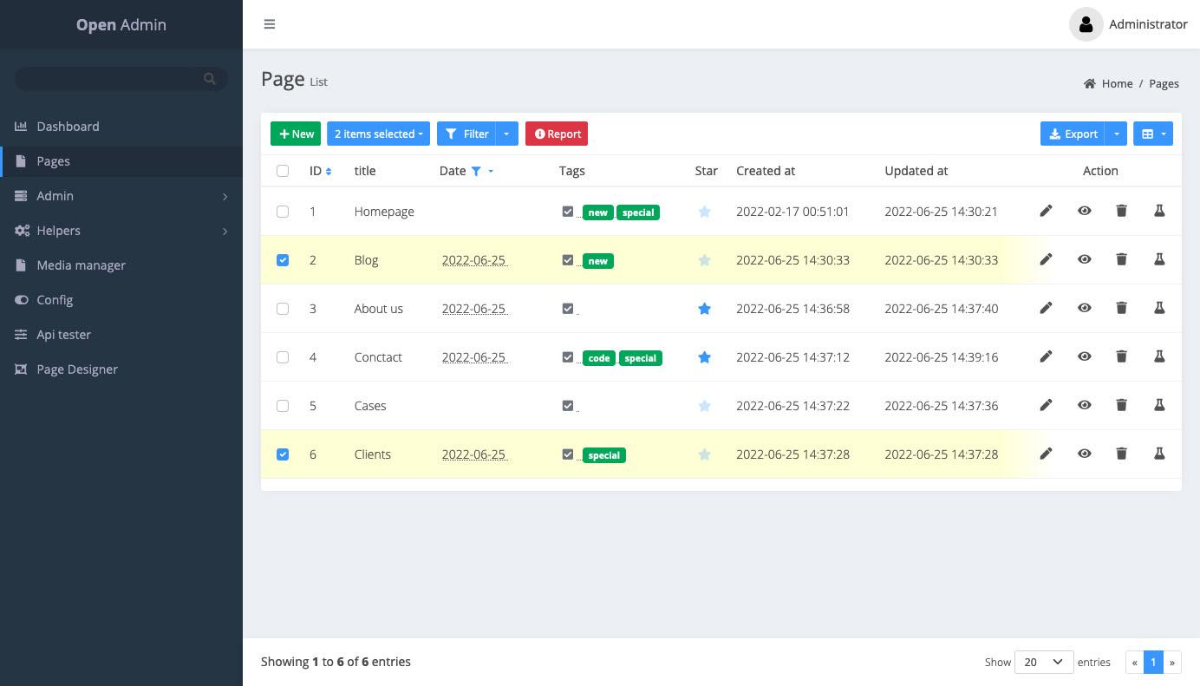
28 | A  B  C | Create web pages of given designs using the grid system of Bootstrap.  (Link: CSS Layouts for practice - Google Drive)  Layout-1(A)  Layout-2(B)  Layout-3(C)
29 | A  B  C | Apply CSS and Bootstrap to implement the following layouts.  (Link: CSS Layouts for practice - Google Drive)  Layout-4(A)  Layout-5(B)  Layout-6(C)
30 | A  B  C | Explore CSS, Bootstrap, and JQuery using the following layouts.  (Link: CSS Layouts for practice - Google Drive)  Layout-7(A)  Layout-8(B)  Layout-9(C)

