Baseline Ceiling Effects Determine When Prompt Optimization
Matches Fine-Tuning: A Controlled Comparison for Agentic
Tool Use Across Task Complexity and Data Regimes
Niveditha S Nair
Department of AI & Emerging Technologies
School of Science, Technology, Engineering and Mathematics
Chinmaya Vishwavidyapeeth Deemed-to-be University, Ernakulam, India
niveditha.cvv230143@cvv.ac.in

Abstract
Automatic prompt optimization tools, such as DSPy, have been shown to match or beat fine-tuning on tasks like classification, question answering, and summarization, often needing far fewer labeled examples. But almost no study compares these tools on agentic tasks that need many steps and tool calls. We compare DSPy, using MIPROv2, against QLoRA fine-tuning, both on the same open model, Llama-3.1-8B-Instruct. We test three levels of task difficulty: single tool call, multi-tool chains, and error recovery, on held-out data the model has not seen. Our central finding is that neither method wins uniformly; which one wins depends on what skill the task needs. On multi-tool chains (baseline 41.7%), DSPy reached 100% success using only 10 training examples, while QLoRA, trained on the same 10 examples, reached 83.3%. On error recovery (baseline 90.0%), our first DSPy run failed on all 6 held-out tasks (0%), repeatedly reissuing the same failed tool call instead of recognizing the error and stopping. We diagnosed this directly and built a lightweight repetition-guard mechanism that detects an identical repeated tool call and stops the program instead of retrying it. With this guard added, DSPy recovered to 83.3%, matching QLoRA's robustness on this tier while still leading on multi-tool chains. On the easiest level, single tool call (baseline 93.8%), both methods reached 100% regardless of training set size, since the baseline left little room for either method to differentiate itself. These results show that a method's advantage on one agentic skill does not transfer to another, that failures can be diagnosed and directly fixed with small, targeted mechanisms, and that claims of one method being generally superior should be checked skill-by-skill rather than assumed.
Keywords: agentic AI; tool use; prompt optimization; DSPy; fine-tuning; QLoRA; large language models

1. Introduction
Agentic AI systems increasingly plan, call tools, and act on their own, rather than just answering a single question. This skill matters: calling the right tool, with the right arguments, in the right order, and recovering when something goes wrong. Getting this wrong can be costly in any real deployment, so understanding how to build this skill reliably matters.
Automatic prompt optimization frameworks such as DSPy [1] and GEPA [4] have recently been reported to match or exceed fine-tuning. This has been shown on classification, QA, and summarization tasks, using far fewer labeled examples. Meanwhile, practitioner surveys suggest fine-tuning remains uncommon in production agent systems. The guidance on which method to use is mostly based on general rules, not controlled experiments. Almost none of this guidance targets agentic, multi-step, tool-calling behavior specifically. In these tasks, failures build up across steps. A model can pick the wrong tool, use bad arguments, call tools in the wrong order, or fail to recover from an error. This differs from a single wrong answer in a simpler task.
This paper reports a controlled comparison of automatic prompt optimization, DSPy [1] using MIPROv2 [2], against lightweight fine-tuning, QLoRA [3]. We test three tiers of agentic task complexity: single tool call, multi-tool chains, and chains requiring error recovery. We evaluate on held-out generalization splits, since prompt optimization can overfit to its optimization set just as fine-tuning can overfit to its training set. Rather than assuming complexity increases uniformly with tier number, we find the untouched baseline itself is highly uneven across tiers — near-ceiling on Tier 1 and Tier 3, but far from it on Tier 2 — and that this unevenness is exactly what determines whether the two methods can be meaningfully compared at all on a given tier. Where DSPy failed badly (Tier 3), we go a step further: we diagnose the failure directly from model output and propose a small, targeted mechanism that fixes most of it, rather than reporting the failure as a fixed endpoint.
Contributions:
- A task suite spanning three tiers of agentic complexity, each with a held-out generalization split, designed to separate planning, tool-selection, and error-recovery failures rather than collapsing them into a single accuracy score.
- A controlled comparison of automatic prompt optimization and lightweight fine-tuning on the same base model, same data, and same evaluation protocol.
- Evidence that ties between methods on some tasks reflect a baseline ceiling effect rather than genuine method equivalence, and that where a real comparison is possible, which method wins depends on the specific skill the task demands.
- A repetition-guard mechanism, diagnosed directly from a catastrophic DSPy failure on error-recovery tasks and validated to recover most of that gap without harming performance on tasks that already worked, offered as a concrete, lightweight technical contribution alongside the empirical comparison.

2. Related Work
Automatic prompt optimization. Tools such as DSPy [1] treat prompts and few-shot examples as things that can be optimized. They search over instructions and examples using MIPRO/MIPROv2 [2]. This search uses a small labeled set and a scoring method. Past results on classification, QA, and summarization show this kind of optimization can match or beat fine-tuning. It often needs far fewer labeled examples. Newer work, GEPA [4], builds on this idea using natural-language feedback on what the model did, and reports gains over MIPROv2 of more than 10 percentage points on some tasks. Most recently, JTPRO [7] jointly optimizes global instructions and per-tool argument descriptions together, reporting gains over GEPA specifically on tool-calling reliability as the number of available tools grows. We use MIPROv2 rather than GEPA or JTPRO in our own experiments mainly because of the free-tier GPU memory limits we worked under (Section 3.4); GEPA's search process in particular is more rollout-heavy, and we could not fit it reliably alongside a locally-served 8B model in 4-bit. We see re-running our comparison with GEPA or JTPRO as prompt optimizers as a natural next step (Section 6).
Combining prompt and weight optimization. BetterTogether [8] is the closest prior work to ours, and the direct precedent for comparing prompt optimization against fine-tuning within the DSPy ecosystem. Rather than treating the two as alternatives, BetterTogether alternates between optimizing prompts and optimizing weights for the same modular pipeline, letting the model teach itself. Tested on multi-hop QA, math reasoning, and classification across three base models, combining both strategies outperformed weight optimization alone by up to 60% and prompt optimization alone by up to 6%, averaged across models and tasks. Our paper asks a narrower, different question: not whether combining the two beats either alone, which BetterTogether already answers, but whether prompt optimization alone can match or exceed fine-tuning alone on agentic tool-use tasks specifically, and under what conditions the comparison itself is even meaningful. We see our ceiling-effect finding as complementary to BetterTogether rather than competing with it.
Loop and repetition detection in agents. The specific failure our repetition guard addresses — an agent repeatedly executing the same action without recognizing it has already failed — is a documented general problem, not one we discovered. Hou et al. [9] study Infinite Agentic Loops across 6,549 real-world LLM agent repositories, finding that a majority of production agent frameworks already expose some bound (max iterations, recursion limits) precisely because unbounded repetition is a known failure class, though such bounds are often present without an accompanying mechanism to recognize and gracefully report the repetition itself, rather than simply truncating execution. Roitman [10] documents action deduplication (hashing recent tool-and-argument pairs to detect an exact repeat) as one of several standard loop-detection techniques used in production agent harnesses, alongside iteration caps and semantic-similarity checks. Our repetition guard is, in this sense, an instance of an already-known engineering pattern, not a new general algorithm. What is different about our version is where it came from and how it was evaluated: rather than being designed in advance as a generic safety net, it was diagnosed directly from a specific, controlled failure (DSPy-optimized prompting scoring 0% on a held-out tier), and its effect was measured as a before/after comparison within a rigorous evaluation (0% to 83.3%), rather than assumed to help. We also show that MIPROv2's prompt optimization process, on its own and under our resource constraints, did not learn to avoid this repetition — the guard was necessary as an external control-flow addition, not something the optimizer converged to unprompted. We report this as a small, honestly-scoped contribution: a validated application of a known technique to a specific, diagnosed failure in an agentic prompt-optimization pipeline, not a novel loop-detection algorithm in its own right.
Fine-tuning for agents. Parameter-efficient fine-tuning methods, such as LoRA [5] and its quantized version QLoRA [3], are still the most common way to adapt models. But industry surveys show these methods are not widely used in production agent systems. This is often due to cost and the extra engineering work fine-tuning pipelines need.
Agentic evaluation. Existing agent and tool-use benchmarks, such as ToolLLM [6], usually report only whether the final task succeeded. They do not break down which step failed. This makes it hard to know if a failure came from bad planning, picking the wrong tool, or failing to recover from an error. Our task design adds explicit failure-mode tags and a tier where errors are added on purpose.
Positioning. As far as we know, no past work directly compares prompt optimization alone and fine-tuning alone under matched conditions on multi-step, tool-calling tasks with an explicit error-recovery tier, diagnoses a specific optimizer failure mode directly from output, and proposes a targeted mechanism to address it. This is the gap our paper addresses.

3. Method
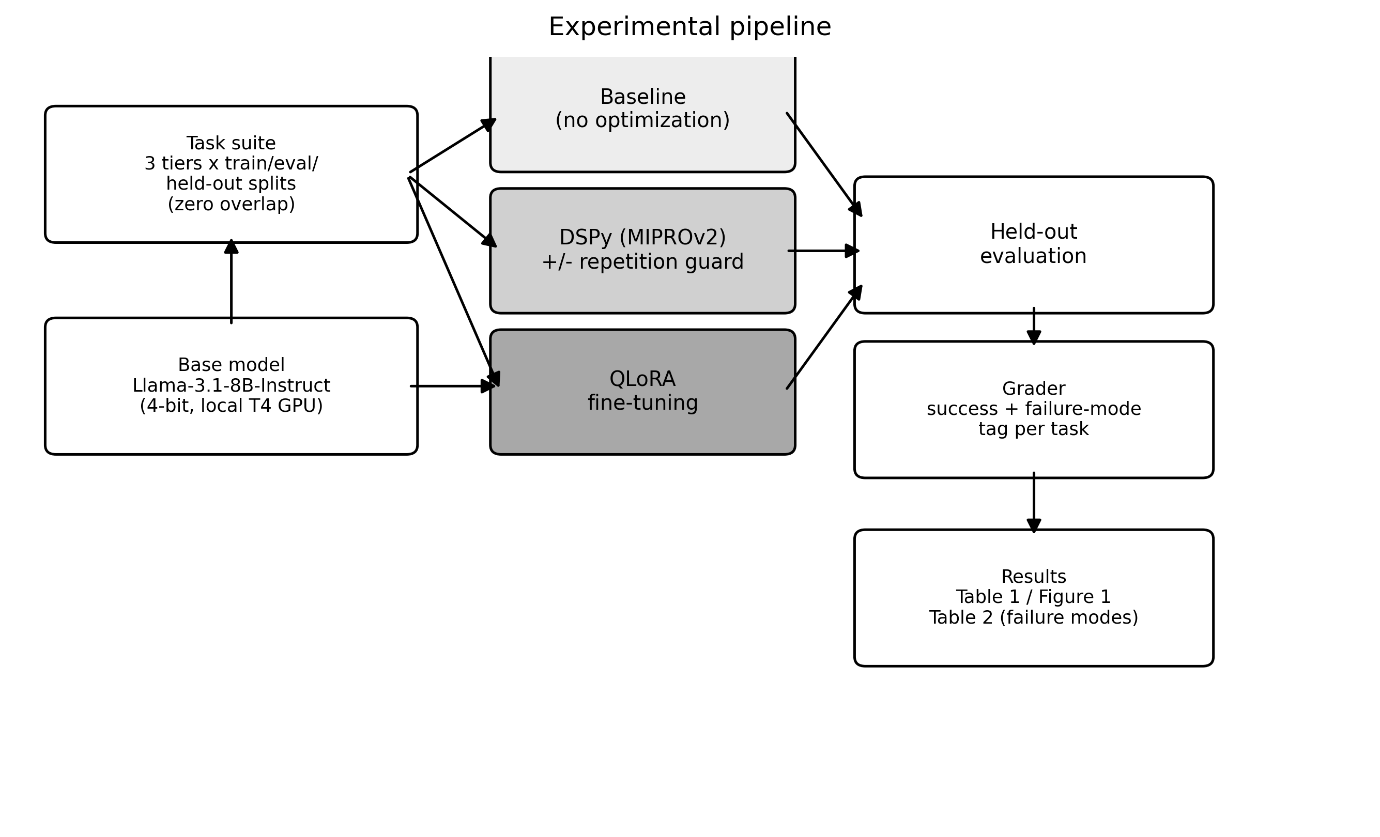
Figure 0. Experimental pipeline: the same base model is evaluated under three conditions on each tier's held-out split, scored by a grader that assigns both a success/failure label and a failure-mode tag.

3.1 Base model
We chose Llama-3.1-8B-Instruct over Qwen2.5-7B-Instruct after a small pilot test. The test checked how reliably each model called tools, using 10 single-tool-call prompts. Llama-3.1-8B-Instruct made a correctly formed tool call on all 10 prompts, with no extra hedging text. Qwen2.5-7B-Instruct got 9 out of 10 correct, and added an unprompted caveat on one unclear request instead of just calling the tool. We served both models locally, using 4-bit quantization (NF4), so each fit on one free-tier T4 GPU with 16GB of memory.

3.2 Task suite
Tasks are grouped into three tiers of growing agentic complexity. Each tier uses deterministic Python tool simulators instead of live external APIs. This makes every run free, easy to repeat, and simple to grade exactly.
- Tier 1 — Single tool call (16 tasks, 8 held-out): one request that needs exactly one correctly-formed tool call.
- Tier 2 — Multi-tool chains (12 tasks, 6 held-out): 2-3 tool calls in a row, where later calls may depend on earlier results.
- Tier 3 — Error recovery (10 tasks, 6 held-out): similar to Tier 2, but one tool call returns an error, or a result that conflicts with an earlier assumption (e.g. a scheduling conflict). Success means noticing the problem and reporting it, instead of acting as if nothing is wrong.
Each tier has a held-out generalization set: tasks with the same structure but different names or values, used only for testing, never for optimization or fine-tuning training. We built training data for DSPy and QLoRA from a separate, larger pool of template-and-entity combinations, distinct from both the evaluation and held-out prompts, so training, evaluation, and generalization-testing data never overlap.

3.3 Conditions
- Baseline: a fixed few-shot prompt, no optimization, tested on the full tier task set.
- DSPy-optimized: MIPROv2 [2] optimizes the prompt using N training examples, run against the locally-served base model, tested on the held-out split.
- QLoRA fine-tuned: parameter-efficient (LoRA [5], r=16) fine-tuning of the same base model, using the quantized QLoRA [3] method on the same N training examples, tested on the held-out split using the same multi-turn tool-execution setup as the baseline.
For Tier 2 and Tier 3, the DSPy program itself runs a loop with a set number of turns: it predicts the next action, runs it against the simulator, feeds the result back, and repeats. This is needed because a single prediction cannot describe a multi-step plan. To match this, QLoRA is trained on full multi-turn trajectories, meaning every tool call and result in the correct chain, not just one call.

3.4 Data regimes and compute constraints
Because of limited time and free GPU access, we tested DSPy and QLoRA at N=10 and N=50 on Tier 1, and at N=10 only on Tier 2 and Tier 3. We used a deliberately reduced MIPROv2 configuration throughout (fewer candidate instructions and examples, fewer trials, some meta-prompt features turned off) to fit inside a free GPU's memory limits. We note these gaps clearly in the Limitations section, rather than filling them in with guesses.

3.5 Repetition-guard mechanism
As reported in Section 4, our initial DSPy-optimized program failed on all 6 Tier 3 held-out tasks. Direct inspection of the model's output (Table 2) showed that in 5 of 6 cases, the program reissued the identical tool call with identical arguments repeatedly, up to the turn limit, without using its own conversation history to recognize the call had already failed. In the sixth case, the program's output could not be parsed as a valid tool call or a final answer.
We built a lightweight mechanism to address both patterns directly, without changing the underlying DSPy signature or optimization process. A repetition guard tracks every (tool, arguments) pair already attempted; if the program's next proposed action exactly matches one already tried, the guard stops the loop immediately and reports the earlier failure, instead of re-executing a call to a deterministic tool that can only return the same error again. A malformed-JSON retry guard gives the program one explicit corrective nudge if a turn's output cannot be parsed as either a tool call or a final answer, before falling back to treating the raw text as the answer. Both guards sit in the control flow around the same MIPROv2-optimized predictor; the optimizer itself is unchanged. This repetition-detection approach is a known pattern in production agent frameworks (Section 2); our contribution is applying it to a specific, diagnosed failure and measuring its effect directly, rather than proposing a new detection algorithm.
We tested this mechanism by re-running DSPy optimization and evaluation with the guard in place, on the same Tier 3 held-out set, and additionally on Tier 2's held-out set as a regression check (since Tier 2 already achieved 100% without any guard, and we wanted to confirm the guard does not disrupt tasks that did not need it). Results are reported in Section 4.

3.6 Metrics
- Task success rate on the held-out generalization split (our main measure) for DSPy and QLoRA; on the full tier set for the baseline.
- Failure-mode tagging: we label each failure as wrong tool selected, bad arguments, missing/incomplete call, wrong step order, or failure to report an injected error or conflict.

4. Results
Table 1. Task success rate by tier and condition.
Tier | Condition | Eval set | Success rate
Tier 1 (single call) | Baseline | — | 93.8% (15/16)
Tier 1 (single call) | DSPy-optimized, N=10 | held-out | 100% (8/8)
Tier 1 (single call) | QLoRA fine-tuned, N=10 | held-out | 100% (8/8)
Tier 1 (single call) | DSPy-optimized, N=50 | held-out | 100% (8/8)
Tier 1 (single call) | QLoRA fine-tuned, N=50 | held-out | 100% (8/8)
Tier 2 (multi-tool chain) | Baseline | — | 41.7% (5/12)
Tier 2 (multi-tool chain) | DSPy-optimized, N=10 | held-out | 100% (6/6)
Tier 2 (multi-tool chain) | DSPy-optimized + guard, N=10 | held-out | 100% (6/6)
Tier 2 (multi-tool chain) | QLoRA fine-tuned, N=10 | held-out | 83.3% (5/6)
Tier 3 (error recovery) | Baseline | — | 90.0% (9/10)
Tier 3 (error recovery) | DSPy-optimized, N=10 | held-out | 0% (0/6)
Tier 3 (error recovery) | DSPy-optimized + guard, N=10 | held-out | 83.3% (5/6)
Tier 3 (error recovery) | QLoRA fine-tuned, N=10 | held-out | 83.3% (5/6)

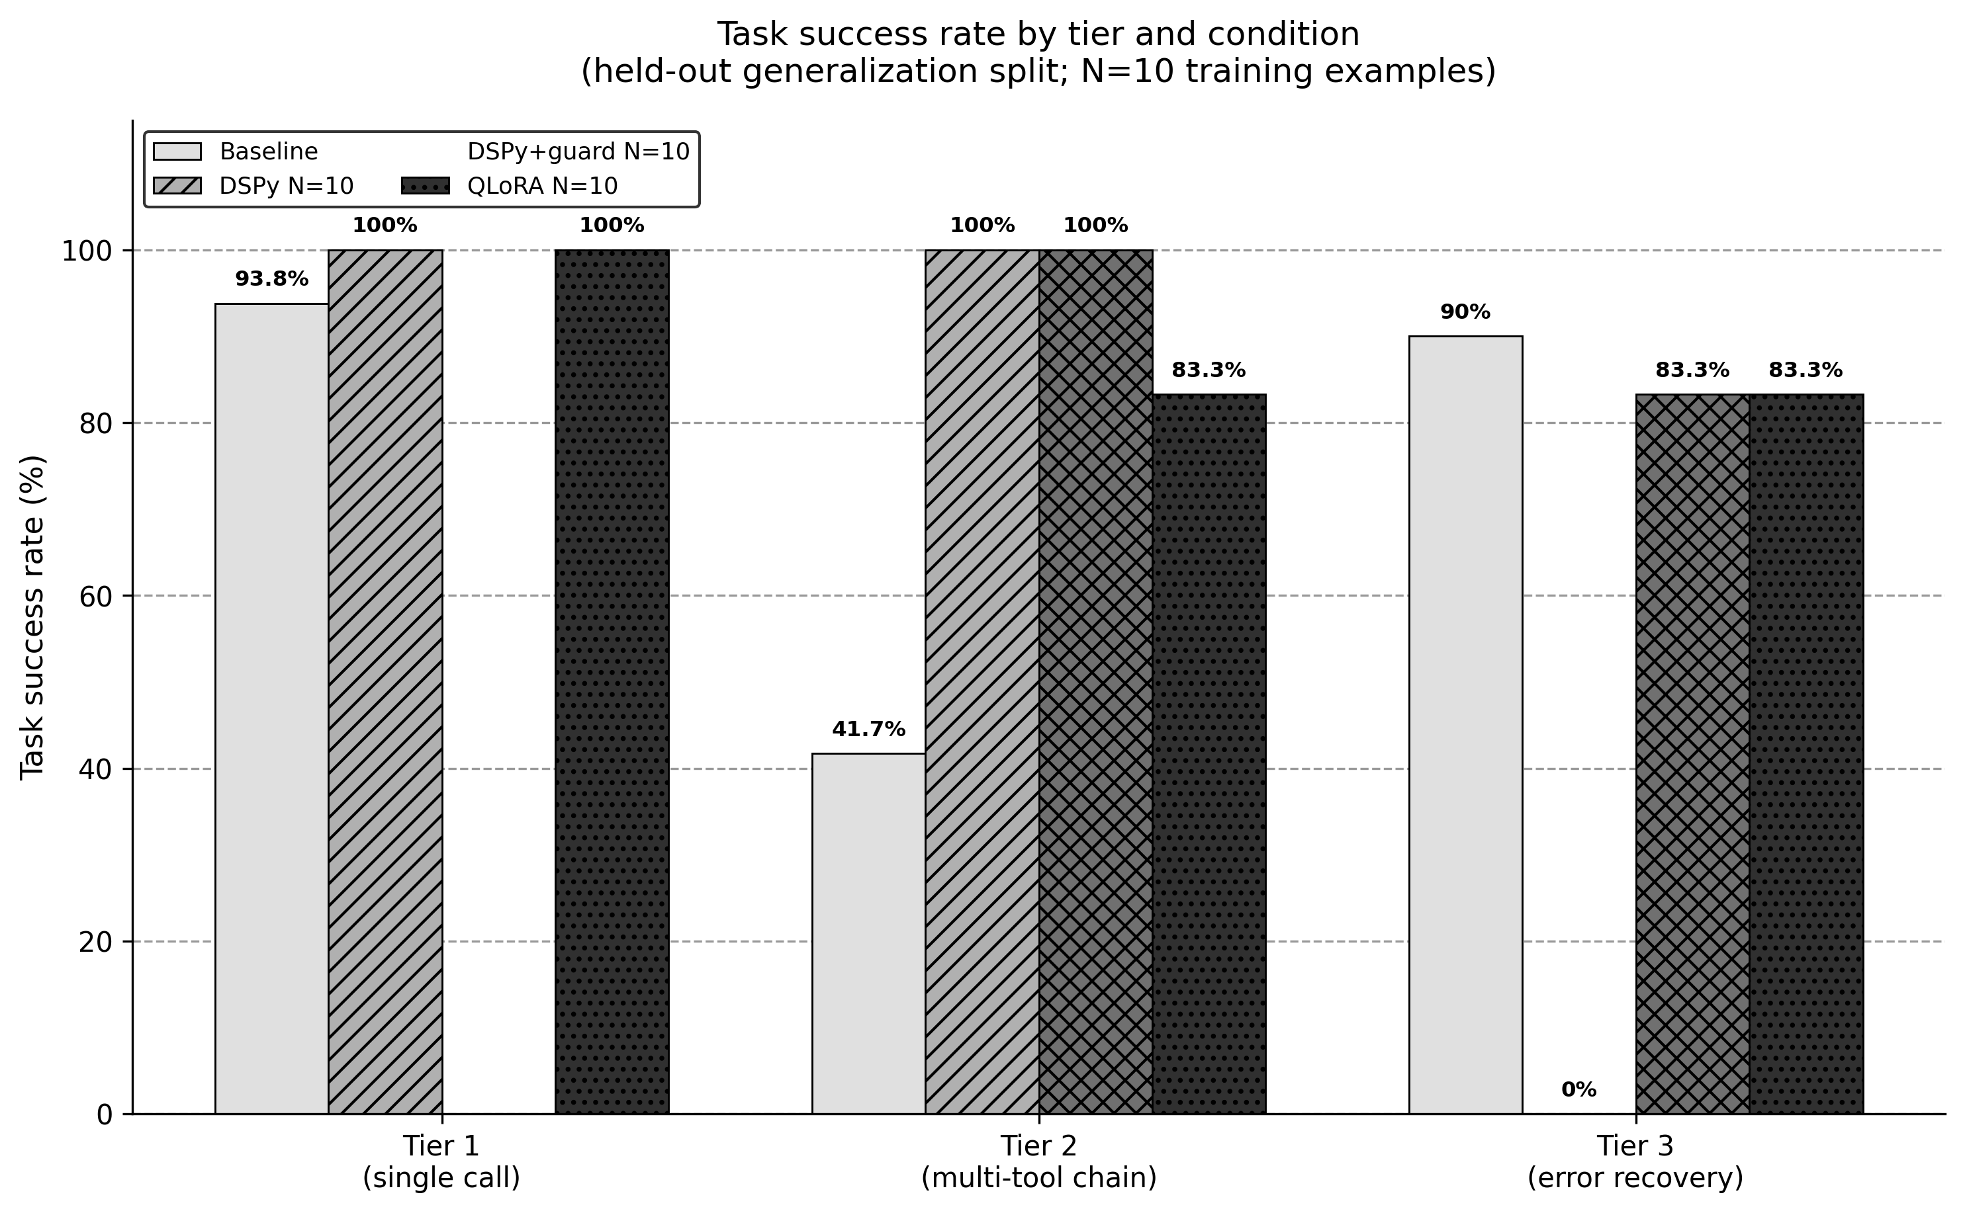
Figure 1. Task success rate by tier and condition (same data as Table 1). The repetition guard (DSPy+guard) recovers Tier 3 from complete failure to parity with QLoRA, without affecting Tier 2's already-perfect result.

Two clear patterns stand out before accounting for the guard. First, on Tier 1, the untouched baseline was already close to the ceiling, at 93.8%. Both DSPy and QLoRA reached 100%, no matter if they used 10 or 50 training examples. This tier simply does not leave enough room to tell the two methods apart. Second, on Tier 2, the baseline was far from the ceiling, at 41.7%. Both methods made large gains here. But DSPy-optimized prompting reached 100% at N=10, while QLoRA, fine-tuned on the exact same 10 examples, only reached 83.3%.
We treat this Tier 2 gap carefully rather than overstating it. The held-out set has only 6 tasks, so we computed an exact statistical comparison rather than reporting the raw percentages alone. The 95% exact binomial confidence interval for DSPy's 6/6 is [54.1%, 100%]; for QLoRA's 5/6 it is [35.9%, 99.6%]. These intervals overlap substantially. Because DSPy passed every task, the only possible discordant outcome is DSPy-pass/QLoRA-fail, of which there is exactly one; an exact McNemar-style test on this single discordant pair gives p = 1.0, meaning the observed gap is not statistically significant at this sample size. We report the gap because it is the actual result we observed, and because it lines up with a specific, checkable failure-mode explanation (Section 5), but we do not claim it as a firmly established effect.
On Tier 3, our initial (un-guarded) DSPy run failed on all 6 held-out tasks (0%, exact 95% CI [0%, 45.9%]), while QLoRA fine-tuning remained close to baseline at 83.3%. We inspected every DSPy failure directly rather than reporting the number alone. In 5 of 6 cases, the optimized program called the identical tool with identical arguments repeatedly, up to the 6-turn limit, without ever producing a final answer; for example, one task called get_weather with the same nonexistent city 6 times in a row. In the sixth case, the model called an unrelated tool with fabricated placeholder arguments, then produced malformed JSON attempting a second call.
With the repetition-guard mechanism (Section 3.5) added, DSPy's Tier 3 held-out success rate recovered from 0% to 83.3% (5/6, exact 95% CI [35.9%, 99.6%]) — exactly matching QLoRA's robustness on this tier. The regression check on Tier 2 confirmed the guard caused no harm: DSPy with the guard still reached 100% (6/6), identical to the un-guarded result. The one remaining Tier 3 failure with the guard in place is a different, third failure pattern: the model called search_flights with fabricated placeholder arguments instead of book_flight from the very first turn — an initial wrong-tool-selection error, not a repetition or parsing failure, and therefore not addressed by either guard. We report this honestly rather than claiming the guard resolves every failure mode it encounters.
Tier 3's baseline (90.0%) sits closer to Tier 1's ceiling than to Tier 2's open room. The one baseline failure here was a badly formed tool call (invalid JSON), not a reasoning mistake. Several results that looked like failed recoveries, under an early and narrow keyword-matching grader, turned out to be correct recoveries once we widened the grader's keyword list to match how the model actually phrased things (for example, "does not support" instead of the original "not supported"). This is a useful note for anyone building similar automatic recovery-detection graders: a narrow keyword list can miss real successes.
Table 2. Diagnosed failure patterns, compiled by directly inspecting model output rather than relying on the failure-type label alone.
Failure pattern | Where observed | Count | Description
Narrates plan instead of executing next call | Tier 2 Baseline; Tier 2 QLoRA N=10 | 3 | Model describes the remaining tool call in prose (e.g. "the book_flight function is then called with...") without actually emitting it.
Argument-substitution error on repeated call | Tier 2 Baseline | 1 | Calls the same tool twice with identical arguments instead of the two distinct values the task requires (e.g. get_weather('Tokyo') twice instead of two different cities).
Malformed tool-call JSON | Tier 3 Baseline; Tier 3 DSPy N=10 (un-guarded) | 2 | Produces a tool-call attempt with invalid JSON syntax (e.g. a missing closing quote), which fails to parse as any tool call.
Non-terminating identical-call repetition | Tier 3 DSPy N=10 (un-guarded) | 5 | Reissues the same failed tool call with identical arguments repeatedly, up to the turn limit, without using conversation history to recognize the call already failed. Resolved by the repetition guard (Section 3.5) in 5 of 5 cases.
Wrong tool selected (plausible near-miss) | Tier 1 Baseline; Tier 3 DSPy N=10 (both guarded and un-guarded) | 3 | Calls a related but incorrect tool (e.g. get_currency_rate instead of convert_currency, or search_flights instead of book_flight) from the first turn. Not addressed by the repetition/malformed-JSON guards, since the initial tool choice itself is wrong, not repeated or malformed.

Most Tier 2 baseline failures fell into two patterns. First, the model would describe the rest of the plan in words instead of actually making the next tool call (for example, saying "the book_flight function is then called with..." without really calling it). Second, the model made argument mistakes when calling the same tool twice in a row (for example, calling get_weather twice with the same city, instead of the two different cities the task required).

5. Discussion
The main finding is this: we cannot fairly judge automatic prompt optimization against fine-tuning without first checking how much room there is above the untouched baseline, and even where a real comparison is possible, we cannot assume one method wins across all agentic skills — nor should a catastrophic failure be treated as a fixed endpoint rather than something to diagnose and address. On Tier 1, both methods looked tied at 100%. This tie is fully explained by the baseline already sitting at 93.8% — there is simply no room left for either method to show a difference.
On Tier 2 and Tier 3, both tiers had real room above baseline. Before the guard, the two methods swapped places: DSPy led decisively on Tier 2 (100% vs. 83.3%) but failed completely on Tier 3 (0% vs. 83.3%). We diagnosed the Tier 3 failure directly rather than accepting the number as a black box: the optimized program repeatedly reissued the identical failed tool call, never using its own conversation history to recognize the call had already failed. This suggested a specific, fixable problem rather than a fundamental limitation of prompt optimization on this skill. The repetition-guard mechanism (Section 3.5) confirmed that suspicion: with a small, targeted addition to the program's control flow, requiring no change to the underlying optimization process, Tier 3 recovered to 83.3%, matching QLoRA. This reframes the paper's central finding: rather than "DSPy fails at error recovery," the more accurate and more useful claim is that DSPy's failure on this skill was diagnosable and directly fixable with a lightweight mechanism, once the specific behavioral pattern was identified.
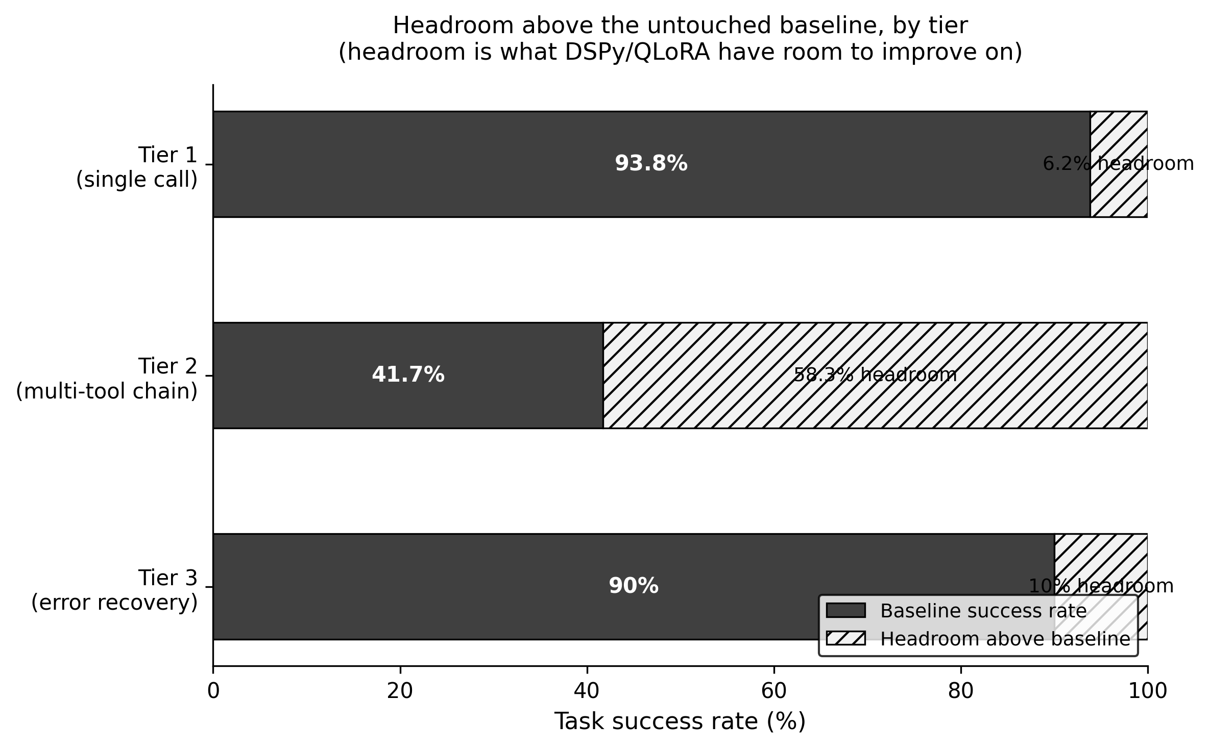
Figure 2. Headroom above the untouched baseline, by tier. Tier 2's large headroom is what allows a real gap between methods to appear; Tier 1's small headroom leaves little room for any method to differentiate itself.

This explanation for Tier 2's smaller gap is also directly confirmed, not just plausible. QLoRA's single Tier 2 miss (task t2_ho_004, "Check my calendar for 2026-08-03 and look up the price of a monitor") shows the same narrates-instead-of-executes pattern identified in the untouched baseline: the model correctly called get_calendar_events, received a real result, and then wrote a paragraph describing what the lookup_price function would return, instead of actually calling it. A good instruction and a few demonstrations, as DSPy provides, appear to correct this specific habit directly, while QLoRA's gradient update on 10 full chains did not fully suppress it on this held-out case.
For practitioners, the lesson is not "prefer prompt optimization" or "prefer fine-tuning" in general. It is to test both methods on the specific skill the agent needs, and to treat an unexpected failure as something to diagnose rather than a final verdict on a method's capability. Where the baseline is already near ceiling, as we saw for single tool calls (Tier 1), no comparison between methods will tell you much, no matter which one you pick. Where there is real room to improve, our results show both that prompt optimization can win decisively with very little data (Tier 2), and that an apparent catastrophic failure on a different skill (Tier 3) may be a specific, fixable behavioral pattern rather than a fundamental limit — direct inspection of failures, not just aggregate accuracy, is what makes the difference between the two conclusions.

6. Limitations
- We used only one base model (Llama-3.1-8B-Instruct) and one random seed per condition. Results may not carry over to other models, sizes, or seeds. A lightweight check on a second model (e.g. re-running just the Tier 2/3 baseline on Qwen2.5-7B-Instruct, which we already evaluated informally during model selection) would help establish whether the ceiling-effect and skill-dependent patterns generalize; we leave this to future work.
- We tested Tier 2 and Tier 3 at N=10 only. We leave the N=50 comparisons for these tiers, where the real DSPy-vs-QLoRA gaps appeared, to future work — unlike Tier 1's N=50, which added little since Tier 1 was already at ceiling at N=10.
- The Tier 2 (100% vs. 83.3%) and Tier 3-with-guard (83.3% vs. 83.3%) comparisons rest on 6 held-out tasks and a single seed per condition. We report exact confidence intervals in Section 4; the Tier 2 gap does not reach significance at this sample size (McNemar-style p = 1.0). Repeating both comparisons with multiple seeds, and expanding the held-out sets, would be the most direct way to confirm or disconfirm them at scale.
- The repetition guard was validated only on Tier 2 (regression check) and Tier 3 (main test), and only against the two failure modes it was designed for (identical repetition, malformed JSON). It did not, and was not expected to, fix the distinct wrong-tool-selection failure that remained in Tier 3's guarded result. We have not tested whether the guard helps or harms performance on other tasks or models.
- Our un-guarded DSPy Tier 3 result was obtained under the same deliberately reduced MIPROv2 configuration used throughout (fewer candidate instructions and examples, fewer trials, some meta-prompt features turned off), needed to fit inside a free GPU's memory limits. We cannot fully separate how much of the original 0% resulted from this constraint versus a more general tendency, though the guard's recovery to 83.3% under the same constrained configuration suggests the control-flow fix, not a larger search budget, was what mattered most here.
- We used deterministic simulated tools instead of real APIs. This removes real-world noise, such as rate limits, schema changes, and delays, that could affect agentic failures in a deployed system.
- Our task sets are small (10 to 16 tasks per tier, 6 to 8 held-out). One flipped result on a 6-task held-out set changes the reported rate by about 17 percentage points, which is why we report exact confidence intervals rather than percentages alone.
- Our Tier 2 training-data generator leaves out the flight-search-then-book pattern. The simulated world only has 6 possible flight routes, and all 6 are already used in the Tier 2 test and held-out sets, leaving no room to make new training examples without repeating test data.
- The failure-mode taxonomy in Table 2 was built and applied by a single author, without independent validation (e.g. a second grader or inter-rater agreement check). We caught and corrected one grader calibration issue during the study (Section 4), which increases our confidence in the final taxonomy but does not substitute for independent validation.

7. Conclusion
Across three tiers of agentic tool-use complexity, we find that automatic prompt optimization and fine-tuning cannot be fairly compared when the untouched baseline is already near the ceiling, and that even where a fair comparison is possible, neither method wins uniformly. Prompt optimization matched correct multi-step tool-chaining perfectly at just 10 examples, clearly outperforming fine-tuning on that skill. On a different skill, recognizing a tool error and stopping to report it, the same resource-constrained prompt optimization initially failed completely — but we diagnosed the specific cause directly from model output (repeated identical tool calls, ignoring conversation history) and built a lightweight repetition-guard mechanism that recovered performance to parity with fine-tuning, without affecting the tier that already worked. This shows that a method's advantage on one agentic skill does not transfer automatically to another, but also that an apparent catastrophic failure need not be treated as a fixed limitation: direct diagnosis of agentic failure modes can turn a negative result into both a more accurate finding and a concrete, reusable technical contribution.

Declarations
Funding: This research received no external funding. All experiments were run using freely available cloud GPU resources (Google Colab, free tier).
Conflict of Interest: The author declares no conflict of interest.
Ethical Approval: Not applicable. This study did not involve human participants, human data, or animals.
Data Availability: The task suite, grading code, training-data generators, and experimental results generated in this study are available at https://github.com/nive62tech/agentic-prompt-vs-finetune.
Author Contributions: N.S.N. designed the study, built the task suite and experimental pipeline, ran all experiments, diagnosed failure modes and designed the repetition-guard mechanism, analyzed the results, and wrote the manuscript.

References
[1] Khattab O, Singhvi A, Maheshwari P, Zhang Z, Santhanam K, Vardhamanan S, Haq S, Sharma A, Joshi TT, Moazam H, Miller H, Zaharia M, Potts C (2024) DSPy: compiling declarative language model calls into self-improving pipelines. International Conference on Learning Representations
[2] Opsahl-Ong K, Ryan MJ, Purtell J, Broman D, Potts C, Zaharia M, Khattab O (2024) Optimizing instructions and demonstrations for multi-stage language model programs. In: Proceedings of the 2024 Conference on Empirical Methods in Natural Language Processing, pp 9340–9366
[3] Dettmers T, Pagnoni A, Holtzman A, Zettlemoyer L (2023) QLoRA: efficient finetuning of quantized LLMs. Adv Neural Inf Process Syst 36:10088–10115
[4] Agrawal LA, Tan S, Soylu D, Ziems N, Khare R, Opsahl-Ong K, Singhvi A, Shandilya H, Ryan MJ, Jiang M, Potts C, Sen K, Dimakis AG, Stoica I, Klein D, Zaharia M, Khattab O (2026) GEPA: reflective prompt evolution can outperform reinforcement learning. International Conference on Learning Representations (Oral)
[5] Hu EJ, Shen Y, Wallis P, Allen-Zhu Z, Li Y, Wang S, Wang L, Chen W (2022) LoRA: low-rank adaptation of large language models. International Conference on Learning Representations
[6] Qin Y, Liang S, Ye Y, Zhu K, Yan L, Lu Y, Lin Y, Cong X, Tang X, Qian B, Zhao S, Hong L, Tian R, Xie R, Zhou J, Gerstein M, Li D, Liu Z, Sun M (2024) ToolLLM: facilitating large language models to master 16000+ real-world APIs. International Conference on Learning Representations
[7] Ghoshal S, Mittal A, Singh J, Ballesteros M, Sun W, Tu F, Singh S, Benajiba Y, Shah F, Bharadwaj S, Ravi S, Roth D (2026) JTPRO: a joint tool-prompt reflective optimization framework for language agents. In: Findings of the Association for Computational Linguistics: ACL 2026, pp 40573–40595
[8] Soylu D, Potts C, Khattab O (2024) Fine-tuning and prompt optimization: two great steps that work better together. In: Proceedings of the 2024 Conference on Empirical Methods in Natural Language Processing, pp 10696–10710
[9] Hou X, Wang S, Zhao Y, Wang H (2026) When agents do not stop: uncovering infinite agentic loops in LLM agents. arXiv:2607.01641
[10] Roitman H (2026) The hitchhiker's guide to agentic AI: from foundations to systems. arXiv:2606.24937

