SSN COLLEGE OF ENGINEERING, KALAVAKKAM
(An Autonomous Institution, Affiliated to Anna University, Chennai)
DEPARTMENT OF COMPUTER SCIENCE AND ENGINEERING
UCS1411 - OPERATING SYSTEMS LAB

NAME : NIVEDHITHA D
REGNO: 185001104

Lab Exercise 7: Implementation of Banker’s algorithm (deadlock avoidance)

AIM:
Develop a C program to implement the Banker’s algorithm for deadlock avoidance

DRIVER CODE: bankers.c

#include <stdio.h>
#include <stdlib.h>
#include <unistd.h>
#include <termios.h>

#define N 10

int P = 5;
int R = 3;

//FUNCTION TO IMPLEMENT getch() DUE TO THE ABSENCE OF <conio.h> IN gcc COMPILER

char getch()
{
char buf=0;

struct termios old={0};

fflush(stdout);

if(tcgetattr(0, &old)<0)
perror("tcsetattr()");

old.c_lflag&=~ICANON;
old.c_lflag&=~ECHO;
old.c_cc[VMIN]=1;
old.c_cc[VTIME]=0;

if(tcsetattr(0, TCSANOW, &old)<0)
perror("tcsetattr ICANON");

if(read(0,&buf,1)<0)
perror("read()");

old.c_lflag|=ICANON;
old.c_lflag|=ECHO;

if(tcsetattr(0, TCSADRAIN, &old)<0)
perror ("tcsetattr ~ICANON");

return buf;
}

// Function to read data
void read_data(int process[], char resource[], int available[], int maximum[][N], int allocated[][N])
{
printf("\n\n\tREAD DATA\n\n");

printf("\n\tEnter the number of processes: ");
scanf("%d", &P);

printf("\n\tProcess IDs\n\n");
for(int i=0; i<P; i++)
{
printf("\tEnter process ID: P");
scanf("%d", &process[i]);
}
printf("\n\tEnter the number of resources:");
scanf(" %d", &R);

printf("\n\tResource Details\n\n");
for(int i=0; i<R; i++)
{
printf("\tEnter resource ID: ");
scanf(" %c", &resource[i]);

printf("\tNumber of available instances: ");
scanf("%d", &available[i]);
}

printf("\n\tMaximum Requirement\n");
for(int i=0; i<P; i++)
{
printf("\n\tEnter maximum requirement for P%d:\n",process[i]);

for(int j=0; j<R; j++)
{
printf("\tFor resource %c: ", resource[j]);
scanf("%d", &maximum[i][j]);
}
}

printf("\n\tAllocated\n");
for(int i=0; i<P; i++)
{
printf("\n\tEnter allocated instances for P%d:\n",process[i]);

for(int j=0; j<R; j++)
{
printf("\tFor resource %c: ", resource[j]);
scanf("%d", &allocated[i][j]);
}
}
}

// Function to print the data in the form of a table
// NOTE: This formatting works only for a max of 4 no. of resources
void print_table(int process[], char resource[], int available[], int maximum[][N], int allocated[][N], int need[][N])
{
// For reference, in case the table formatting requires change
// 7 12 12 12 12

printf("\n\n\tPRINT DATA\n\n");

printf("\n\t+-------+------------+------------+------------+------------+");
printf("\n\t| PID | Allocation | Maximum | Need | Available |");
printf("\n\t+-------+------------+------------+------------+------------+");

// To print the Resource Names
printf("\n\t| |");
for(int i=0; i<4; i++)
{
for(int j=0; j<R; j++)
printf("%*c", 12/R, resource[j]);
printf("|");
}

printf("\n\t+-------+------------+------------+------------+------------+");

// To print the details of each process
for(int i=0; i<P; i++)
{
printf("\n\t| P%d |", process[i]);

for(int j=0; j<R; j++)
printf("%*d", 12/R, allocated[i][j]);
printf("|");

for(int j=0; j<R; j++)
printf("%*d", 12/R, maximum[i][j]);
printf("|");

for(int j=0; j<R; j++)
printf("%*d", 12/R, need[i][j]);
printf("|");

for(int j=0; j<R; j++)
{
if(i == 0)
printf("%*d", 12/R, available[j]);
else
{
printf(" ");
break;
}
}
printf("|");

printf("\n\t+-------+------------+------------+------------+------------+");
}
}

// Function to find the need of each process
void calculateNeed(int need[][N], int maximum[][N], int allocated[][N])
{
// Calculating Need of each P
for (int i = 0 ; i < P ; i++)
for (int j = 0 ; j < R ; j++)
need[i][j] = maximum[i][j] - allocated[i][j];
}

// Safety Algorithm Function
int isSafe(int available[], int maximum[][N], int allocated[][N], int need[][N])
{
int finish[N];
int safeSeq[N];
int work[N];
int flag;
int index ;

// Marking all processes as unfinishished
for(int i=0; i<P; i++)
finish[i] = 0;

//Calculating work matrix
for (int i=0; i<R ; i++)
work[i] = available[i];

index = 0;
for (int p=0; p<P; p++)
{
for (int i=0; i<P; i++)
{
if (finish[i] == 0)
{
flag = 0;

for (int j=0; j<R; j++)
{
if (need[i][j] > work[j])
{
flag = 1;
break;
}
}

if (flag == 0)
{
safeSeq[index++] = i;
for (int k=0; k<R; k++)
work[k] += allocated[i][k];
finish[i] = 1;
}
}
}

if (flag == 1)
{
printf("\n\n\tUNSAFE: System is not in safe state !");
return 0;
}
}

printf("\n\n\tSAFE STATE: System is in safe state !");
printf("\n\n\tSAFETY SEQUENCE: ");
printf("< ");
for (int i = 0; i < P ; i++)
printf("P%d, ", safeSeq[i]);

printf("\b\b >");
printf("\n");

return 1;
}

// MAIN PROGRAM

int main()
{
char choice;

int process[N];
char resource[N];

int available[N];
int maximum[N][N];
int allocated[N][N];

int need[N][N];
// Default problem details used for testing
// This is provided to quickly check if the program works and for debugging purposses

// If read data isn't chosen, this is the problem solved
// When data is given by the user, user-defined problem is solved

// Process IDs
process[0] = 0;
process[1] = 1;
process[2] = 2;
process[3] = 3;
process[4] = 4;

// Resources IDs
resource[0] = 'A';
resource[1] = 'B';
resource[2] = 'C';

// Available instances of resources
available[0] = 3;
available[1] = 3;
available[2] = 2;

// Maximum R that can be allocated
// to processes
maximum[0][0] = 7;
maximum[0][1] = 5;
maximum[0][2] = 3;

maximum[1][0] = 3;
maximum[1][1] = 2;
maximum[1][2] = 2;

maximum[2][0] = 9;
maximum[2][1] = 0;
maximum[2][2] = 2;

maximum[3][0] = 2;
maximum[3][1] = 2;
maximum[3][2] = 2;

maximum[4][0] = 4;
maximum[4][1] = 3;
maximum[4][2] = 3 ;

// Resources allocated to processes
allocated[0][0] = 0;
allocated[0][1] = 1;
allocated[0][2] = 0;

allocated[1][0] = 2;
allocated[1][1] = 0;
allocated[1][2] = 0;

allocated[2][0] = 3;
allocated[2][1] = 0;
allocated[2][2] = 2;

allocated[3][0] = 2;
allocated[3][1] = 1;
allocated[3][2] = 1;

allocated[4][0] = 0;
allocated[4][1] = 0;
allocated[4][2] = 2;

system("clear");

//DISPLAYING THE MENU

do
{
system("clear");

printf("\n\n\t+----------------------------+\n");
printf("\t\tMENU OPTIONS\n");
printf("\t+----------------------------+\n\n");

printf("\t1. READ DATA\n\n");
printf("\t2. PRINT DATA\n\n");
printf("\t3. SAFETY SEQUENCE\n\n");
printf("\t4. EXIT\n\n");

printf("\n\n\tENTER choice: ");
scanf(" %c", &choice);

switch(choice)
{
case '1': system("clear");
read_data(process, resource, available, maximum, allocated);

getch();
break;

case '2':
// Calculating need matrix
calculateNeed(need, maximum, allocated);
print_table(process, resource, available, maximum, allocated, need);
getch();
break;

case '3': calculateNeed(need, maximum, allocated);
isSafe(available, maximum, allocated, need);

getch();
break;

case '4': system("clear");
return 0;
break;

default: printf("\n\tINVALID OPTION .....!!!!!\n\n");
getch();
}
}while(choice!=5);
}

OUTPUT:

TEST:(for checking and debugging w/o giving input)

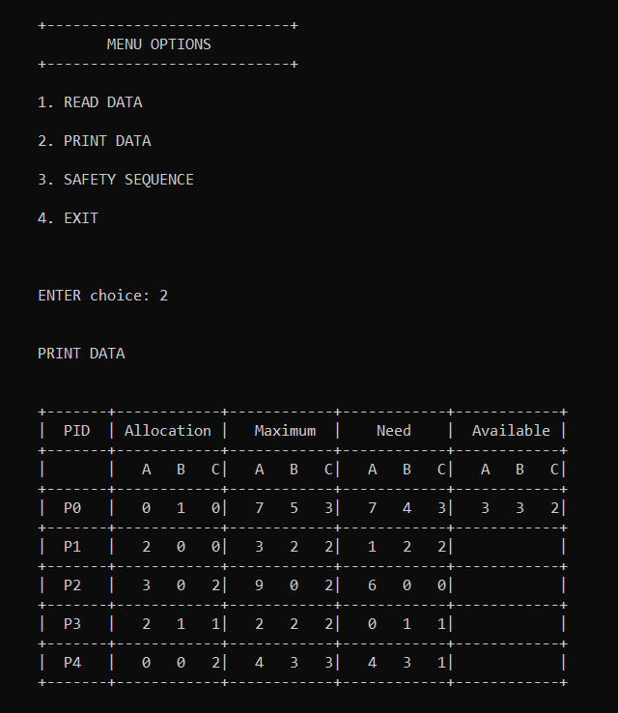
+-------------------------------------+ MENU OPTIONS +-------------------------------------+ 1. READ DATA 2. PRINT DATA 3. SAFETY SEQUENCE 4. EXIT
ENTER choice: 3

SAFE STATE: System is in safe state !
SAFETY SEQUENCE: < P1, P3, P4, P0, P2 >

+-------------------------------------+ MENU OPTIONS +-------------------------------------+ 1. READ DATA 2. PRINT DATA 3. SAFETY SEQUENCE 4. EXIT
ENTER choice: 4

RUN1:

+-------------------------------------+ MENU OPTIONS +-------------------------------------+ 1. READ DATA 2. PRINT DATA 3. SAFETY SEQUENCE 4. EXIT
ENTER choice: 1

READ DATA
Enter the number of processes: 5
Process IDs Enter process ID: P0
Enter process ID: P1
Enter process ID: P2
Enter process ID: P3
Enter process ID: P4

Enter the number of resources:4

Resource Details Enter resource ID: A
Number of available instances: 3
Enter resource ID: B
Number of available instances: 2
Enter resource ID: C
Number of available instances: 1
Enter resource ID: D
Number of available instances: 1

Maximum Requirement Enter maximum requirement for P0:
For resource A: 6
For resource B: 0
For resource C: 1
For resource D: 2

Enter maximum requirement for P1:
For resource A: 2
For resource B: 7
For resource C: 5
For resource D: 0
Enter maximum requirement for P2:
For resource A: 2
For resource B: 3
For resource C: 5
For resource D: 6

Enter maximum requirement for P3:
For resource A: 1
For resource B: 6
For resource C: 5
For resource D: 3

Enter maximum requirement for P4:
For resource A: 1
For resource B: 6
For resource C: 5
For resource D: 6

Allocated Enter allocated instances for P0:
For resource A: 4
For resource B: 0
For resource C: 0
For resource D: 1

Enter allocated instances for P1:
For resource A: 1
For resource B: 1
For resource C: 0
For resource D: 0

Enter allocated instances for P2:
For resource A: 1
For resource B: 2
For resource C: 5
For resource D: 4

Enter allocated instances for P3:
For resource A: 0
For resource B: 6
For resource C: 3
For resource D: 3

Enter allocated instances for P4:
For resource A: 0
For resource B: 2
For resource C: 1
For resource D: 2

+-------------------------------------+ MENU OPTIONS +-------------------------------------+ 1. READ DATA 2. PRINT DATA 3. SAFETY SEQUENCE 4. EXIT
ENTER choice: 2

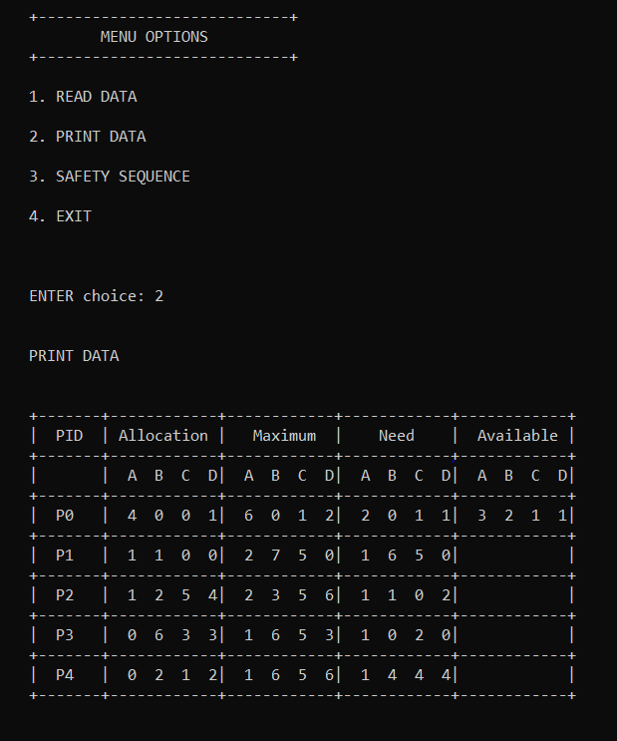

+-------------------------------------+ MENU OPTIONS +-------------------------------------+ 1. READ DATA 2. PRINT DATA 3. SAFETY SEQUENCE 4. EXIT
ENTER choice: 3

SAFE STATE: System is in safe state !

SAFETY SEQUENCE: < P0, P2, P3, P4, P1 >

+-------------------------------------+ MENU OPTIONS +-------------------------------------+ 1. READ DATA 2. PRINT DATA 3. SAFETY SEQUENCE 4. EXIT
ENTER choice: 4

