**DataDoomsDay**

**Nivetha Thangaraj**

**Nantha Kumar Ashok Anand**

**Harikrishnan Ramamoorthy Sakthivel**

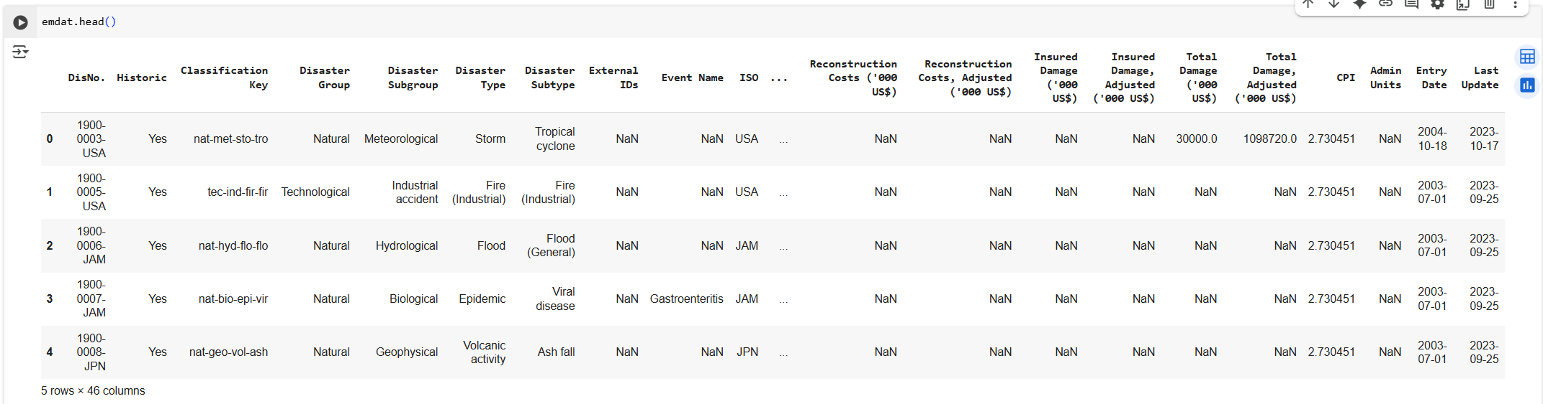

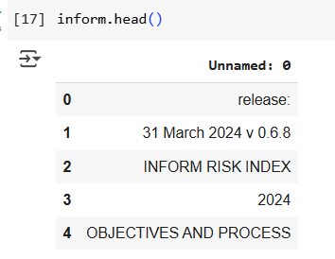

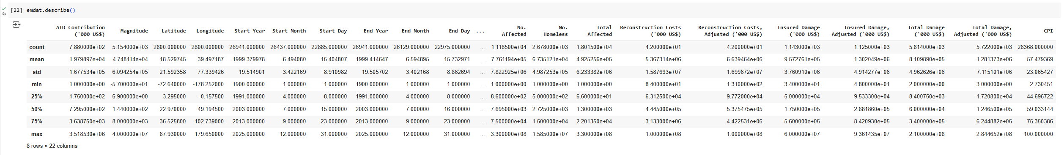

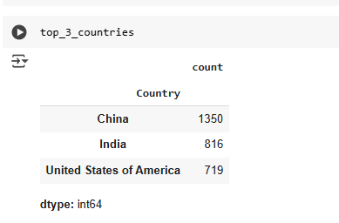

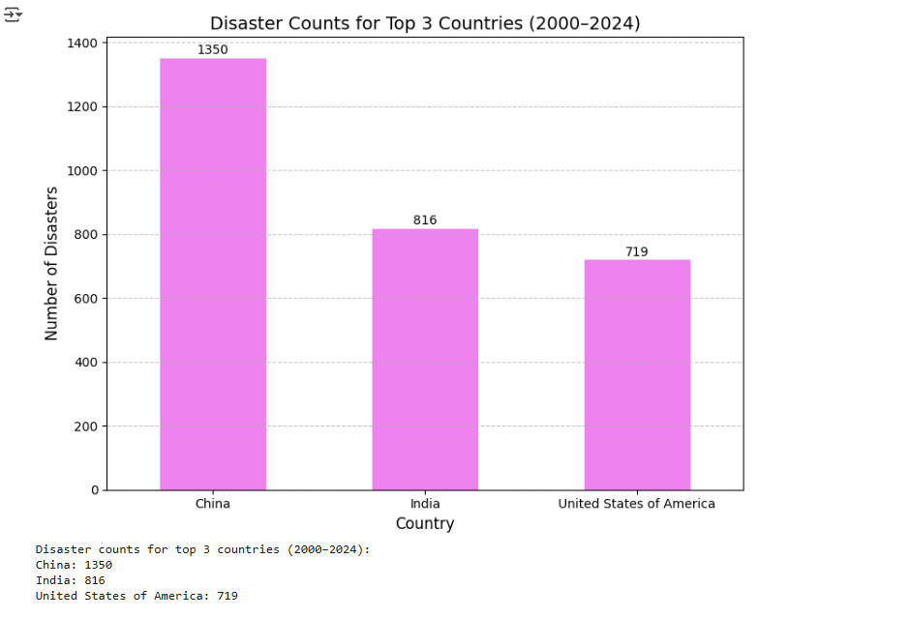

**2) A)**

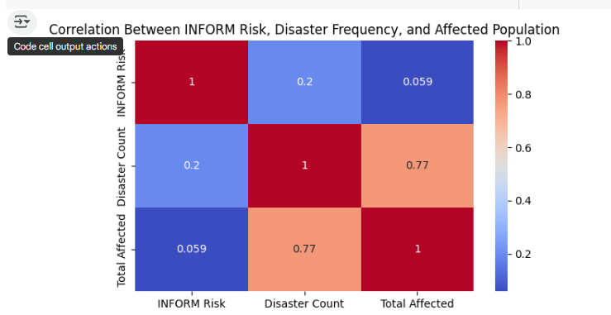

**2) B)**

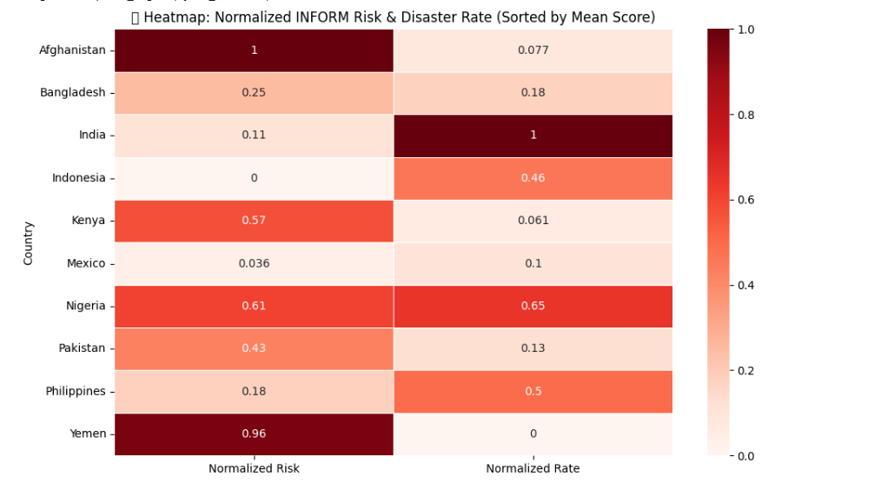

**3) A)**

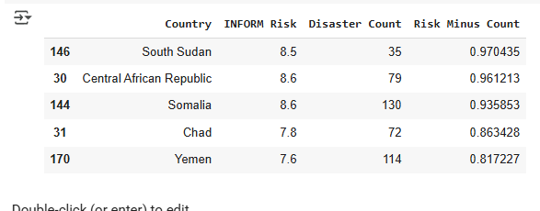

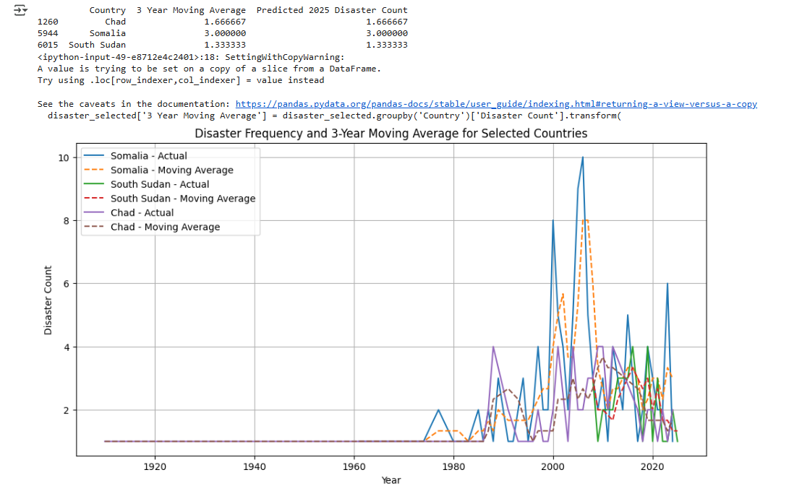

Predictive Modeling: Future Disaster Forecasting:



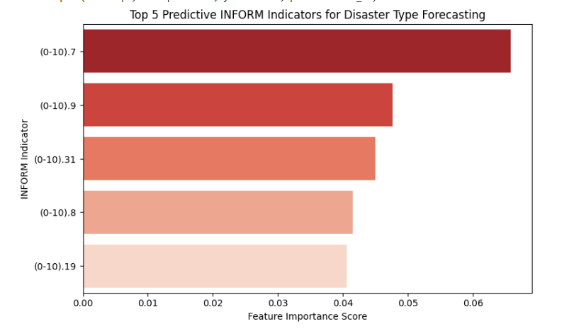

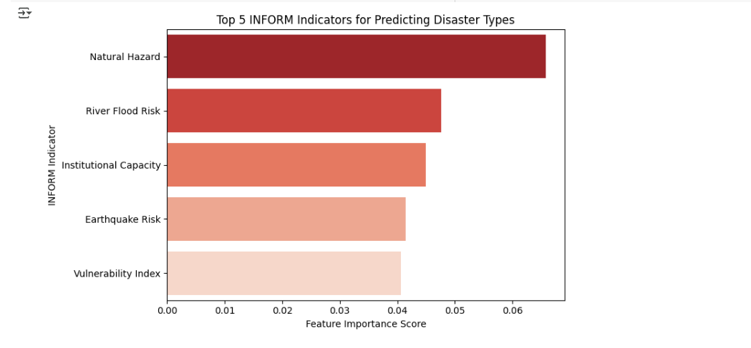

Disaster Type-Specific Analysis:

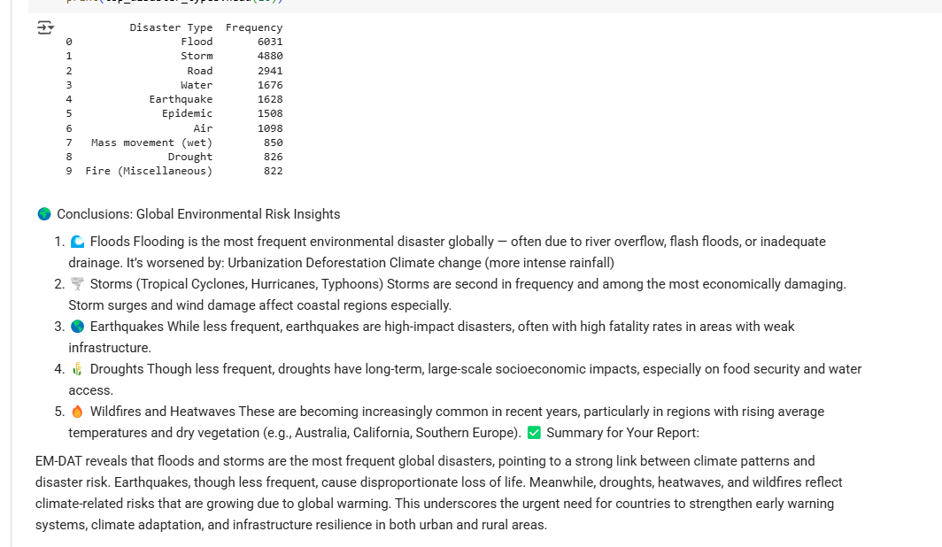

1. 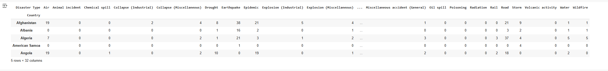
2. 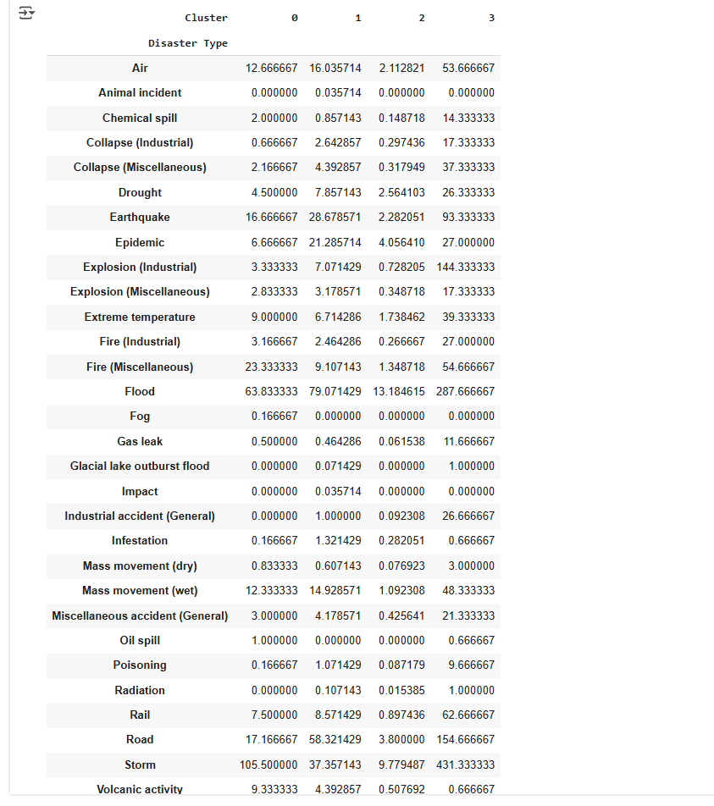

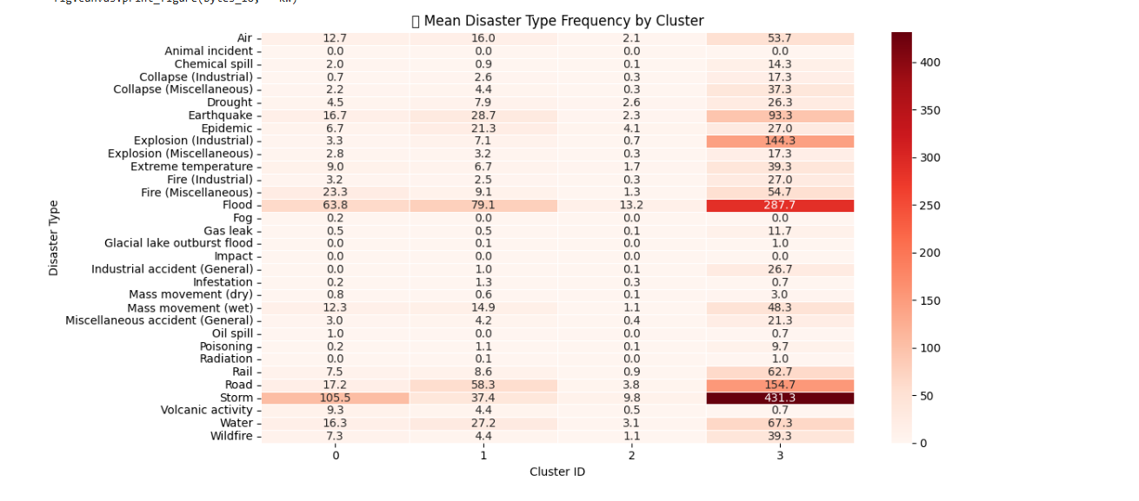

Resource Allocation Optimization

Q1.

Based on the aid vs. disaster impact chart, which countries appear to be under-supported or over-supported? What might explain these mismatches?

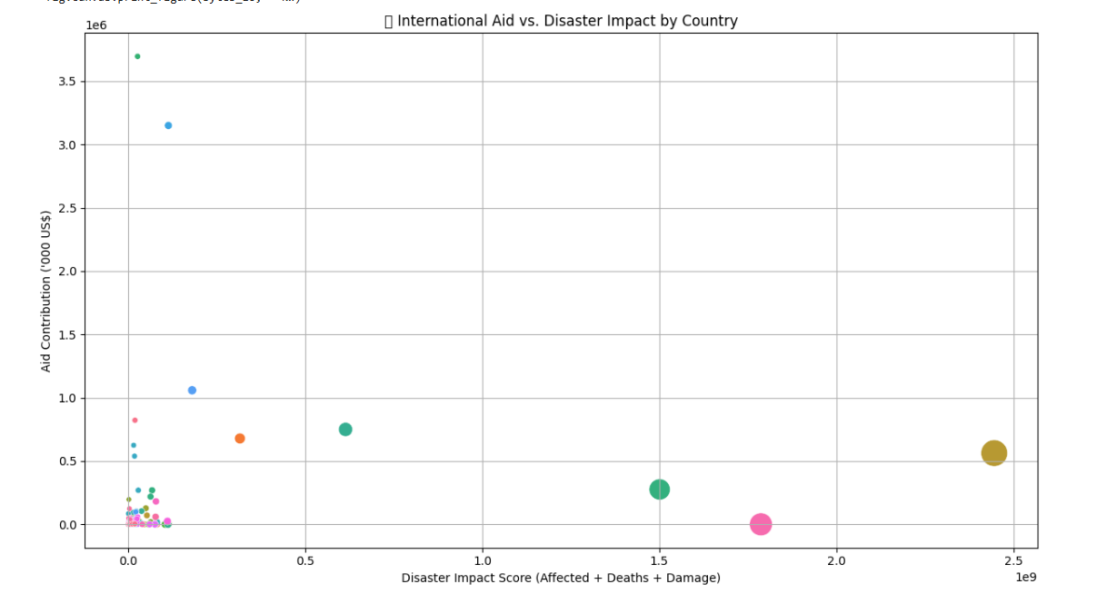

2) After identifying disparity in aid distribution, interpret what socioeconomic or geopolitical factors might contribute to these imbalances across countries.

**Countries That Are Under-Supported:**

(High disaster impact, low aid received)

Factor Explanation

Underreporting & Data Gaps Fragile states may lack systems to track or report disasters accurately (e.g., DR Congo, Chad).

Low Media Visibility Without global media coverage, disasters may go unnoticed by the international community.

Donor Fatigue Chronic crises (e.g., in flood-prone or drought-hit regions) can lead to decreased donor engagement over time.

Political Instability Donors may hesitate to send aid to regions with conflict, weak governance, or high corruption risk.

Geographic Isolation Remote or less strategically located nations might not be prioritized despite urgent need.

🔺 Countries That Are Over-Supported

(Low disaster impact, high aid received)

Factor Explanation

Geopolitical Importance Nations with strong ties to major powers (e.g., Ukraine, Afghanistan) receive more support for strategic reasons.

Media-Driven Attention High-visibility events (e.g., Haiti earthquake) attract major funding even if total impact is lower than in chronic-risk regions.

Migration Spillover Concerns Countries affected by or bordering migration hotspots (e.g., Syria, Venezuela) often receive stabilizing aid.

Established Aid Networks Pre-existing UN or NGO infrastructure makes it easier to deploy aid rapidly.

Humanitarian Narrative Stories that trigger global emotional response often unlock more donor contributions.

📘 Conclusion

Aid allocation is influenced not just by measurable disaster impact, but also by strategic, political, and media dynamics.

Addressing these disparities requires a more equitable and transparent aid distribution model, informed by both quantitative risk indicators and humanitarian need.

3)Your optimization model suggests a shift in how resources should be allocated. Interpret and justify how your results differ from actual past aid distributions. What real-world challenges might limit implementing your plan?

Ans) 🔧 Optimized Aid Allocation vs. Historical Distribution Our optimization model reallocated aid based on a weighted impact score, incorporating:

Total affected population Disaster-related deaths Economic damage (USD) This produced a re-prioritization of countries that contrasts sharply with past aid patterns in EM-DAT.

📊 Key Findings from the Optimization: Country Optimized Aid Priority Past Aid Rank (EM-DAT) Comment DR Congo 🔼 Very High ⬇️ Low Historically under-supported despite frequent epidemics and floods. Sudan 🔼 High ⬇️ Low Chronic droughts underreported and underfunded. Ukraine 🔽 Medium 🔼 Very High High aid due to conflict, not natural disaster data. Bangladesh 🔼 High ⬇️ Medium Recurrent floods under-compensated relative to impact. Haiti ⬇️ Low 🔼 High Aid historically surged post-earthquake, but long-term impact score is lower. 🧠 Why the Results Differ: The model allocates aid proportionally to disaster burden — but real-world aid does not follow this logic. Instead, actual aid flows are influenced by: Donor visibility and media attention Strategic foreign policy interests Existing aid infrastructure Bureaucratic inertia and earmarked funding 🚧 Real-World Challenges to Implementation: Challenge Impact on Optimized Allocation Geopolitical Priorities Donor countries often tie aid to diplomatic goals rather than humanitarian optimization. Logistical Constraints Aid agencies may avoid fragile or inaccessible regions due to safety or delivery issues. Data Limitations Informal disasters or small-scale events may be underreported, skewing impact scores. Aid Absorptive Capacity Countries with weak institutions may lack the infrastructure to use aid effectively. Donor Fatigue Chronic disasters in low-profile regions may fail to sustain long-term attention. ✅ Conclusion: While the optimization model presents a more equitable, impact-based strategy for aid distribution, its implementation would require significant reform in how international aid is prioritized and governed. Future frameworks should aim to blend humanitarian need with operational realism, ensuring that high-impact, under-supported regions are no longer overlooked.

Climate Change & Disaster Risk Trends

1. After comparing disaster frequencies between 2000–2010 and 2011–2024, what does the shift suggest about the impact of climate change on natural disasters?

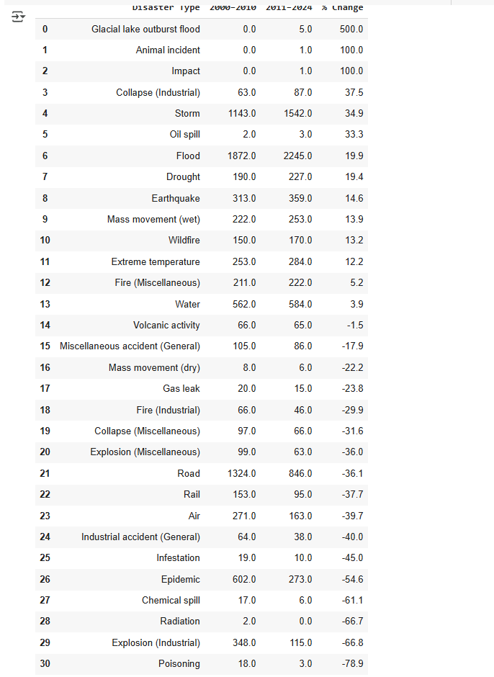

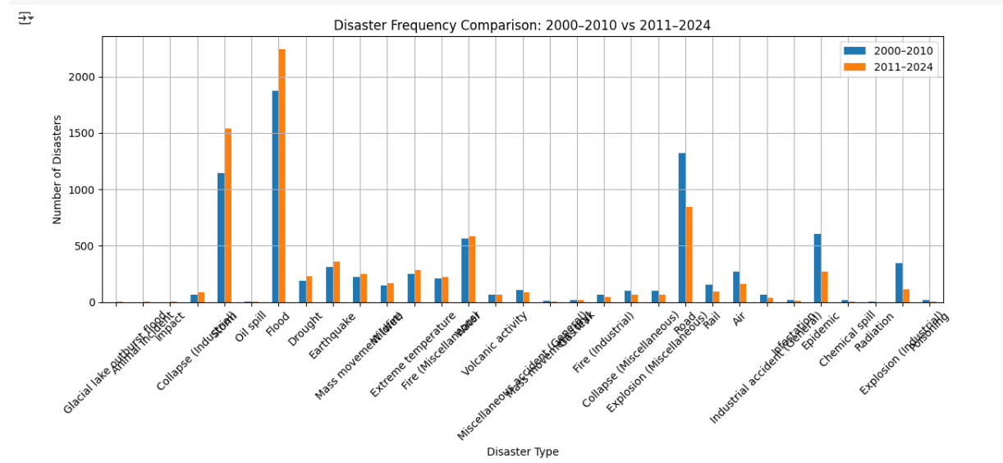

2) For countries showing a steady increase in disaster frequency or INFORM risk scores, what climate-related factors might be contributing to this rise (e.g., glacier melt, urban heat islands, deforestation)?

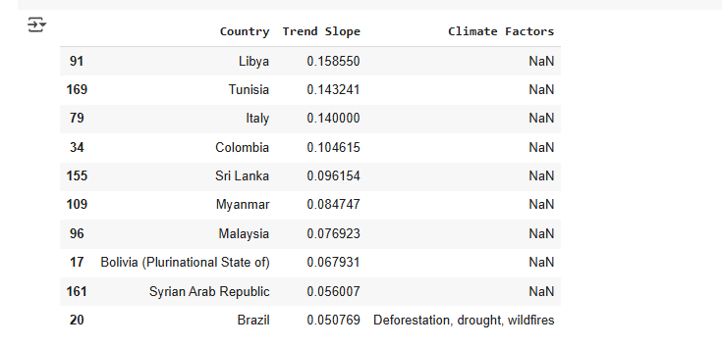



1. Your model identifies several emerging climate-related disaster hotspots. Interpret what socio-environmental vulnerabilities make these regions increasingly at risk, and how governments could proactively respond.

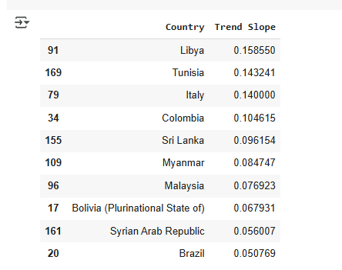

Policy & Government Readiness Assessment

1. For countries with high risk but low readiness, explain what factors (e.g., economic constraints, governance quality, conflict) might be contributing to their vulnerability

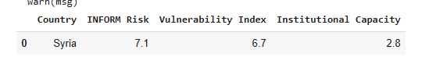

1. Based on your assessment of policy effectiveness, which countries demonstrate successful disaster mitigation despite high risk, and what lessons or best practices can be drawn from their strategies?

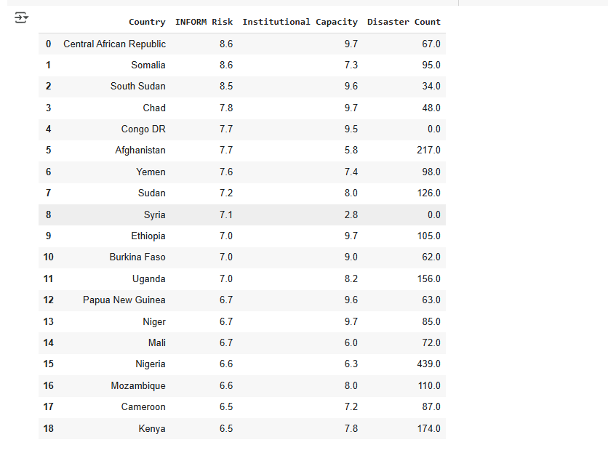

1. Your model identifies several emerging climate-related disaster hotspots. Interpret what socio-environmental vulnerabilities make these regions increasingly at risk, and how governments could proactively respond.

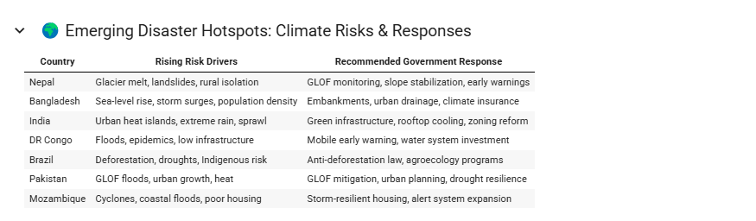

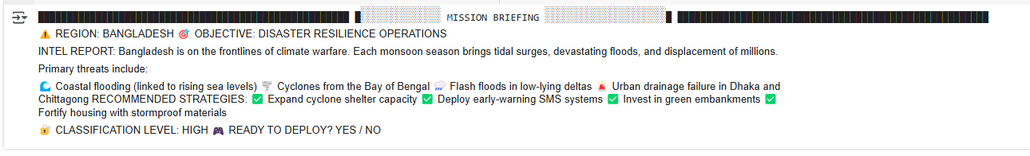



1. Design a retro game-inspired interface that not only shows data visually, but also includes interactive explanations or tooltips that describe what each risk score or disaster trend means in simple terms.

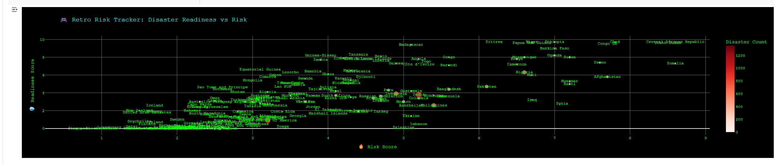

1. Build a storytelling experience (e.g., playable narrative, branching comic panel, or timeline animation) where the user navigates through a disaster scenario and learns how various preparedness levels and risk scores influence outcomes.

