**MINI PROJECT REPORT**

**Facial Recognition AttendanceSystem**

**Mini Project report submitted in partial fulfillment of the Requirements for the Award of**

**the Degree of**

**BACHELOR OF TECHNOLOGY**

**In**

**COMPUTER SCIENCE AND ENGINEERING**

**By**

**Nived K V - TLY21CS045 Ouchith Rajeendran - TLY21CS046 Sangeerth A K- TLY21CS052 Sreenand N- TLT21CS058**

**Under the Guidance of**

**Rinil**



**DEPARTMENT OF COMPUTER SCIENCE AND ENGINEERING**

**COLLEGE OF ENGINEERING THALASSERY**

**AFFILIATED TO A P J ABDUL KALAM TECHNOLOGICAL UNIVERSITY, KERALA**

**2022**

**i**

**COLLEGE OF ENGINEERING THALASSERY**

**DEPARTMENT OF COMPUTER SCIENCE AND ENGINEERING**



CERTIFICATE

This is to certify that the project report entitled **Facial Recognition Attendance System,** submitted by **Nived K V, Ouchith Rajeendran, Sangeerth A K, Sreenand N** in the

partial fulfillment for the award of the Degree of Bachelor of Technology in Computer Science

and Engineering to **A P J ABDUL KALAM TECHNOLOGICAL UNIVERSITY, KERALA,** is a record of bonafied work carried out under my guidance and supervision.

**Mr. Rinil**

Asst. Prof., Dept. of CSE

College Of Engineering,Thalassery

(Project Guide)

**Mrs. Shejina & Mrs. Asha**

Asst. Prof., Dept. of CSE

College of Engineering,Thalassery

(Project Coordinators)

**HEAD OF THE DEPARTMENT**

**DATED SIGNATURE**

**ii**

**ACKNOWLEDGEMENT**

We would like to express our sincere gratitude to all those who have contributed to the successful completion of this project. Firstly, we would like to thank our Principal for providing us with the necessary infrastructure and resources to carry out this project. We extend our heartfelt appreciation to our project guide, **Asst. Prof. Rinil**, for providing us with invaluable guidance and support throughout the project. She has been a constant source of motivation and has provided us with insightful feedback that has helped us shape our project. We also extend our sincere thanks to our project coordinator, **Prof. Shejina and Prof.Asha Vijayan**, for coordinating the project and providing us with the necessary resources and facilities to complete the project.

We are also grateful to the Head of the Department for providing us with the opportunity to carry out this project and for supporting us throughout the project. Their trust in our abilities gave us the confidence to take on this challenging project. We would like to acknowledge all the faculty members who provided us with their valuable insights and feedback throughout the project. Their guidance and support have been instrumental in the success of this project.

Finally, we would like to thank our families and friends who supported us during the ups and downs of this project. We are grateful for their encouragement and understanding. In conclusion, we express our sincere gratitude to all those who have contributed to the successful completion of this project. Each and every contribution has been valuable and we appreciate the effort put in by everyone involved.

**iii**

**CONTENTS**

**CHAPTER PAGE_NUMBER**

**1. Introduction** 1

**2. Literature Survey 2**

**3.** **Problem statement 3**

**4. Existing system 4**

**5. Proposed system 5**

**6. Software and hardware requirements 5**

**6.1 Software Requirements 6**

**6.2 Hardware Requirements 6**

**7. Development tools 8**

**7.1 Integrated Development Environment 8**

**7.2 Computer Vision Libraries 8**

**7.3 Face Recognition Library 8**

**7.4 Version Control System 9**

**8. Software Design 10**

**8.1 System Architecture 10**

**8.2 Use case diagram 11**

**9. Modular divisions 11**

**9.1 User interface module 12**

**9.2 Face Detection Module 12**

**9.3 Face Alignment Module 12**

**9.4 Face Extraction Module 12**

**9.5 Face Matching Module 12**

**9.6 Attendance Management Module 12**

**10. Coding procedure 13**

**10.1 Requirement Analysis 13**

**10.2 System Design 13**

**10.3 Technology Selection 13**

**10.4 User Interface Development 14**

**10.5 Face Recognition 14**

**10.6 Attendance Management 14**

**11. User Interface 15**

**12. Conclusion 16**

**13. Bibliography 17**

## 1.Introduction

## Face Recognition Attendance System (FRAS) is the complete system to record attendance without much interference in very less time. It saves time and effort of the teacher in the university where we only get one hours of time for one class. FRAS record attendance with the help of face recognition. It marks the attendance of all students in the class by obtaining data from the database and match with present face data and saves the result in the database (Excel Sheet). This system makes the attendance process easy and minimizes the interference of the teachers. Which provides them more time to teach and take full advantage of their period time. The main objective of this project is to develop face recognition based automated student attendance system. In order to achieve better performance, the test images and training images of this proposed approach are limited to frontal and upright facial images that consist of a single face only. The test images and training images must be captured by using the same device to ensure no quality difference. In addition, the students must register in the database to be recognized. The enrolment can be done on the spot through the user-friendly interface.

## 2.Literature Survey

Survey provides an overview of various facial recognition techniques used in attendance systems, including eigenface, Fisherface, and deep learning-based approaches. It discusses the strengths and limitations of each technique and explores their applications in educational institutions, workplaces, and other settings.

This research paper presents a real-time facial recognition attendance system based on deep learning techniques. It describes the architecture of the system, which includes a convolutional neural network (CNN) for face detection and recognition. Experimental results demonstrate the system's accuracy and efficiency in capturing attendance data.

Here this paper proposes a privacy-preserving facial recognition attendance system that employs to protect sensitive biometric data. It discusses the design and implementation of the system, highlighting how encryption techniques can be applied to ensure data security while maintaining the system's functionality.

It examines how these systems can help enforce social distancing measures and contactless attendance tracking in educational institutions and workplaces like the situation of pandemic COVID-19

This study compares different facial recognition attendance systems available in the market, evaluating their accuracy, usability, and cost-effectiveness. It provides insights into the features and functionalities offered by each system and offers recommendations for selecting the most suitable solution based on specific requirements.

**3**

## 3.Problem Statement

Traditional student attendance marking technique is often facing a lot of trouble. The face recognition student attendance system emphasizes its simplicity by eliminating classical student attendance marking technique such as calling student names or checking respective identification cards. There are not only disturbing the teaching process but also causes distraction for students during exam sessions. Apart from calling names, attendance sheet is passed around the classroom during the lecture sessions. The lecture class especially the class with a large number of students might find it difficult to have the attendance sheet being passed around the class. Thus, face recognition attendance system is proposed in order to replace the manual signing of the presence of students which are burdensome and causes students get distracted in order to sign for their attendance. Furthermore, the face recognition based automated student attendance system able to overcome the problem of fraudulent approach and lecturers does not have to count the number of students several times to ensure the presence of the students.

The paper proposed by Zhao, W et al. (2003) has listed the difficulties of facial identification. One of the difficulties of facial identification is the identification between known and unknown images. In addition, paper proposed by Pooja G.R et al. (2010) found out that the training process for face recognition student attendance system is slow and time-consuming. In addition, the paper proposed by Priyanka Wagh et al. (2015) mentioned that different lighting and head poses are often the problems that could degrade the performance of face recognition based student attendance system. Hence, there is a need to develop a real time operating student attendance system which means the identification process must be done within defined time constraints to prevent omission. The extracted features from facial images which represent the identity of the students have to be consistent towards a change in background, illumination, pose and expression. High accuracy and fast computation time will be the evaluation points of the performance.

## 4.Existing System

Calling name or roll number of the student for attendance is not only a problem of time consumption but also it needs energy. So an automatic attendance system can solve all above problems. There are some automatic attendances making system which are currently used by much institution. One of such system is biometric technique and RFID system. Although it is automatic and a step ahead of traditional method it fails to meet the time constraint. The student has to wait in queue for giving attendance, which is time taking.

Arun Katara et al. (2017) mentioned disadvantages of RFID (Radio Frequency Identification) card system, fingerprint system and iris recognition system. RFID card system is implemented due to its simplicity. However, the user tends to help their friends to check in as long as they have their friend’s ID card. The fingerprint system is indeed effective but not efficient because it takes time for the verification process so the user has to line up and perform the verification one by one. However for face recognition, the human face is always exposed and contain less information compared to iris. Iris recognition system which contains more detail might invade the privacy of the user. Voice recognition is available, but it is less accurate compared to other methods. Hence, face recognition system is suggested to be implemented in the student attendance system.

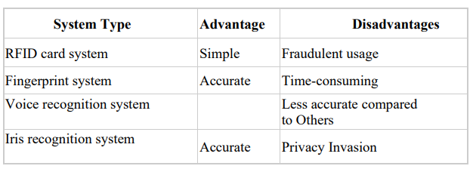

## 

## 5.Proposed System

This project introduces an involuntary attendance marking system, devoid of any kind of interference with the normal teaching procedure. The system can be also implemented during exam sessions or in other teaching activities where attendance is highly essential. This system eliminates classical student identification such as calling name of the student, or checking respective identification cards of the student, which can not only interfere with the ongoing teaching process, but also can be stressful for students during examination sessions. In addition, the students have to register in the database to be recognized. The enrolment can be done on the spot through the user-friendly interface.

We are setting up to design a system comprising of two modules. The first module (face detector) is a mobile component, which is basically a camera application that captures student faces and stores them in a file using computer vision face detection algorithms and face extraction techniques. The second module is a desktop application that does face recognition of the captured images (faces) in the file, marks the students register and then stores the results in a database for future analysis.

## 6.Software and Hardware requirements

The development and production of a face recognition attendance system require specific software and hardware requirements. These requirements ensure the system operates efficiently and with high accuracy. In this report, we will discuss the necessary software and hardware requirements for the development and production of the proposed face recognition attendance system.

#### 6.1.Software Requirements:

Operating System: The face recognition attendance system can be developed on different operating systems such as Windows, Linux, or Mac OS.

Programming Language: The system can be developed using Python with appropriate libraries for machine learning and computer vision.

Python Libraries: The system requires libraries such as sys, os, tkinter, sqlite3, numpy.

Computer Vision Libraries: Computer vision libraries such as OpenCV can be used to process the image data from the camera and extract features required for gesture recognition.

#### 6.2.Hardware Requirements:

Camera: A camera is required to capture hand gesture data. The camera can be an external webcam or an integrated camera on the device.

Processor: The system should have a processor with sufficient processing power to process image data from the camera and run machine learning algorithms.

Memory: Sufficient memory is required to store the trained machine learning model, image data, and other program data.

Graphics Processing Unit (GPU): A dedicated GPU can accelerate the machine learning model's training and inference process, leading to faster recognition of faces.

Display: The system should have a display for interacting with the users.

Input Device: The system requires an input device, such as a keyboard and a touchpad to launch the application and select the desired options.

In summary, the software requirements for the proposed face recognition attendance system include the operating system, programming language, python libraries and computer vision libraries. The hardware requirements include a camera, processor, memory, GPU, display, and input device. Adequate consideration of both software and hardware requirements is crucial for the successful development and implementation of the face recognition attendance system.

## Development Tools

The proposed face recognition attendance system will be developed using various development tools, including IDEs, machine learning frameworks, computer vision libraries, face recognition library, high-performance hardware, version control systems, and documentation tools. In this report, we will discuss these development tools in detail and their significance in developing the proposed system.

#### 7.1.Integrated Development Environment (IDE):

An IDE provides a comprehensive environment for software development, including tools for writing and editing source code, debugging, and testing. PyCharm, Eclipse, and Visual Studio are popular IDEs that support multiple programming languages and can be used for developing the face recognition attendance system. The use of an IDE is necessary for the development of the project report as it ensures efficient coding and debugging.

#### 7.2.Computer Vision Libraries:

Computer vision libraries provide pre-built algorithms and functions for image processing and analysis. OpenCV is a popular computer vision library that can be used for processing image data from the camera and extracting features required for face recognition. The use of computer vision libraries is necessary for the project report as it allows the system to recognize and detect faces from the camera.

#### 7.3.Face Recognition Library:

Face recognition Library, cv2 is necessary for the project report as it allows the system to recognize and detect different faces.

#### 7.4.Version Control System:

Version control systems are used to track changes in the source code, collaborate with team members, and revert to previous versions if necessary.The use of a version control system is necessary for the project report as it allows efficient collaboration and version tracking among team members.

In conclusion, the development and production of a face recognition attendance system requires various development tools, including an IDE, machine learning frameworks, computer vision libraries, face recognition library, high-performance hardware, version control systems, and documentation tools. These tools are essential for efficient and accurate development, testing, and operation of the system. The use of these tools ensures that the face recognition attendance system operates securely, efficiently, and with minimal downtime

The face recognition attendance system has the potential to revolutionize the way of traditional attendance system, making it more intuitive and convenient. With the use of machine learning and computer vision techniques, the system can accurately recognize and detect faces and mark attendance.

Overall, the proposed face recognition attendance system can have significant implications for various fields, including education, healthcare, and industries. The development tools used in the project will enable developers to build a robust and reliable system that can be easily integrated .

## 8.Software Design

#### 8.1 System Architecture

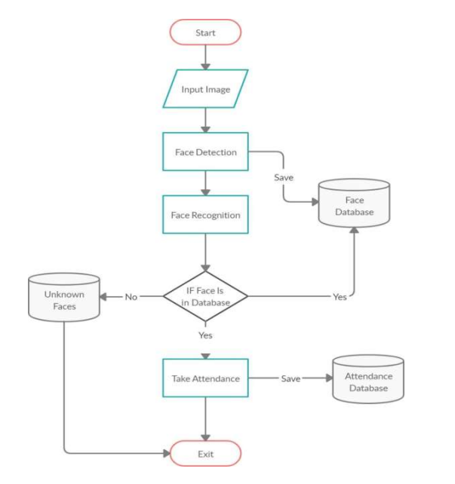

Figure 1.1

#### 8.2 Use Case Diagram

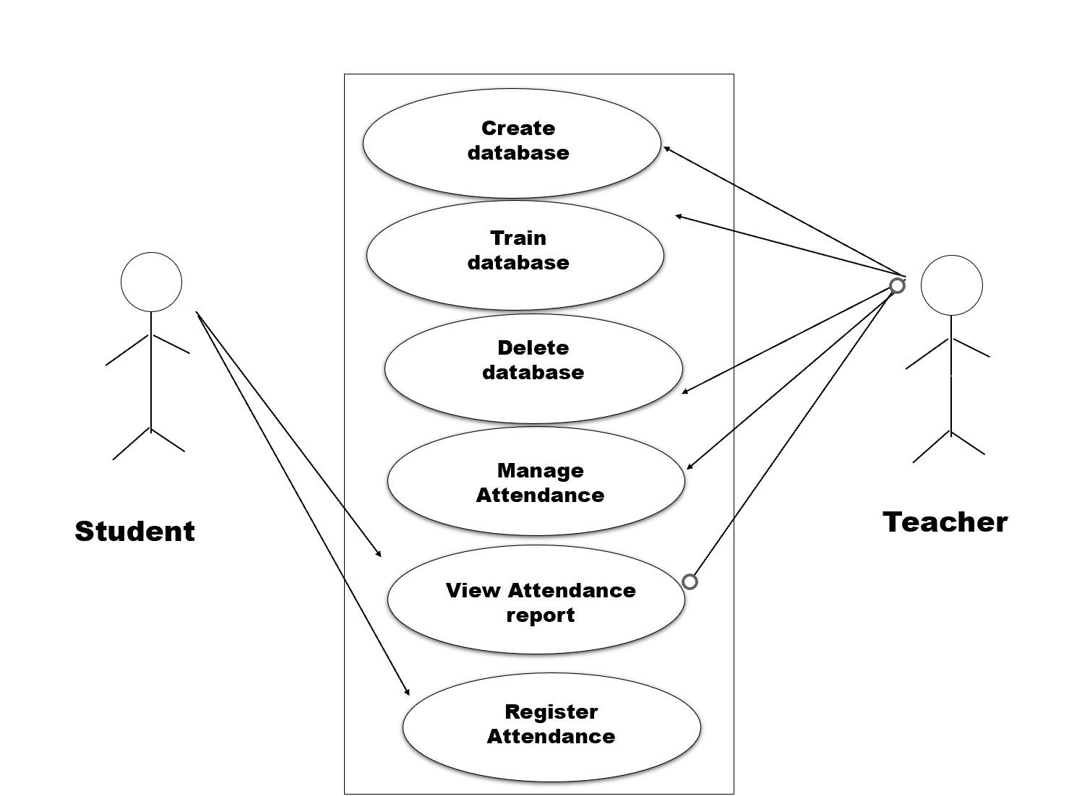

Figure 1.2

## 9.Modular Divisions

To ensure a structured and organized approach in developing the face recognition attendance system, it is beneficial to divide the project into several well-defined modules. These modules allow for focused development and easy management of specific functionalities. Here are the suggested modules for the project:

#### 9.1.User Interface Module

This module is responsible for creating the user interface (UI) components and handling user interactions.

It utilizes libraries such as Tkinter to build the UI elements, including buttons, sliders, and display areas.

It captures user input through face and mark attendance.

#### 9.2 Face Detection Module:

This module detects and captures human faces with an images or video frame. It’s the first step in face recognition process.

#### 9.3 Face Alignment Module:

Once faces are detected this module aligns them to a standardized position , correct for variation in pose, tilt, and scale. This step ensures consistent facial features for accurate recognition.

#### 9.4.Face Extraction Module:

This module extracts distinctive features from face images using Convolutional Neural Networks(CNNs) or Linear Discriminant Analysis(LDA).

#### 9.5.Face Matching Module:

This module compare the captured images to identify matches.

#### 9.6.Attendance Management Module:

Once faces are recognized this module records attendance data such as time, date and name.

# 10.Coding Procedures

The coding procedure for the facial recognition system involves requirement analysis, system design, technology selection, documentation, ongoing maintenance and updates. These steps ensure the successful implementation of the system. Begin by installing the necessary dependencies and obtaining the application's source code. Configure the application by setting up OpenCV for face recognition. Lastly, create documentation that includes installation instructions, configuration guidelines, and usage explanations. By combining OpenCV and Python coding procedures, you can create an application that allows users to mark attendance.

### 10.1.Requirement Analysis:

Gather and analyse the requirements for face recognition attendance system. Identify the specific functionalities, such as registering in the database, training the dataset, marking the attendance and viewing the attendance.

### 10.2.System Design:

Design the overall architecture and structure of the system.

Identify the different modules or components required for face recognition, training the dataset, attendance management. Define the data flow and interaction between the modules to ensure seamless operation.

### 10.3.Technology Selection:

Choose the appropriate libraries and frameworks for implementing face recognition and system control functionalities in Python. Consider libraries such as OpenCV, for face recognition and image processing.

### 

### 10.4.User Interface Development:

Develop a graphical user interface (GUI) using Python libraries like Tkinter.

Create UI components to provide controls for navigation.

Ensure the UI is responsive and efficient.

### 10.5.Face Recognition:

Utilize the selected libraries (e.g.OpenCV) for face recognition and detection.

Implement algorithms to process input from the camera and interpret the faces. Map the detected faces to the dataset.

### 10.6.Attendance Management:

Once faces are recognized this module records attendance data such as time, date and name.

# 11. User Interface

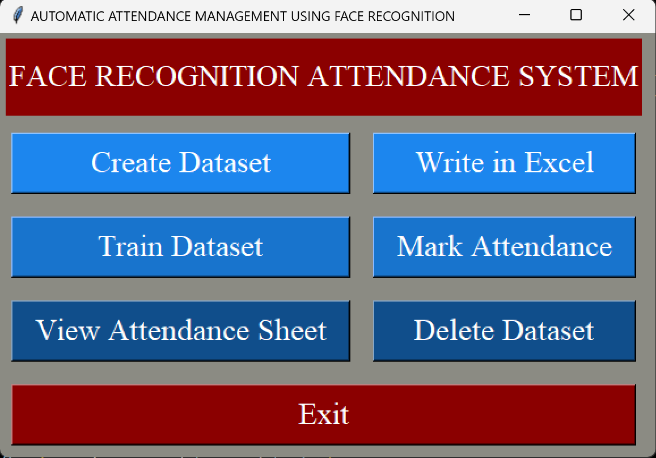

The face recognition attendance system offers a user interface with options for creating and training dataset, mark attendance, write in excel, view attendance sheet, delete dataset. The admin has control over all this features whereas students can only view the attendance sheet.

# 12.Conclusion

Face recognition systems are part of facial image processing applications and their significance as a research area are increasing recently. Implementations of system are crime prevention, video surveillance, person verification, and similar security activities. The face recognition system implementation can be part of Universities. Face Recognition Based Attendance System has been envisioned for the purpose of reducing the errors that occur in the traditional (manual) attendance taking system. The aim is to automate and make a system that is useful to the organization such as an institute. The efficient and accurate method of attendance in the office environment that can replace the old manual methods. This method is secure enough, reliable and available for use. Proposed algorithm is capable of detect multiple faces, and performance of system has acceptable good results.

# 13.Bibliography

[1]. A brief history of Facial Recognition, NEC, New Zealand,26 May 2020.[Online]. Available: https://www.nec.co.nz/market-leadership/publications-media/a-brief-history-of-facialrecognition/

[2]. Face detection,TechTarget Network, Corinne Bernstein, Feb, 2020.[Online]. Available: <https://searchenterpriseai.techtarget.com/definition/face-detection>.

[3]. Paul Viola and Michael Jones, Rapid Object Detection using a Boosted Cascade of Simple Features. Accepted Conference on Computer Vision and Pattern Re cognition, 2001.

[4]. Face Detection with Haar Cascade,Towards Data Science-727f68dafd08,Girija Shankar Behera, India, Dec 24, 2020.[Online]. Available:https://towardsdatascience.com/face-detectionwith-haar-cascade-727f68dafd08.

[5].FaceRecognition: Understanding LBPH Algorithm,Towards Data Science90ec258c3d6b,Kelvin Salton do Prado, Nov 11, 2017.[Online]. Available :https://towardsdatascience.com/face-recognition-how-lbph-works-90ec258c3d6b.

[6]github.com

[7]youtube.com

[8]chatGPT