Heart Disease MLOps
A reproducible end-to-end machine-learning assignment report

Course: AIMLCZG523 — Machine Learning Operations
Assignment: 01 — End-to-End Model Development and Deployment
Student name / ID: _______________________________________
Repository URL: __________________________________________
Report generated: 2026-10-20
Dataset: UCI Heart Disease (Cleveland; target: 0 vs 1-4) (303 rows)
Selected candidate: random_forest_tuned

Educational exercise only. This model is not a medical diagnostic tool and must not be used to make clinical decisions.

1. Objective and dataset
This assignment demonstrates a reproducible machine-learning lifecycle for binary classification on the UCI Cleveland Heart Disease dataset. The source contains 13 patient attributes and a disease-severity field (0–4); the target is normalized to 0 for severity 0 and 1 for severities 1–4.
The acquisition script downloads the canonical UCI Cleveland CSV, preserves the raw file, converts '?' values to missing values, coerces columns to numeric, and writes a cleaned CSV. Source: https://archive.ics.uci.edu/dataset/45/heart+disease
Profile | Observed value
Rows | 303
Predictor features | 13
Class 0 / absent | 164
Class 1 / present | 139
Feature fields with missing values | ca: 4, thal: 2
The dataset is small, historical, and not representative of a present-day clinical population. Its results are an engineering demonstration, not evidence of clinical validity.

2. Exploratory data analysis
EDA was generated from the cleaned 303-row dataset. The numeric distributions are split by the binary target; class counts are shown explicitly so metrics are not interpreted in isolation.
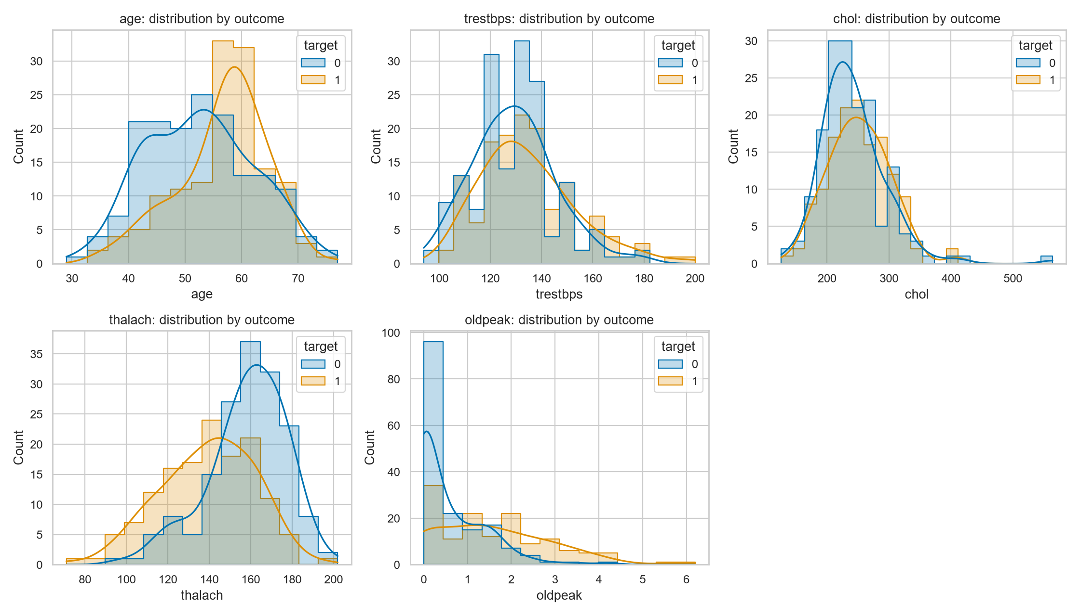
Target counts: class 0 = 164; class 1 = 139. See artifacts/eda/class_balance.png for the generated class-balance figure.
Observed histograms show substantial spread in age, blood pressure, cholesterol, maximum heart rate, and oldpeak; these single-variable plots do not establish causal relationships.

3. Data quality and feature engineering
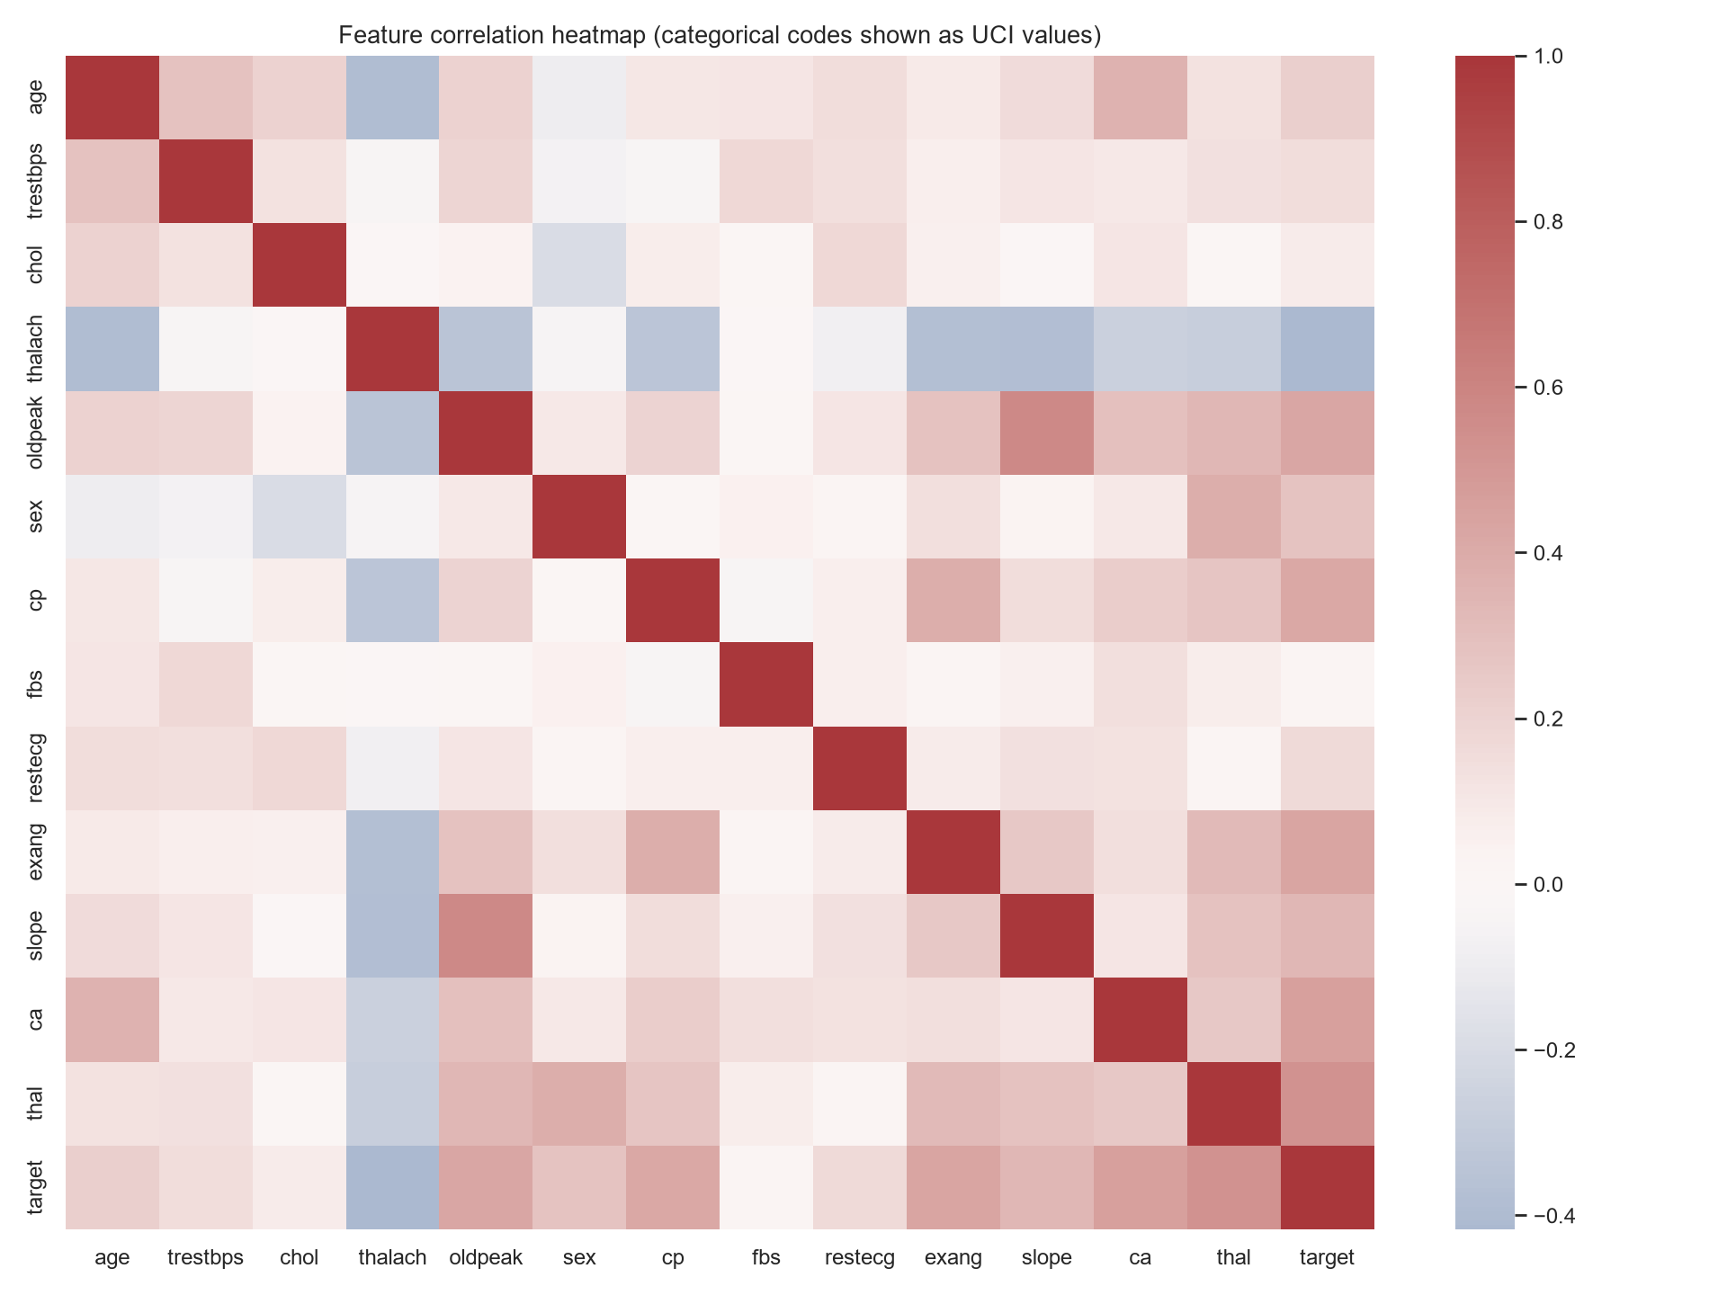
The numeric features age, trestbps, chol, thalach, and oldpeak use median imputation followed by standardization. The coded features sex, cp, fbs, restecg, exang, slope, ca, and thal use most-frequent imputation and one-hot encoding with unseen categories ignored.
All transformers are fitted inside each cross-validation fold and stored with the classifier in one scikit-learn pipeline. This prevents using holdout information to fit preprocessing and keeps inference consistent.
The heatmap displays source codes as numeric values for compact exploration; correlations of categorical codes should not be interpreted as a continuous ordinal relationship.

4. Model development and evaluation
The data was split once using a stratified 80/20 training/holdout split (random state 42). Candidate selection used shuffled five-fold stratified cross-validation on training data, with mean ROC-AUC as the primary metric. Accuracy, precision, recall, and ROC-AUC are all reported.
Candidate | CV AUC | Test accuracy | Test precision | Test recall | Test AUC
random_forest_tuned | 0.903 | 0.869 | 0.812 | 0.929 | 0.957
logistic_regression_baseline | 0.902 | 0.885 | 0.839 | 0.929 | 0.966
logistic_regression_tuned | 0.902 | 0.885 | 0.839 | 0.929 | 0.966
random_forest_baseline | 0.899 | 0.885 | 0.818 | 0.964 | 0.946
Selected model: random_forest_tuned. Selection rule: Highest mean stratified cross-validation ROC-AUC on training data.
The holdout metrics are reported after selection and are not used to choose the model. Small-sample results have substantial uncertainty and may vary with a different split.

5. Tuning, MLflow, and reproducibility
Four tracked candidates compare Logistic Regression and Random Forest baselines with tuned versions. Logistic Regression searches C = 0.1, 1, and 10. Random Forest searches maximum depth = None, 5, or 10 and minimum leaf size = 1, 2, or 4. The forest uses 300 trees and class weighting.
The MLflow experiment is heart-disease-uci. Each run logs estimator and tuning parameters, fold and split configuration, all four cross-validation and holdout metrics, a ROC/confusion-matrix plot, and the fitted pipeline. Tracking URI used: sqlite:///C:/MLOps_Assignment1_2025AE05440/mlflow.db
The selected pipeline is saved to models\heart_disease.joblib; the complete metrics and split details are in artifacts/training_summary.json. Reproduce with python -m src.data, python -m src.eda, and python -m src.train.
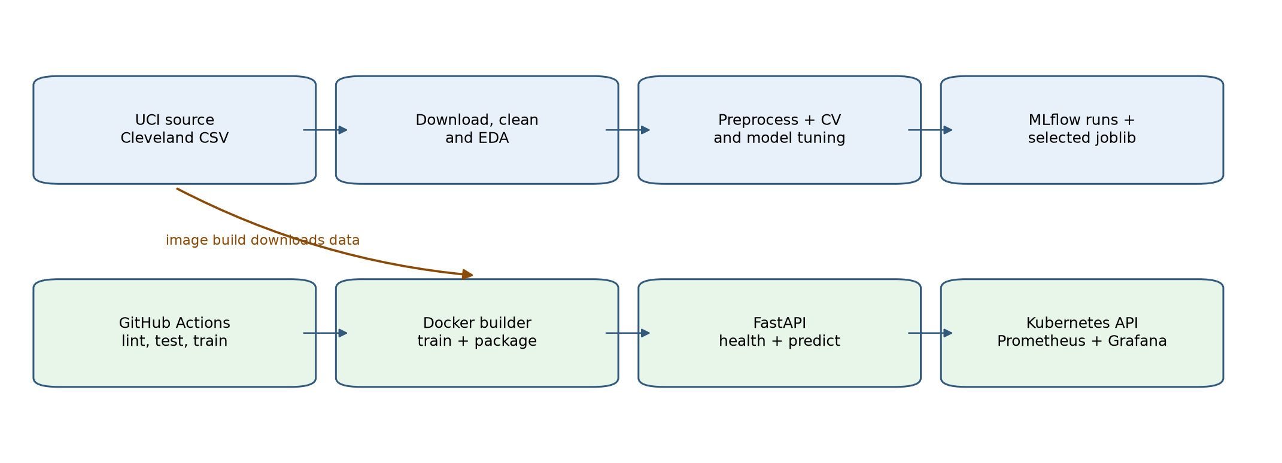
The serialized joblib/MLflow pickle artifacts are generated by this trusted training workflow. Do not load model files obtained from untrusted sources.

6. Prediction service and monitoring
FastAPI provides GET /health, POST /predict, GET /metrics, and interactive documentation at /docs. The request schema validates 13 named features and rejects extra fields. The response provides a binary label, model confidence, and positive-class score; this score is not medical advice.
Sample field | Observed result
Input | Synthetic example (63-year-old UCI-coded feature values)
Prediction | 0
Label | disease_absent
Confidence | 0.590
Positive-class score | 0.410
Request logs contain method, path, status, and duration only; payloads are not logged. /metrics exposes request counters in Prometheus text format. Compose provisions Prometheus and Grafana with a dashboard showing API scrape health, request totals, and request rate by path and status.

7. Testing, continuous integration, and Docker
The local Pytest suite passed: 12 tests on Python 3.14.7, covering target cleaning and missing features, source schema validation, fitting both classifier pipelines, health/prediction behavior, request metrics, and input validation. Ruff linting and formatting checks pass.
GitHub Actions is configured for Python 3.11 and 3.12. On a published repository it runs lint, tests, data acquisition, EDA, model training, and uploads run artifacts. No GitHub run URL is claimed because this workspace has not been published to a student repository.
The multi-stage Dockerfile trains in a builder stage and copies the preprocessing/model artifact into a Python 3.12 runtime image. The API runs as a non-root user with a health check; Compose enables a read-only root filesystem and drops Linux capabilities.
The local Docker Compose integration test passed: the API container became healthy, sample prediction and metrics worked, Prometheus reported its target UP, Grafana health was OK, and the provisioned dashboard was found. The temporary validation stack and test-only volumes were removed afterward.

8. Kubernetes deployment and runbook
The Kubernetes manifest defines two replicas, readiness/liveness probes, resource requests and limits, a non-root security context, and a LoadBalancer Service in the isolated `heart-disease-mlops` namespace. `kubectl apply -k k8s` provisions the API, Prometheus, Grafana, scrape configuration, datasource, and dashboard. Prometheus and Grafana are internal services accessed by port-forward.
Local runbook: docker build -t heart-disease-api:local .; run scripts/create_grafana_secret.ps1; kubectl apply -k k8s; wait for the API, Prometheus, and Grafana rollouts. Forward the API with kubectl port-forward -n heart-disease-mlops service/heart-disease-api 18000:80, and forward Prometheus/Grafana to 19090/13000. Run scripts/verify_deployment.ps1 with these endpoint URLs. For Minikube, load the built image first. A local LoadBalancer may remain pending; use port-forward for local access.
The Docker Desktop Kubernetes deployment was rolled out in an isolated namespace. Both API replicas and the Prometheus and Grafana pods became ready; sample prediction, Prometheus target health, Grafana health, and dashboard provisioning checks passed. The local LoadBalancer external IP remained pending, so the verified endpoint used port-forward. No public cloud deployment or screenshot is claimed; capture original screenshots from your lab run.

9. Limitations, conclusion, and submission evidence
The Cleveland dataset is small and historical; the class distribution and correlations may not generalize. The holdout estimate is uncertain. This model is not validated for clinical use. Responsible production use would require representative data, calibration, subgroup/fairness analysis, prospective validation, privacy controls, and domain governance.
The implementation demonstrates acquisition, EDA, preprocessing, model comparison/tuning, MLflow logging, unit tests, CI configuration, an API, containerization, Kubernetes resources, and provisioned Prometheus/Grafana monitoring configuration. Local model training, Docker Compose, and Docker Desktop Kubernetes API/monitoring integration were verified. Public cloud deployment, student GitHub Actions, screenshots, and video remain student-run evidence items.
- Add student name/ID and your GitHub repository URL.
- Capture original screenshots of the verified Docker and Kubernetes runs.
- Add a public cloud endpoint only if you actually deploy to a cloud cluster.
- Publish the repository, run GitHub Actions, and record its run URL.
- Record your short end-to-end pipeline video.
- Write your own reflection and discuss the measured trade-offs.
- Verify this DOCX renders to ten pages in Word, then save/submit it.
Generated evidence files: artifacts/eda/, artifacts/training_summary.json, models/heart_disease.joblib, and mlflow.db. Generated DOCX values come from the current local model run; update them after retraining.

