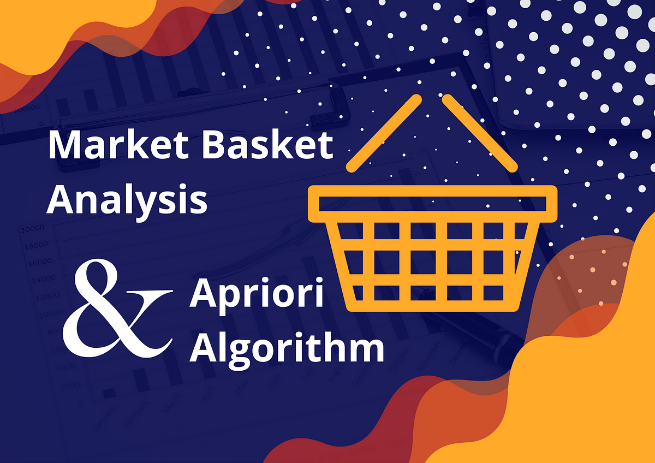

* Market basket analysis is **a data mining technique used by retailers to increase sales by better understanding customer purchasing patterns**.
* It involves analyzing large data sets, such as purchase history, to reveal product groupings, as well as products that are likely to be purchased together.
* In market basket analysis (also called association analysis or frequent item set mining), you **analyze purchases that commonly happen together**.
* For example, people who buy bread and peanut butter also buy jelly. Or people who buy shampoo might also buy conditioner

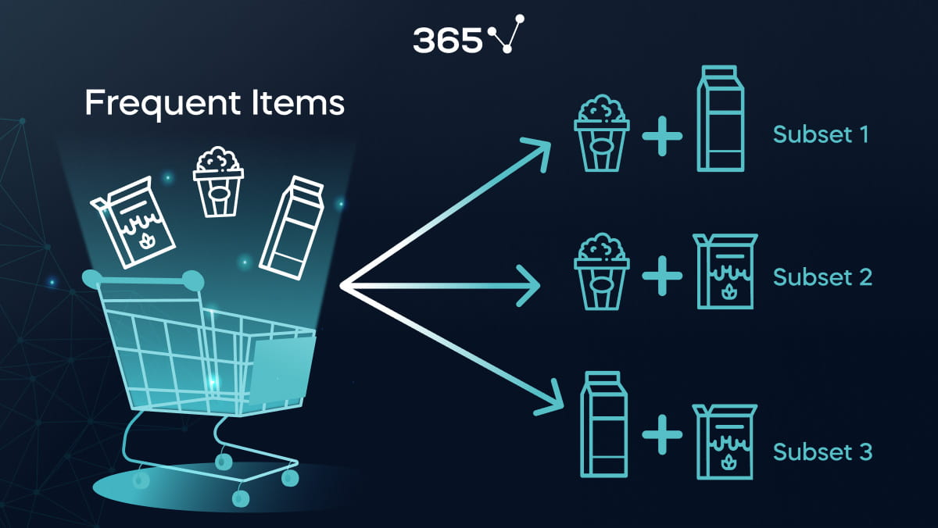

**Process:**

v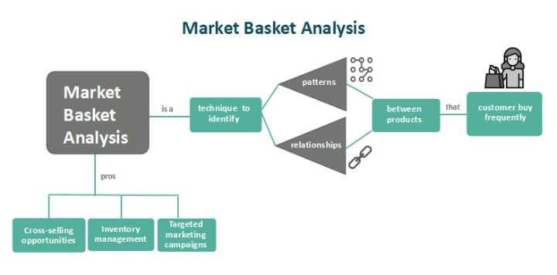

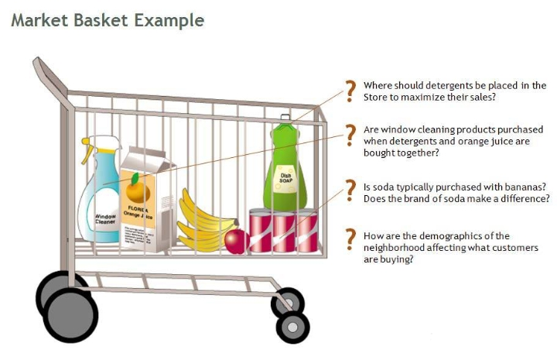

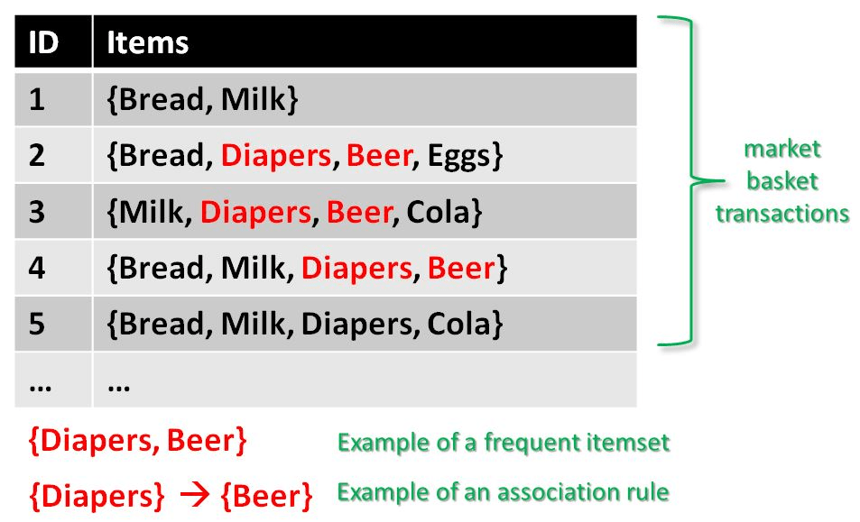**Apriori Algorithm:**

**Ck: Candidate item set of size k**

**Lk: Frequent item set of size k**

**L1={frequent items};**

**For (k=1; Lk!=0; k++) do begin**

**Ck+1= Candidates generated from Lk;**

**For each transaction t in the database do**

**Increment the count of all candidates in Ck+1 that are contained in t**

**Lk+1=candidates in Ck+1 with min_support**

**End**

**Return UkLk;**

**Flowchart:**



**Benefits:**

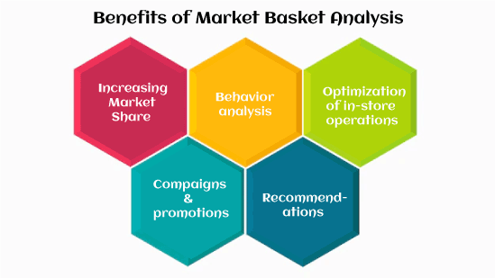

**Conclusion:**

* We have shown how Market basket analysis using association rules works in determining the customer buying patterns.
* To put it simply, market basket analysis **helps the retailers know about the products frequently bought together so as to keep those items always available in their inventory**