SDLC: Testing, Linux and Server
Practice Assignment on Testing, Linux and Servers:
Task 1: System Monitoring Setup
Install & configure htop:
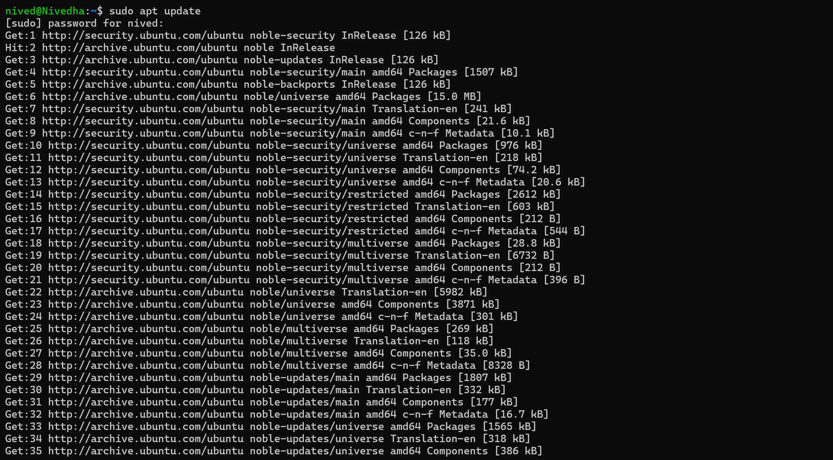
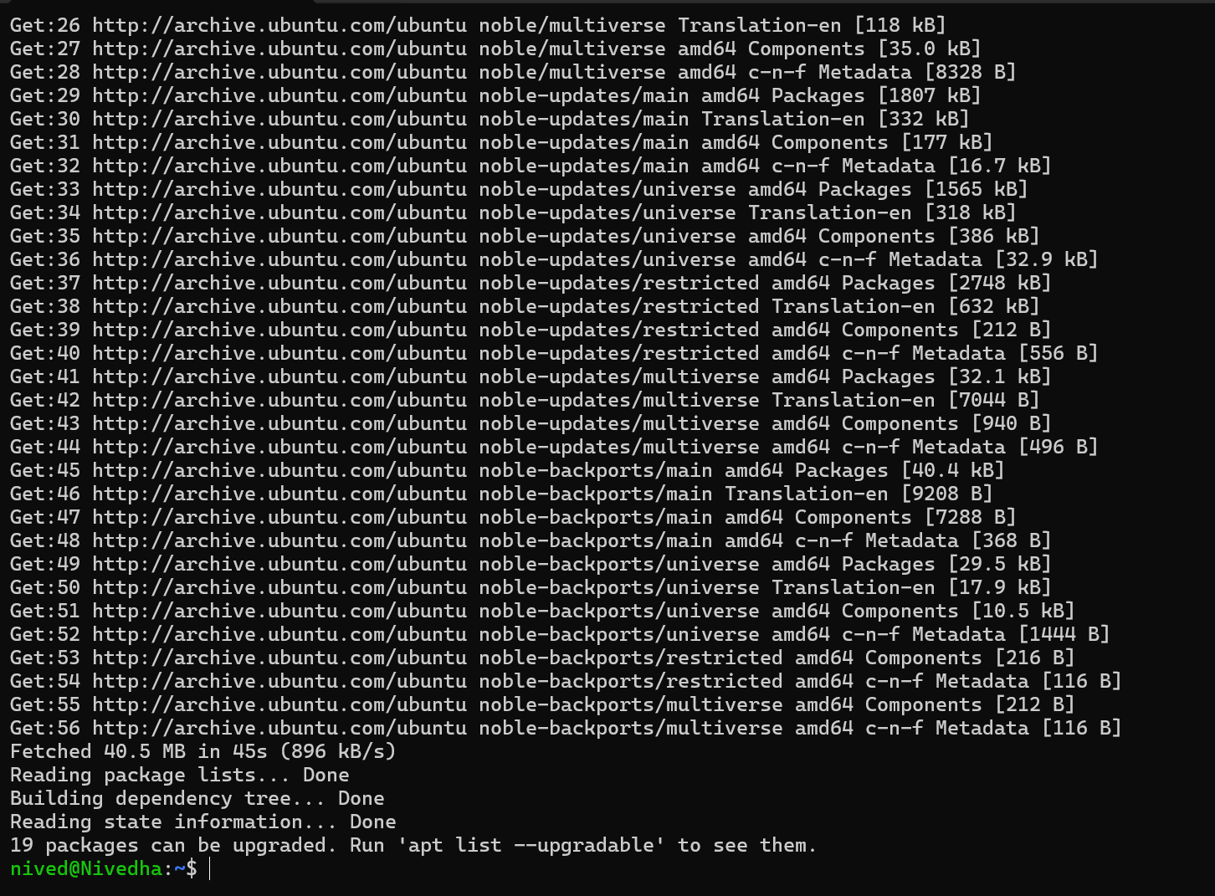
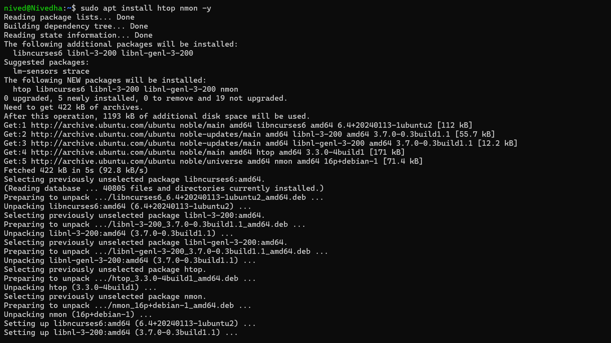

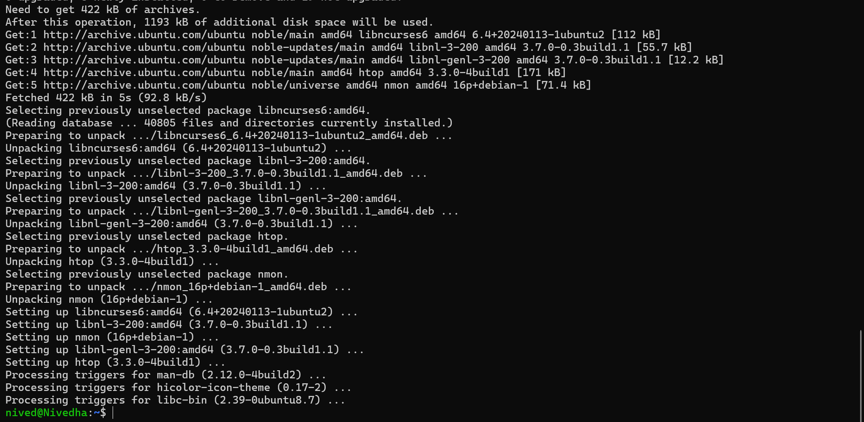
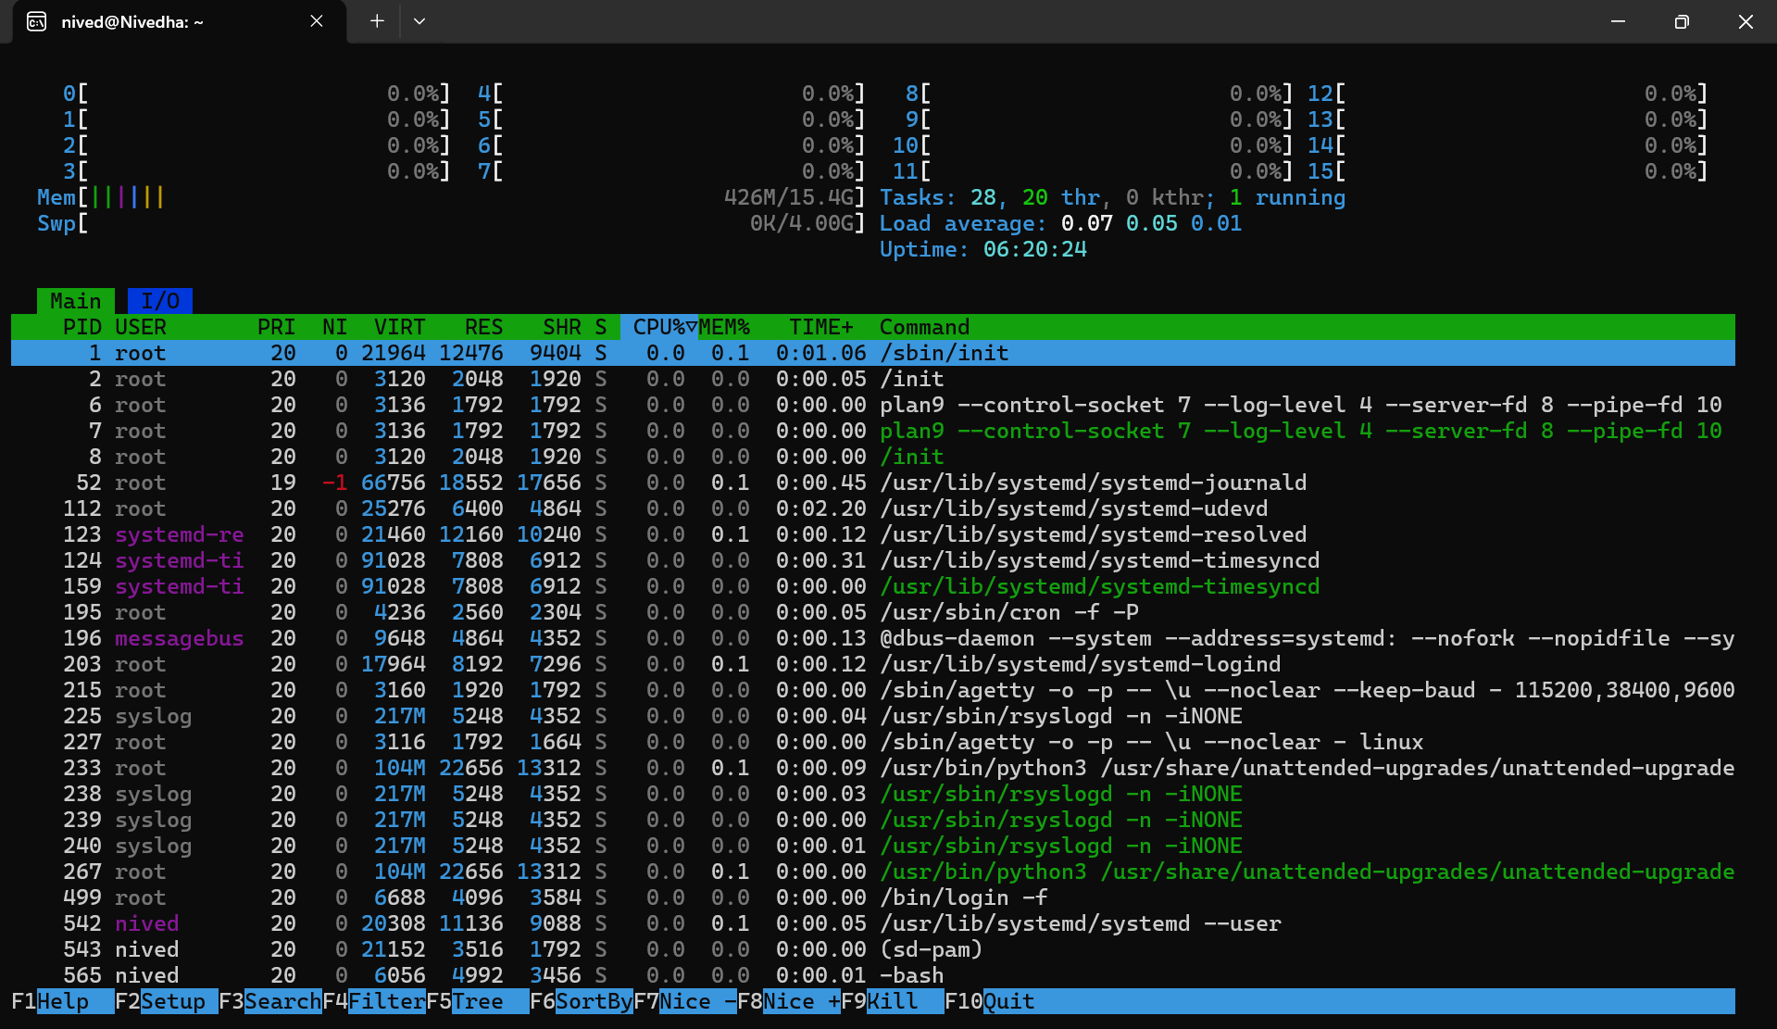
Disc Usage & Tracking:
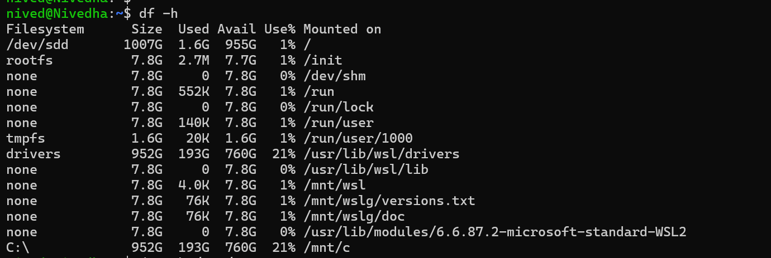

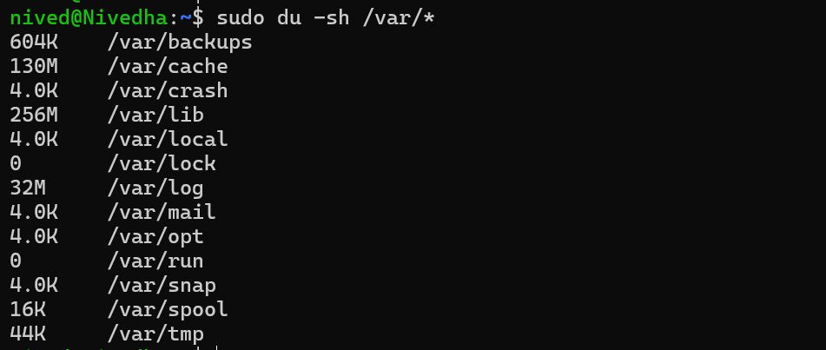

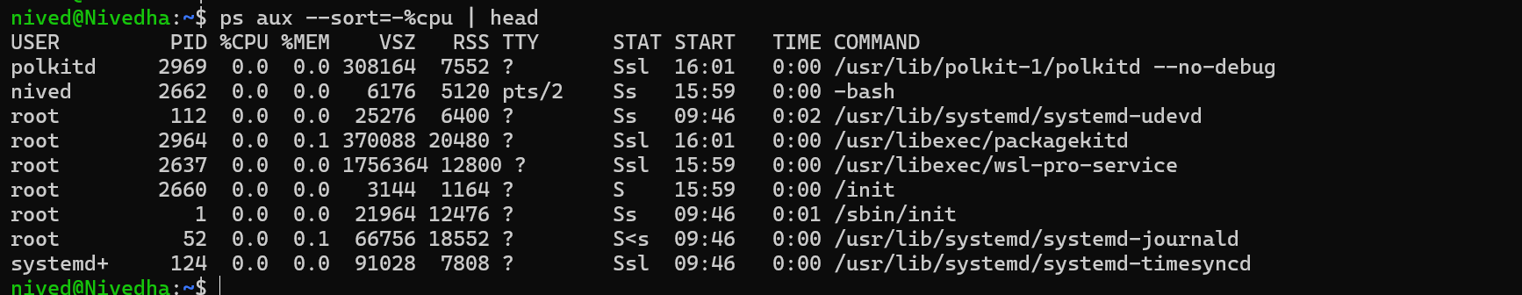

Monitoring Bash Script:
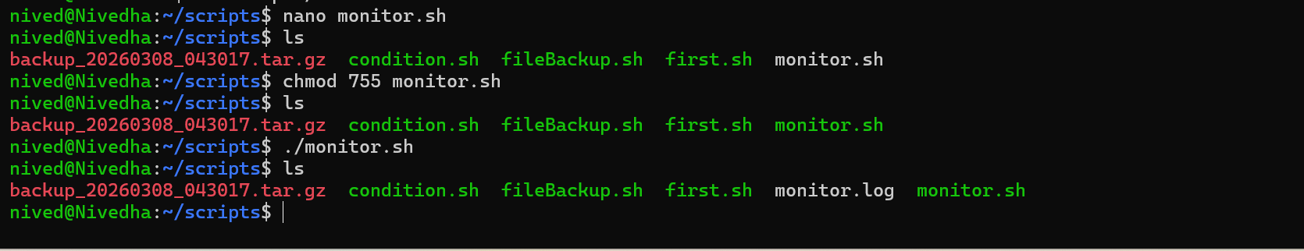

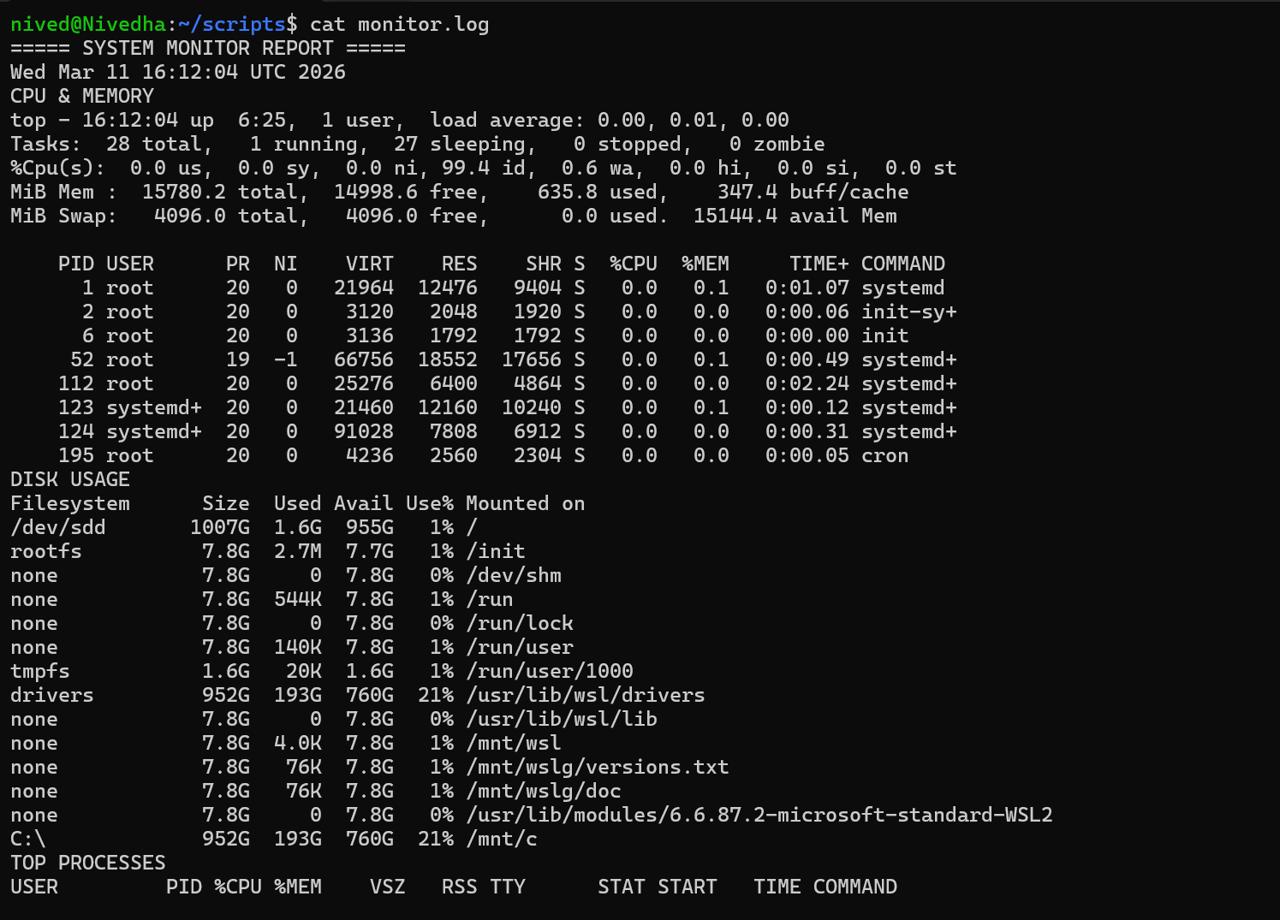

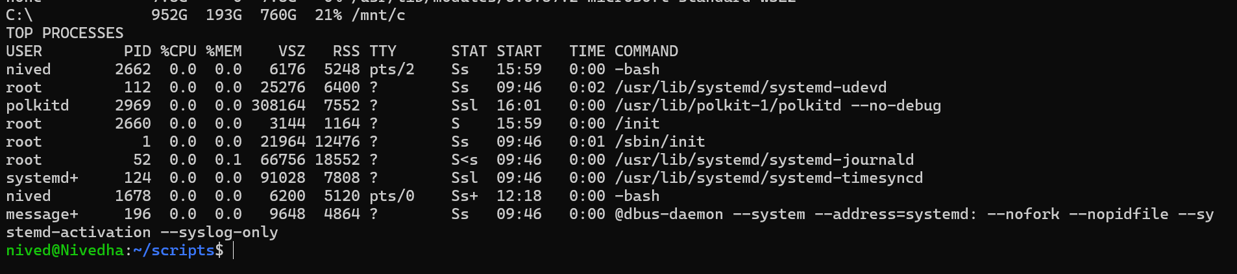

Task 2: User Management and Access Control
Create User Sarah & mike:
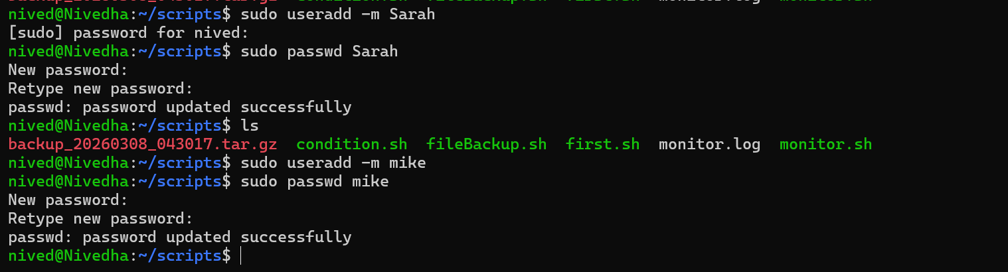
Check User:
Create Workspace:
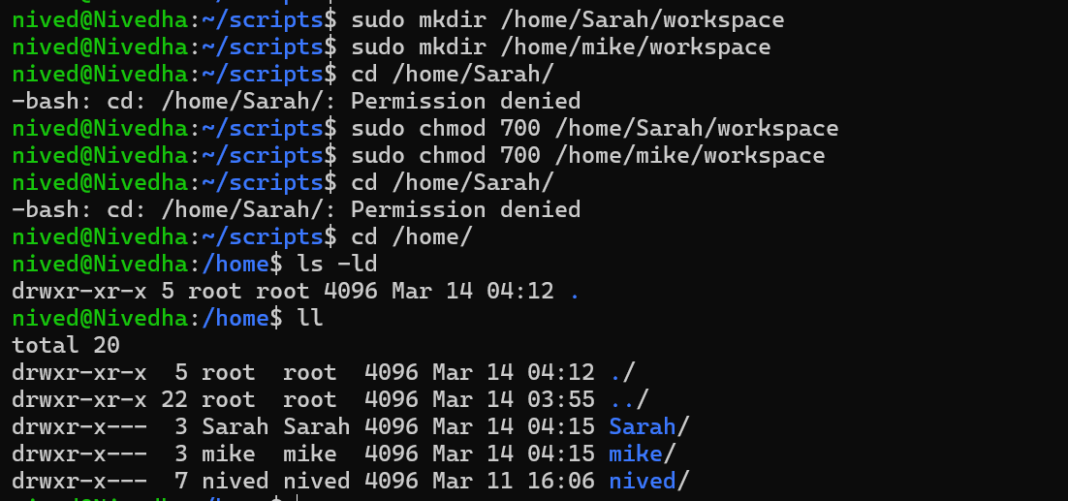

Change password expiry to 30 days:
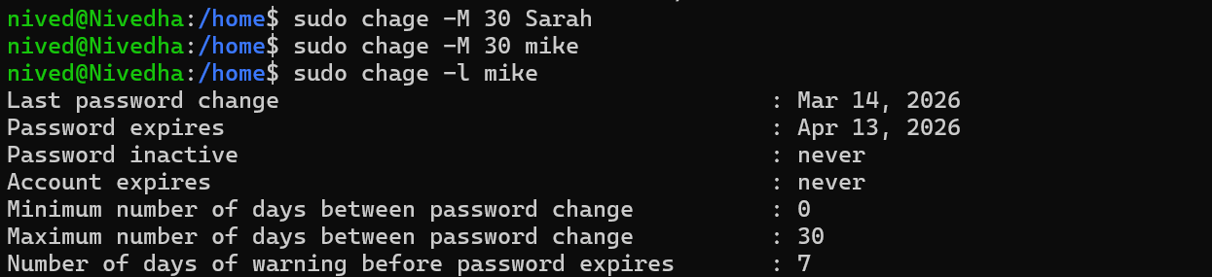
Task 3: Backup Configuration for Web Servers
Backup Dir Creation:
Apache Backup (Sarah):
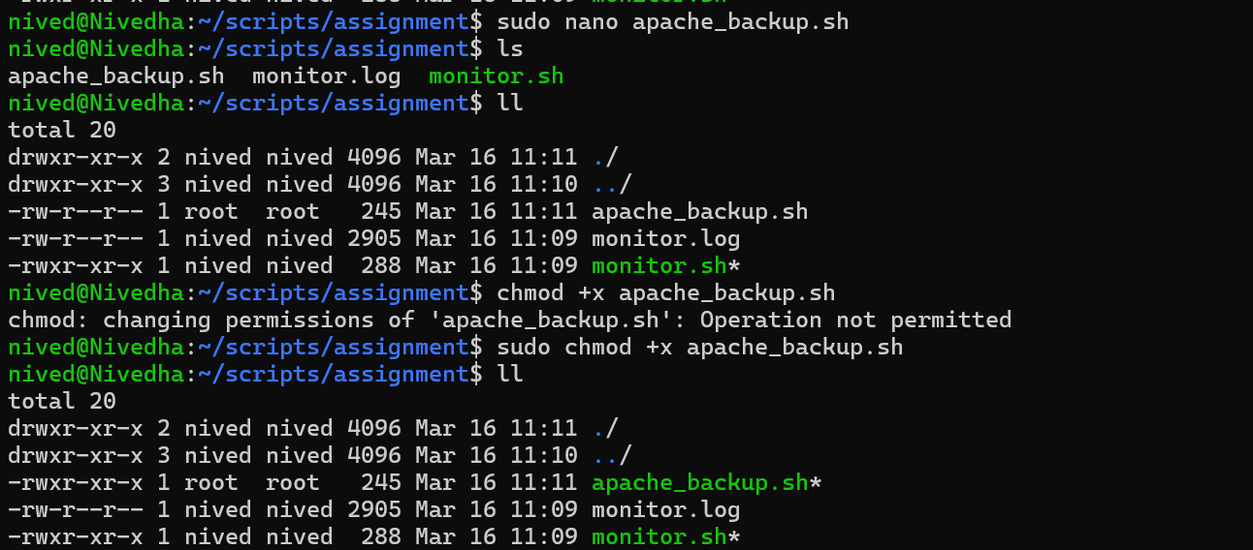
Nginx Backup (mike):
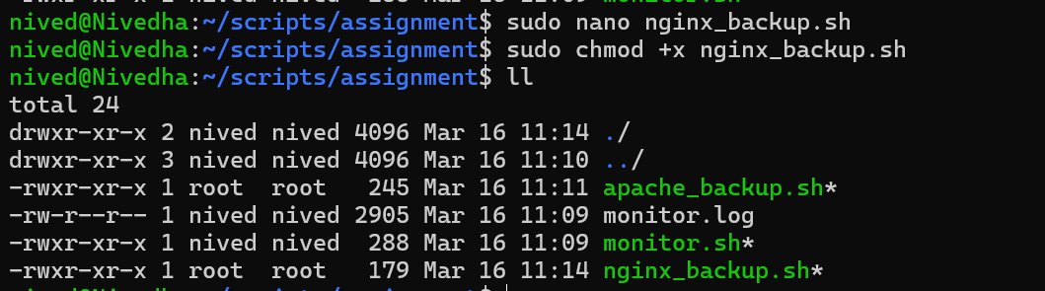
Crontab Configuration:
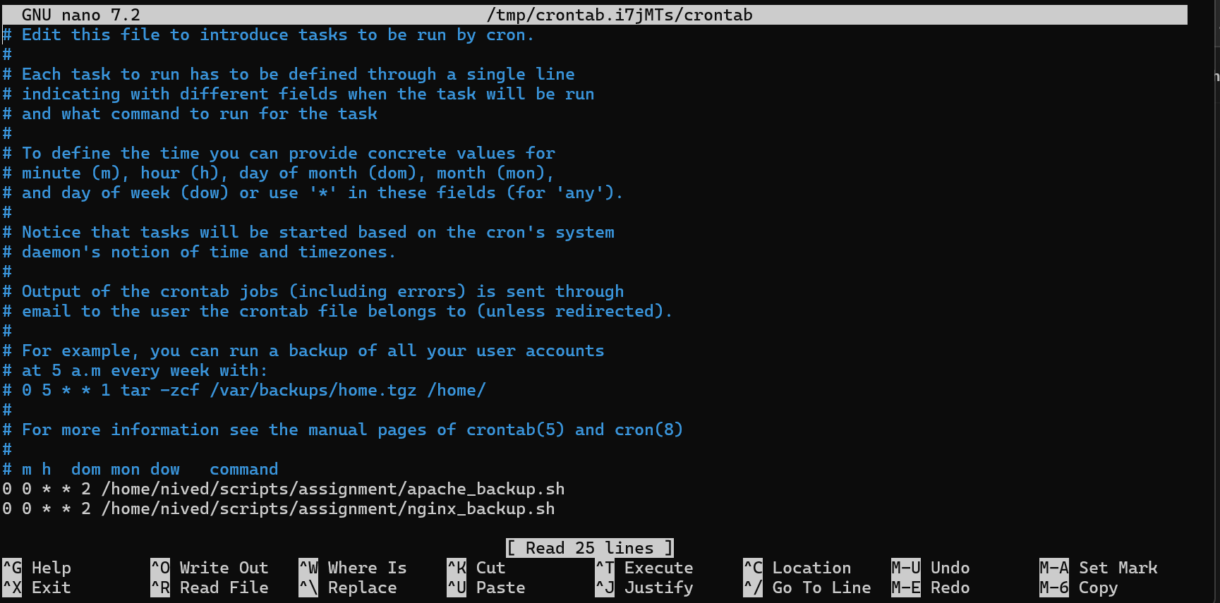

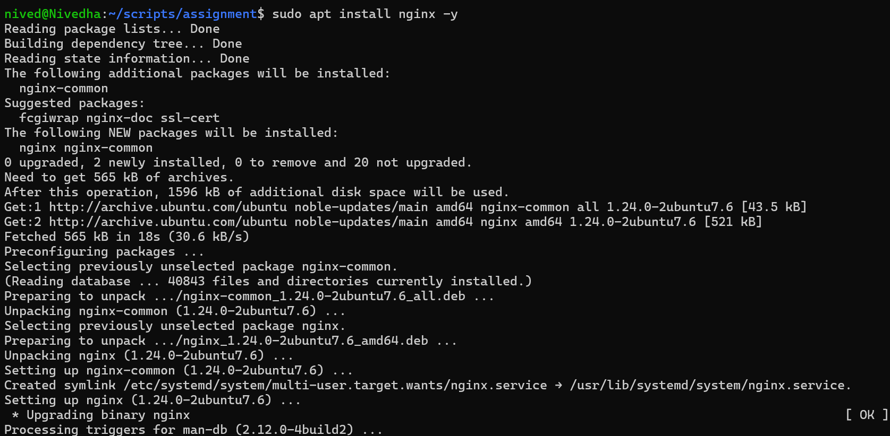

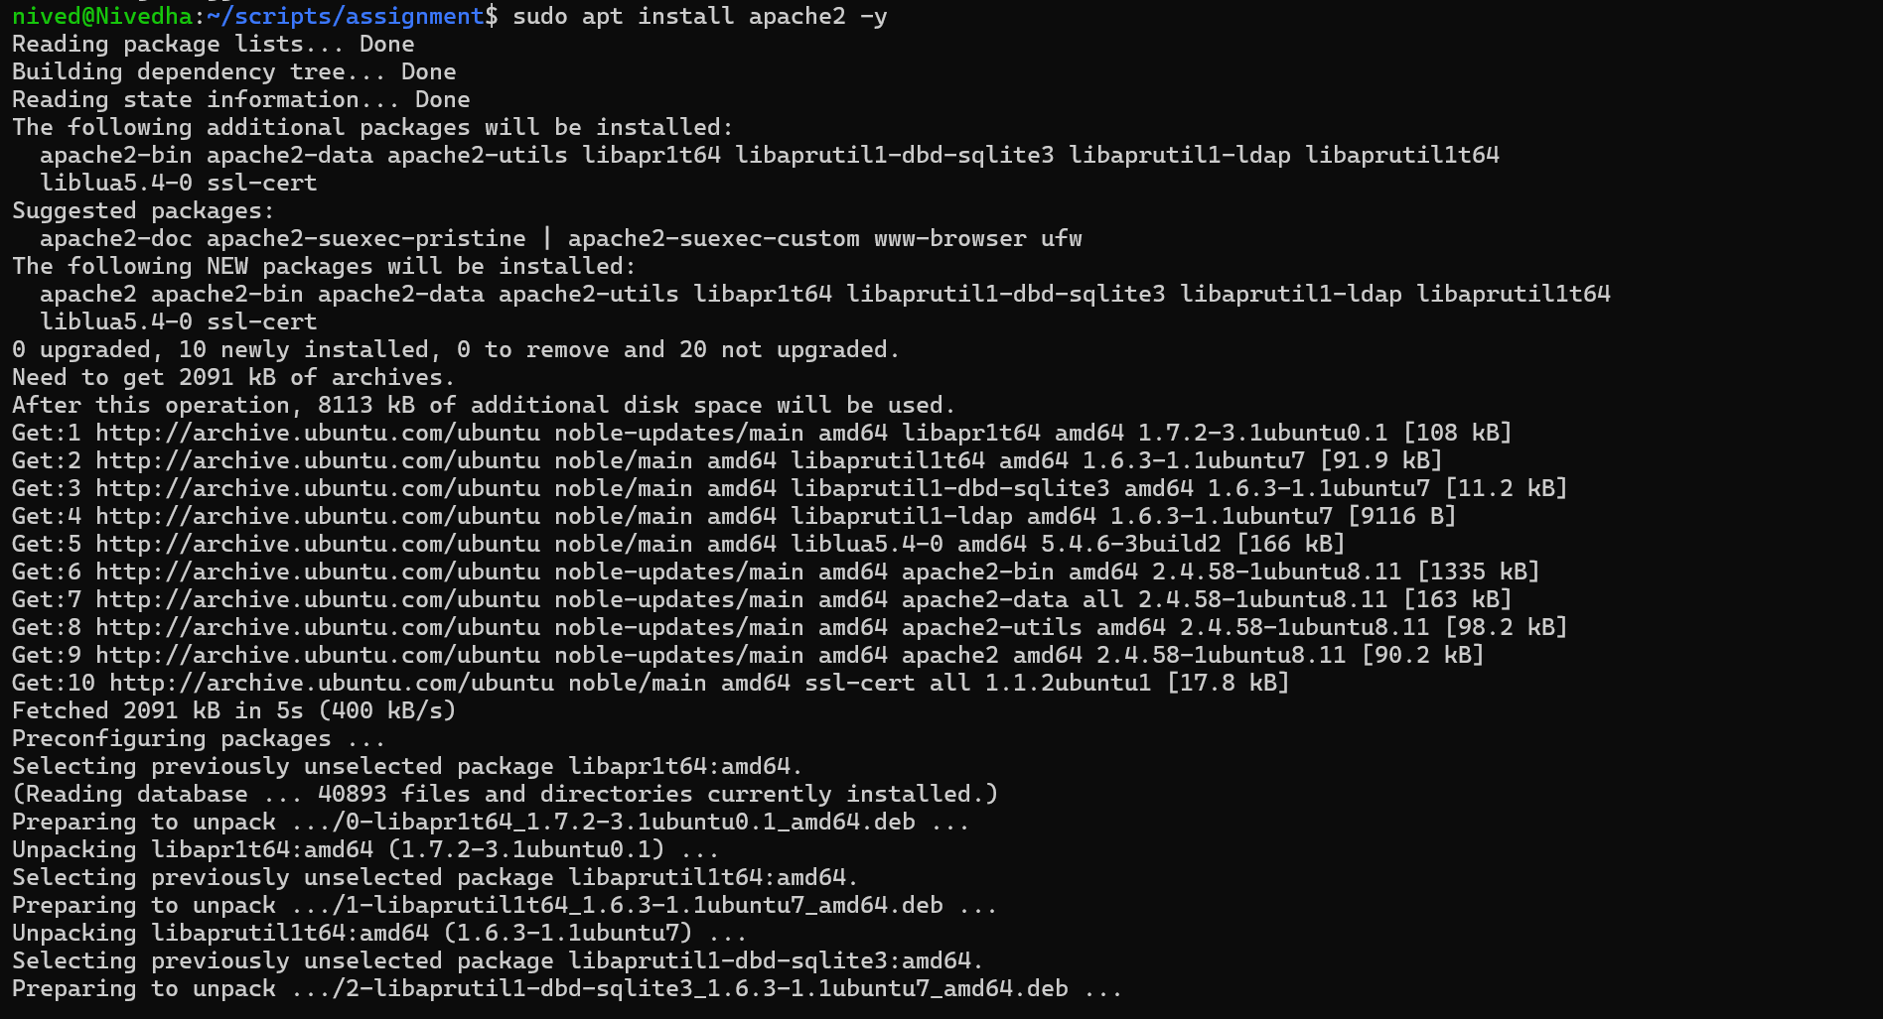
nived@Nivedha:~/scripts/assignment$ sudo ./apache_backup.sh
tar: Removing leading `/' from member names
/etc/apache2/
/etc/apache2/mods-enabled/
/etc/apache2/mods-enabled/setenvif.load
tar: Removing leading `/' from hard link targets
/etc/apache2/mods-enabled/reqtimeout.load
/etc/apache2/mods-enabled/authz_user.load
/etc/apache2/mods-enabled/alias.conf
/etc/apache2/mods-enabled/env.load
/etc/apache2/mods-enabled/autoindex.conf
/etc/apache2/mods-enabled/auth_basic.load
/etc/apache2/mods-enabled/reqtimeout.conf
/etc/apache2/mods-enabled/autoindex.load
/etc/apache2/mods-enabled/authn_file.load
/etc/apache2/mods-enabled/alias.load
/etc/apache2/mods-enabled/authz_host.load
/etc/apache2/mods-enabled/dir.conf
/etc/apache2/mods-enabled/mpm_event.load
/etc/apache2/mods-enabled/negotiation.load
/etc/apache2/mods-enabled/setenvif.conf
/etc/apache2/mods-enabled/deflate.conf
/etc/apache2/mods-enabled/dir.load
/etc/apache2/mods-enabled/mime.conf
/etc/apache2/mods-enabled/access_compat.load
/etc/apache2/mods-enabled/authn_core.load
/etc/apache2/mods-enabled/negotiation.conf
/etc/apache2/mods-enabled/mpm_event.conf
/etc/apache2/mods-enabled/filter.load
/etc/apache2/mods-enabled/status.conf
/etc/apache2/mods-enabled/authz_core.load
/etc/apache2/mods-enabled/status.load
/etc/apache2/mods-enabled/mime.load
/etc/apache2/mods-enabled/deflate.load
/etc/apache2/magic
/etc/apache2/sites-enabled/
/etc/apache2/sites-enabled/000-default.conf
/etc/apache2/conf-enabled/
/etc/apache2/conf-enabled/serve-cgi-bin.conf
/etc/apache2/conf-enabled/other-vhosts-access-log.conf
/etc/apache2/conf-enabled/charset.conf
/etc/apache2/conf-enabled/localized-error-pages.conf
/etc/apache2/conf-enabled/security.conf
/etc/apache2/mods-available/
/etc/apache2/mods-available/setenvif.load
/etc/apache2/mods-available/authn_dbm.load
/etc/apache2/mods-available/substitute.load
/etc/apache2/mods-available/cgi.load
/etc/apache2/mods-available/authn_dbd.load
/etc/apache2/mods-available/unique_id.load
/etc/apache2/mods-available/reqtimeout.load
/etc/apache2/mods-available/suexec.load
/etc/apache2/mods-available/proxy_ajp.load
/etc/apache2/mods-available/socache_shmcb.load
/etc/apache2/mods-available/actions.load
/etc/apache2/mods-available/proxy_html.conf
/etc/apache2/mods-available/authz_owner.load
/etc/apache2/mods-available/authz_user.load
/etc/apache2/mods-available/mpm_prefork.load
/etc/apache2/mods-available/proxy_html.load
/etc/apache2/mods-available/ssl.conf
/etc/apache2/mods-available/usertrack.load
/etc/apache2/mods-available/auth_form.load
/etc/apache2/mods-available/mpm_prefork.conf
/etc/apache2/mods-available/proxy_balancer.load
/etc/apache2/mods-available/alias.conf
/etc/apache2/mods-available/proxy_http2.load
/etc/apache2/mods-available/actions.conf
/etc/apache2/mods-available/env.load
/etc/apache2/mods-available/authnz_ldap.load
/etc/apache2/mods-available/autoindex.conf
/etc/apache2/mods-available/mpm_worker.load
/etc/apache2/mods-available/heartbeat.load
/etc/apache2/mods-available/auth_basic.load
/etc/apache2/mods-available/lbmethod_bytraffic.load
/etc/apache2/mods-available/cern_meta.load
/etc/apache2/mods-available/ratelimit.load
/etc/apache2/mods-available/cache_socache.load
/etc/apache2/mods-available/imagemap.load
/etc/apache2/mods-available/remoteip.load
/etc/apache2/mods-available/reqtimeout.conf
/etc/apache2/mods-available/ext_filter.load
/etc/apache2/mods-available/headers.load
/etc/apache2/mods-available/authz_groupfile.load
/etc/apache2/mods-available/ssl.load
/etc/apache2/mods-available/http2.conf
/etc/apache2/mods-available/autoindex.load
/etc/apache2/mods-available/authn_file.load
/etc/apache2/mods-available/proxy_fdpass.load
/etc/apache2/mods-available/alias.load
/etc/apache2/mods-available/session_dbd.load
/etc/apache2/mods-available/authz_host.load
/etc/apache2/mods-available/include.load
/etc/apache2/mods-available/info.conf
/etc/apache2/mods-available/dbd.load
/etc/apache2/mods-available/reflector.load
/etc/apache2/mods-available/dir.conf
/etc/apache2/mods-available/charset_lite.load
/etc/apache2/mods-available/ldap.load
/etc/apache2/mods-available/mpm_event.load
/etc/apache2/mods-available/negotiation.load
/etc/apache2/mods-available/lua.load
/etc/apache2/mods-available/session.load
/etc/apache2/mods-available/proxy_http.load
/etc/apache2/mods-available/setenvif.conf
/etc/apache2/mods-available/authn_socache.load
/etc/apache2/mods-available/deflate.conf
/etc/apache2/mods-available/proxy_scgi.load
/etc/apache2/mods-available/dav_lock.load
/etc/apache2/mods-available/asis.load
/etc/apache2/mods-available/request.load
/etc/apache2/mods-available/userdir.conf
/etc/apache2/mods-available/slotmem_shm.load
/etc/apache2/mods-available/sed.load
/etc/apache2/mods-available/data.load
/etc/apache2/mods-available/log_debug.load
/etc/apache2/mods-available/proxy_hcheck.load
/etc/apache2/mods-available/http2.load
/etc/apache2/mods-available/proxy.load
/etc/apache2/mods-available/dialup.load
/etc/apache2/mods-available/dir.load
/etc/apache2/mods-available/lbmethod_bybusyness.load
/etc/apache2/mods-available/mime.conf
/etc/apache2/mods-available/cache_disk.conf
/etc/apache2/mods-available/proxy.conf
/etc/apache2/mods-available/access_compat.load
/etc/apache2/mods-available/dav_fs.load
/etc/apache2/mods-available/dav.load
/etc/apache2/mods-available/heartmonitor.load
/etc/apache2/mods-available/proxy_fcgi.load
/etc/apache2/mods-available/mpm_worker.conf
/etc/apache2/mods-available/proxy_uwsgi.load
/etc/apache2/mods-available/cgid.load
/etc/apache2/mods-available/lbmethod_heartbeat.load
/etc/apache2/mods-available/vhost_alias.load
/etc/apache2/mods-available/mime_magic.load
/etc/apache2/mods-available/ldap.conf
/etc/apache2/mods-available/cache_disk.load
/etc/apache2/mods-available/session_cookie.load
/etc/apache2/mods-available/allowmethods.load
/etc/apache2/mods-available/info.load
/etc/apache2/mods-available/authn_core.load
/etc/apache2/mods-available/socache_memcache.load
/etc/apache2/mods-available/log_forensic.load
/etc/apache2/mods-available/dump_io.load
/etc/apache2/mods-available/expires.load
/etc/apache2/mods-available/rewrite.load
/etc/apache2/mods-available/proxy_balancer.conf
/etc/apache2/mods-available/slotmem_plain.load
/etc/apache2/mods-available/socache_redis.load
/etc/apache2/mods-available/xml2enc.load
/etc/apache2/mods-available/macro.load
/etc/apache2/mods-available/negotiation.conf
/etc/apache2/mods-available/authz_dbd.load
/etc/apache2/mods-available/proxy_connect.load
/etc/apache2/mods-available/ident.load
/etc/apache2/mods-available/auth_digest.load
/etc/apache2/mods-available/proxy_wstunnel.load
/etc/apache2/mods-available/file_cache.load
/etc/apache2/mods-available/mpm_event.conf
/etc/apache2/mods-available/proxy_ftp.load
/etc/apache2/mods-available/speling.load
/etc/apache2/mods-available/brotli.load
/etc/apache2/mods-available/dav_fs.conf
/etc/apache2/mods-available/userdir.load
/etc/apache2/mods-available/proxy_express.load
/etc/apache2/mods-available/socache_dbm.load
/etc/apache2/mods-available/filter.load
/etc/apache2/mods-available/lbmethod_byrequests.load
/etc/apache2/mods-available/authn_anon.load
/etc/apache2/mods-available/status.conf
/etc/apache2/mods-available/authz_core.load
/etc/apache2/mods-available/authnz_fcgi.load
/etc/apache2/mods-available/status.load
/etc/apache2/mods-available/mime.load
/etc/apache2/mods-available/session_crypto.load
/etc/apache2/mods-available/echo.load
/etc/apache2/mods-available/cache.load
/etc/apache2/mods-available/cgid.conf
/etc/apache2/mods-available/buffer.load
/etc/apache2/mods-available/proxy_ftp.conf
/etc/apache2/mods-available/deflate.load
/etc/apache2/mods-available/authz_dbm.load
/etc/apache2/mods-available/md.load
/etc/apache2/mods-available/mime_magic.conf
/etc/apache2/apache2.conf
/etc/apache2/sites-available/
/etc/apache2/sites-available/000-default.conf
/etc/apache2/sites-available/default-ssl.conf
/etc/apache2/ports.conf
/etc/apache2/envvars
/etc/apache2/conf-available/
/etc/apache2/conf-available/serve-cgi-bin.conf
/etc/apache2/conf-available/other-vhosts-access-log.conf
/etc/apache2/conf-available/charset.conf
/etc/apache2/conf-available/localized-error-pages.conf
/etc/apache2/conf-available/security.conf
/var/www/html/
/var/www/html/index.nginx-debian.html
/var/www/html/index.html
Final Backup:
