**CHIKKANNA GOVERNMENT ARTS COLLEGE**

**TIRUPUR-641602**

**(AFFILIATED TO BHARATHIAR UNIVERSITY)**



**TEAM MEMBERS NAME AND REGISTER NUMBER:**

**PAVITHRA P (2022K0011)**

**NANDHINI A (2022K0008)**

**NIVEDHITHA A (2022K0009)**

**BHARATHI S (2022K0002)**

**INDHUMADHI S (2022K0005)**

**GITHUB LINK : https://github.com/nivedhithanivi06/Early-predition-for-chronic-kidney-diease-detection-A-progressive-approach-to-health-management**

**DEPARTMENT OF COMPUTER SCIENCE**

**CHIKKANNA GOVERNMENT ARTS COLLEGE**

**NAAN MUDHALVAN PROJECT WORK**

**(AFFILIATED TO BHARATHIAR UNIVERSITY)**

**TIRUPUR-641602**

**TITLE** : **Early Prediction For Chronic Kidney Disease Detection:a Progressive Approach To Health Management**

This is to certify that this is a bonafide record of work done by the above students of III B.Sc (CS) Degree **NAAN MUDHALVAN PROJECT** during the year ……….

Submitted for the Naan Mudhalvan  project work held on………….20

**CLASS TUTOR HEAD OF THE DEPARTMENT**

**INDEX**

|  |  |  |  |
| --- | --- | --- | --- |
| **S.No.** | **Date** | **Contents** | **Page No.** |
| **1** |  | INTRODUCTION |  |
| **2** |  | PROBLEM DEFINITION&DESIGN THINKING |  |
| **3** |  | RESULT |  |
| **4** |  | ADVANTAGES & DISADVANTAGES |  |
| **5** |  | APPLICATIONS |  |
| **6** |  | CONCLUSION |  |
| **7** |  | FUTURE SCOPE |  |
| **8** |  | APPENDIX |  |

**INTRODUCTION**

**1.1 OVERVIEW**

1. The selection of the "Early Prediction Chronic Kidney Disease Detection: A Progressive Approach to Health Management" project requires

2. Firstly, the project should align with the organization's overall strategy and mission. If the organization's mission is to improve health outcomes for patients with chronic conditions, then this project would be a suitable choice.

3. This project aims to address this problem by developing a machine learning model and web application to predict CKD likelihood and improve health management for patients.

**1.2 PURPOSE**

1.Chronic kidney disease (CKD) is a condition that affects millions of people worldwide and can lead to serious complications such as kidney failure if left untreated. Early detection of CKD is crucial for effective management and prevention of further damage to the kidneys.

2.One potential solution for early detection of CKD is the use of predictive analytics and machine learning algorithms. By analyzing a patient's medical history, demographics, and other relevant data, these algorithms can identify individuals who are at high risk of developing CKD. This information can then be used to initiate early interventions and lifestyle modifications that can help slow the progression of the disease. actively managing the disease, patients can reduce their risk of complications and improve their overall quality of life.

**PROBLEM DEFINITION & DESIGN THINKING.**

**2.1 EMPATHY MAP**

An empathy map is a collaborative visualization used to articulate what we know about a particular type of user. It externalizes knowledge about users in order to 1) create a shared understanding of user needs, and 2) aid in decision making.

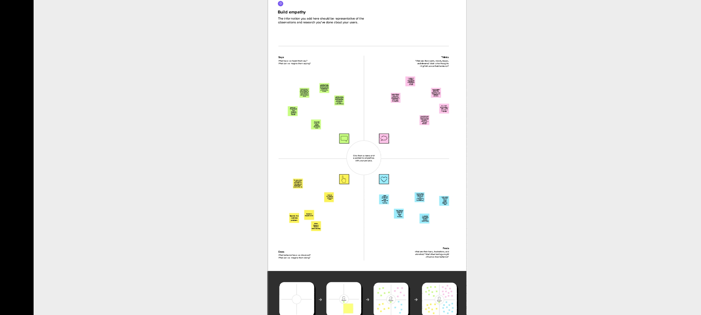

**2.2 IDEATION AND BRAINSTROMIN**

* Once a patient has been diagnosed with CKD, a comprehensive health management plan can be put in place. This may include regular monitoring of kidney function, dietary changes, medication management, and lifestyle modifications such as regular exercise and smoking cessation. This information can then be used to initiate early interventions and lifestyle modifications that can help slow the progression of the disease.

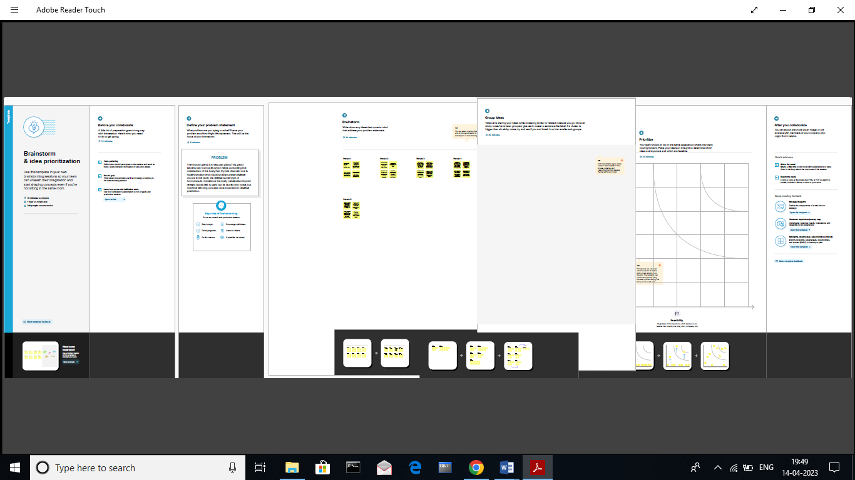

**RESULT**

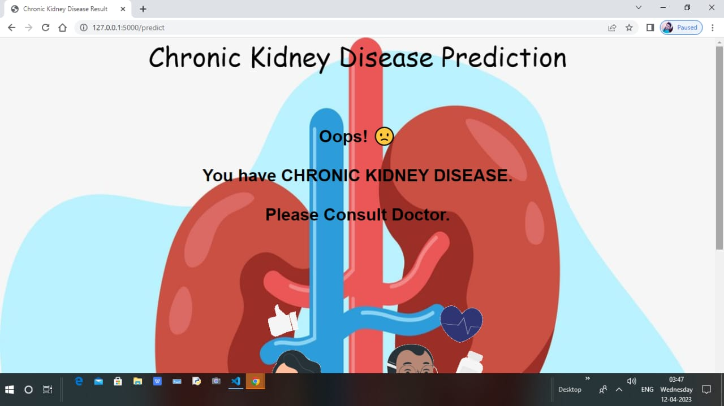

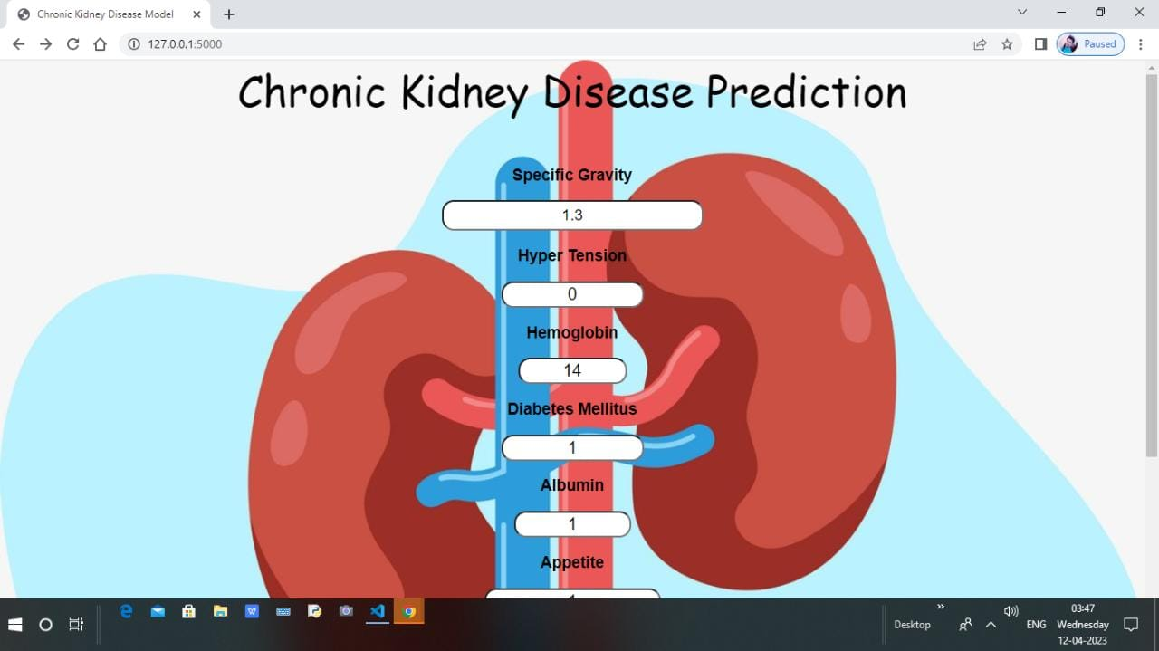

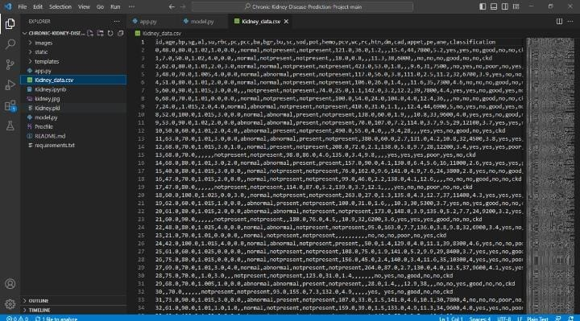 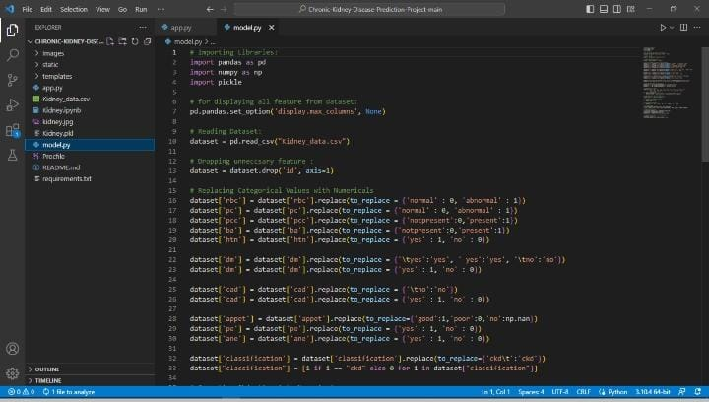

**SAMPLE CODING**

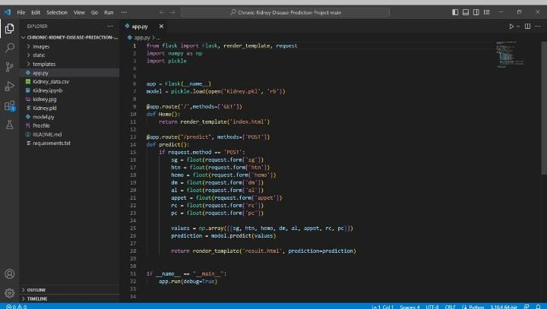

**ADVANTAGES**

1.The goals of early detection are to prevent the progression of chronic kidney disease and its associated complications, with subsequent improvements in patient outcomes and reductions in the impact of chronic kidney disease on healthcare resources.

2.Kidney function tests check how well your kidneys are working. Healthy kidneys assist with removing waste from your body. Conditions such as diabetes or high blood pressure can affect your kidney function. You may also need a kidney function test to diagnose or rule out an infection.Healthcare providers must also have access to up-to-date information and resources on CKD, including treatment options, lifestyle modifications, and patient education materials.

**DISADVANTAGES**

1.Having CKD increases the chances of having heart disease and stroke. Managing high blood pressure, blood sugar, and cholesterol levels—all factors that increase the risk for heart disease and stroke—is very important for people with CKD.

2.Low calcium levels and high phosphorus levels in the blood, which can cause bone disease and heart disease. This may include patient portals, mobile apps, or other digital platforms that allow for real-time monitoring of CKD symptoms and treatment adherence. High potassium levels in the blood, which can cause an irregular or abnormal heartbeat and lead to death.

**CONCLUSION**

* Chronic renal failure represents a critical period in the evolution of chronic renal disease and is associated with complications and comorbidities that begin early in the course of the disease. These conditions are initially subclinical but progress relentlessly and may eventually become symptomatic and irreversible.
* Mortality in patients with end stage renal disease remains 10-20 times higher than that in the general population. The focus in recent years has thus shifted to optimising the care of these patients during the phase of chronic kidney disease, before the onset of end stage renal disease. This review summarises current knowledge about the various stages of chronic renal disease, the risk factors that lead to progression of disease, and their association with common cardiovascular risk factors.

**FUTURE SCOPE**

* Novel therapeutic alternatives for ESRD include wearable artificial kidneys, xenotransplantation, stem cell–based therapy, and bioengineered and bio-artificial kidneys. Of note, one of the main objectives of these novel therapeutic approaches should be to maintain patients at home and to avoid dialysis centers.
* This review summarises current knowledge about the various stages of chronic renal disease, the risk factors that lead to progression of disease, and their association with common cardiovascular risk factors.
* Further research and development are needed to improve the accuracy and reliability of machine learning models in predicting flight delays. Carriers attribute fight to several causes such as bad weather conditions,airspace congestion and use of smaller aircraft by airlines.

**APPENDIX**

**Early Prediction For Chronic Kidney Disease Detection:a Progressive Approach To Health Management**

**VIDEO LINK:https://youtu.be/eW0t9XxAxkc**