Project Weekly Progress Report Agile – Scrum

|  |  |
| --- | --- |
| **Semester** | **W2023, SEM-2** |
| **Course Code** | **AML-2404** |
| **Section** | **Section 2** |
| **Group Name** | **D** |
| **Student names/Student IDs** | **Jash Vaghasiya - C0884733**  **Nivedini Kathagonda - C0872720**  **Keval Parmar - C0882386**  **Monil Rupawala - C0882370**  **Sai Divya Madhuri Guntupalli - C0882360** |
| **Reporting Week** | **9** |
| **Team Lead for the reporting week** | **Sai Divya Madhuri Guntupalli** |

**1. Progress Made in Reporting** **Week:**

This week, I made significant progress on my project, which entails creating a backend using Flask and a frontend using React. To begin, I concentrated on configuring the Flask backend. I built the routes and endpoints required for user login, data retrieval, and modification. JWT (JSON Web Tokens) were used for user authentication since they provide a safe and stateless technique for authenticating user requests. This entailed creating tokens after a successful login and attaching them to subsequent requests for permission. I installed the React components on the frontend and linked them to the Flask backend API. I created the user interface and added user registration, login, and data display functions.

Overall, the integration of Flask and React enabled me to construct a solid foundation for my project and pave the way for future development.

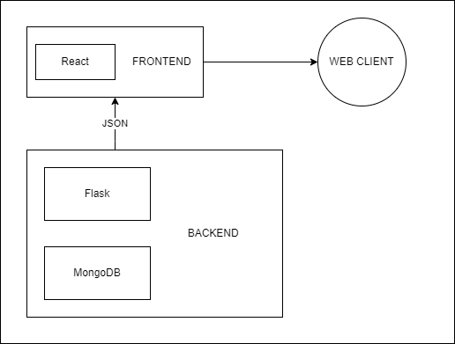

**2. Difficulties Encountered in Reporting Week:**

However, when attempting to store the status of the JWT token in the browser, I ran into a problem. Even though I had implemented the necessary logic to hold the token, it did not survive between page refreshes or browser sessions. This created a massive difficulty for user authentication because users would have to log in repeatedly, resulting in a bad user experience. I looked at possible causes of this problem, such as faulty token storage techniques or problems with browser settings. I double-checked my code to ensure the token was adequately produced and transmitted in the answers. Furthermore, I investigated several methods to token storage, such as local storage or cookies, but they were still waiting to produce the expected results.