Project Weekly Progress Report  
Agile – Scrum

|  |  |
| --- | --- |
| Semester | W2023, SEM-2 |
| Course Code | AML-2404 |
| Section | Section 2 |
| Group Name | D |
| Student names/Student IDs | Jash Vaghasiya - C0884733  Nivedini Kathagonda - C0872720  Keval Parmar - C0882386  Monil Rupawala - C0882370  Sai Divya Madhuri Guntupalli - C0882360 |
| Reporting Week | 5 |
| Team Lead for the reporting week | Sai Divya Madhuri Guntupalli |

# **Progress Made in Reporting** **Week:**

We made tremendous progress during the fifth week of creating our skin care recommendation system. The preprocessing stage, where we prepared the data for additional analysis, is almost finished. We started developing our baseline modeling strategy at the same time.

One necessary action we took was to vectorize numerous elements, including product descriptions and highlights. We can adequately process consumer input thanks to this conversion and compare it to the information about the currently available product. We can use mathematical methods to measure the similarity between several texts by presenting the text as vectors.

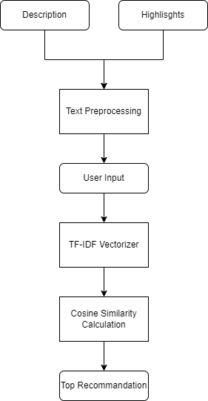

We used the "cosine similarity" statistic to assess how closely user input and product descriptions matched. This measurement expresses the similarity of two vectors by quantifying the cosine of their angle. We determined checking scores based on these statistics to determine how well the customer's needs and the product descriptions matched.

Our team wants to improve the recommendation algorithm even further in the future. We are looking into other ideas that offer different approaches to processing consumer needs and product features, potentially resulting in more varied and precise recommendations.

Overall, the development of our skincare recommendation system is progressing steadily. Preprocessing is almost finished, and baseline modeling is in progress.

# **Difficulties Encountered in Reporting Week:**

Matching consumer concerns with the proper product recommendations is an issue we encountered while developing our skin care recommendation system. Instead of addressing the customer's unique problem with dark circles, the system occasionally recommended goods for dark spots.

We are actively investigating new ideas and methods to address this problem and improve the precision of our recommendations.