**1.How are inline and block elements different from each other?**

A block-level element always starts on a new line and takes up the full width available (stretches out to the left and right as far as it can).eg :<div>

An inline element does not start on a new line and only takes up as much width as necessary.eg:span

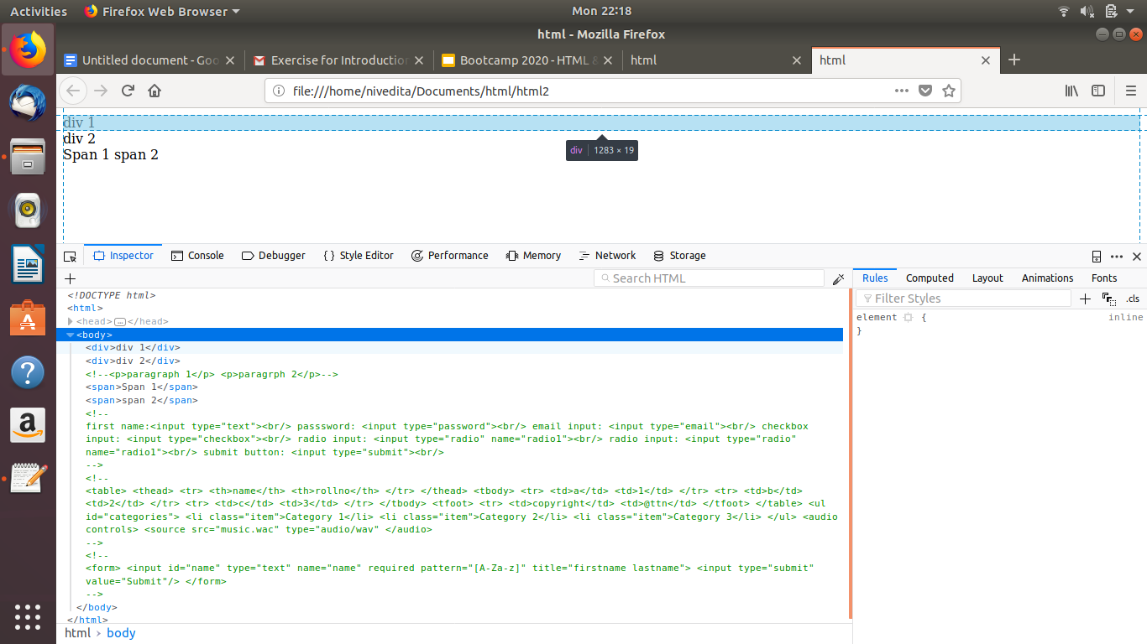

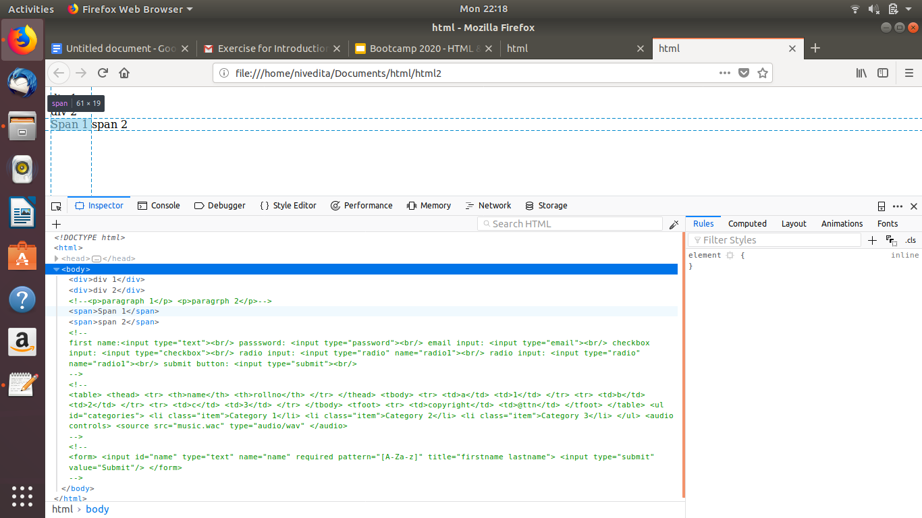

**2. Explain the difference between visibility:hidden and display:none**

display:none

means that the tag in question will not appear on the page at all (although you can still interact with it through the dom). There will be no space allocated for it between the other tags.

visibility:hidden

means that unlike display:none, the tag is not visible, but space is allocated for it on the page. The tag is rendered, it just isn't seen on the page.

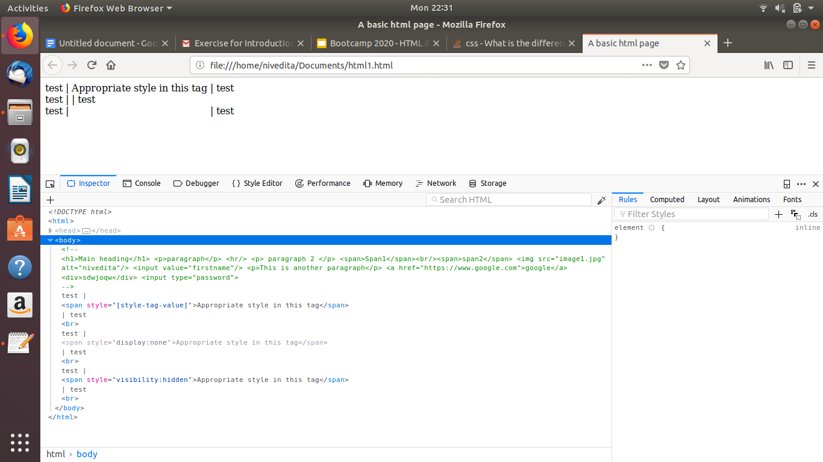

**3.Explain the clear and float properties.**

**Float:**

The float property is used for positioning and formatting content

The float property can have one of the following values:

* left - The element floats to the left of its container
* right - The element floats to the right of its container
* none - The element does not float (will be displayed just where it occurs in the text). This is default
* inherit - The element inherits the float value of its parent

**Clear:**

The clear property specifies what elements can float beside the cleared element and on which side.The clear property can have one of the following values:

* none - Allows floating elements on both sides. This is default
* left - No floating elements allowed on the left side
* right- No floating elements allowed on the right side
* both - No floating elements allowed on either the left or the right side
* inherit - The element inherits the clear value of its parent

**4. explain difference between absolute, relative,fixed and static.**

ABSOLUTE: An element with position: absolute; is positioned relative to the nearest positioned ancestor (instead of positioned relative to the viewport, like fixed).However; if an absolute positioned element has no positioned ancestors, it uses the document body, and moves along with page scrolling.

RELATIVE: An element with position: relative; is positioned relative to its normal position. Setting the top, right, bottom, and left properties of a relatively-positioned element will cause it to be adjusted away from its normal position. Other content will not be adjusted to fit into any gap left by the element.

FIXED: An element with position: fixed; is positioned relative to the viewport, which means it always stays in the same place even if the page is scrolled. The top, right, bottom, and left properties are used to position the element.A fixed element does not leave a gap in the page where it would normally have been located.

STATIC: HTML elements are positioned static by default.Static positioned elements are not affected by the top, bottom, left, and right properties.An element with position: static; is not positioned in any special way; it is always positioned according to the normal flow of the page.

**5. Write the HTML code to create a table in which there are 4 columns( ID , Employee Name, Designation, Department) and at least 6 rows. Also do some styling to it.**

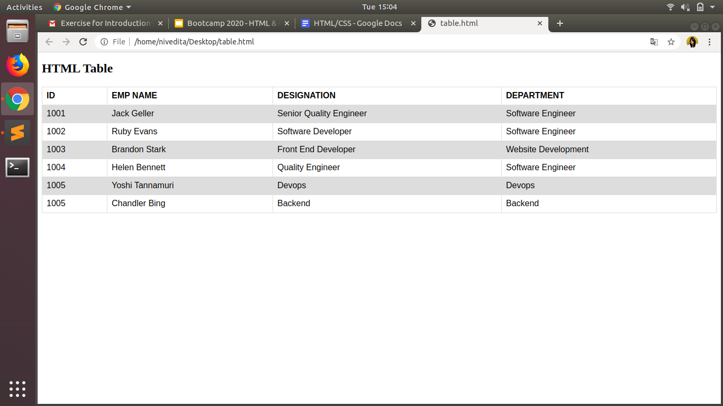

**6. Why do we use meta tags?**

1.The <meta> tag provides metadata about the HTML document. Metadata will not be displayed on the page, but will be machine parsable.

2.Meta elements are typically used to specify page description, keywords, author of the document, last modified, and other metadata. Also, it helps to improve the SEO( Search Engine Optimization) of a web page by using certain keywords related to the web page.

3.<meta> tags always go inside the <head> element.

**7. Explain box model.**

All HTML elements can be considered as boxes. In CSS, the term "box model" is used when talking about design and layout.

The CSS box model is essentially a box that wraps around every HTML element. It consists of: margins, borders, padding, and the actual content.

Explanation of the different parts:

* **Content** - The content of the box, where text and images appear
* **Padding** - Clears an area around the content. The padding is transparent
* **Border** - A border that goes around the padding and content
* **Margin** - Clears an area outside the border. The margin is transparent

The box model allows us to add a border around elements, and to define space between elements.

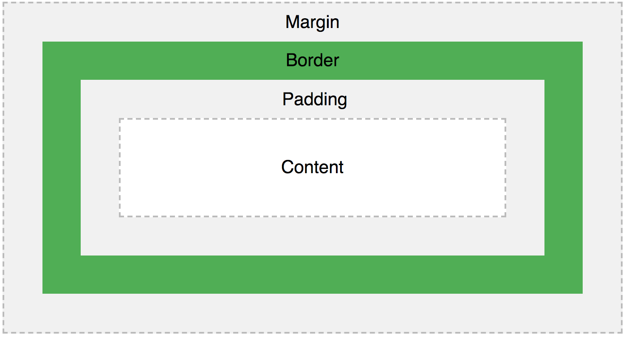

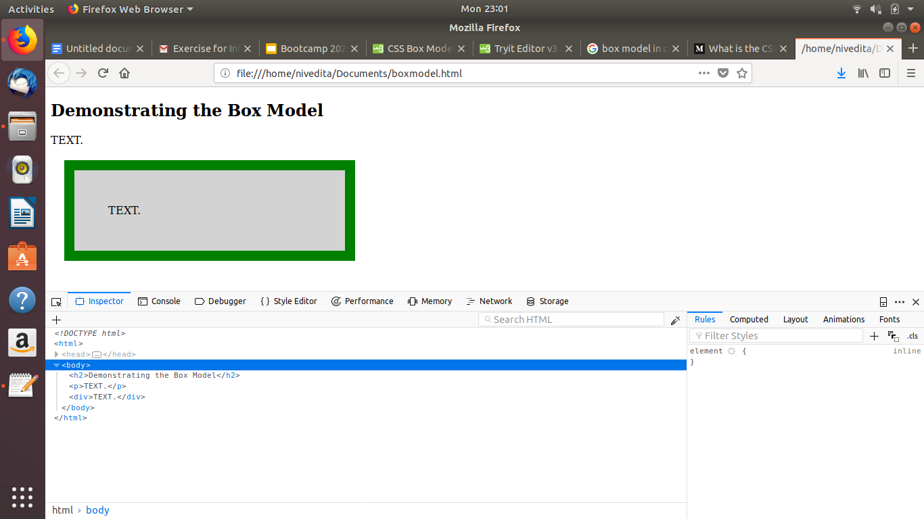

**8. What are the different types of CSS Selectors?**

* Universal Selector
* Class Selector
* ID Selector
* Element Selector
* Descendant Selector
* Child Selector
* Adjacent Sibling Selector
* General Sibling Selector

**9. Define Doctype.**

A doctype defines the valid building blocks of an HTML document. It defines the document structure with a list of validated elements and attributes. A doctype can be declared inline inside an HTML document, or as an external reference.

**10. Explain 5 HTML5 semantic tags.**

**<section>** element defines a section in a document.

**<article>** element specifies independent, self-contained content.

**<header>** element specifies a header for a document or section.

**<footer>** element specifies a footer for a document or section.

**<aside>** element defines some content aside from the content it is placed in (like a sidebar).

**11. Create HTML for web-page.jpg**

**12. Create HTML for form.png**