1.Git Setup<https://confluence.atlassian.com/bitbucket/set-up-git-744723531.html>

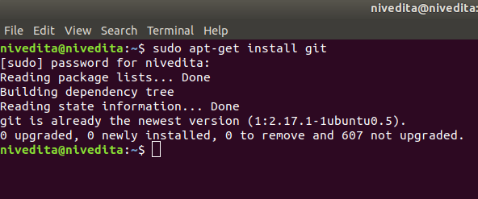

2.Initialize a Git Repository

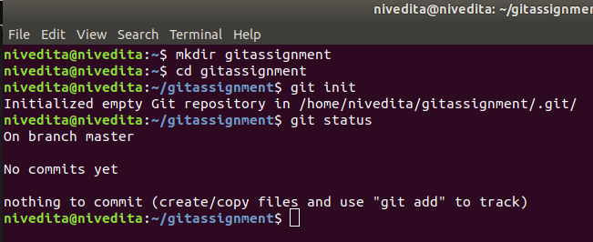

3.Add files to the repository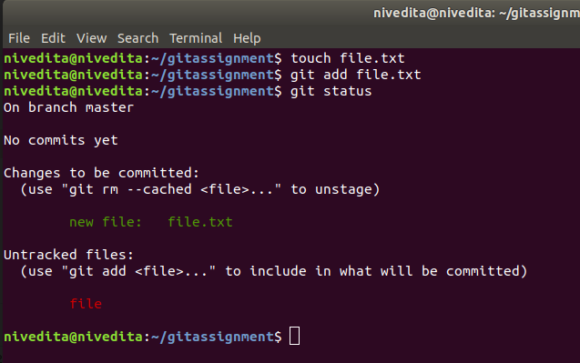

4.Unstage 1 file

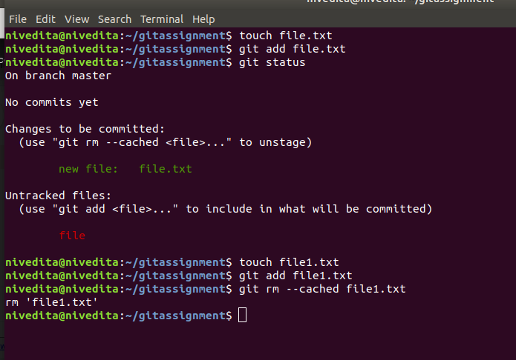

5.Commit the file

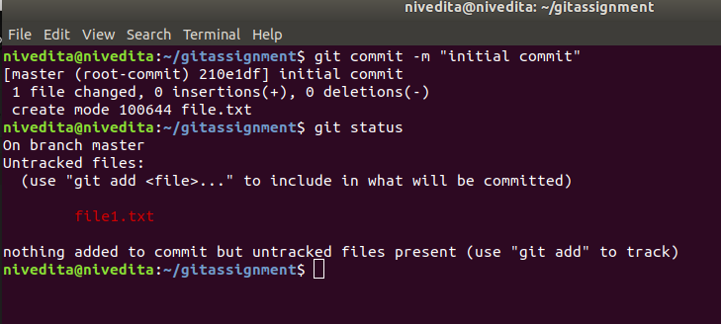

6.Add a remote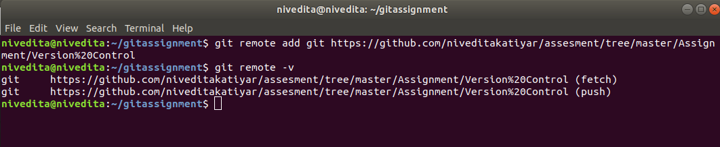

7.Undo changes to a particular file

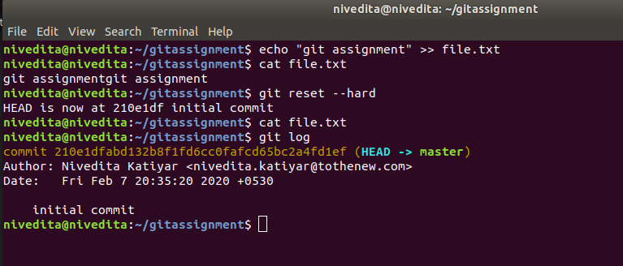

8. PUSH CHANGES to github

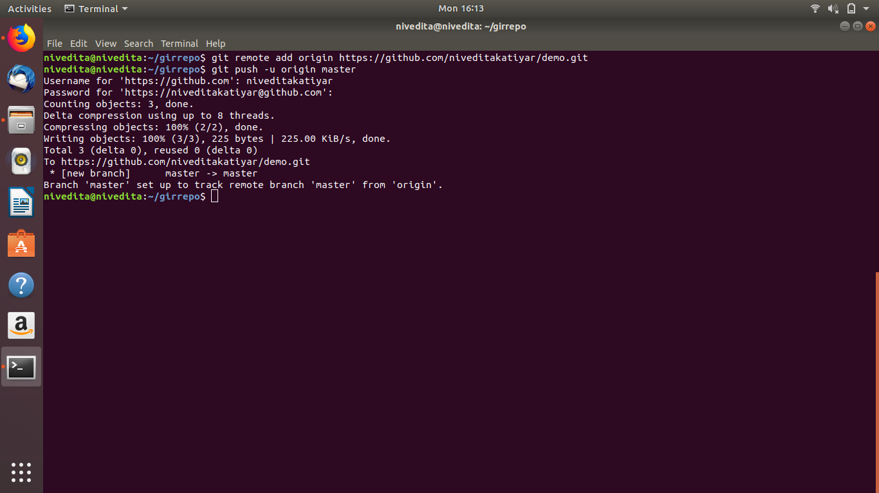

9.Clone the repository

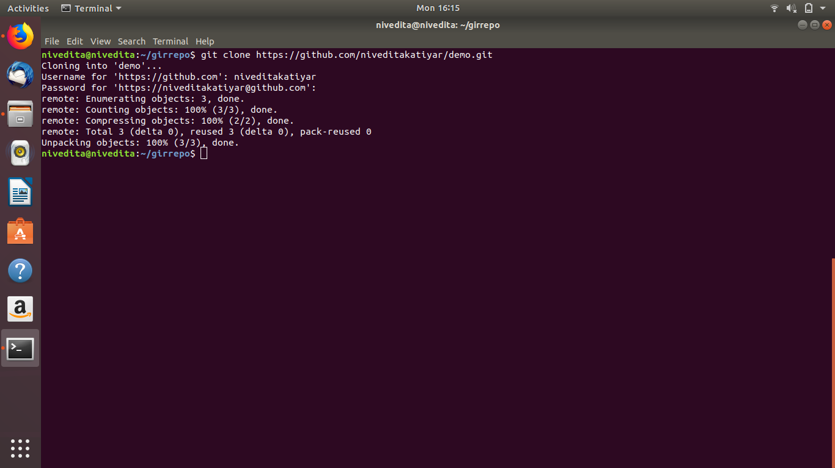

10. Add chages to one copies and pull to other

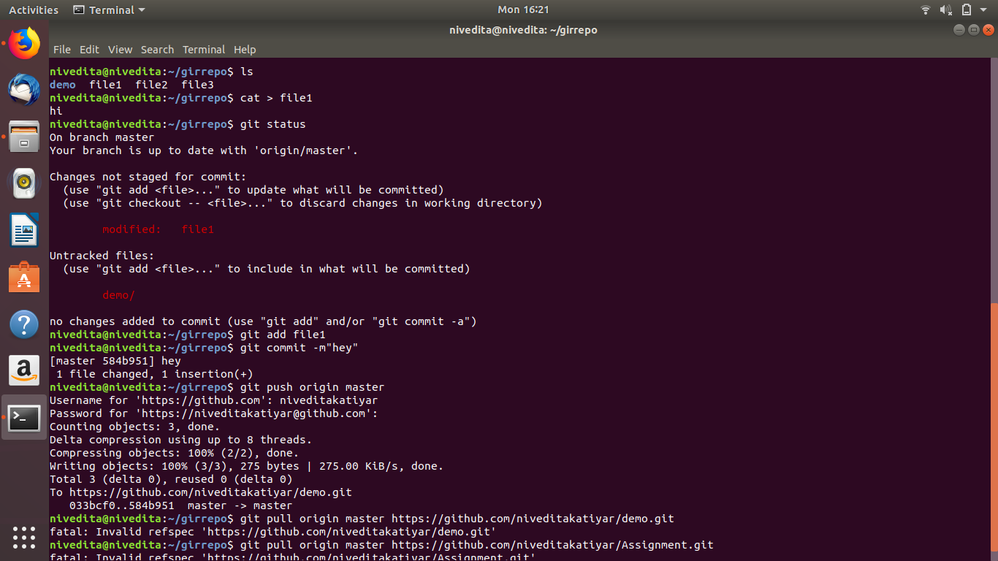

11check differences between a file and its staged version

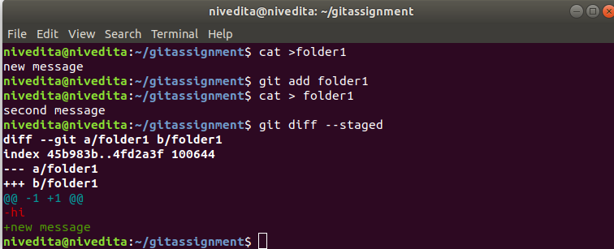12 Ignore a few files to be checked in

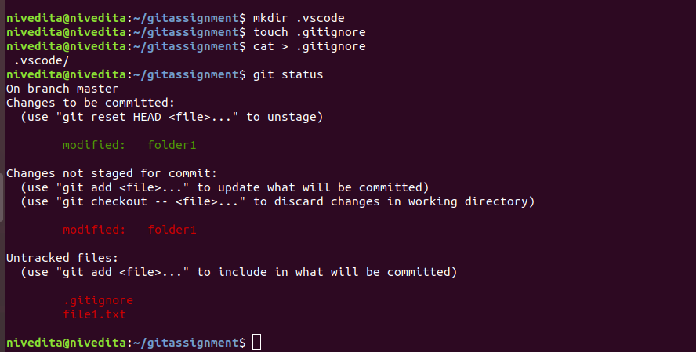

13 Create a new branch.

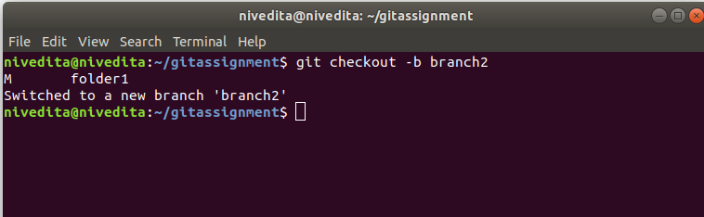

14.diverge them and commit

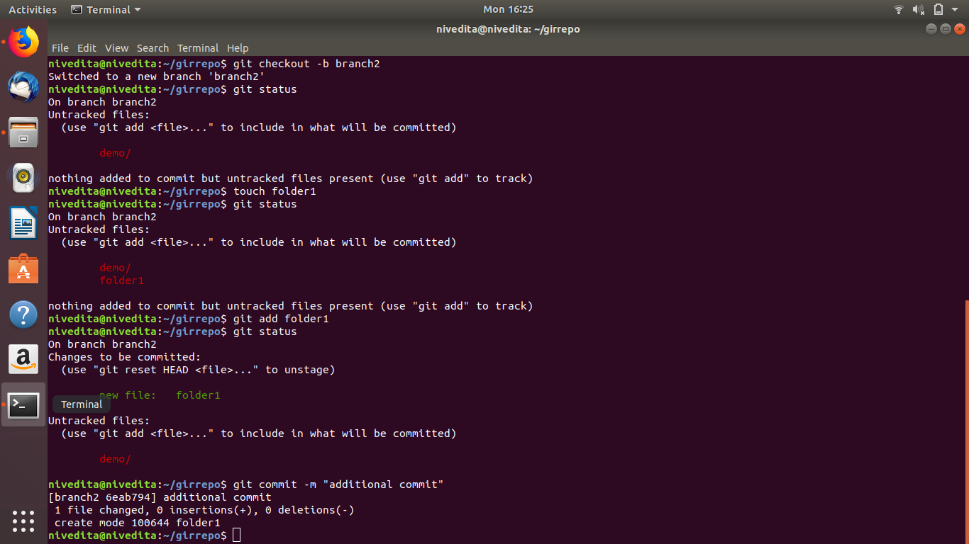

17. Stash the change and pop them

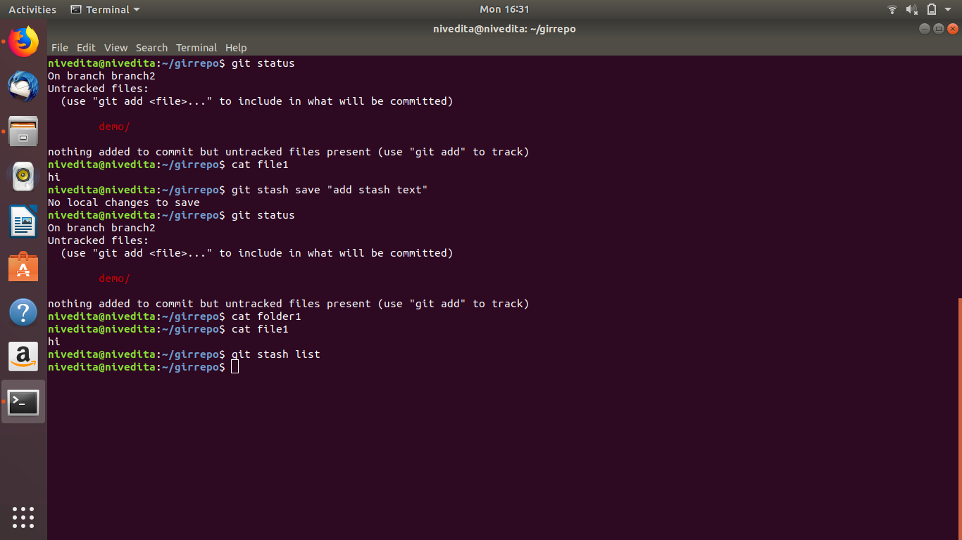

18.Add the following code to your .bashrc file : color_prompt="yes"

parse_git_branch() {

git branch 2> /dev/null | sed -e '/^[^*]/d' -e 's/* \(.*\)/(\1)/'

}

if [ "$color_prompt" = yes ]; then

PS1='\u@\h\[\033[00m\]:\[\033[01;34m\]\W\[\033[01;31m\] $(parse_git_branch)\[\033[00m\]\$ '

else

PS1='\u@\h:\W $(parse_git_branch)\$ '

fi

unset color_prompt force_color_prompt

