Assignment-2

Q1.Create a class named ‘student’ with string variable ‘name’ and integer variable ‘roll_no’.Assign the value of roll_no as ‘2’ and that of name as “john” by creating an object of the class student.

class student

{

String name;

introllno;

}

class a2q1

{

public static void main(String args[])

{

student s=new student();

s.name="john";

s.rollno=2;

System.out.println("Name:"+s.name+"\nRoll No.:"+s.rollno);

}

}

## Output:-

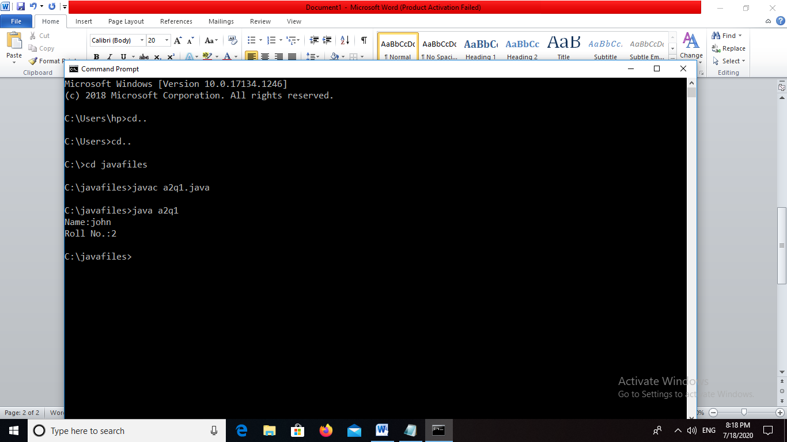

Q2. Assign and print the roll number,phone number and address of two students having names “Sam” and “John” respectively by creating two objects of class student.

class student

{

String name;

String address;

longphoneno;

introllno;

student(String a,Stringb,longc,int d)

{

name=a;

address=b;

phoneno=c;

rollno=d;

}

}

class a2q2

{

public static void main(String args[])

{

student s1=new student("Sam","Latur",90961424,1);

student s2=new student("John","Pune",93701246,2);

System.out.println("Rollno:"+s1.rollno+"\nNmae:"+s1.name+"\nAddress:"+s1.address+"\nPhone no.:"+s1.phoneno);

System.out.println("Rollno:"+s2.rollno+"\nNmae:"+s2.name+"\nAddress:"+s2.address+"\nPhone no.:"+s2.phoneno);

}

}

### Output:

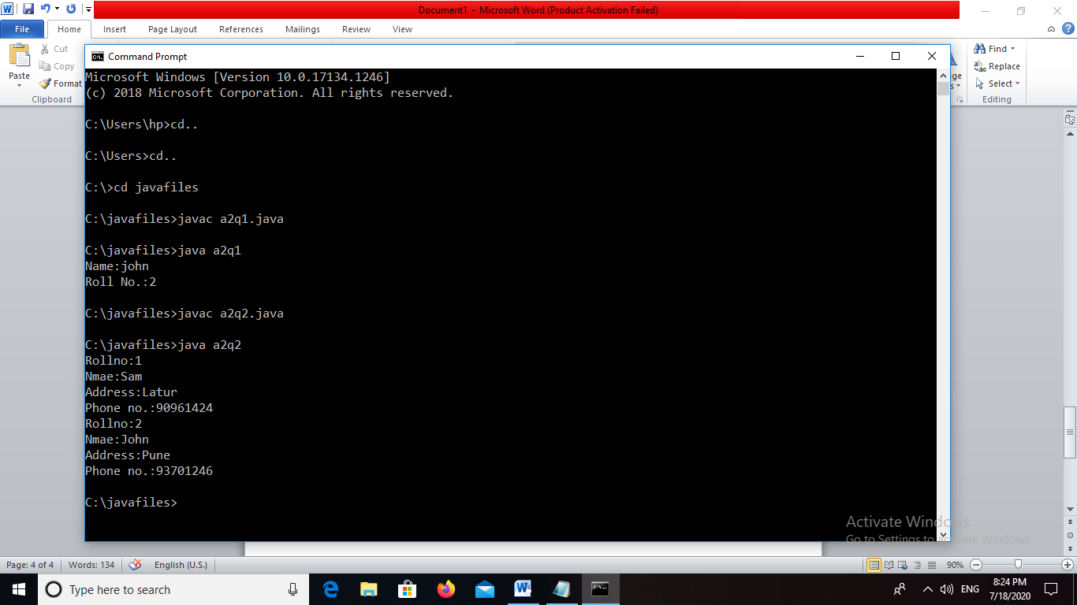

Q3. Write a program to print the area and perimeter of a triangle having sides of 3,4 and 5 units by creating a class named triangle without any parameter in its constructor.

class Triangle{

inta,b,c;

public double getArea(){

double s = (a+b+c)/2.0;

returnMath.pow((s*(s-a)*(s-b)*(s-c)),.5);

}

public double getPerimeter(){

return (a+b+c)/2.0;

}

}

class a2q3{

public static void main(String[] args){

Triangle t = new Triangle();

t.a = 2;

t.b = 5;

t.c = 6;

System.out.println("Area=" +t.getArea());

System.out.println("perimeter=" +t.getPerimeter());

}

}

#### Output:

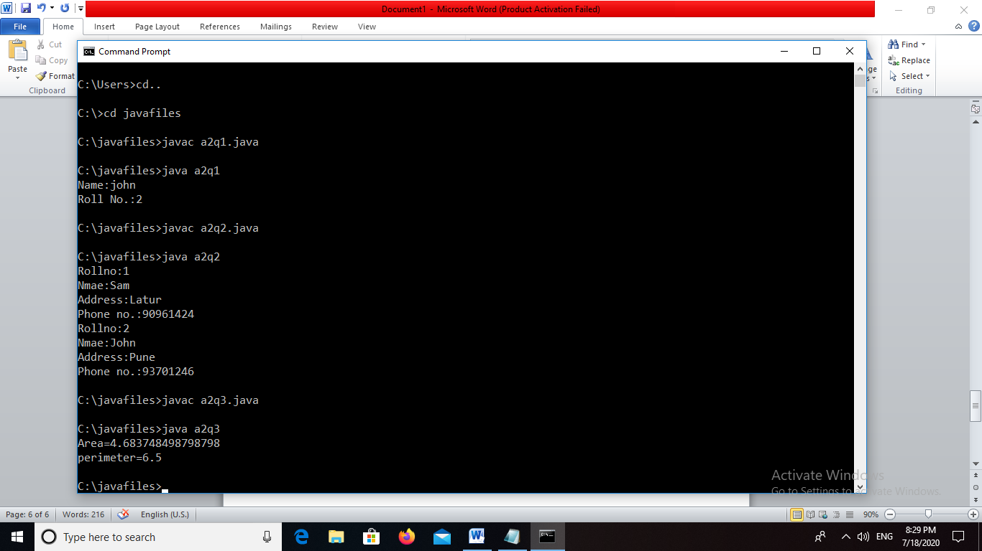

Q4. Write a program to print the area and perimeter of a triangle having sides of 3,4,5units by creating a class named triangle with constructor having the three sides as its parameters.

class Triangle{

inta,b,c;

Triangle(intp,intq,int r)

{

a=p;

b=q;

c=r;

}

public double getArea(){

double s = (a+b+c)/2.0;

returnMath.pow((s*(s-a)*(s-b)*(s-c)),.5);

}

public double getPerimeter(){

return (a+b+c)/2.0;

}

}

class a2q4{

public static void main(String[] args){

Triangle t = new Triangle(2,5,6);

System.out.println("Area=" +t.getArea());

System.out.println("perimeter=" +t.getPerimeter());

}

}

#### Output:

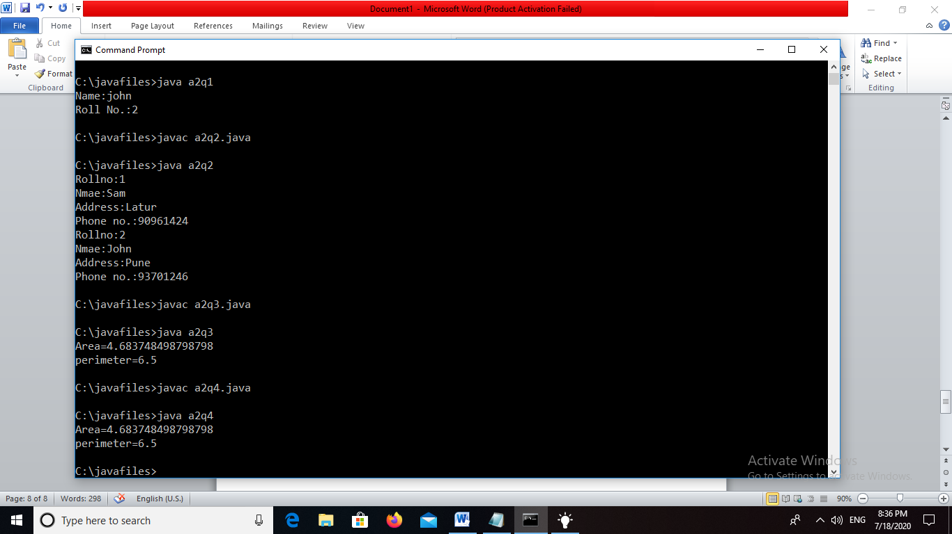

Q5. Write a program to print the area of two rectangle having sides(4,5) and (5,8) respectively by creating a class named rectangle with a method named area which returns the area and length and breadth passed as parameters to its constructor.

class Rectangle{

int length;

int breadth;

public Rectangle(int l, int b){

length = l;

breadth = b;

}

publicintgetArea(){

return length*breadth;

}

publicintgetPerimeter(){

return 2*(length+breadth);

}

}

class a2q5{

public static void main(String[] args){

Rectangle a = new Rectangle(4,5);

Rectangle b = new Rectangle(5,8);

System.out.println("Area : "+a.getArea()+" Perimeter is "+a.getPerimeter());

System.out.println("Area : "+b.getArea()+" Perimeter is "+b.getPerimeter());

}

}

#### Output:

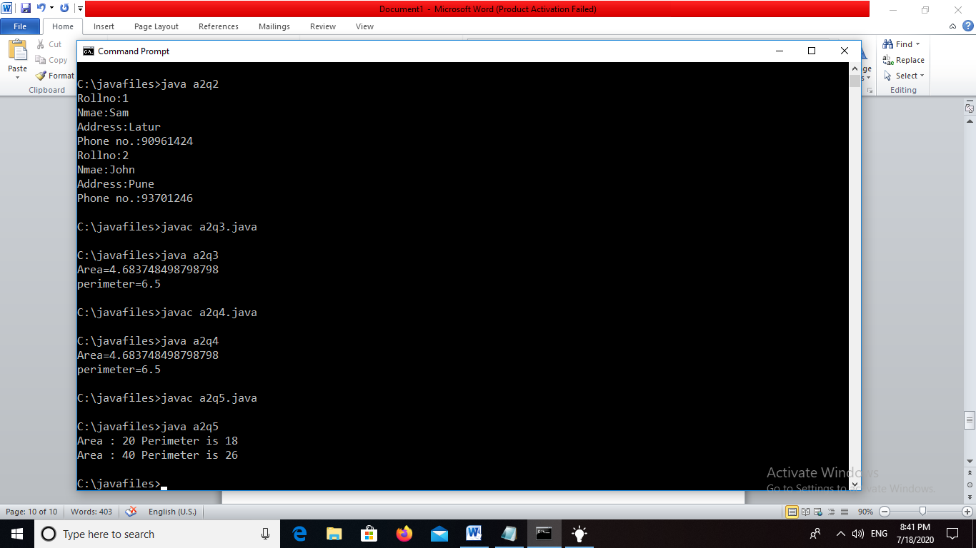

Q6. Write a program to print the area of a rectangle by creating a class named area having two methods.First method named as setDim takes length and breadth of rectangle as parameters and and the second method named as getArea returns the area of the rectangle.Length and breadth of rectangle are entered through keyboard.

class area{

int length;

int breadth;

public void setDim(intp,int q)

{

length=p;

breadth=q;

}

publicintgetArea(){

return length*breadth;

}

}

class a2q6{

public static void main(String[] args){

area a = new area();

intp,q;

p=Integer.parseInt(args[0]);

q=Integer.parseInt(args[1]);

a.setDim(p,q);

System.out.println("Area : "+a.getArea());

}

}

#### Output:

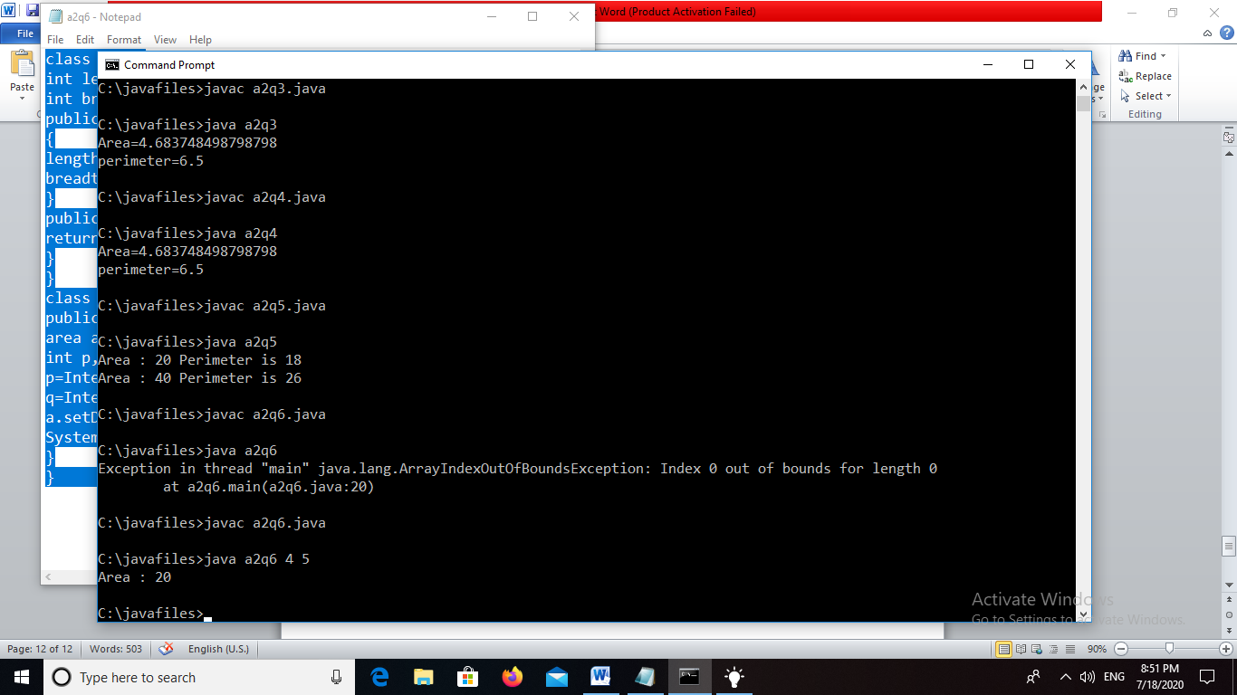

Q.7 Write a program to print the area of a rectangle by creating a class named area taking the values of its length and breadth as parameters of its constructor and having a method named returnArea which returns the area of the rectangle .Length and breadth of rectangle are entered through keyboard.

importjava.util.*;

class Area{

int length;

int breadth;

public Area(int l, int b){

length = l;

breadth = b;

}

publicintgetArea(){

return length*breadth;

}

}

class a2q7{

public static void main(String[] args){

Scanner s = new Scanner(System.in);

intl,b;

System.out.println("Enter length");

l = s.nextInt();

System.out.println("Enter breadth");

b = s.nextInt();

Area a = new Area(l,b);

System.out.println("Area : "+a.getArea());

}

}

#### Output:

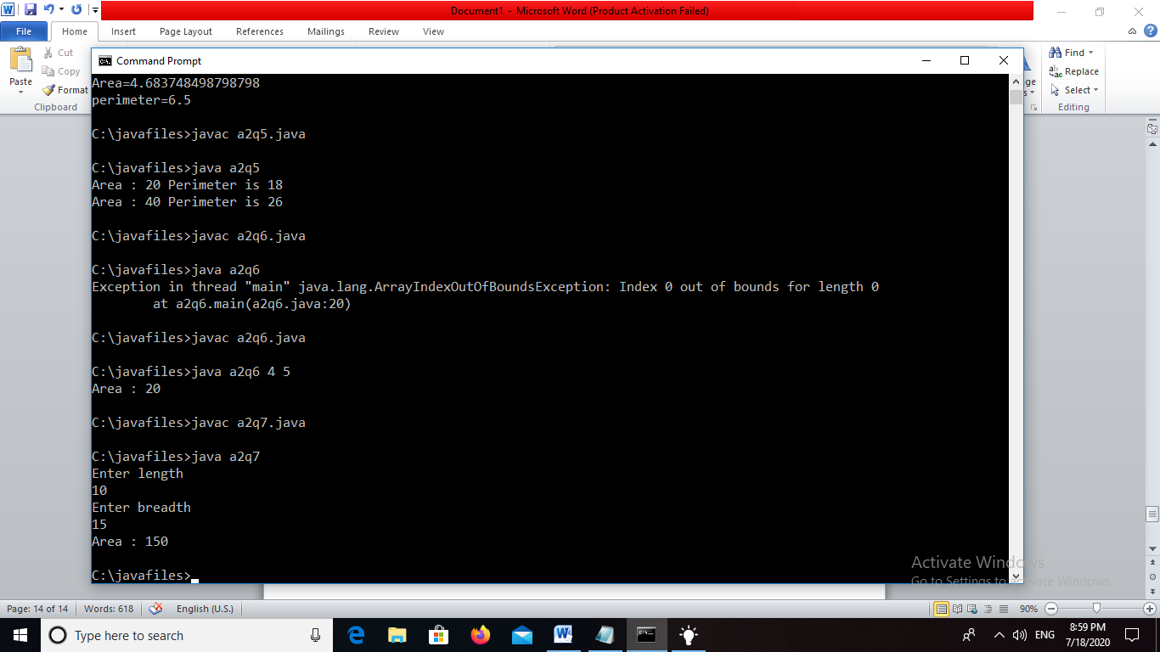

Q8. Print the average of three numbers entered by user by creating a class named average having a method to calculate and print the average.

importjava.util.*;

class average{

intavg;

public void calculate(intl,intm,int n){

avg=(l+m+n)/3;

}

public void print()

{

System.out.println("Average="+avg);

}

}

class a2q8{

public static void main(String[] args){

int a;

int b;

int c;

Scanner s = new Scanner(System.in);

average x=new average();

System.out.println("Enter first number");

a = s.nextInt();

System.out.println("Enter second number");

b = s.nextInt();

System.out.println("Enter third number");

c=s.nextInt();

x.calculate(a,b,c);

x.print();

}

}

#### Output:

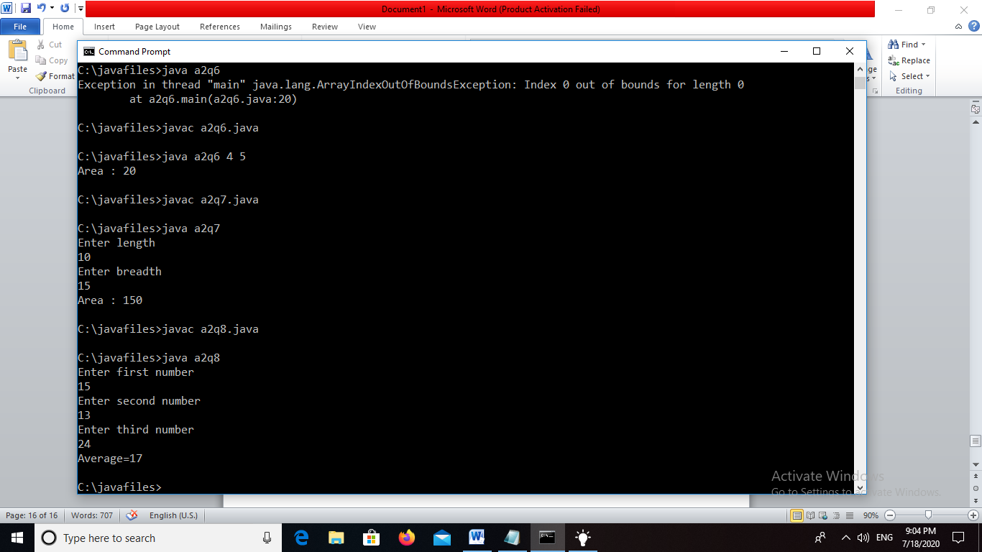

Q9. Print the sum,difference and product of two complex numbers by creating a class named complex with separate methods for each operation whose real and imaginary parts are entered by user.

importjava.util.*;

class Complex{

int real;

intimag;

public Complex(int r, int i){

real = r;

imag = i;

}

public static Complex add(Complex a, Complex b){

return new Complex((a.real+b.real),(a.imag+b.imag));

}

public static Complex diff(Complex a, Complex b){

return new Complex((a.real-b.real),(a.imag-b.imag));

}

public static Complex product(Complex a, Complex b){

return new Complex(((a.real*b.real)-(a.imag*b.imag)),((a.real*b.imag)+(a.imag*b.real)));

}

public void printComplex(){

if(real == 0 &&imag!=0){

System.out.println(imag+"i");

}

else if(imag == 0 && real!=0){

System.out.println(real);

}

else{

System.out.println(real+"+"+imag+"i");

}

}

}

class a2q9{

public static void main(String[] args){

Complex c = new Complex(4,5);

Complex d = new Complex(9,4);

Complex e = Complex.add(c,d);

Complex f = Complex.diff(c,d);

Complex g = Complex.product(c,d);

e.printComplex();

f.printComplex();

g.printComplex();

}

}

#### Output:

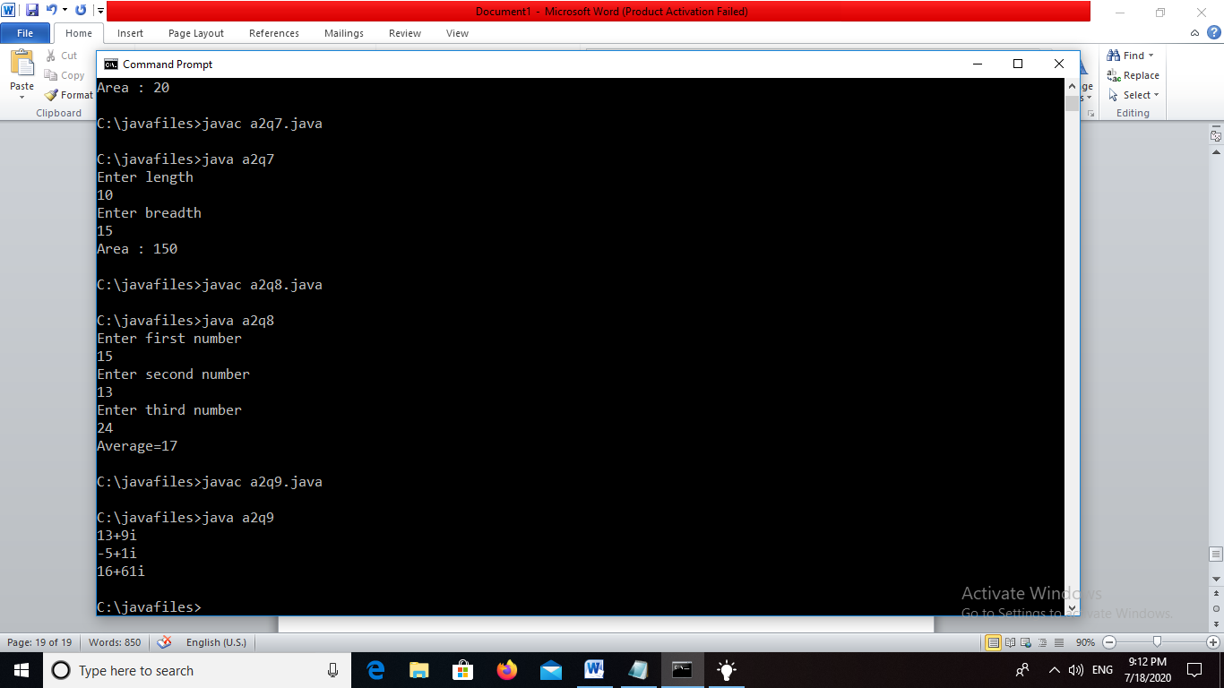

Q10.Write a program that would print the information(name,year of joining ,salary,address) of three employees by creating a class named employee.The output should be as follows:

Name Year of joining Address

Robert 1994 64C-WallStreat

Sam 2000 68D-WallStreat

John 1999 26B-WallStreat

Program:

class Employee{

private String name, address;

privateint year, salary;

public Employee(String n, int y, intsal, String add){

name = n;

year = y;

salary = sal;

address = add;

}

public String getName(){

return name;

}

publicintgetYear(){

return year;

}

publicintgetSalary(){

return salary;

}

public String getAddress(){

return address;

}

}class a2q10{

public static void main(String[] args){

Employee e1 = new Employee("Robert", 1994, 500000, "64C- WallsStreet");

Employee e2 = new Employee("Sam", 2000, 740000, "68d- WallsStreet");

Employee e3 = new Employee("John", 1999, 600000, "26B- WallsStreet");

System.out.println("Name\tYear of joining\tSalary\tAddress");

System.out.println(e1.getName()+"\t"+e1.getYear()+"\t\t\t"+e1.getSalary()+"\t"+e1.getAddress()); // printing details of employee 1

System.out.println(e2.getName()+"\t"+e2.getYear()+"\t\t\t"+e2.getSalary()+"\t"+e2.getAddress()); // printing details of employee 2

System.out.println(e3.getName()+"\t"+e3.getYear()+"\t\t\t"+e3.getSalary()+"\t"+e3.getAddress()); // printing details of employee 3

}

}

#### Output:-

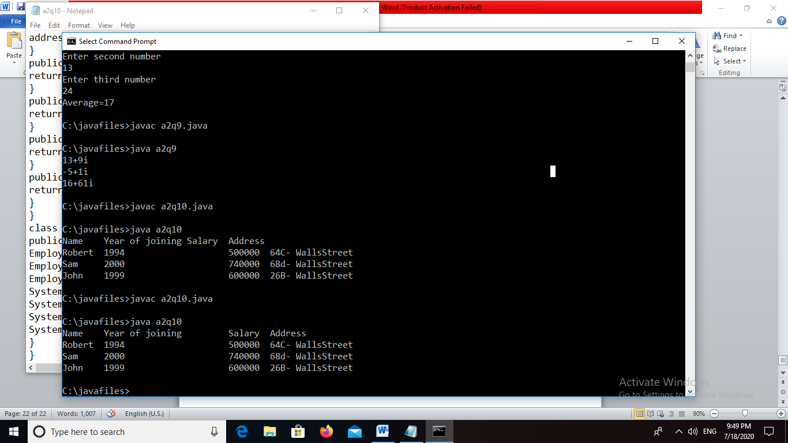

Q11. Add two distances in inch-feet by creating named addDistance.

importjava.util.*;

class Distance

{

Private int feet;

Private int inches;

public void getDistance()

{

Scanner sc=new Scanner(System.in);

System.out.print("Enter feet: ");

feet=sc.nextInt();

System.out.print("Enter inches: ");

inches=sc.nextInt();

}

public void showDistance()

{

System.out.println("Feet: "+ feet + "\tInches: "+ inches);

}

public void addDistance(Distance D1, Distance D2)

{

inches=D1.inches+D2.inches;

feet=D1.feet+D2.feet+(inches/12);

inches=inches%12;

}

}

public class a2q11

{

public static void main(String []s)

{

try

{

Distance D1=new Distance();

Distance D2=new Distance();

Distance D3=new Distance();

System.out.println("Enter first distance: ");

D1.getDistance();

System.out.println("Enter second distance: ");

D2.getDistance();

D3.addDistance(D1,D2);

System.out.println("Total distance is:" );

D3.showDistance();

}

catch (Exception e)

{

System.out.println("Exception occurred :"+ e.toString());

}

}

}

#### Output:-

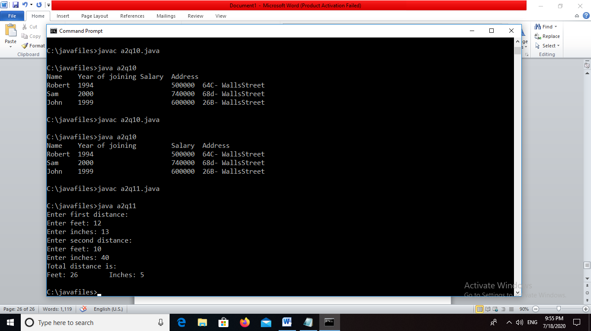

Q12. Write a program by creating employee class having the following methods and print the final salary.

1.getInfo() which takes the salary,number of hours of work per day of employee as parameter

2.addSal() which adds $10 to salary of the employee if it is less than $500.

3.AddWork() which adds $5 to salary of employee if the number of hours of work per day is more than 6 hours.

import java.util.*;

classEmployeeDetail {

private String name;

private float salary, hours;

publicEmployeeDetail() {

name = " ";

salary = 0;

hours = 0;

}

public void getInfo(String n, float sal, float hr) {

name = n;

salary = sal;

hours = hr;

}

public float AddSal() {

if(salary<500) {

salary = salary + 10;

}

return salary;

}

public float AddWork() {

if(hours > 6) {

salary = salary + 5;

}

return salary;

}

}

classTestEmployee {

float salary;

publicTestEmployee(float sal) {

salary = sal;

}

public void printSal() {

System.out.println("Salary : " + salary);

}

}

class a2q12

{

public static void main (String[] args)

{

EmployeeDetailemp = new EmployeeDetail();

Scanner sc = new Scanner(System.in);

System.out.println("Enter name");

String name = sc.nextLine();

System.out.println("Enter salary");

float salary = sc.nextFloat();

System.out.println("Enter no. of hours of work");

float hours = sc.nextFloat();

emp.getInfo(name, salary, hours);

salary = emp.AddSal();

salary = emp.AddWork();

TestEmployee test = new TestEmployee(salary);

test.printSal();

}

}

#### Output:-

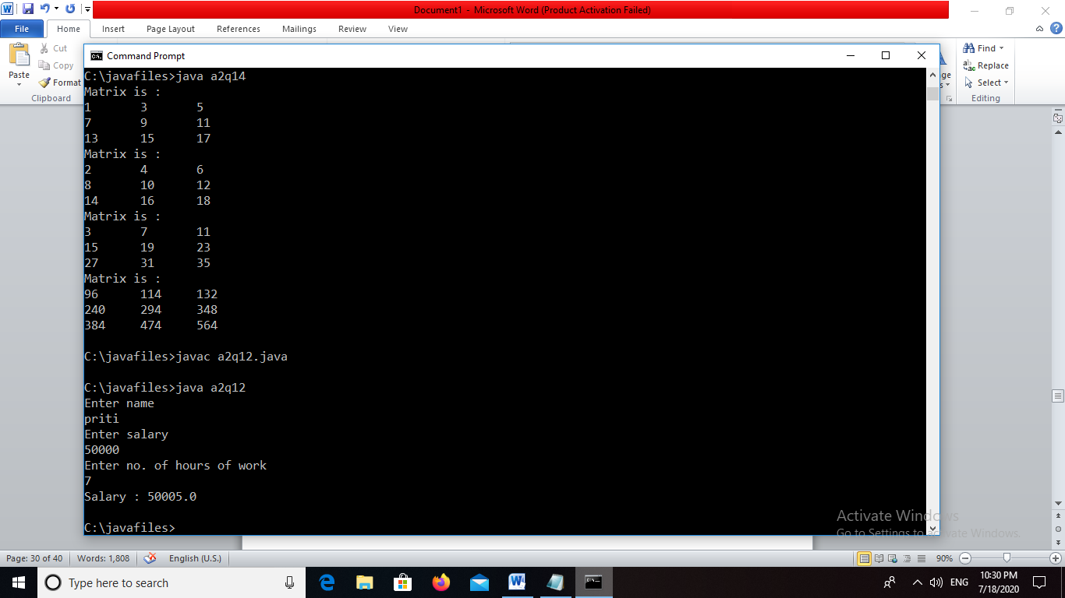

Q13. Create a class matrix containing constructor that initializes the number of rows and number of columns of a new matrix object.The matrix class has the followinginformation:

1-number of rows of matrix

2-number of columns of matrix

3-elements of matrix in the form of 2D array

import java.util.*;

class matrix

{

private double[][] mat;

int row, column;

matrix()

{

row=0;

column=0;

}

matrix(int r, int c)

{

row = r;

column = c;

mat = new double[row][column];

}

public void get_input()

{

Scanner s = new Scanner(System.in);

int i=0,j=0;

System.out.println("Enter the matrix elements(row-wise)");

for (i=0; i < row; i++)

{

for(j=0; j<column; j++)

{

mat[i][j] = s.nextDouble();}

}

}

public void print_matrix()

{

int i = 0, j = 0;

System.out.println("The matrix is:>>");

for (i = 0; i < row; i++)

{

System.out.println("");

for (j = 0; j < column; j++)

{

System.out.print(" "+mat[i][j]);

}

}

}

}

class a2q13

{

private static matrix m1,m2,ans;

public static void main(String args[])

{int i = 0, j = 0,r=0,c=0;

Scanner s = new Scanner(System.in);

System.out.println("Enter no. of rows:");

r = s.nextInt();

System.out.println("Enter no. of columns:");

c = s.nextInt();

System.out.println("Enter the first matrix:>>");

m1 = new matrix(r,c);

m1.get_input();

m1.print_matrix();

}

}

Output:

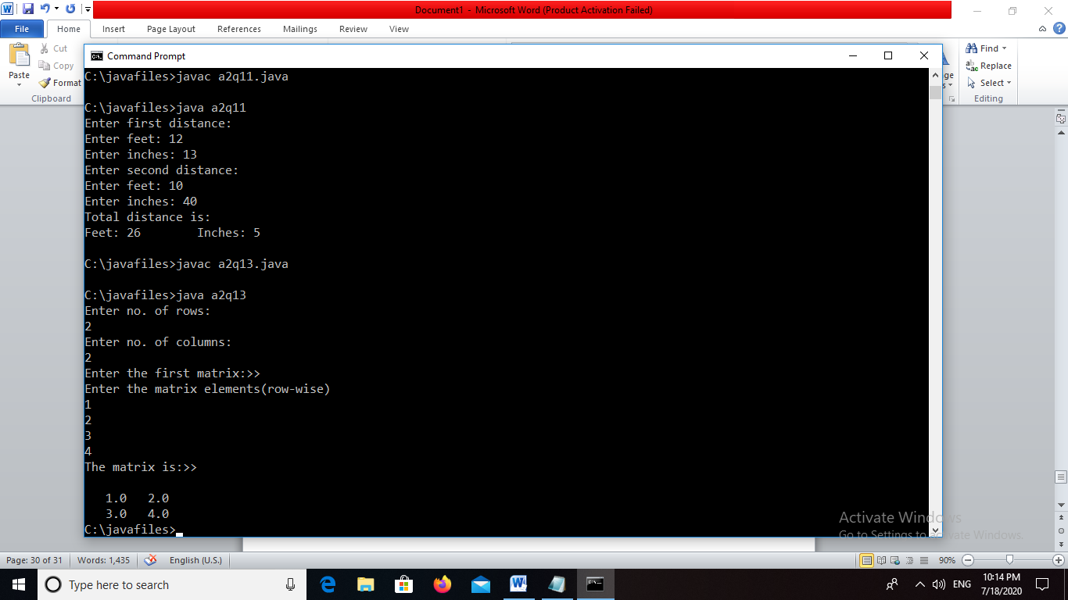

Q14. The Matrix class has methods for each of the following:

1-get the number of rows

2-get the number of columns

3-set the elements of matrix at the given position (i,j)

4-adding 2 matrices.If the matrices are not addable,”Matrix cannot be added” will be displayed.

5-multiplying 2 matrices

Program:

int row;

int column;

int[][] a;

public Matrix(int r, int c){

row = r;

column = c;

a = new int[row][column];

}

publicintgetRows(){

return row;

}

publicintgetColumns(){

return column;

}

publicintgetElement(int r, int c){

return a[r][c];

}

public void setElement(int r, int c, int element){

a[r][c] = element;

}

public static Matrix add(Matrix x, Matrix y){

if((x.row == y.row) && (x.column == y.column)){

Matrix m = new Matrix(x.row,x.column);

for(int i = 0;i<m.row;i++){

for(int j = 0;j<m.column;j++){

m.setElement(i,j,(x.getElement(i,j)+y.getElement(i,j)));

}

}

return m;

}

else{

System.out.println("Matrices can not be added");

return new Matrix(0,0);

}

}

public static Matrix product(Matrix x, Matrix y){

Matrix m = new Matrix(x.row,y.column);

for(int j = 0;j<x.row;j++){

for(int i = 0;i<y.column;i++){

int sum = 0;

for(int k = 0;k<x.column;k++){

sum = sum+(x.getElement(j,k)*y.getElement(k,i));

}

m.setElement(j,i,sum);

}

}return m;

}

public void printMatrix(){

System.out.println("Matrix is :");

for(int i = 0;i<row;i++){

for(int j = 0;j<column;j++){

System.out.print(a[i][j]+"\t");

}

System.out.println("");

}

}

}

class a2q14{

public static void main(String[] args){

Matrix m = new Matrix(3,3);

Matrix n = new Matrix(3,3);

int k = 1;

for(int i = 0;i<3;i++){

for(int j = 0;j < 3;j++){

m.setElement(i,j,k);

k++;

n.setElement(i,j,k);

k++;

}

}

m.printMatrix();

n.printMatrix();

Matrix o = Matrix.add(m,n);

o.printMatrix();

Matrix p = Matrix.product(m,n);

p.printMatrix();

}

}

#### Output:

