**STUDENT DATABASE MANAGEMENT SYSTEM.**

* C++ code.
* Use Code::Blocks OR Dev C++ platform to run the code.

**MODULES PRESENT IN THE PROJECT:**

|  |
| --- |
| **MAIN MENU :**  **1 : STUDENT**  **2 : STAFF**  **3 : ADMIN** |

|  |  |  |
| --- | --- | --- |
| **STUDENT**  1.View Profile  2.View Attendance  3.View Marks  4.View Notifications  5.Give a Complaint  6.View Exam Timetable | **STAFF**  1.View Profile  2.Manage attendance  3.Manage Marks | **ADMIN**  1.Add Student  2.Remove student  3.Add staff  4.Remove staff  5.List Students  6.Manage Attendance  7.View Student’s Attendance  8.View student’s marks  9.Add notification  10.Check Complaints  11.Upload Exam Timetable |

**OUTPUT AND EXPLAINATION:**

Figure: 1 MAIN MENU

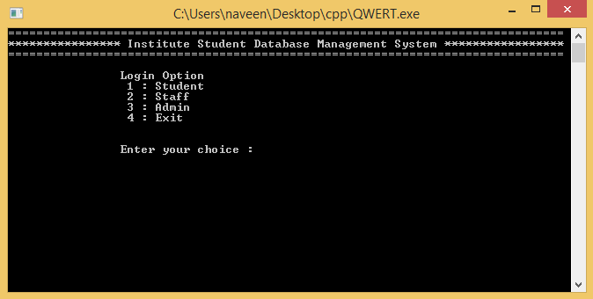

Figure: 2.1 ADMIN LOGIN

Admin id: ADMIN

Admin password: OOP

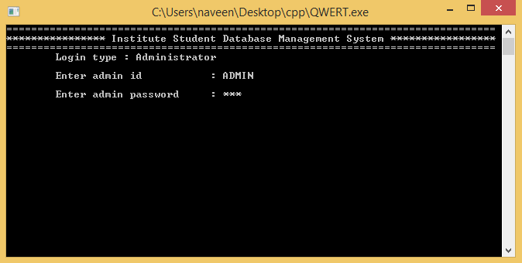

Figure: 2.2 ADMIN MENU

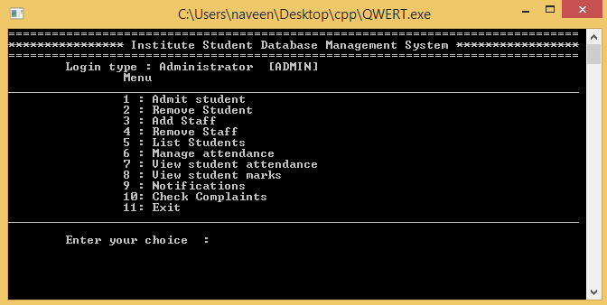

Figure: 2.3 ADMIT NEW STUDENT(Enter student profile)

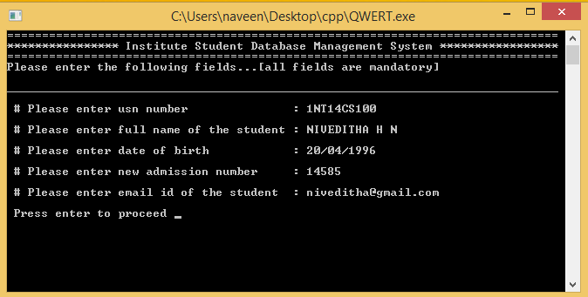

Figure: 2.3.1 CONFIRM STUDENT DETAILS

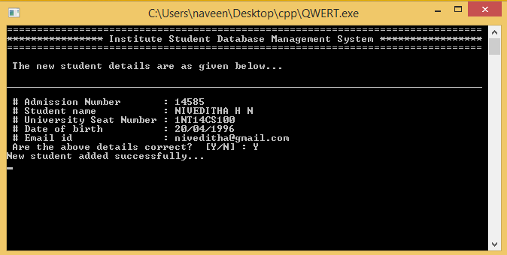

Figure: 2.4 LIST STUDENTS 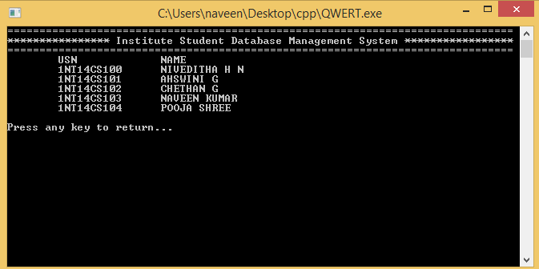

Figure: 2.5 REMOVE STUDENT

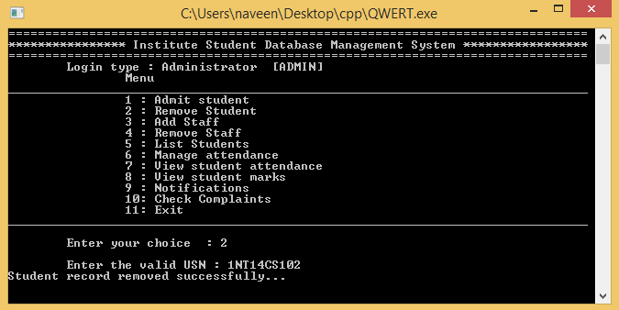

Figure: 2.6 ADMIT STAFF(Enter staff profile)

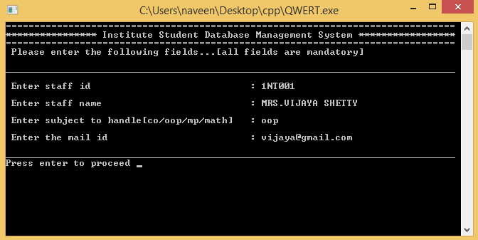

Figure: 2.7 ENTER NOTIFICATION(Students can view this.)

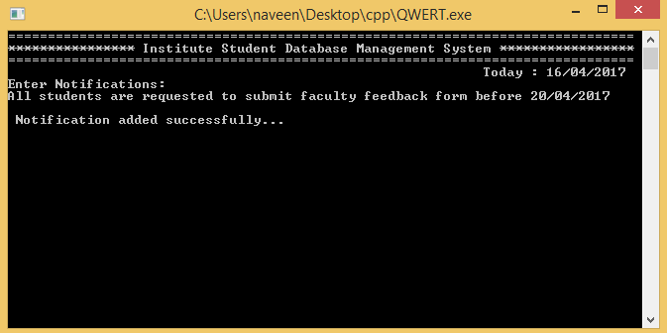

Figure: 2.8 VIEW COMPLAINTS(Given by students)

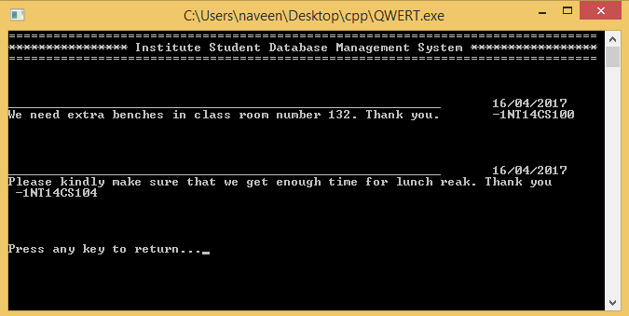

Figure: 3.1 STAFF LOGIN

Staff id : staff id (given by admin ) eg.1NT14001

password : staff id (given by admin ) eg.1NT14001

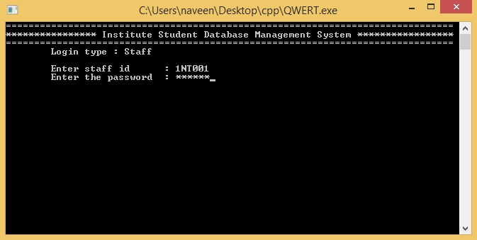

Figure: 3.2 STAFF MENU

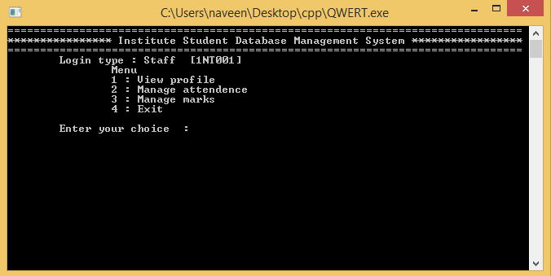

Figure: 3.2 VIEW SELF PROFILE

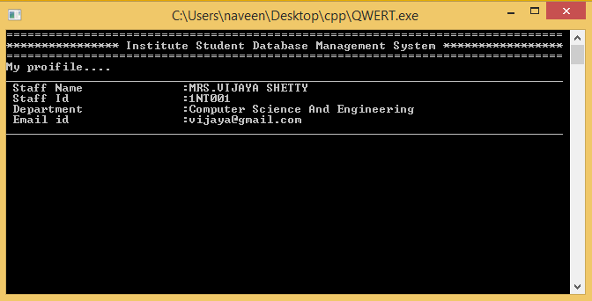

Figure: 3.3 MARK ATTENDENCE(not more than ones in a day)

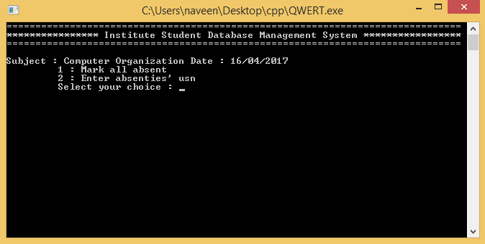

Figure: 3.3.1 ENTER ABSENTIES USN TO MARK ATTENDENCE

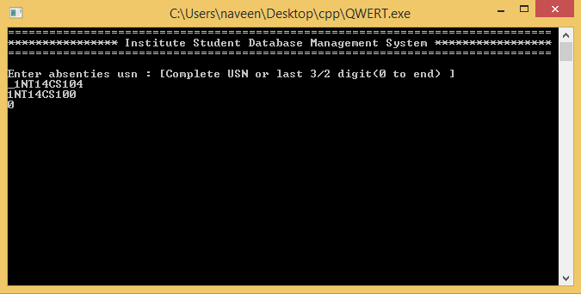

Figure: 3.3.2 SHOWS STATUS AFTER MARKING ATTENDENCE

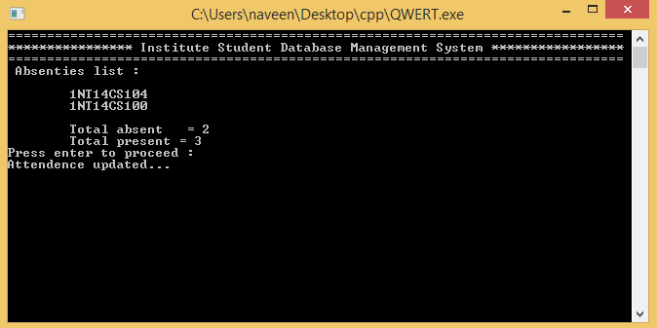

Figure: 3.3.4 IF YOU TRY TO ENTER ATTENDENCE MORE THAN ONES IN A DAY

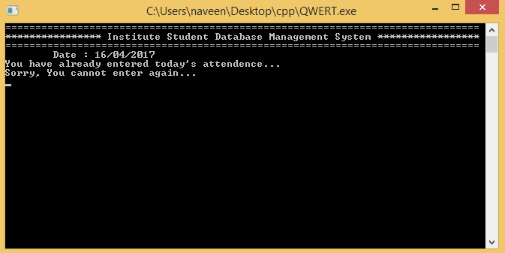

Figure: 3.4 ENTER MARKS(maximum marks)

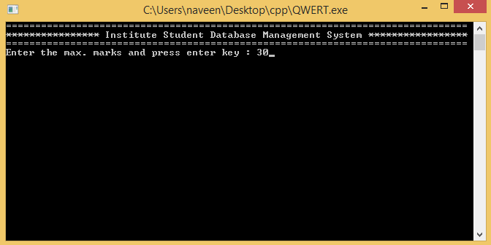

Figure: 3.4.1 ENTER MARKS FOR EACH STUDENT

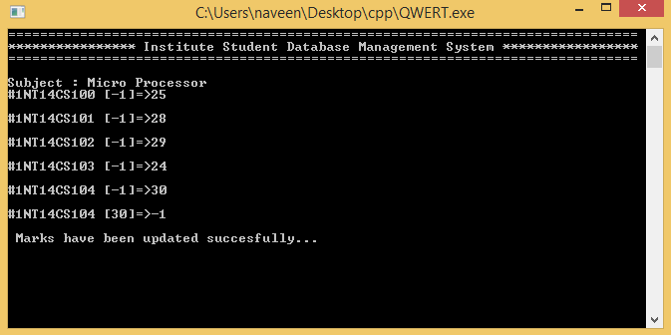

Figure: 4.1 STUDENT LOGIN

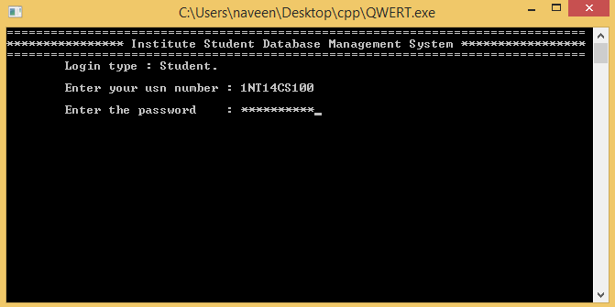

Figure: 4.2 STUDENT MENU

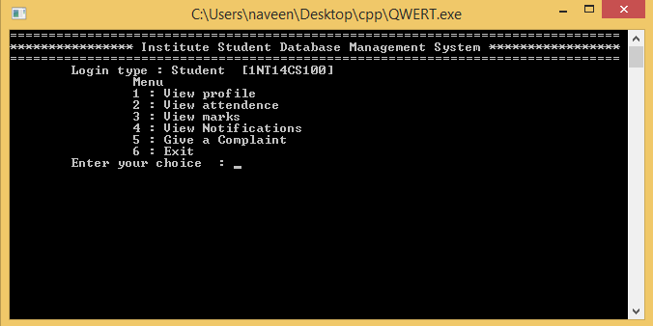

Figure: 4.3 VIEW STUDENT PROFILE

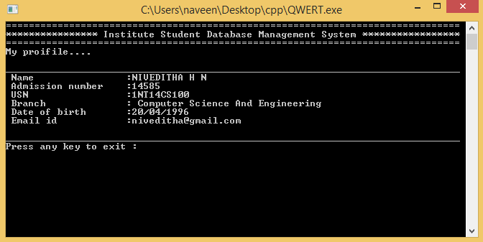

Figure: 4.4 VIEW ATTENDENCE

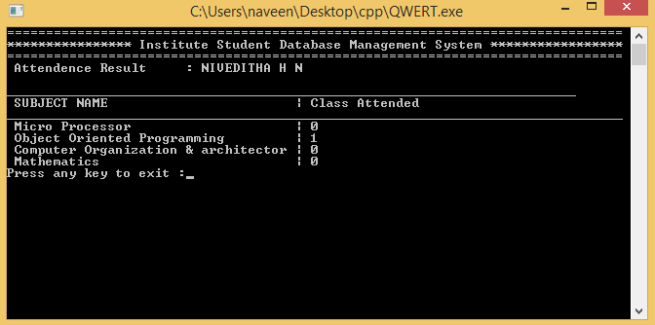

Figure: 4.5 VIEW MARKS

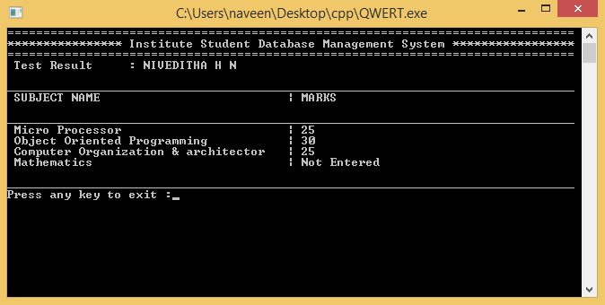

Figure: 4.6 WRITE A COMPLAINT(admin will view this)

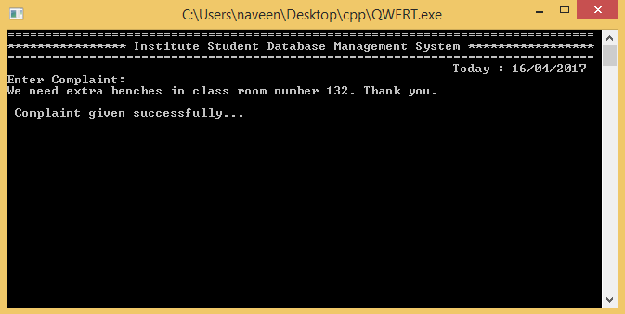

Figure: 4.7 VIEW NOTIFICATIONS

