**Task Manager Application Flow:**

1. Now, you can open Visual Studio Code and open the ‘TMANGULAR’ file present in webapp folder.

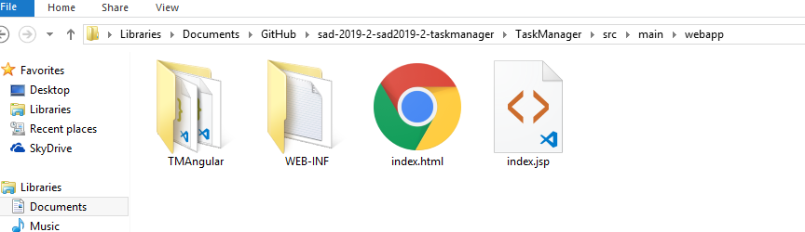

1. In the node_modules folder, kindly install bootstrap and angular devkit using the commands:

npm install --save-dev @angular-devkit/build-angular

npm install bootstrap

1. Then run the Task Manager application using ‘ng serve’ command in terminal.
2. And run the application to start in browser=> localhost:4200
3. The login credentials for manager is:

Username: admin

Password: admin

1. The login credentials for employee is:

Username: user

Password: user