**Task Manager**

Task Manager is a single page project management application which would help to manage and assign work among employees.

The application divides single project into its respective hierarchy which consists of initiatives, epics, stories and tasks.

**Functionalities:**

The application has two levels of hierarchy of employees:

* Managerial users.
* Non-managerial users.

The managerial users includes managers.

The non-managerial users include developers, testers, and architects.

The users can see the epics, stories and tasks assigned to them.

The application has functionalities like Home, Log, Creation, Statistics, and Profile.

**Home:** The user can view the tasks, epics and stories he is working on.

**Log:** The log functionality logs the time taken by the employee to resolve the task and the Issues.

**Creation:** The creation has epic, story, task components. It is allowed only for Managerial users. In Epic tab, the managers can enter the epic details. In Story tab, the managers can enter the story details. In Task tab, the managers can create the task details.

**Statistics:** The issue gets filtered as per the epic and story that the user selects.

**Profile:** The users can see their profile details in this tab.

The user can login to this single page application with his credentials. On the home screen user can choose the epic to see respective stories and tasks. The user can log the time taken by him to work and he can also see the story status. User can click on statistics tab to see statistics of his work in the form of a graph. The user has his profile tab which shows his entire profile details.

**Technologies:**

DB: MySQL

Backend: Java, Springboot Framework, REST API’s

Front-end: Angular 7

**Steps to run the project:**

1. Download the ‘Task Manager’ application from ‘Github’ (<https://github.com/infomediadesign/sad-2019-2-sad2019-2-taskmanager>).
2. Open ‘Eclipse’>’Import’ the ‘Task Manager’ application.
3. Open the ‘TM_DDLv1.0.sql’ file in the Task Manager application in eclipse. You can refer the below screenshot (You need to run the highlighted .sql file from the screenshot). This sql file runs in MySQL Workbench which creates the Database and adds the records to the tables.

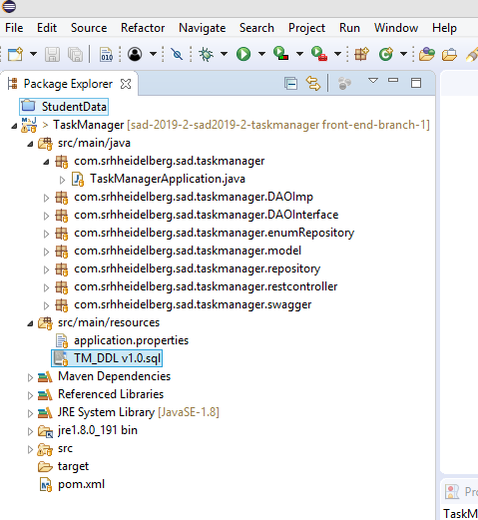

1. In eclipse, choose the Task Manager project and right click to choose ‘Run As’> ‘Maven Clean’ > then again choose ‘Run As’> ‘Maven Install’.
2. Then you need to run the ‘TaskManagerApplication.java’ file as Java Application.