EXPERIMENT-11

**Q** WRITE A PL/SQL PROGRAM FOR FINDING THE GIVEN NUMBER IS PRIME OR NOT.

AIM: TO WRITE A PROGRAM FOR FINDING THE GIVEN NUMBER IS PRIME OR NOT

PROGRAM DESCRIPTION: THE PROGRAM TAKES INPUT FROM THE USER AND CHECKS WETHER THE GIVEN NUMBER IS PRIMEOR NOT.

PROCEDURE : LOGIN INTO SQLPLUS

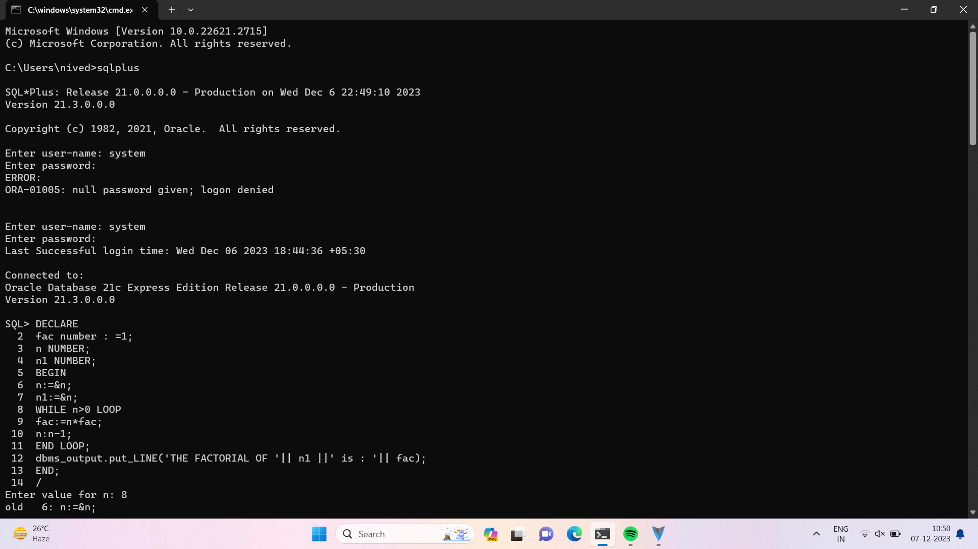

PROGRAM CODE :

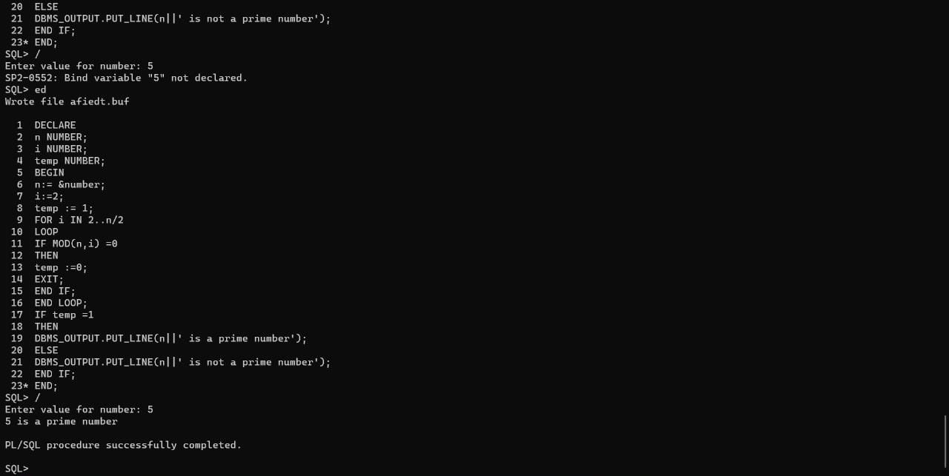

HOW TO RUN THE PROGRAM :

* RUN THE PROGRAM USE TO ‘/ ‘ COMMAND
* BEFORE THE EXECUTION ,”SET SERVEROUT ON “

Command for the purpose of execution.

* To eliminate debugging message the following command should be used i.e “SET VERIFY OFF

Output :

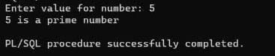

Conclusion : Therefore pl/sql procedure is executed succesfully