**EXPERIMENT-12**

**AIM:** To write a PL/SQL program for displaying the Fibonacci series up to an integer.

**SOURCE CODE & OUTPUT:**

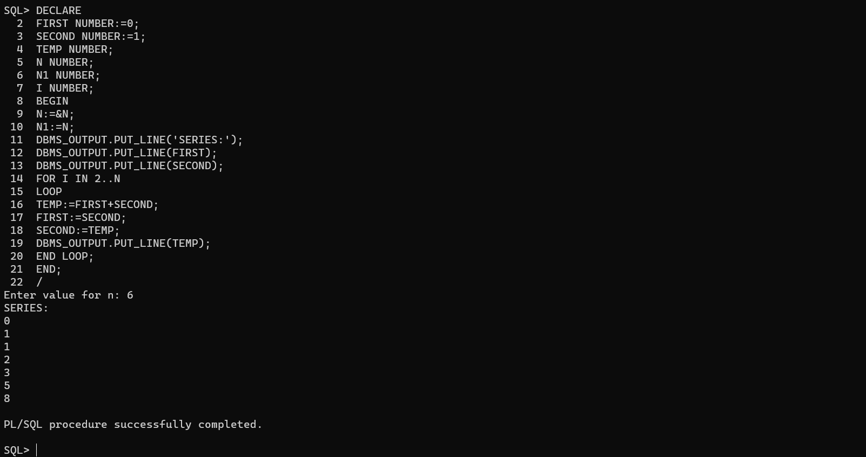

HOW TO RUN THE PROGRAM :

* RUN THE PROGRAM USE TO ‘/ ‘ COMMAND
* BEFORE THE EXECUTION ,”SET SERVEROUT ON “

Command for the purpose of execution.

* To eliminate debugging message the following command should be used i.e “SET VERIFY OFF

**Conclusion:** In this lab, we have practiced a PL/SQL program for displaying Fibonacci series up to an integer.