**EXPERIMENT-13**

**AIM:** To write a PL/SQL program to implement Stored Procedure on table.

**PL/SQL Procedure:**

The PL/SQL stored procedure or simply a procedure is a PL/SQL block which performs one or more specific tasks. It is just like procedures in other programming languages.

The procedure contains a header and a body.

**EXAMPLE-1:**

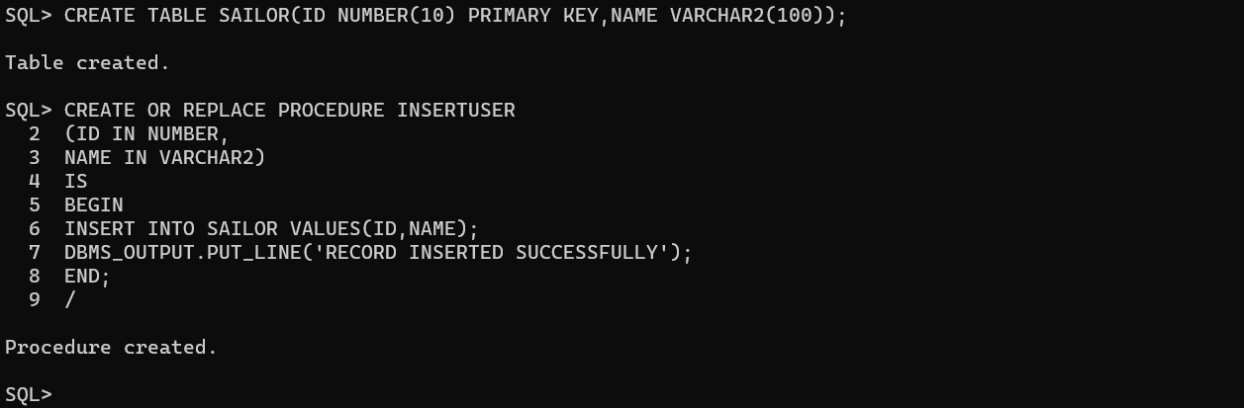

**EXECUTION PROCEDURE:**

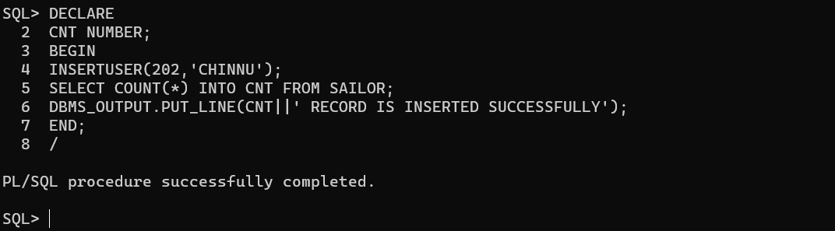

**DROP PROCEDURE:**

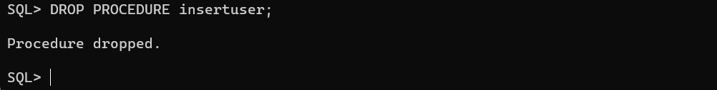

**Conclusion:** In this lab, we have practiced a PL/SQL program to implement Stored Procedure on table.