EXPERIMENT-14

Q. WRITE A PL/SQL PROGRAM TO IMPLEMENT STORED FUNCTION ON TABLE.

AIM: TO WRITE A PL/SQL PROGRAM TO IMPLEMENT STORED FUNCTION ON TABLE.

PROGRAM DESCRIPTION: THE PL/SQL FUNCTION IS VERY SIMILAR TO PL/SQL PROCEDURE.THE MAIN DIFFERENCE BETWEEN PROCEDURE AND A FUNCTION IS A FUNCTION MUST ALWAYS RETURN A VALUE, AND ON OTHER HAND A PROCEDURE MAY OR MAY NOT RETURN A VALUE.

PROCEDURE : LOGIN INTO SQLPLUS

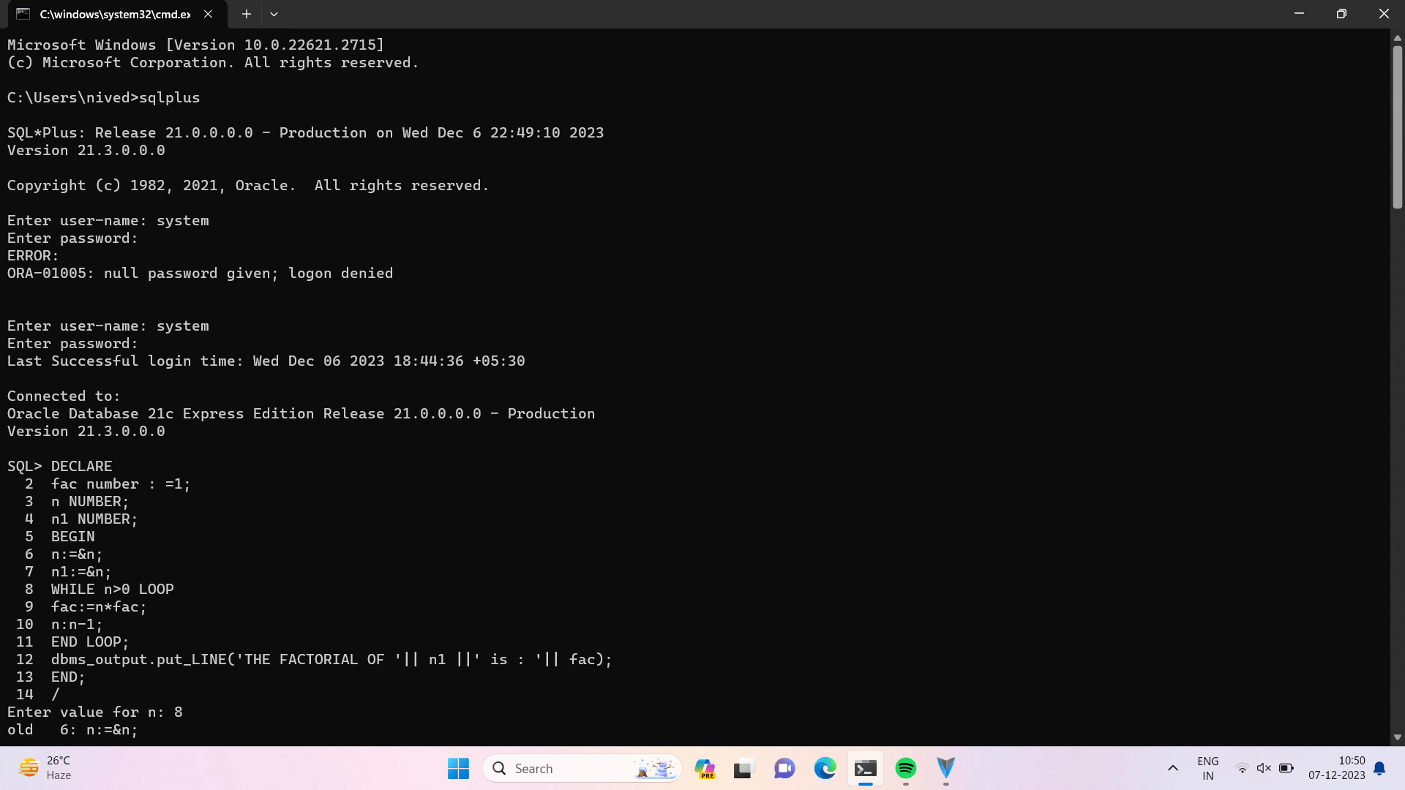

PROGRAM CODE :

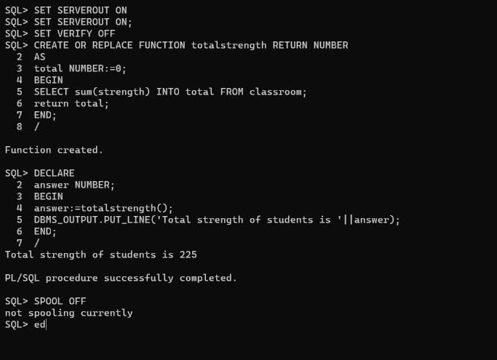

HOW TO RUN THE PROGRAM :

* RUN THE PROGRAM USE TO ‘/ ‘ COMMAND
* BEFORE THE EXECUTION ,”SET SERVEROUT ON “

Command for the purpose of execution.

* To eliminate debugging message the following command should be used i.e “SET VERIFY OFF

Output :

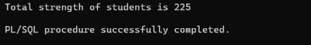

Conclusion : Therefore pl/sql procedure is executed succesfully