**EXPERIMENT-15**

**AIM:** To write PL/SQL program to implement Trigger on table.

**Tigger:**

Trigger is invoked by Oracle engine automatically whenever a specified event occurs. Trigger is stored into database and invoked repeatedly, when specific condition match. Triggers are stored programs, which are automatically executed or fired when some event occurs. Triggers are written to be executed in response to any of the following events.

A database manipulation (DML) statement (DELETE, INSERT, UPDATE).

A database definition (DDL) statement (CREATE, ALTER, DROP).

A database operation (SERVERERROR, LOGON, LOGOFF, STARTUP, SHUTDOWN).

**CREATING A TABLE:**

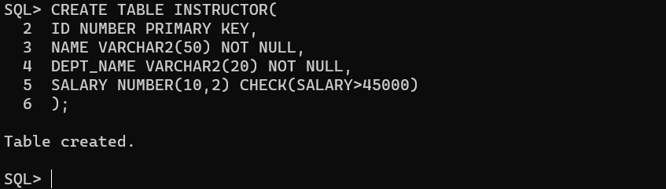

**INSERTING VALUES INTO THE TABLE:**



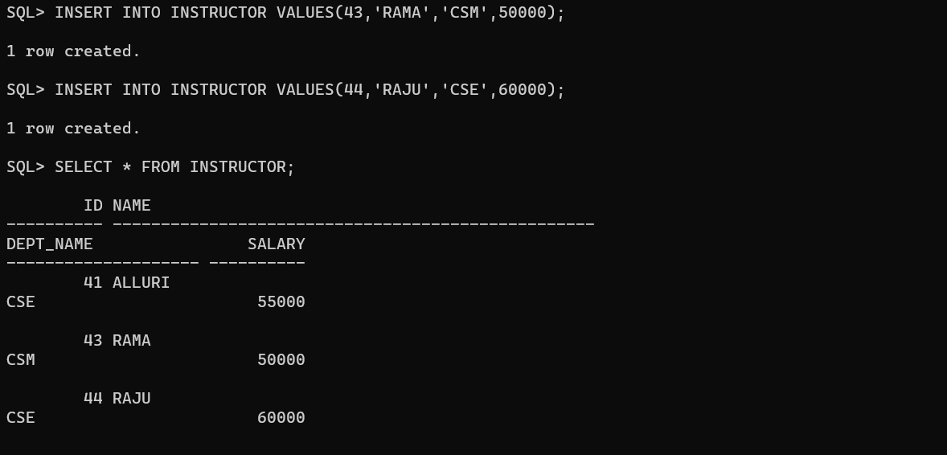

**AN EXAMPLE TO CREATE TRIGGER:**

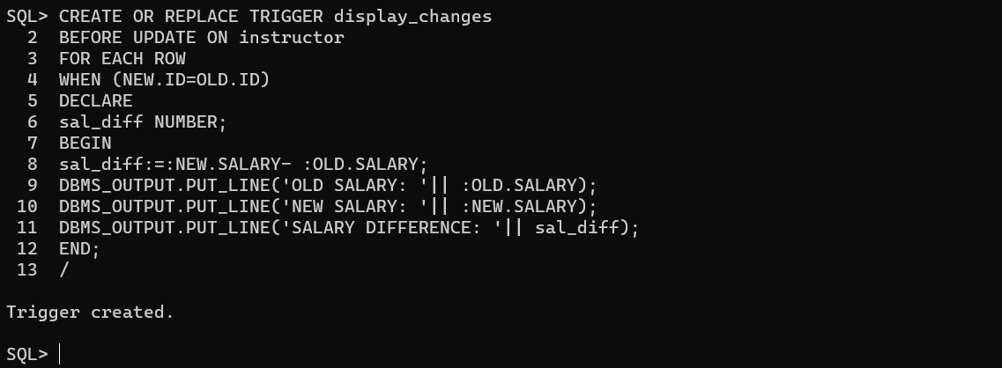

**A PL/SQL Procedure to execute a trigger:**

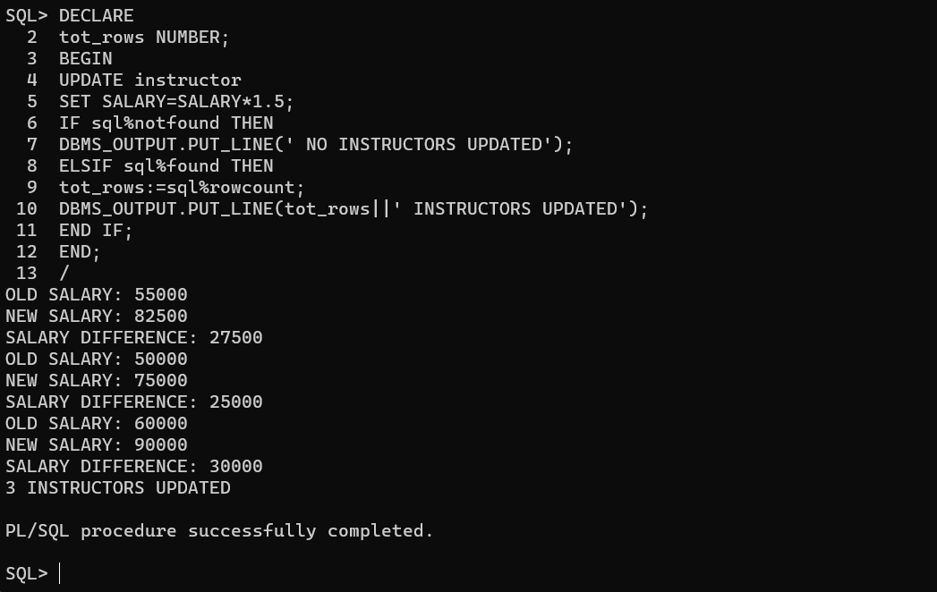

**Conclusion:** In this lab, we have practiced a PL/SQL program to implement Trigger on table.