**EXPERIMENT-16**

**AIM:** To write a PL/SQL program to implement Cursor on table.

**CREATING A TABLE:**

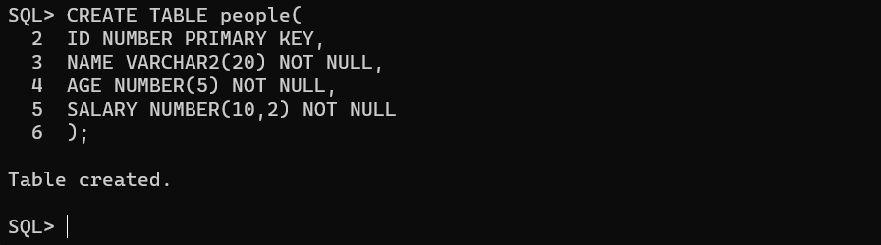

**INSERTING VALUES INTO TABLE:**

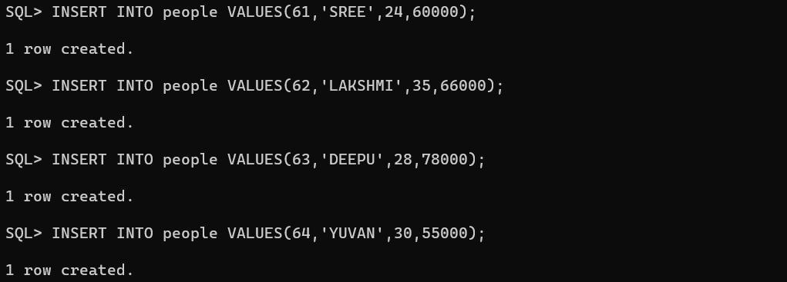

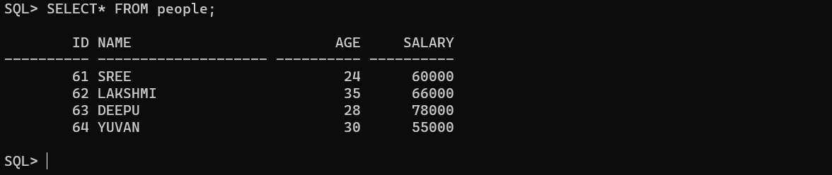

**CREATE UPDATE PROCEDURE:**

**CREATE PROCEDURE:**

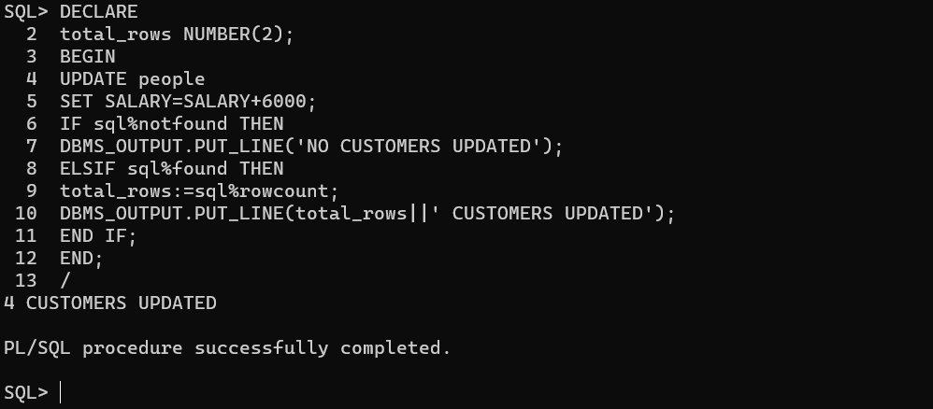

**PL/SQL Program using Explicit Cursors:**

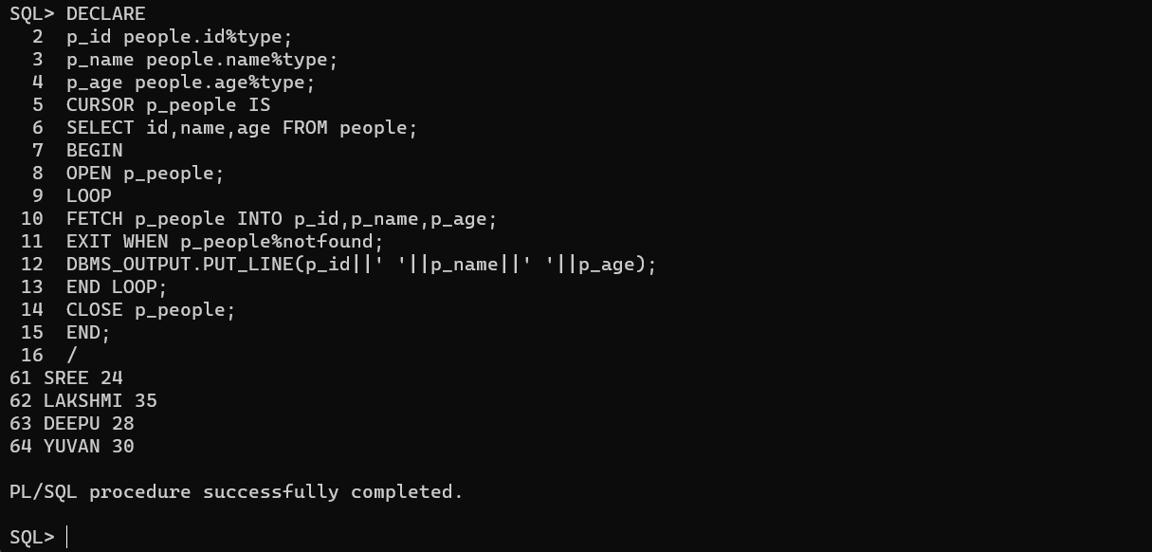

**Conclusion:** In this lab, we have practiced a PL/SQL program to implement Cursor on table.