**EXPERIMENT-2**

**AIM:** To write SQL queries to MANIPULATE TABLES for c=various databases using DML commands (i.e. INSERT, SELECT, UPDATE, DELETE).

**CREATING TABLE:**

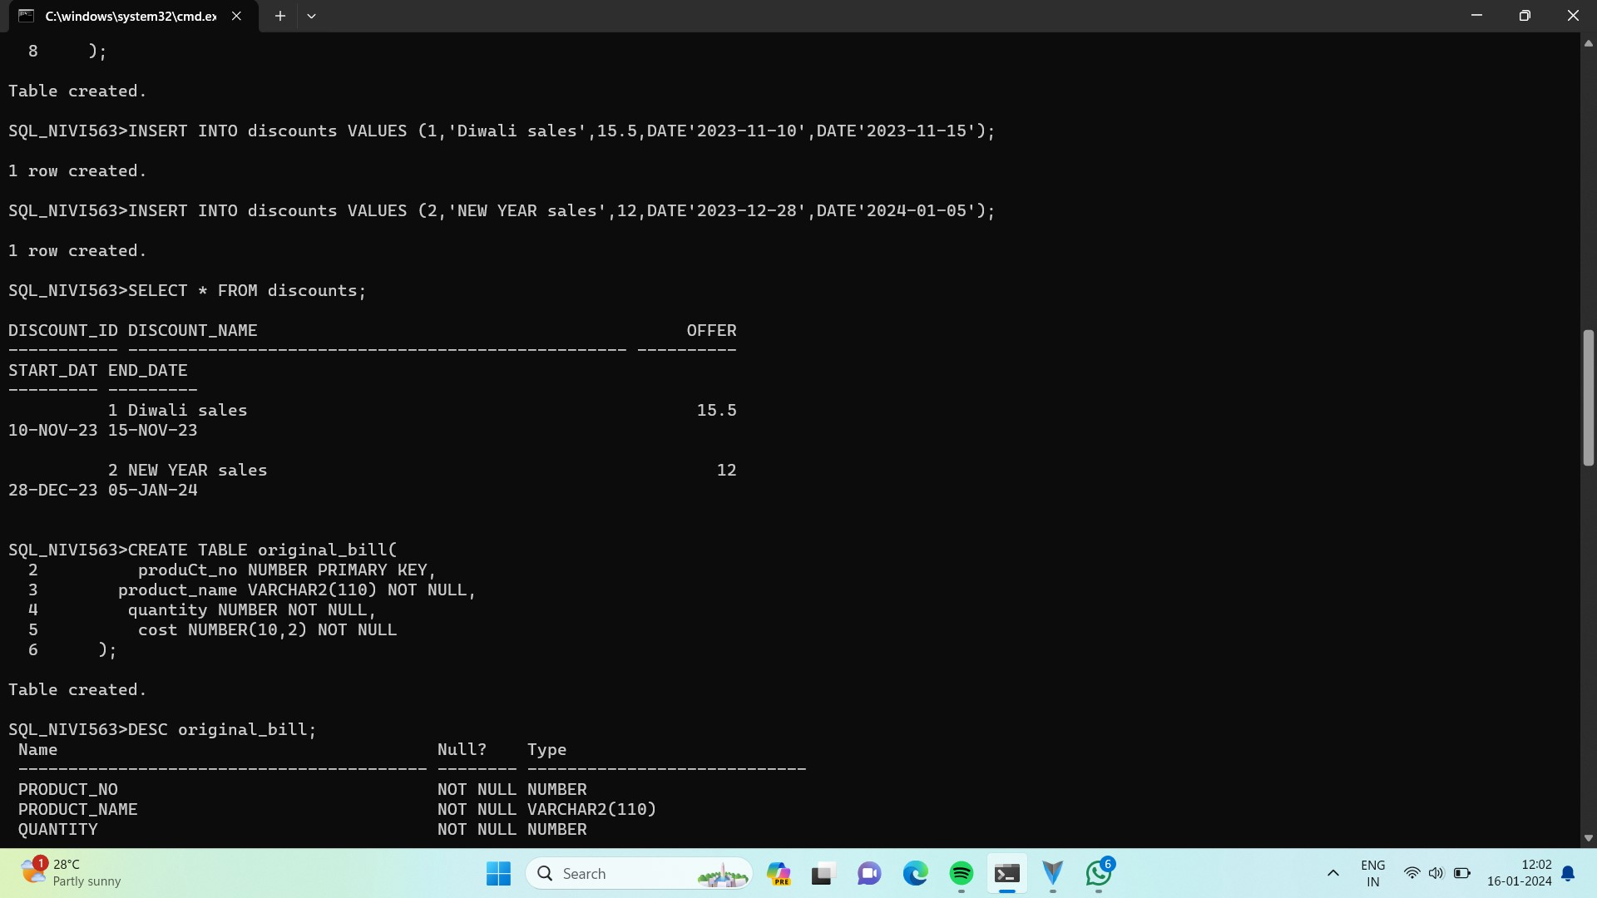

**INSERT COMMAND:**

It is used to add values to a table.

**Syntax:**

INSERT INTO table_name

VALUES (value1, value2, …., valueN);

INSERT INTO table_name (colunm1, colunm2, …., colunmN)

VALUES (value1, value2, ….., valueN);

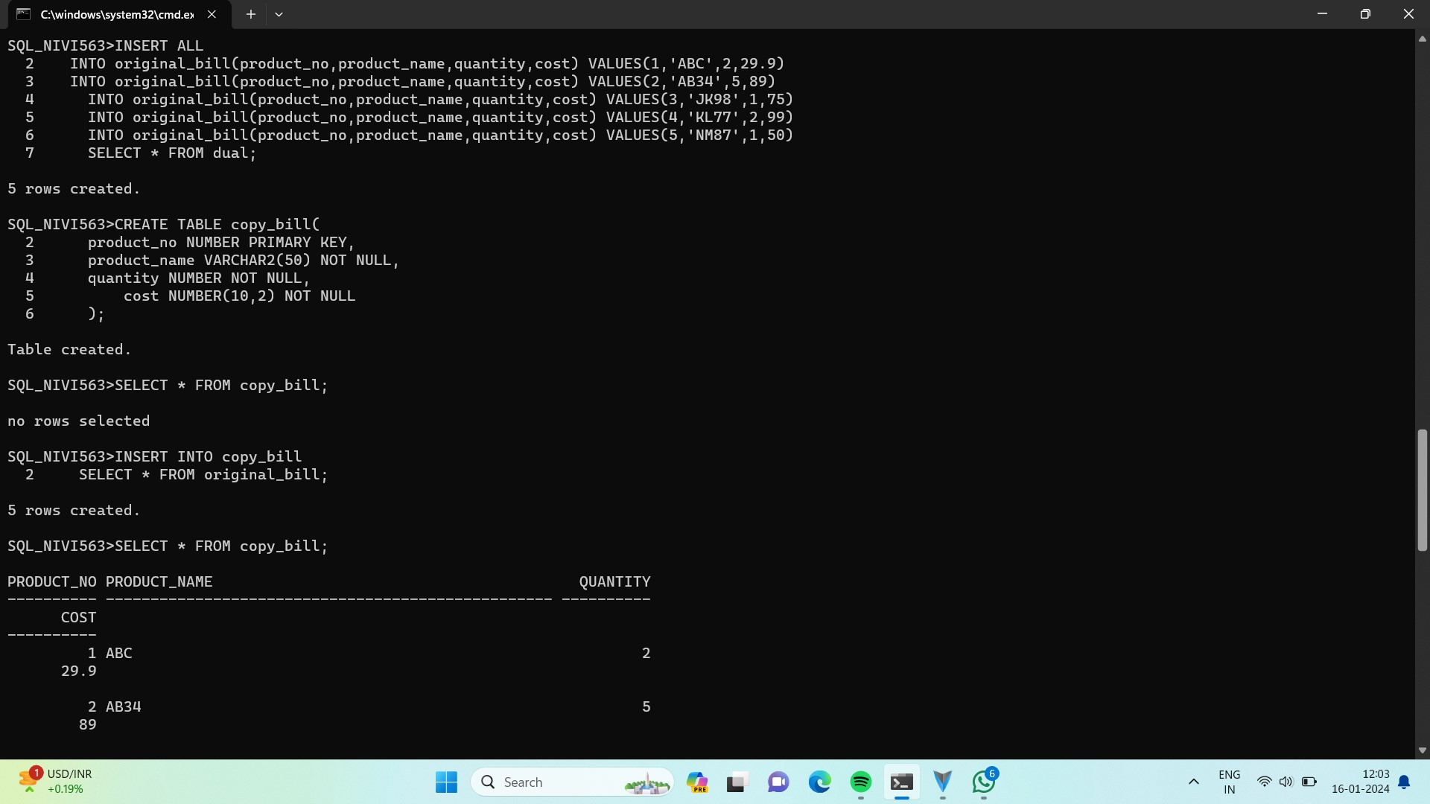

**SELECT COMMAND:**

The SELECT command is used to list the contents of a table.

**Syntax:**

SELECT * FROM table_name:

SELECT column_name FROM table_name;

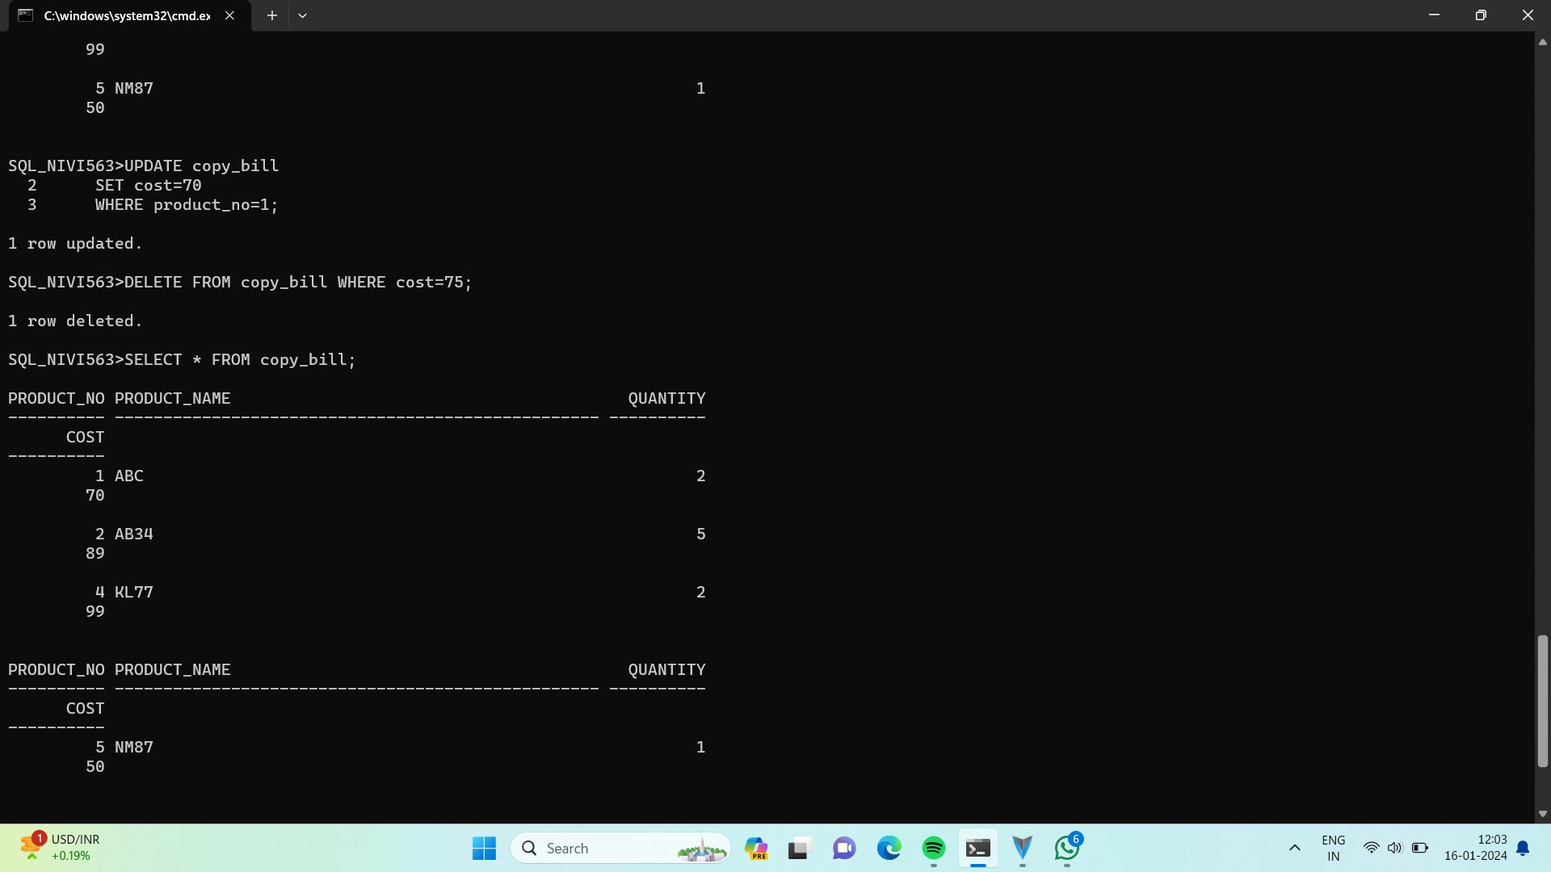

**UPDATE COMMAND:**

The UPDATE command is used to modify the contents of specified table.

**Syntax:**

UPDATE table_name

SET column_name = value [,

Column_name = value]

[WHERE condition_list];

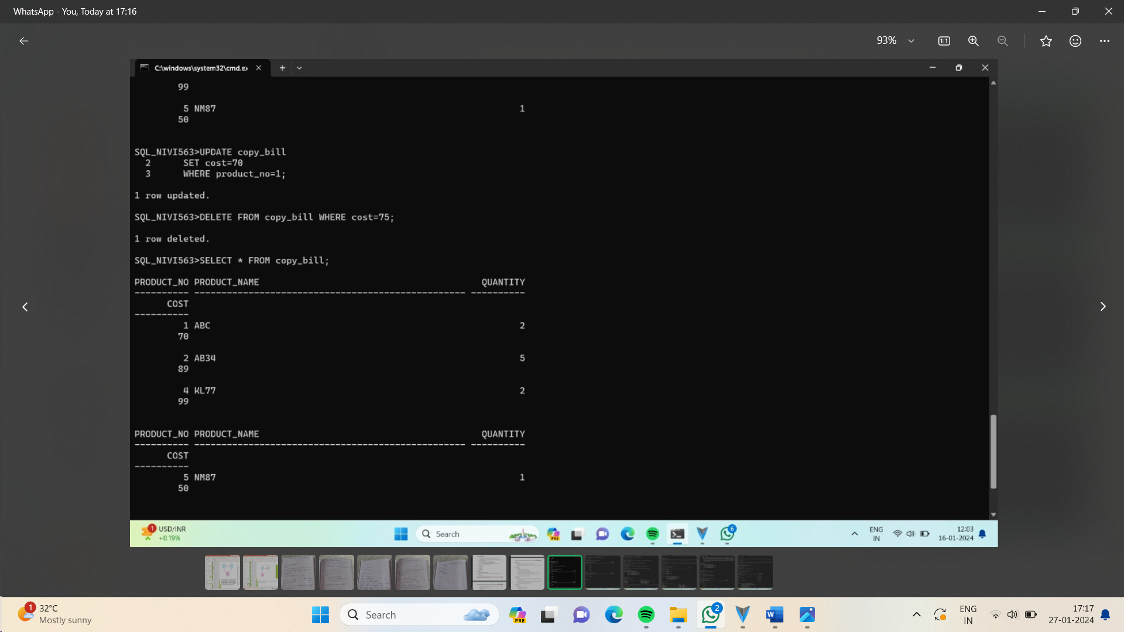

**DELETE COMMAND:**

To delete all rows or specified rows in a table.

**Syntax:**

DELETE FROM table_name [ WHERE condition_list];

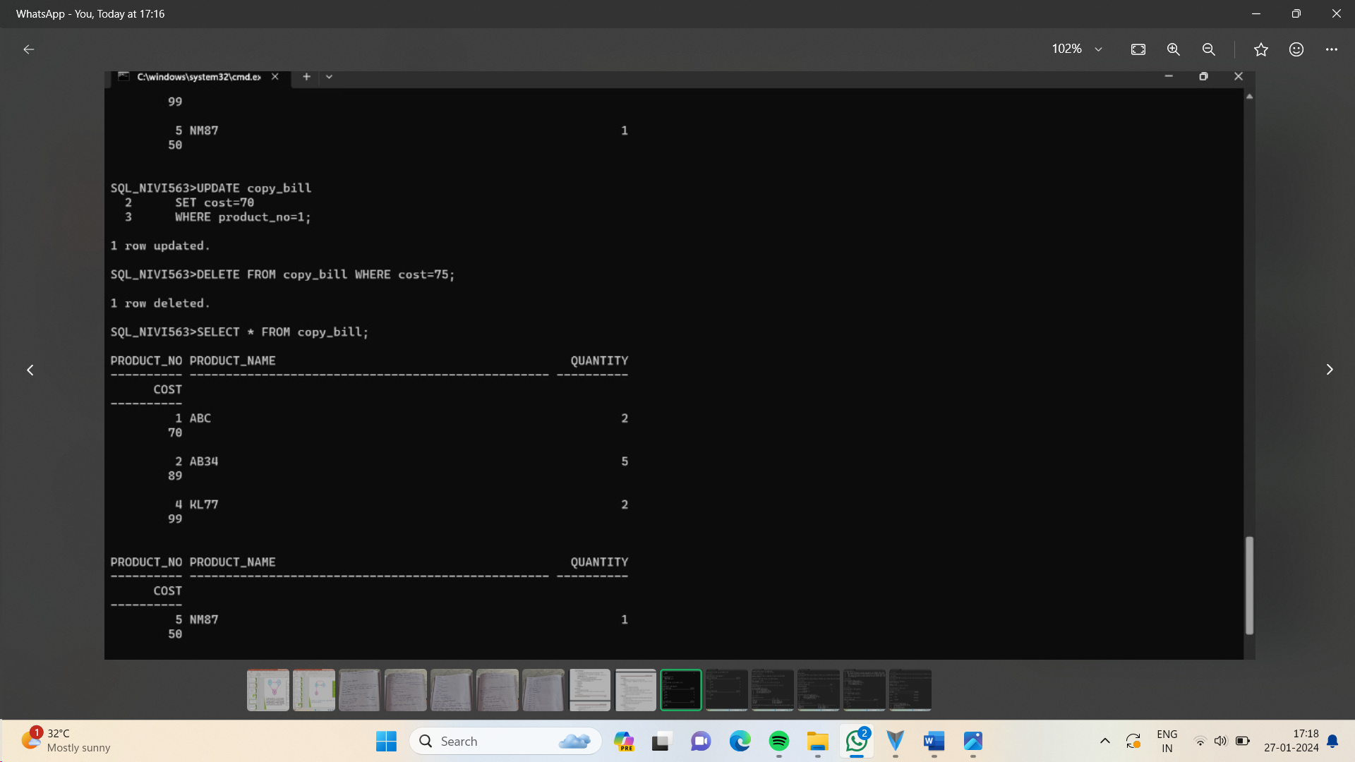

**CONCLUSION:**

In this lab, we have practiced INSERT, SELECT, UPDATE, and DELETE commands for user created table.