**EXPERIMENT-3**

**AIM:** To implement view high level design for various views to CREATE VIEW, ALTER VIEW and DELETE VIEW using DDL commands.

**CREATING TABLE:**

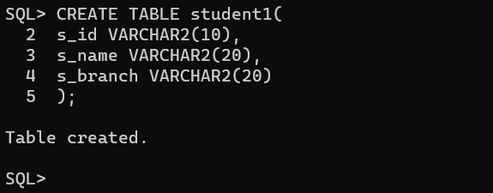

**INSERTING VALUES INTO TABLE student1:**

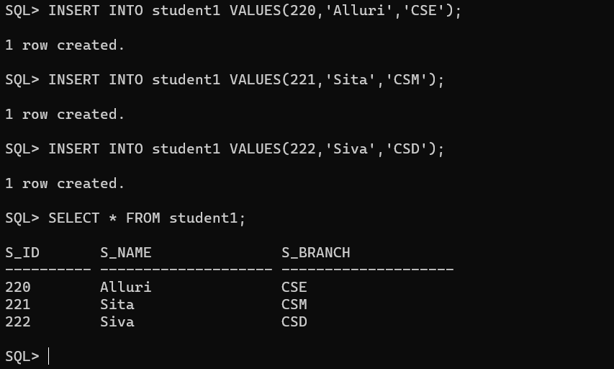

**CREATE VIEW:** Create a view details with attributes s_id and s_name.

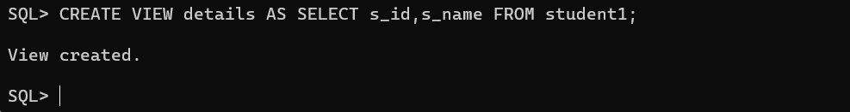

**INSERTING VALUES INTO details view:**

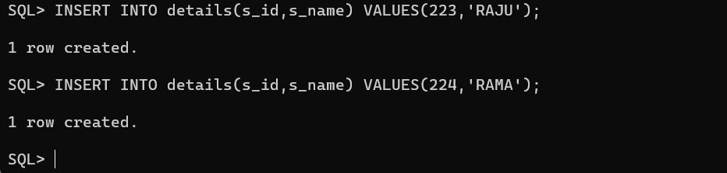

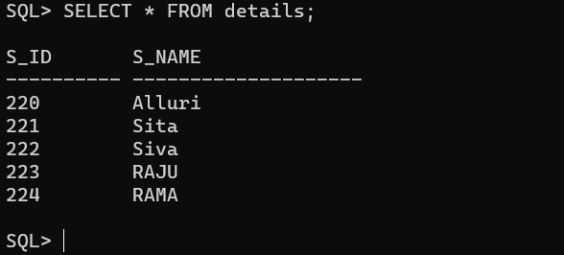

**ALTER VIEW:** Add an attribute branch to the view.

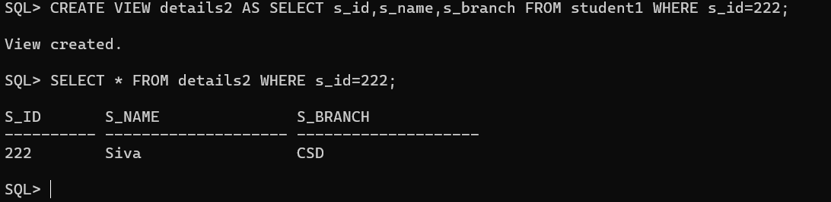

**UPDATE VIEW:** Update the existing name with the new name using UPDATE command.

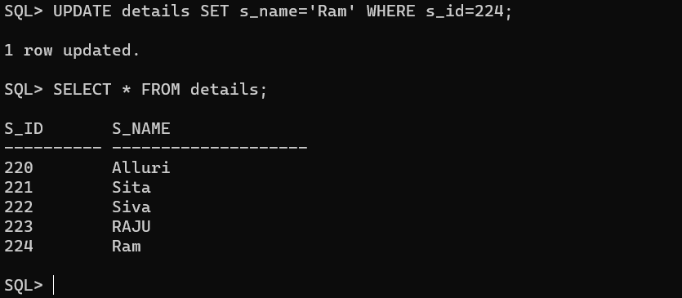

**DROP VIEW:** Drop a view using DROP command.

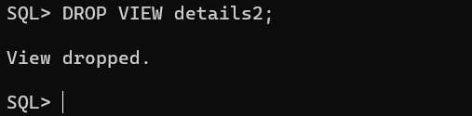

**Conclusion:**

In this lab, we have practiced how to CREATE VIEW, ALTER VIEW, UPDATE VIEW, and DELETE VIEW for user created table.