**EXPERIMENT-4**

**AIM:** To implement SQL queries for set operations like UNION, UNION ALL, INTERSECT, INTERSECT ALL, MINUS, CROSS JOIN, NATURAL JOIN.

**CREATING A TABLE instructor2:**

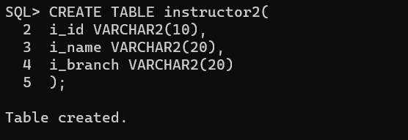

**INSERTING VALUES INTO TABLE instructor2:**

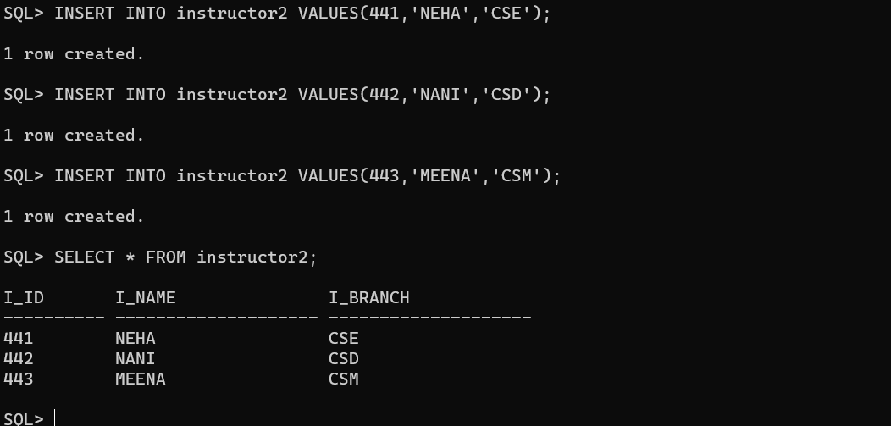

**CREATING TABLE department:**

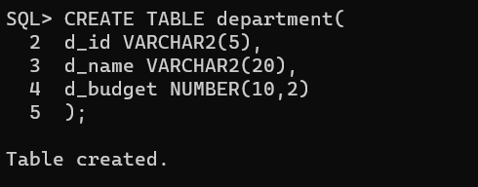

**INSERTING VALUES INTO department:**

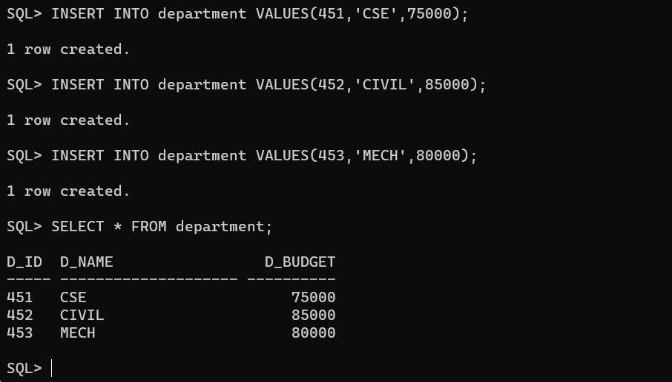

**UNION:** The attributes i_branch from instructor2 and d_name from department are joined using UNION command.

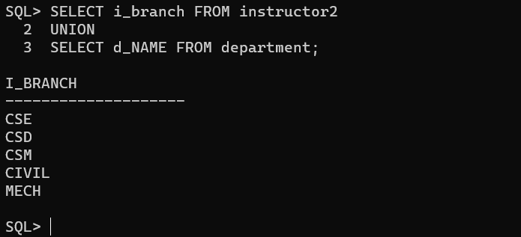

**UNION ALL:** The attributes i_branch from instructor2 and d_name from department are joined along with duplicates using UNION ALL command.

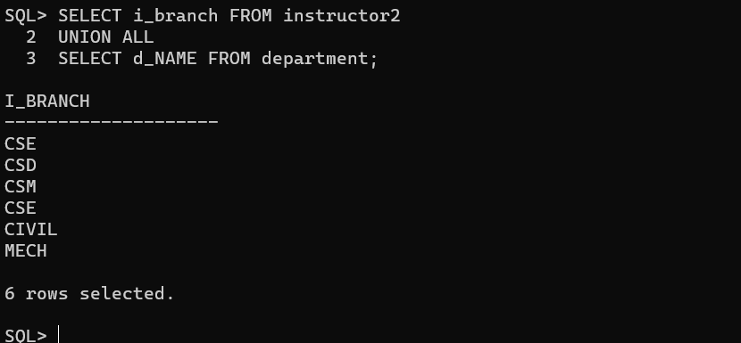

**INTERSECT:** Displays similar values in two or more attributes from department and instructor4 using INTERSECT command.

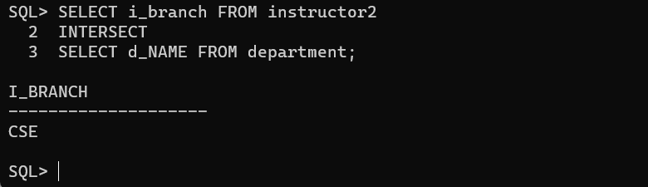

**MINUS:** It eliminates the same values of second column from the first column and represents the remaining values using command MINUS.

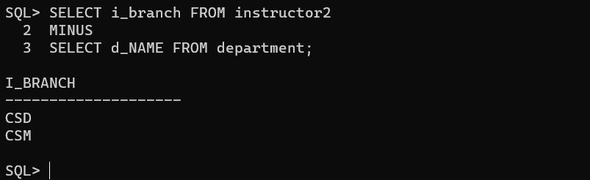

**CROSS JOIN:** Its cross products the all the attributes using CROSS JOIN command.

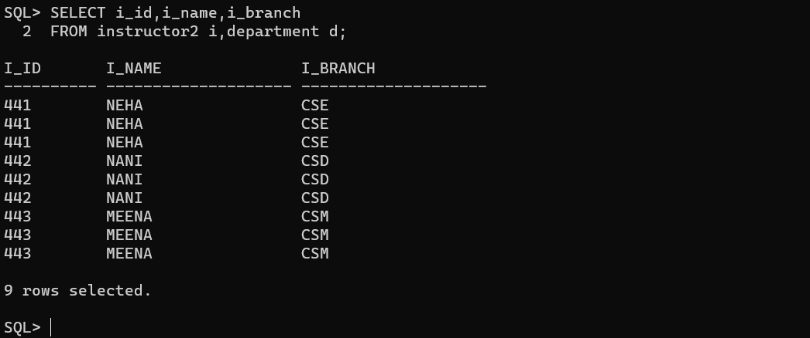

**Conclusion:**

In this lab, we have practiced the set operations like UNION, UNION ALL, INTERSECT, MINUS, CROSS JOIN on user created tables.