**EXPERIMENT-5**

**AIM:**SQL queries to perform SPECIAL OPERATIONS (IS NULL, BETWEEN, LIKE, IN, EXISTS).

**CREATING TABLE-1:**

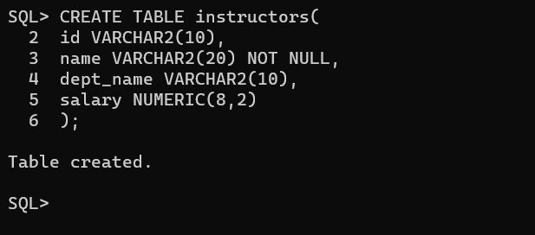

**INSERTING VALUES INTO THE TABLE:**

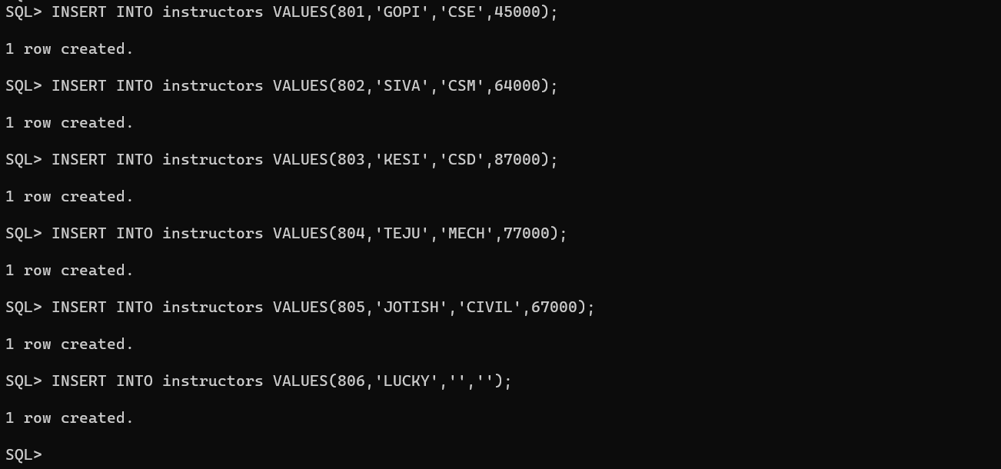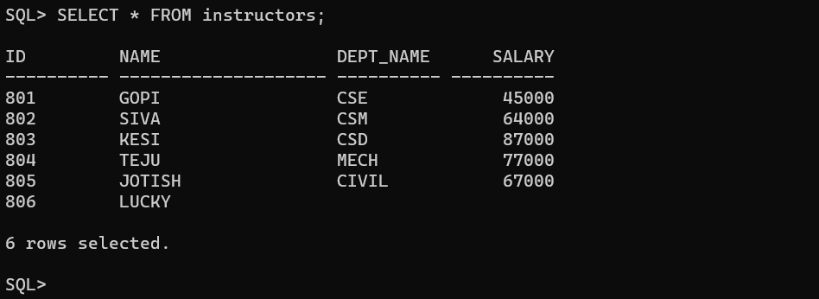

**IS NULL:** It is used to check null values and display null attributes. It displays attributes that have null values.

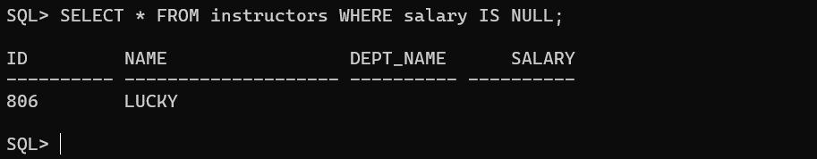

This command displays the salary that are not equal to 64000.

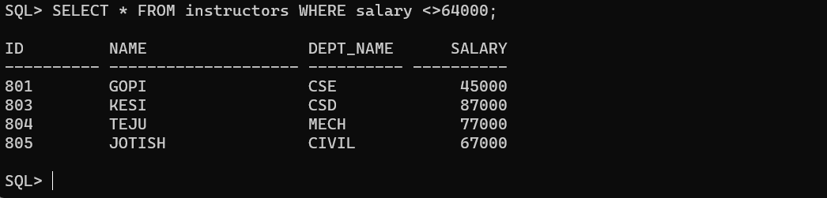

**IS NOT NULL:** It displays attributes that don’t have null values.

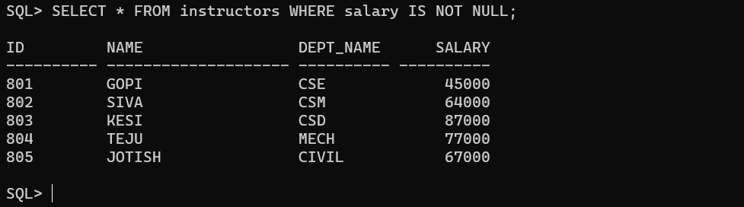

**BETWEEN:** This is used to check range of values.

By following command, it displays all the attributes between 45000 and 77000.

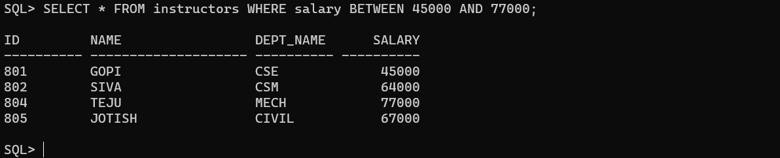

The following command displays salary that are not in between 45000 and 77000.

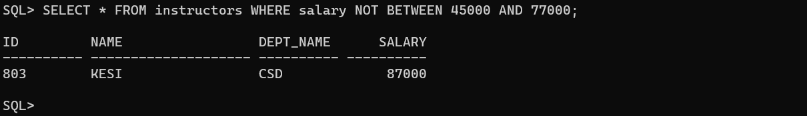

**IN:** This is used to check a member is in a set or not. It displays if the id’s are present in the table.

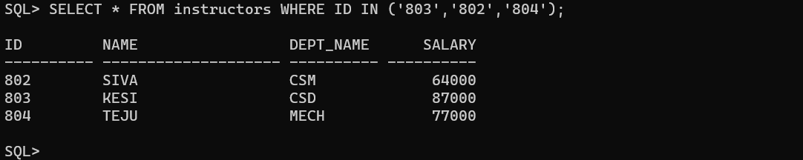

The following command displays all the attributes with id’s except the given id’s.

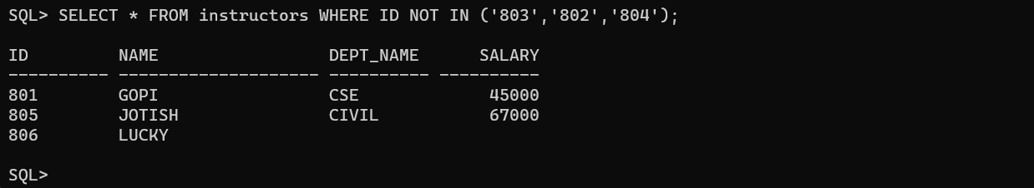

**EXISTS:** This is used to check whether given set is empty or not. It displays null attributes that are null according to the given condition.

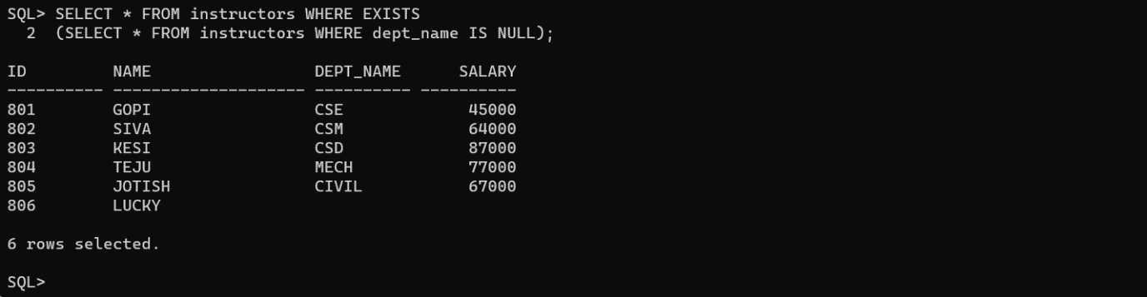

**LIKE:** This is used to check given string is present or not. It displays all the attributes that start with character ‘c’.

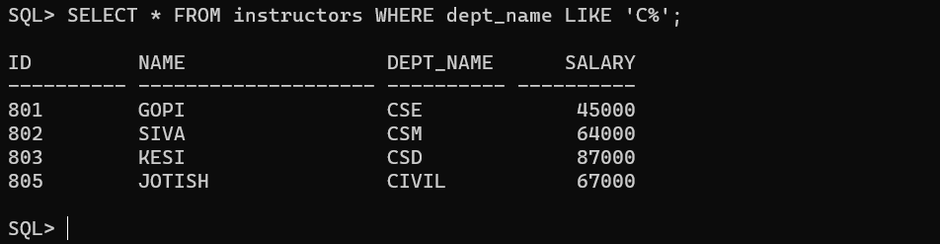

**Conclusion:** In this lab, we have practiced SPECIAL OPERATIONS IS NULL, BETWEEN, LIKE, IN, EXISTS on user created table.