**EXPERIMENT-6**

AIM: To implement SQL queries to perform JOIN OPERATIONS (CONDITIONAL JOIN, EQUI JOIN, LEFT OUTER JOIN, RIGHT OUTER JOIN, FULL OUTER JOIN).

CREATING TABLE-1:

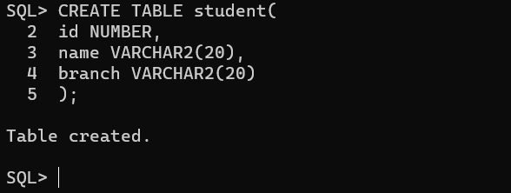

INSERTING VALUES INTO THE TABLE:

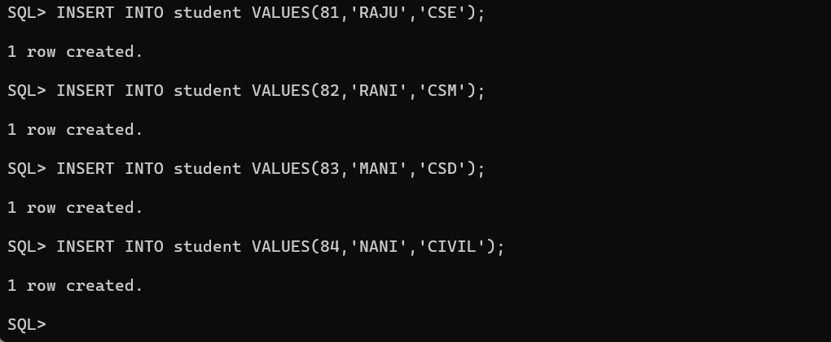

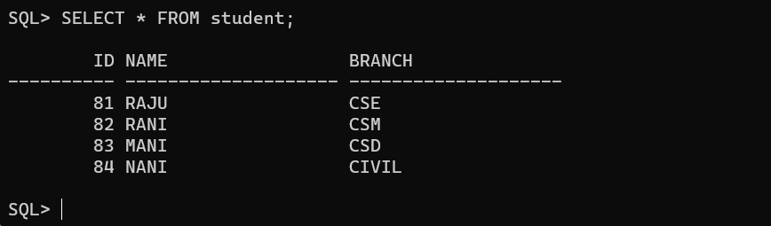

CREATING TABLE-2:

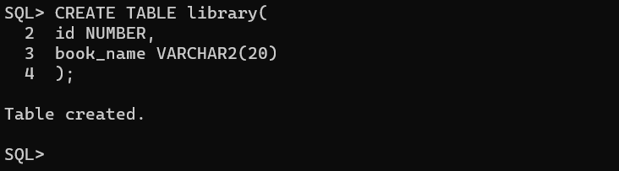

INSERTING VALUES INTO TABLE-2:

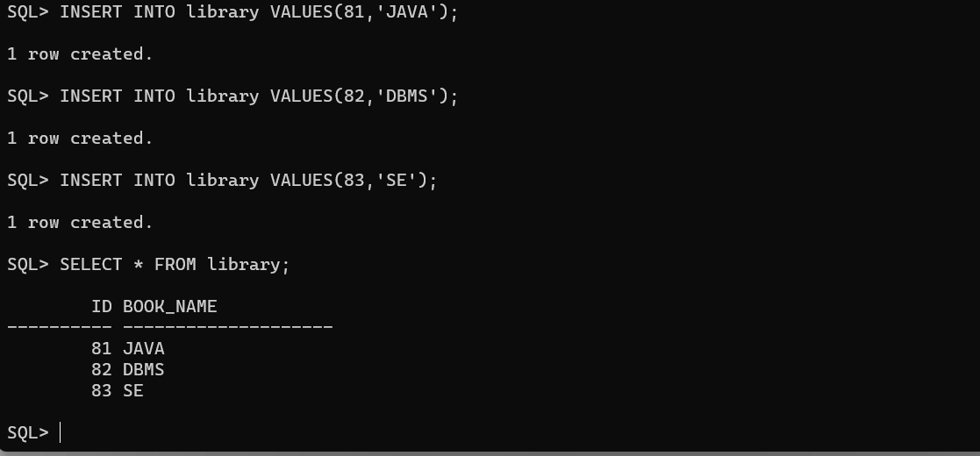

CONDITIONAL JOIN: It helps in retrieving the desired data and performing complex queries.

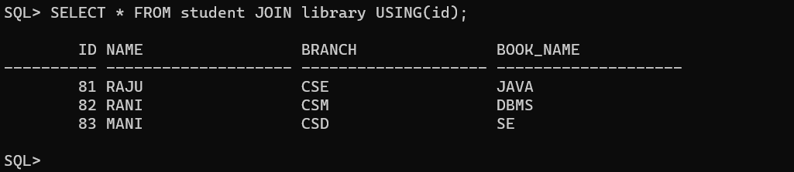

EQUI JOIN: It helps in retrieving related information from different tables by matching corresponding values.



LEFT OUTER JOIN: It combines data from two or more tables based on the matching values in specified columns, but it also includes unmatched rows from the left table.

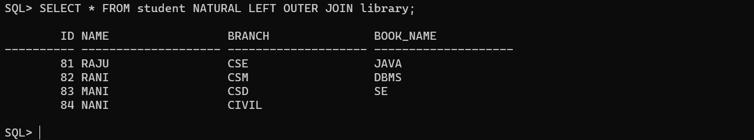

RIGHT OUTER JOIN: It combines data from two or more tables based on the matching values in specified columns, but also includes unmatched rows from he right table.

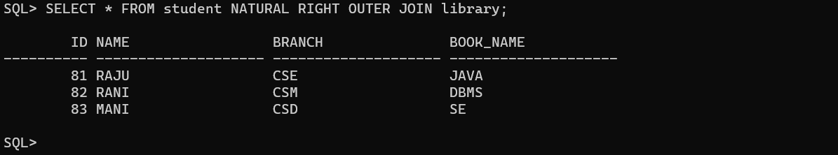

FULL OUTER JOIN: It includes all the rows from both the left and right tables, even if there is no match.

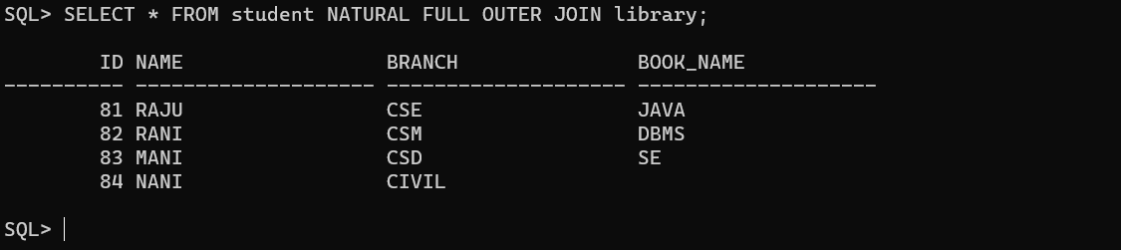

Conclusion: In this lab, we have practiced JOIN OPERATIONS CONDITIONAL JOIN, EQUI JOIN, LEFT OUTER JOIN, RIGHT OUTER JOIN, FULL OUTER JOIN on user created tables.