**EXPERIMENT-7**

**AIM:** To implement SQL queries to perform AGGREGATE OPERATIONS (SUM, COUNT, AVG, MIN, MAX).

**CREATING A TABLE:**

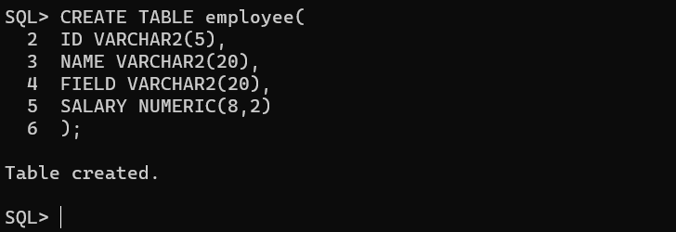

**INSERTING VALUES INTO TABLE:**

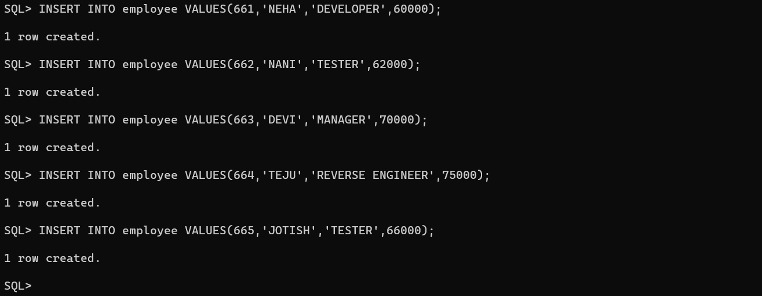

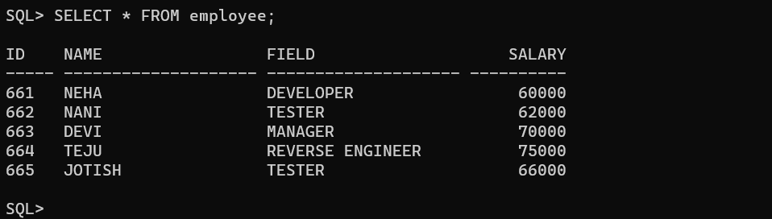

**COUNT:** It displays the count on members present in employee.



**AVERAGE(AVG):** It displays average salary of each employee.

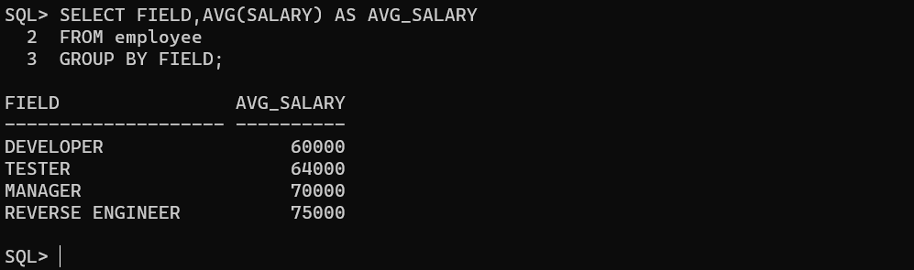

**SUM:** It displays sum of all the salaries from the table.

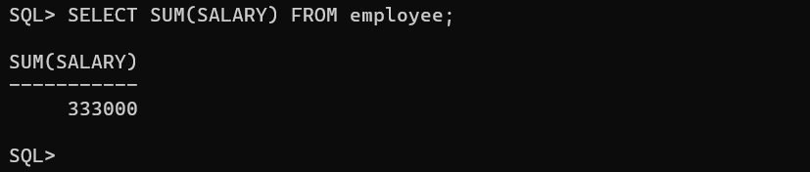

**MIN:** It displays the minimum salary from the table.



**MAX:** It displays the maximum salary from the table.



**Conclusion:** In this lab, we have practiced AGGREGATE OPERATIONS like SUM, COUNT, AVERAGE, MIN, MAX on user created table.