**EXPERIMENT-8**

**AIM:** To implement SQL queries to perform BUILT-IN FUNCTIONS (DATE, TIME).

**CASE CONVERSION:**

**LOWER ():** It converts a string into lowercase.

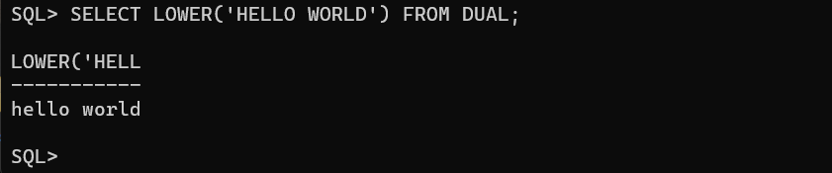

**UPPER ():** It converts a string into uppercase.

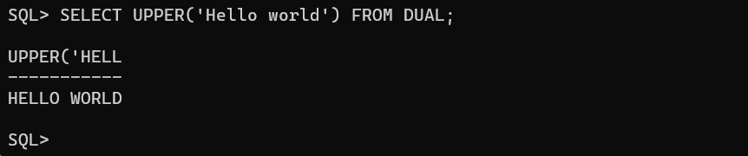

**INITCAP ():** It converts a string into camel case.

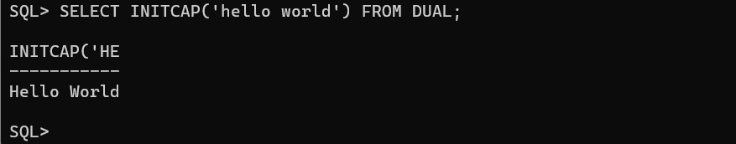

**CONCAT ():** It adds two or more expressions together.

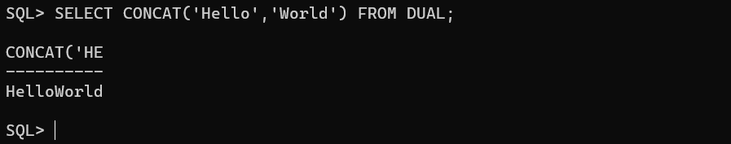

**SUBSTR ():** It extracts a substring from a string.

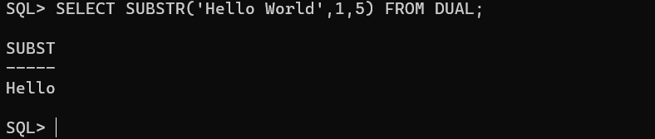

**LENGTH ():** It returns the length of the given string.

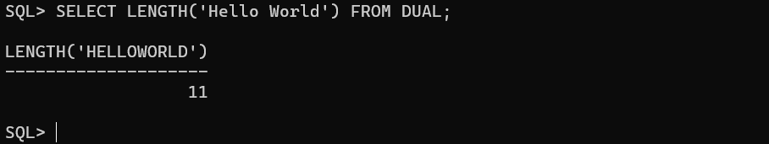

**INSTR ():** It returns the position or the first occurrence of a string in another string.

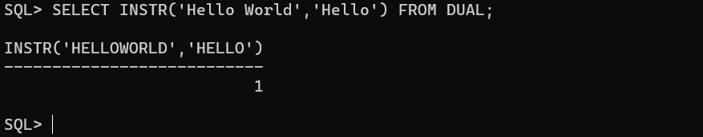

**TRIM ():** It removes the selected one from string.

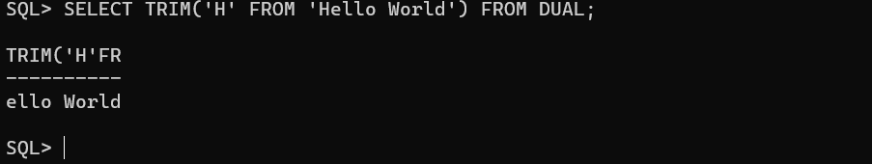

**NUMBER FUNCTIONS:**

**ROUND ():** It returns the specified values.

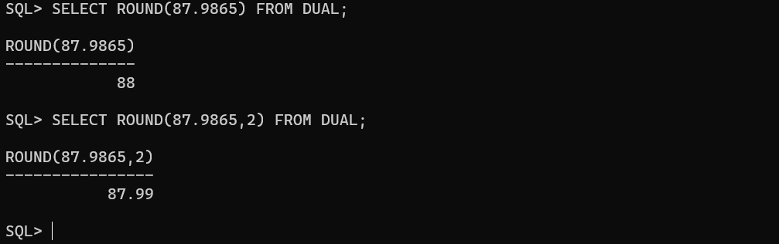

**TRUNCATE ():** It removes the decimal values which are specified.

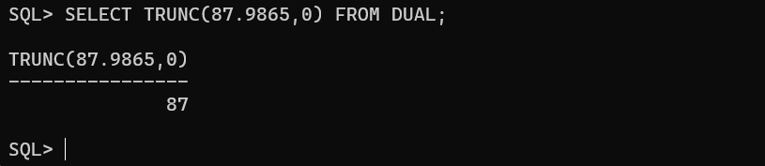

**MOD ():** It returns the remainder.

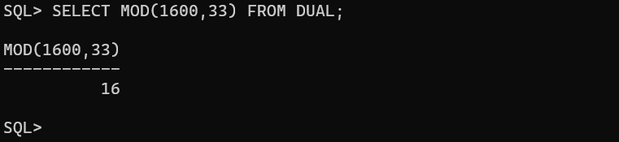

**DATE FUNCTIONS:**

**SYSDATE ():**

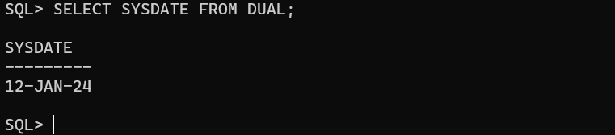

**MONTHS_BETWEEN ():**

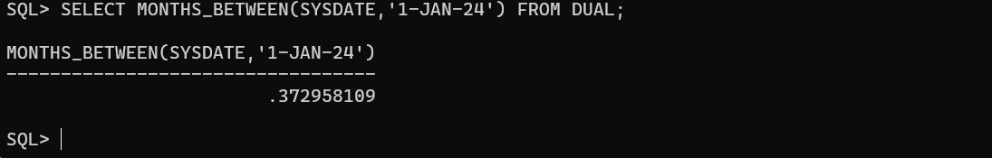

**ADD_MONTHS ():**

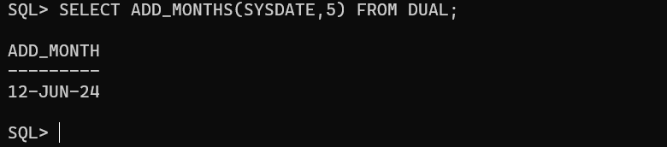

**NEXT_DAY ():**

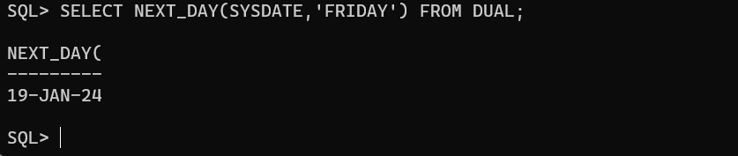

**LAST_DAY ():**

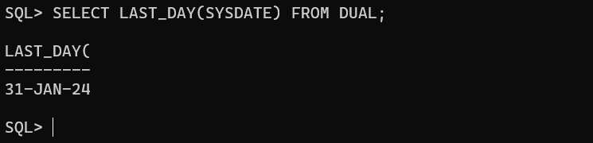

**TRUNC ():**

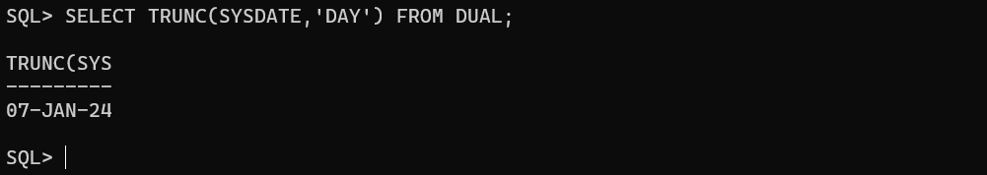

**Conclusion:** In this lab, we have practiced BUILT-IN FUNCTIONS like DATE AND TIME .