**The Cookbook App**

A desktop application for browsing recipes using various options and storing new recipes.

**End users of the application**

1. The application can be used by anybody who wants to cook recipes or to store recipes of their choice.
2. Users looking for recipes based on the different combination of ingredients available with them can find interesting recipes in the application.
3. The application is developed mainly for small households and parties.

**Functionality**

1. When the application is opened, the **main window** displays a list of recipes present in the cookbook app and various options to filter the recipes.
2. The user can search recipes based on combination of ingredients (maximum of 3) and get recipes that can be cooked using those ingredients. The application will suggest ingredients as and when the user types in the ingredient.
3. The user also has options to filter by
   1. Favourite recipes saved by him/her
   2. Recipes created by the user in the application
   3. Filter recipes by recipe name
4. **Favourite** options are available in the recipe list, so the user can mark recipes as favourites.
5. On clicking on the recipe in the list, the user will be able to **view the recipe** in a new window.
6. The recipe details like name, description, image, time required for making the dish, servings made, instructions and ingredients are displayed.
7. If the user has added new recipes through the **add new recipe** option in the main window, the options to **edit/delete** those recipes are available in the view recipe and hence will not be available for built-in recipes within the application. When adding ingredients, the application will suggest options and the quantity entered will be converted according to the input.

**Assumptions**

1. All ingredients are present in the cookbook. Any other ingredient searched will be considered as invalid.
2. While adding/editing recipe, servings combobox gives options from 1-50 servings.
3. While adding/editing recipe, time in hours gives options till 23 hours and in minutes gives options till 59 minutes.
4. The ingredients will have options to select options like kilograms/grams if they are vegetables for example, and options like litre and millilitre in case of liquid.

**Initial wireframes**

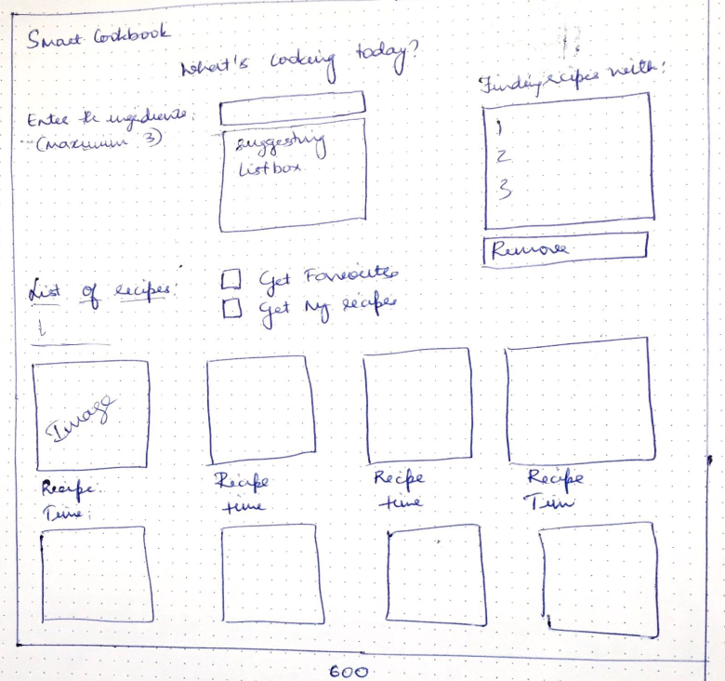 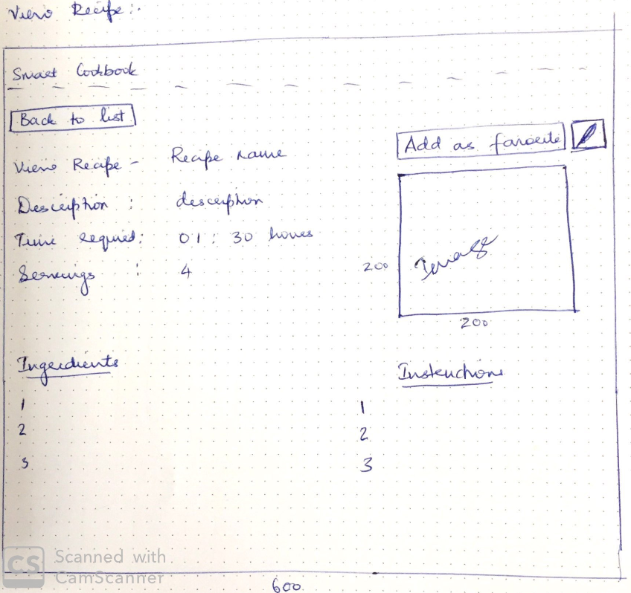

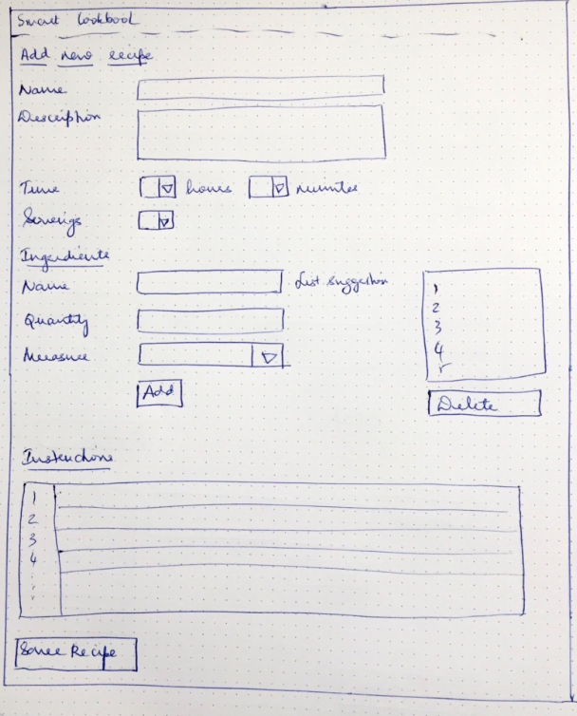

**Approach**

The recipes are saved in xml format, recipes are stored in a model called Recipe and the ingredients are embedded within each recipe.

**Screenshots of the application**

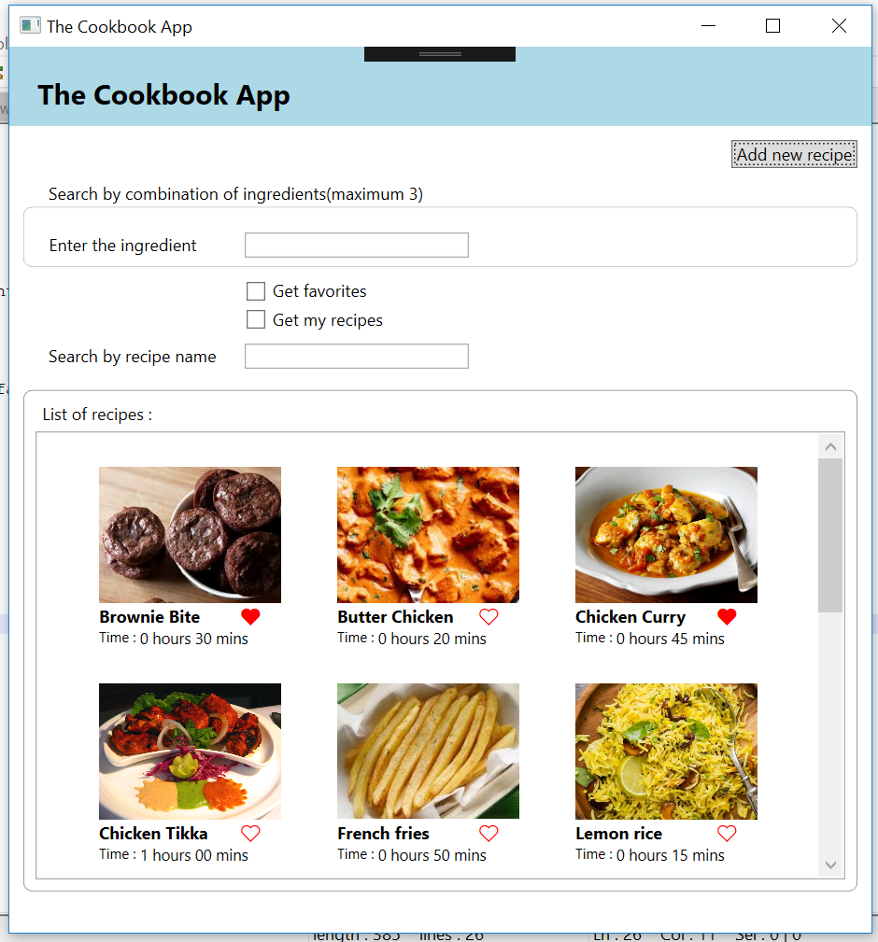 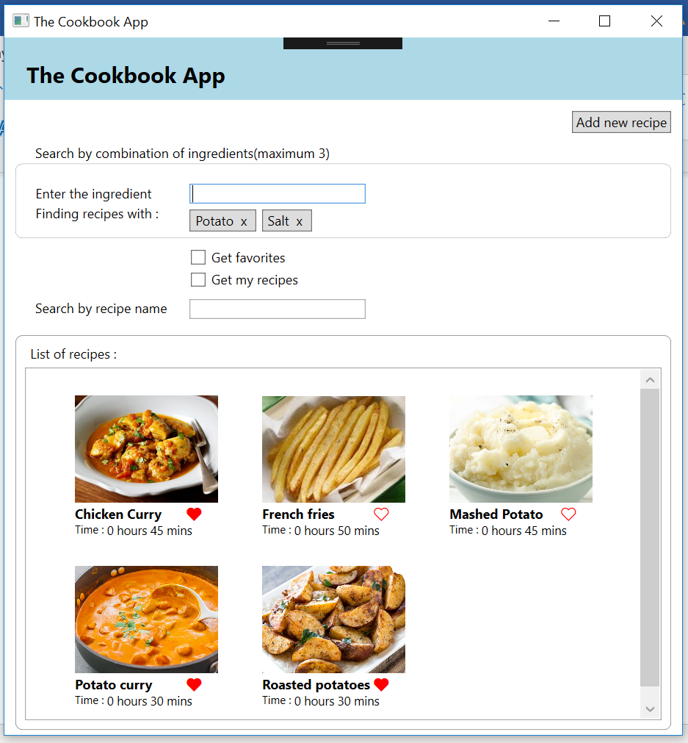

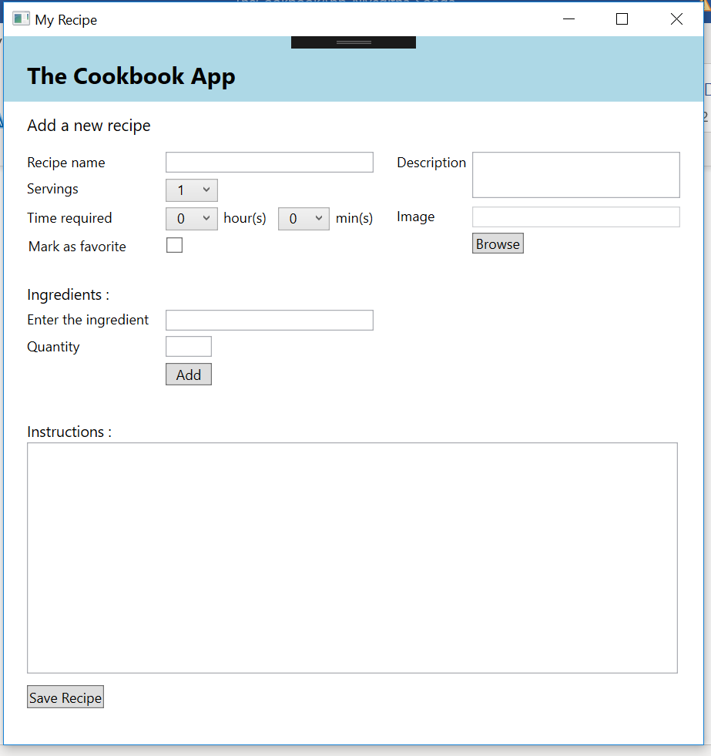

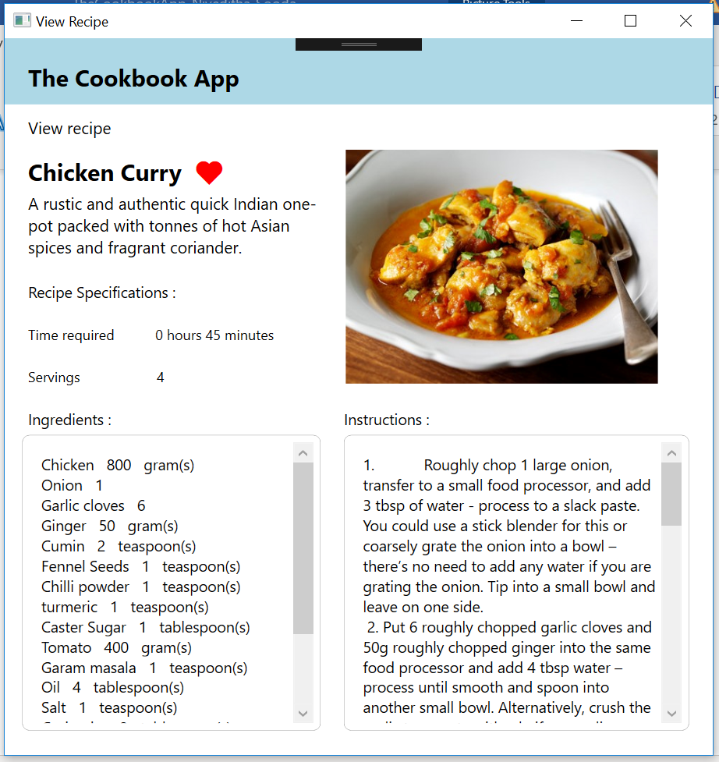 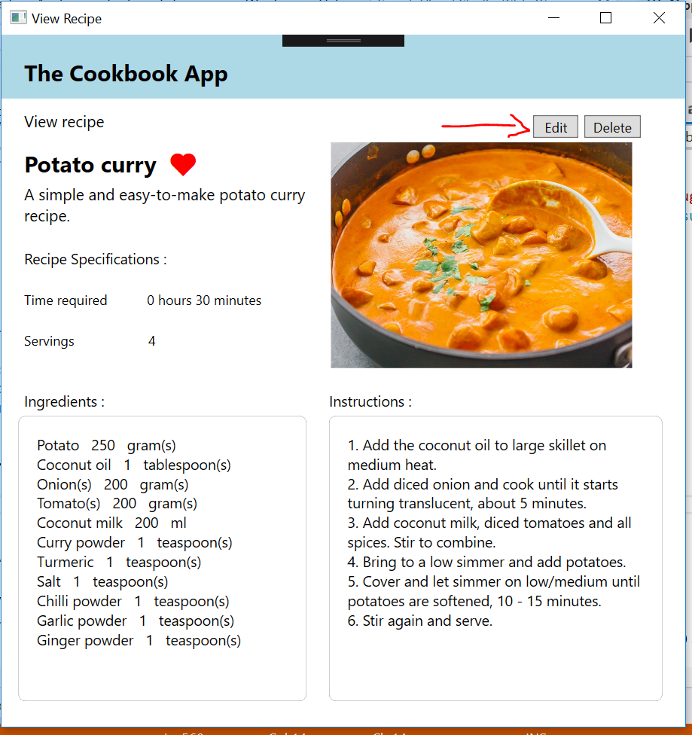

**Principles used**

1. Similiarity: The recipe listing elements show that they are related together as recipes.

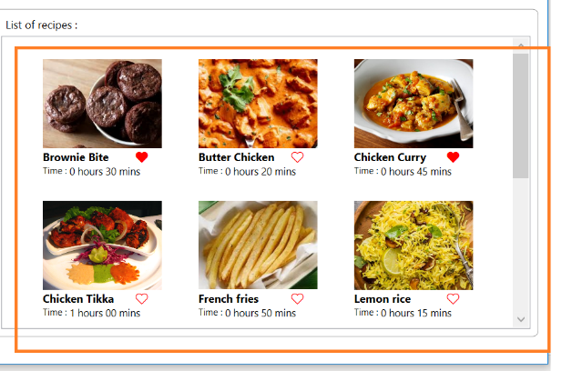

1. Unified connectedness: The search by ingredient combination are enclosed by a border indicating they are connected to each other as filter by combination option.

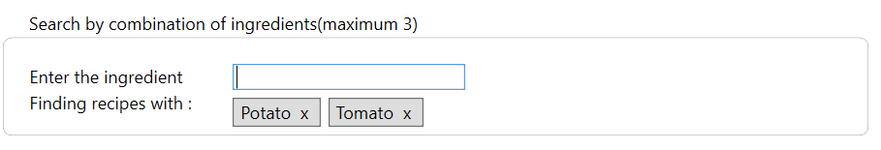

1. Proximity: for example, the ingredients section in view and edit/add recipe show they are related to each other due to the proximity of the sections.

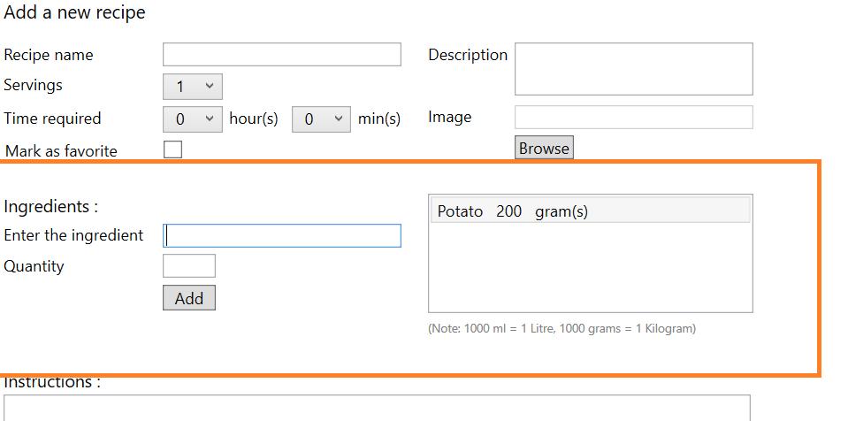

1. Symmetry and order: The view recipe page is divided into sections symmetrically.

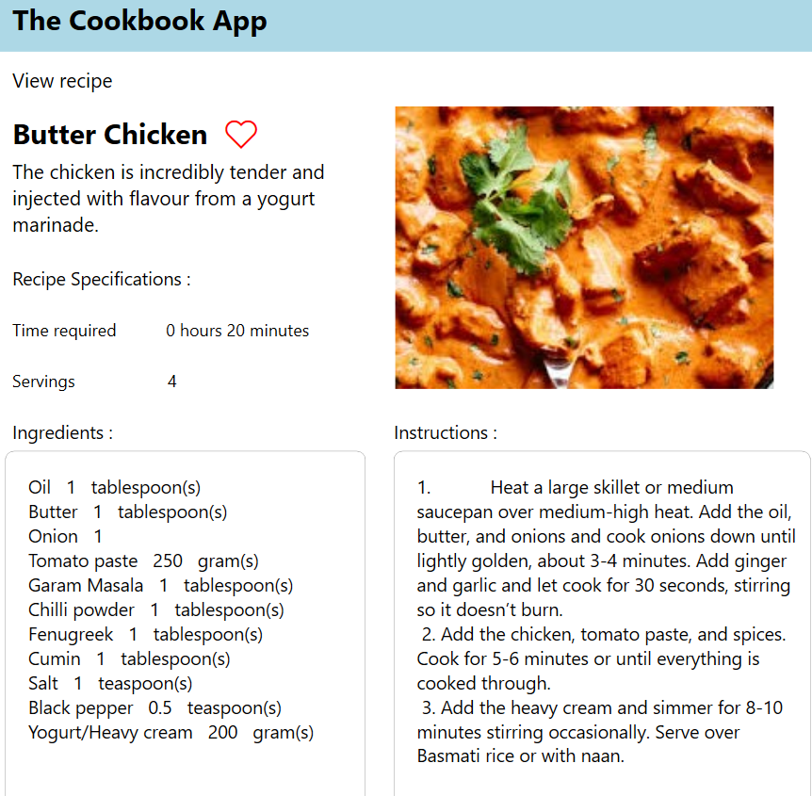

1. Suitability for the task: the user is able to search recipes by various options.
2. Self-descriptiveness: Headers, titles and tooltips describe the application functions.
3. Error tolerance: use of auto suggesting ingredient names to avoid errors by user, setting of ingredient quantity and measures and validations for the same. Selection of same ingredient disabled.
4. Individualization: Ability to add own recipes and modify them.
5. Conformity with user expectations: window position fixed as center and new windows opened similarly. Confirmation popups where required(Delete recipe, close window without recipe name in add).
6. Controllability: Ability to view recipe and return to the list of searched recipe. Ability to add/edit/delete own recipe.

**Future prospects**

1. The option to filter by categories like veg/non-veg, main course/sides/beverages.
2. An option to change servings combobox and change the ingredient measurements according to the servings in view and add/edit screens
3. An option to clone recipes and create an own version of it.